Bushfires and ice • Modelling fire travel
Year 9
Name:

Background
Wildfires commonly occur in Australia and can range from fast-moving grassfires to slower but more intense bushfires. Grassfires are brief, passing in 5-10 seconds, and cause damage to crops, livestock, and farming infrastructure. Bushfires are slower but more dangerous, passing in 2-5 minutes and potentially smouldering for days with intense heat. Fires in tree canopies can spread quickly but require the tops of the trees to be in relatively close contact with each other.
Bushfires are a natural part of Australia's ecosystem, with plants and species adapted to fire. First Nations peoples consider fire a gift to Country and use fire to regenerate the environment.
Bushfires are influenced by factors like fuel availability, weather, and topography (the shape of the landscape). Understanding the science of fire is a key part of the development of ‘Spark’ by CSIRO, a wildfire simulation toolkit for researchers and emergency service agencies. It uses mathematical computer modelling so that users can design and test the likely outcome of a bushfire or grassfire in different Australian environments.

Aim
To use data from CSIRO’s Spark program to determine how fuel loads, weather, and topography affect the spread of fire in grasslands and eucalypt bushland.

Data
Each data set records the calculated fire front at 30-minute intervals over 4 hours from the initial ignition point.
Refer to the following data outputs from CSIRO’s Spark program.

Control: Undisturbed grassland
Test: Undisturbed grassland (humid)
Test: Grazed/Cut grassland
Test: Grassland burned 12 months prior
Test: Undisturbed grassland (windy)
Test: Undisturbed grassland (wind change 1)
Test: Undisturbed grassland (wind change 2)
Control: Eucalyptus bushland
Test: Eucalyptus bushland (10° uphill)
Test: Eucalyptus bushland (10° downhill)
Test: Eucalyptus Bushland (recently burned)
Test: Eucalyptus Bushland (windy)
Unknown 1
Unknown 2

Method
- Identify the point of ignition (at the bottom south end of the bushfire data) for the bushfire shown on either the ‘Control: Eucalyptus bushland’, or the ‘Control: Undisturbed Grassland’ data sets.
- Identify the northern leading edge of each of the 8 fire fronts (HINT: the top of any map is north).
- Use a ruler to measure from the northern front edge of the ignition point to the first fire front. This represents the distance travelled in the first 30 minutes of the fire.
- Each landscape has a different map scale. This means that 1 km may be a different size on each map. The scale measurement is located on the bottom left-hand side of the map.
For example,
1 km
500 m
Or or
Use your ruler to measure the length of the map scale.
- Use ratios to calculate the distance the fire travelled in the first 30 minutes.
$$\frac{actual distance fire travelled (km)}{distance between modelled fire front edge (cm)}=\frac{scale of map (km)}{length of scale of map (cm)}$$

Worked example
A scientist measured the distance the fire travelled on the map as 1.1 cm in 30 minutes. The scale distance was written as 500 m, and the measured length of the map scale ‘box’ was 1 cm.
$$\frac{actual distance fire travelled}{1.1cm}=\frac{0.5 km}{1cmg}$$

$$distance fire travelled=\frac{0.5km}{1cm}×1.1cm$$

$$distance fire travelled=0.550km$$
This means the fire travelled 550m in the first 30 minutes (1.1 km/hr)
- Measure the distance between each fire front on your map and record your results.
- Calculate how quickly the fire travelled in each of the 30 minutes of the model. Record your results.
- Repeat Steps 2-7 on one Test data set that has one condition changed from the control data set.
- If you have access to data software, you may want to do the calculations automatically.
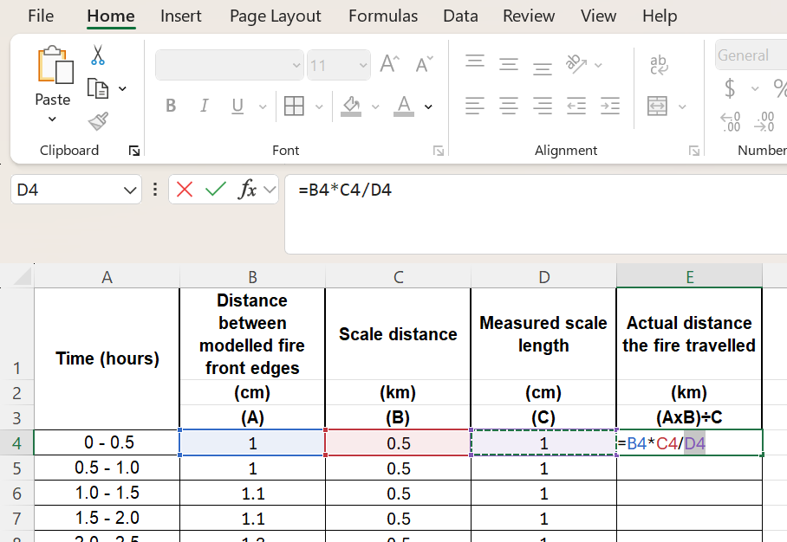

Results
Table 1: Bushfire modelled conditions
Conditions | Control data set | Test data set
Relative humidity

Temperature

Wind speed

Wind direction

Topography

Surface fuel hazard score
(if applicable)
Near-surface fuel hazard score
(if applicable)
Near-surface fuel height
(if applicable)

Table 2: The calculated speed of the fire front during each 30 minutes in ‘Controlled’ conditions.
Time (hours) | Distance between modelled fire front edges  (cm)  (A) | Scale distance  (km)  (B) | Measured scale length (cm)  (C) | Actual distance the fire travelled  (AxB)÷C
0 - 0.5
0.5 - 1.0
1.0 - 1.5
1.5 - 2.0
2.0 - 2.5
2.5 - 3.0
3.0 - 3.5
3.5 - 4.0
Table 2: The calculated speed of the fire front during each 30 minutes in ‘Test’ conditions.
Time (hours) | Distance between modelled fire front edges  (cm)  (A) | Scale distance  (km)  (B) | Measured scale length (cm)  (C) | Actual distance the fire travelled  (AxB)÷C
0 - 0.5
0.5 - 1.0
1.0 - 1.5
1.5 - 2.0
2.0 - 2.5
2.5 - 3.0
3.0 - 3.5
3.5 - 4.0

Discussion
- Describe what the different lines in the bushfire data represent.
- Describe how you identified the direction (north, south, east, or west) in the data.
- Describe how you measured how far the fire spread from the ignition point in the first 30 minutes.
- Describe how parallax error could affect your measurements with the ruler.
- Compare the difference in how fast the fire spread between the Control and the Test conditions.
- Compare your results to the test conditions of other groups in your class. Describe the factors that increased or decreased the rate bushfire spreads.
- The CSIRO Spark program is based on the mathematical modelling of many scientists and mathematicians. Describe how data could have been gathered by the researchers to include in the Spark program. (HINT: consider on the ground measurements and aerial measurements.)
- Explain how modelling of bushfires such as CSIRO Spark could be used by firefighters, government, and community groups
Extension
Use the Spark data of fires in two unknown areas. Hints of the type of fuel is provided by the background pictures. Use your knowledge of how fire travels to infer the weather and topography of the fire shown.

