Bushfire and ice • Measuring carbon storage
Year 9
Name:

Aim
To measure the amount of carbon stored in a local tree and to translate this into the equivalent amount of carbon dioxide.

Equipment
- Measuring tape
- Excel or equivalent program
Optional: camera and/or GPS

Procedure
- Select a local tree with a circumference at least 40 cm.
- Assign your tree a number so that it can be distinguished from other trees in the area. This can be done by:
  - using GPS coordinates.
  - taking a photograph.
  - drawing its distinguishing characteristics.
- Measure up the trunk, 1.3 m from the base of the tree.
- Measure the circumference of the tree (keeping the tape measure level) three times. Record your measurements in Table 1.
- Determine the average circumference of the tree.
- Create a graph that can be used to calculate the amount of carbon in your tree.
  - Enter the data in Table 2 into Excel or an equivalent program.
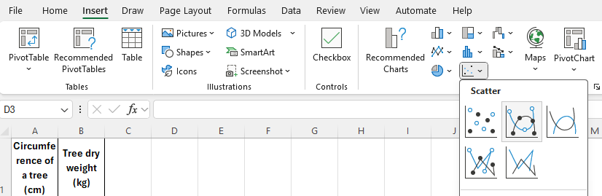
  - Highlight both columns of the graph and select ‘Insert’ and ‘Scatter graph with smooth lines and markers’.

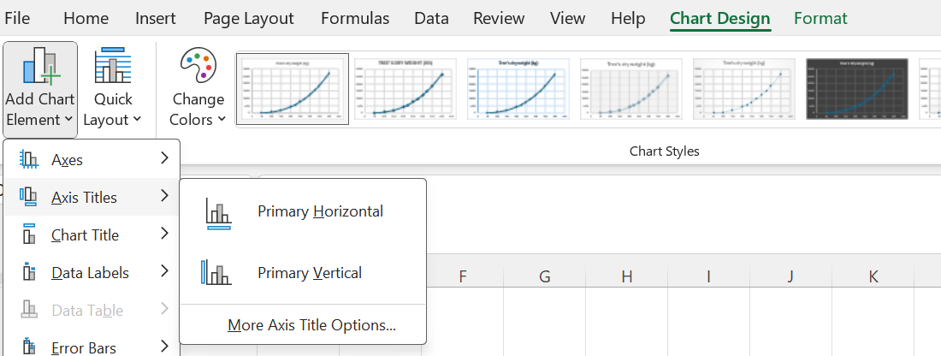
  - Select ‘Add Chart Element’ to add axis titles for the horizontal axis (Diameter of the tree in cm) and the vertical axis (Tree’s biomass in kg).
- Use the graph to calculate the biomass of your tree.
- Use the formula below and the biomass of the tree to calculate the total amount of carbon that was stored in the tree.
Total carbon (kg) = total biomass (kg) x 0.5
- Use the total carbon that was calculated in Step 8 to determine the amount of carbon dioxide that was absorbed from the atmosphere by the tree so that it could grow to its current size.
Carbon dioxide equivalent to biomass = total carbon (kg) x 3.67

Results
Location and description of the tree:

Table 1: Circumference of the tree measurements in cm
 | Measurement 1  (cm) | Measurement 2 (cm) | Measurement 3 (cm) | Average circumference  (cm)
Circumference of the tree

Table 2: Comparison of tree circumference to its dry weight

Circumference of a tree (cm) | Tree’s dry weight (kg)
50 | 106
100 | 668
150 | 1964
200 | 4221
225 | 5771
250 | 7641
275 | 9842
300 | 12410
325 | 15350
350 | 18700
400 | 26674

Discussion
- Describe why the circumference of the tree trunk was measured at 1.3 m from the ground.
- Describe why the circumference of the tree trunk was averaged from three measurements.
- Describe why Table 2 could not be used to measure the amount of carbon in a tree with a circumference larger than 400 cm.
- Explain how the rate a tree grows would affect the validity of your calculations.
- As a scientist, use your knowledge of biomass to explain how you could check the accuracy of Table 2.
- Explain why knowing the biomass of an area may be important in a bushfire area.

Quick reference guide

Table 3: Relationship between the circumference of the tree and the amount of carbon absorbed from the atmosphere.
Circumference of a tree (cm) | Tree's dry weight (kg) | Total carbon (kg) | Total carbon absorbed from the atmosphere
50 | 106 | 53 | 194.51
100 | 668 | 334 | 1225.78
150 | 1964 | 982 | 3603.94
200 | 4221 | 2110.5 | 7745.535
225 | 5771 | 2885.5 | 10589.785
250 | 7641 | 3820.5 | 14021.235
275 | 9842 | 4921 | 18060.07
300 | 12410 | 6205 | 22772.35
325 | 15350 | 7675 | 28167.25
350 | 18700 | 9350 | 34314.5
400 | 26674 | 13337 | 48946.79

Graph 1: Relationship between the circumference of the tree and the amount of carbon absorbed from the atmosphere.

