Bushfire and ice • Carbon cycle game

**Year 9**

|  |  |
| --- | --- |
| **Name:** |  |

### Background

Carbon is one of the essential elements that is found in all of Earth’s spheres. In the layer of gases that surround the Earth (the ATMOSPHERE), carbon is most commonly found in a greenhouse gas: carbon dioxide. Carbon is also found in many of the important molecules found in all living things (the BIOSPHERE). These molecules include molecules used for energy (glucose), genetic material (DNA), and in the enzymes that support all the chemical reactions that are needed to keep an organism alive. Carbon is also dissolved in the many sources of water that form the HYDROSPHERE. The GEOSPHERE is the minerals that form rocks and the Earth’s surface. These rocks can be made of molecules such as calcium carbonate (found in limestone and its metamorphic version, marble) and the dead plant matter that can become fossil fuel.

### Aim

To model the movement of carbon through Earth’s sphere (including the geosphere, biosphere, hydrosphere and atmosphere).

### Materials

* One copy of each station card (laminated)
* 7 dice
* Data sheet (1 per student)

### Set up

1. Create seven stations in different places around the classroom, each with one station card and one die.
2. Divide the class into seven equal groups and assign a starting location for each group.

### Instructions

1. Read the card at your station to identify where you (as a carbon atom) could move to as part of the carbon cycle.
2. Each person at your station individually takes a turn rolling the die and following the directions.
3. Each person should record their movement on the data sheet.
4. Repeat Steps 1-3 another nine times (ten times in total).
5. Draw a picture that represents the movement of carbon across the different parts of the carbon cycle.
6. Draw a graph to represent the length of time (number of turns) each carbon atom spent in a part of the carbon cycle.

### Data

Table 1: Movement of carbon during carbon cycle

|  |  |  |  |
| --- | --- | --- | --- |
| Turn number | Station stop | What happened? | Destination |
| 1 |  |  |  |
| 2 |  |  |  |
| 3 |  |  |  |
| 4 |  |  |  |
| 5 |  |  |  |
| 6 |  |  |  |
| 7 |  |  |  |
| 8 |  |  |  |
| 9 |  |  |  |
| 10 |  |  |  |

### Diagram showing how carbon moves through the carbon cycle

Add labels and any other unrepresented movement that may be needed.



# The ATMOSPHERE

You are currently a molecule of carbon dioxide in the atmosphere,

Roll the die to determine your path.

|  |  |
| --- | --- |
| Roll result | Travel to… |
| 1 | Movement out of the atmosphere takes time. Stay in the ATMOSPHERE. |
| 2 | A plant uses you to photosynthesise. Move into the BIOSPHERE (Plant).  carbon dioxide + water → oxygen + glucose  light |
| 3 | Movement out of the atmosphere takes time. Stay in the ATMOSPHERE. |
| 4 | Movement out of the atmosphere takes time. Stay in the ATMOSPHERE. |
| 5 | You dissolve in water. Move into the HYDROSPHERE (Ocean surface). |
| 6 | A plant uses you to photosynthesise. Move into the BIOSPHERE (Plant).  carbon dioxide + water → oxygen + glucose  light |

# A close-up of a dice AI-generated content may be incorrect.The BIOSPHERE (Plants)

You are currently a molecule in the structure of a plant.

Roll the die to determine your path.

|  |  |
| --- | --- |
| Roll result | Travel to… |
| 1 | A tree sheds its leaves. Move to the GEOSPHERE (Soil). |
| 2 | You are a molecule in the tree’s leaves. Stay in the BIOSPHERE (Plant). |
| 3 | You are eaten by an animal. Move to the BIOSPHERE (Animals). |
| 4 | You are a molecule in the tree’s branch. Stay in the BIOSPHERE (Plant). |
| 5 | You are a molecule in the tree’s trunk. Stay in the BIOSPHERE (Plant). |
| 6 | You are a molecule in the tree’s roots. Stay in the BIOSPHERE (Plant). |

# A close-up of a dice AI-generated content may be incorrect.The BIOSPHERE (Animals)

You are currently a molecule in the structure of an animal.

Roll the die to determine your path.

|  |  |
| --- | --- |
| Roll result | Travel to… |
| 1 | You are a molecule in the animal’s muscles. Stay in the BIOSPHERE (Animal). |
| 2 | The animal dies and decomposes into the soil. Move to the GEOSPHERE (Soil). |
| 3 | The animal who ate you uses the molecule you are in for energy and breathes you out as carbon dioxide. Go to the ATMOSPHERE. |
| 4 | You are eaten by a predator. Stay in the BIOSPHERE (Animal). |
| 5 | The animal who ate you uses the molecule you are in for energy and breathes you out as carbon dioxide. Go to the ATMOSPHERE. |
| 6 | The animal who ate you uses the molecule you are in for energy and breathes you out as carbon dioxide. Go to the ATMOSPHERE. |

# A close-up of a dice AI-generated content may be incorrect.The GEOSPHERE (Soil)

You are currently a molecule in the rocks and soil.

Roll the die to determine your path.

|  |  |
| --- | --- |
| Roll result | Travel to… |
| 1 | You are stored in the soil. Stay in the GEOSPHERE. |
| 2 | A plant’s root absorbs you as a carbonate. Go to BIOSPHERE (Plants). |
| 3 | You move deeper underground. Go to GEOSPHERE (Fossil fuel). |
| 4 | You are decomposed by fungi that produce carbon dioxide. Move into the ATMOSPHERE. |
| 5 | You are trapped in the soil. Stay in the GEOSPHERE (Soil). |
| 6 | You move deeper underground. Go to GEOSPHERE (Fossil fuel). |

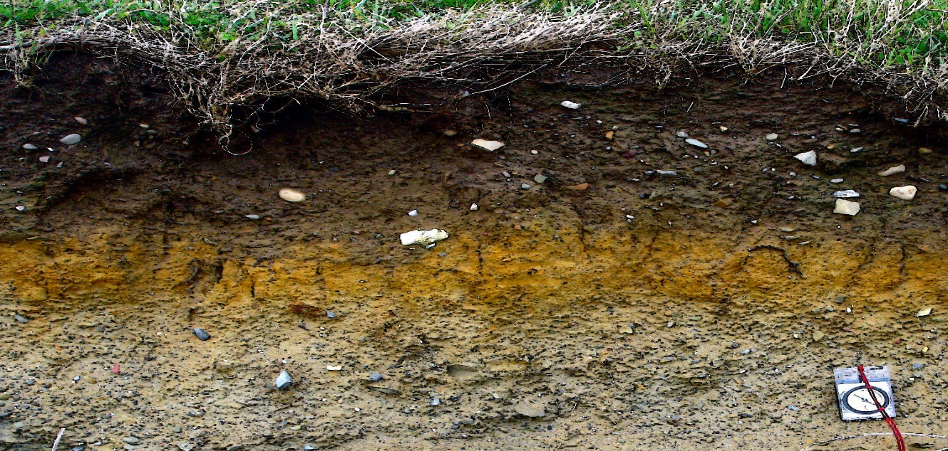

# A close-up of a dice AI-generated content may be incorrect.The HYDROSPHERE (Ocean surface)

You are currently a molecule dissolved in the ocean’s water surface.

Roll the die to determine your path.

|  |  |
| --- | --- |
| Roll result | Travel to… |
| 1 | Currents pull you deeper below the surface. Go to HYDROSPHERE (Deep ocean). |
| 2 | You surf the ocean currents. Stay in the HYDROSPHERE (Ocean surface). |
| 3 | Your carbon atom was part of an ocean animal that died and sank to the bottom of the ocean. Go to HYDROSPHERE (Deep ocean). |
| 4 | You are frozen in glacial ice. Go to the HYDROSPHERE (Deep ocean). |
| 5 | You escape the surface of the water. Go to the ATMOSPHERE. |
| 6 | You escape the surface of the water. Go to the ATMOSPHERE. |

# A close-up of a dice AI-generated content may be incorrect.The HYDROSPHERE (Deep ocean)

You are currently a molecule dissolved in the deep water of the ocean.

Roll the die to determine your path.

|  |  |
| --- | --- |
| Roll result | Travel to… |
| 1 | Currents keep you at the bottom of the ocean. Stay in the HYDROSPHERE (Deep ocean). |
| 2 | You are frozen in the glacial ice. Stay in the HYDROSPHERE (Deep ocean). |
| 3 | Ocean currents push you back to the surface of the ocean. Go to HYDROSPHERE (Ocean surface). |
| 4 | Ocean currents push you back to the surface of the ocean. Go to HYDROSPHERE (Ocean surface). |
| 5 | You mix it with melted glacial ice. Go to HYDROSPHERE (Ocean surface). |
| 6 | An animal has taken you up as a source of food in the deep ocean. Go to BIOSPHERE (Animal). |

# A close-up of a dice AI-generated content may be incorrect.The GEOSPHERE (Fossil fuel)

You are currently part of the oil buried deep in the GEOSPHERE.

Roll the die to determine your path.

|  |  |
| --- | --- |
| Roll result | Travel to… |
| 1 | No one has yet discovered you. Stay in the GEOSPHERE (Fossil fuel). |
| 2 | No one has yet discovered you. Stay in the GEOSPHERE (Fossil fuel). |
| 3 | No one has yet discovered you. Stay in the GEOSPHERE (Fossil fuel). |
| 4 | No one has yet discovered you. Stay in the GEOSPHERE (Fossil fuel). |
| 5 | You have been pumped to the surface by humans. You have been part of a combustion reaction in a car. Move to the ATMOSPHERE. |
| 6 | You have been pumped to the surface by humans. You have been part of a combustion reaction in a car. Move to the ATMOSPHERE. |

