Name:

Bushfire and ice • Bushfire empathy map
Year 9

THINK  What are people thinking about? | FEEL  What emotions are people describing or showing?
SAY  How do people describe what happened? | 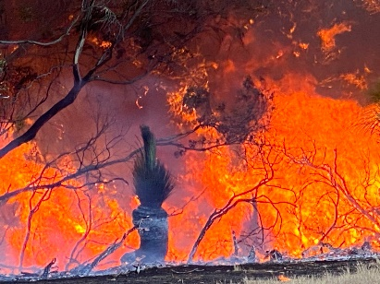  DO  How are people moving and acting?

