Bushfire and ice • Australian ecosystems—answers

**Year 9**

### Savanna woodland

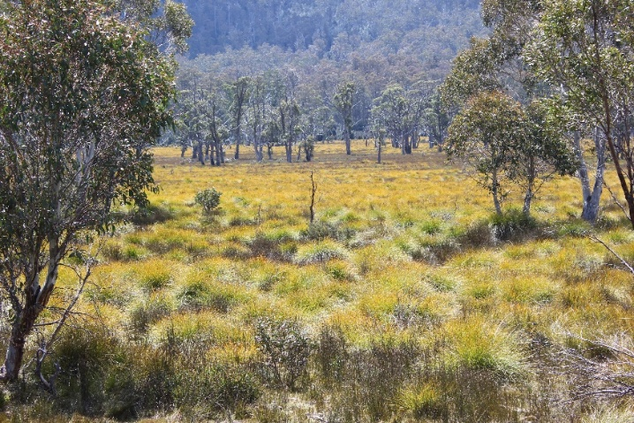

### Savanna grassland

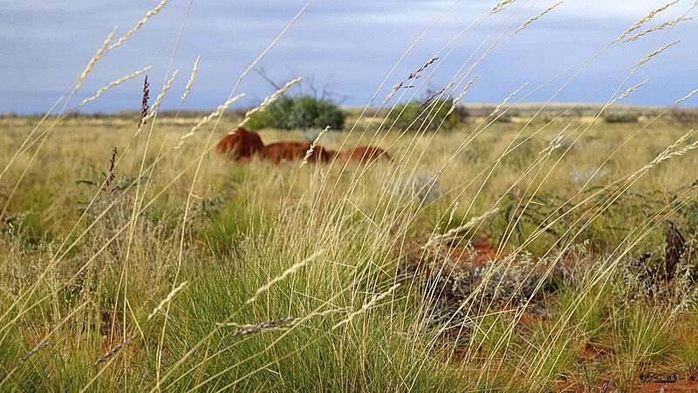

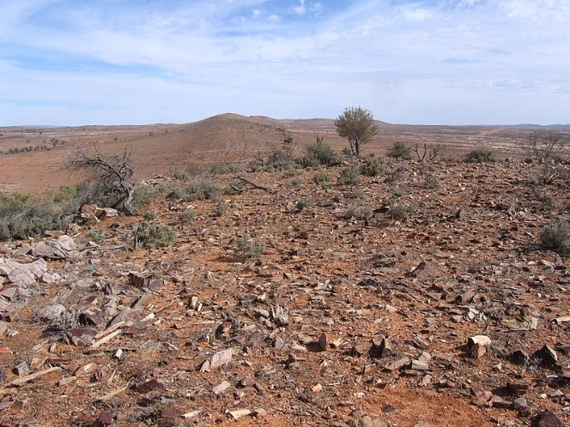

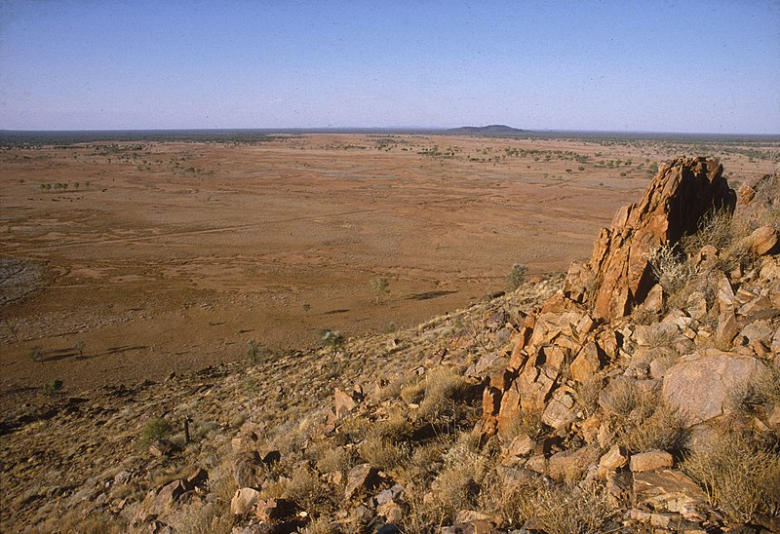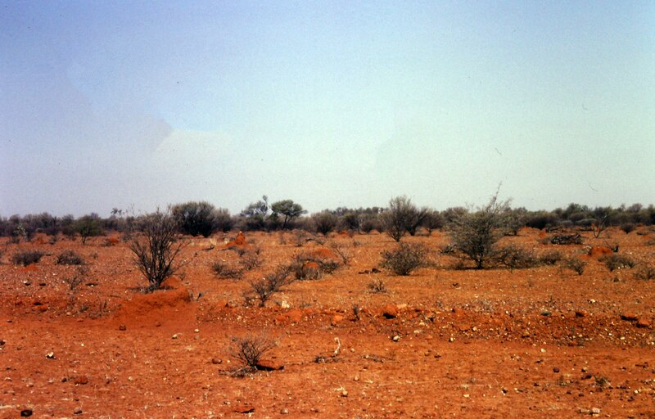

### Temperate grassland

Red borders indicate that these pictures could also be classified under temperate conditions.

### Rainforest

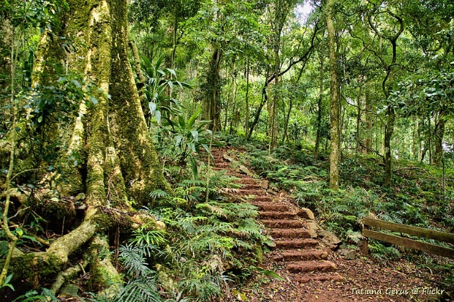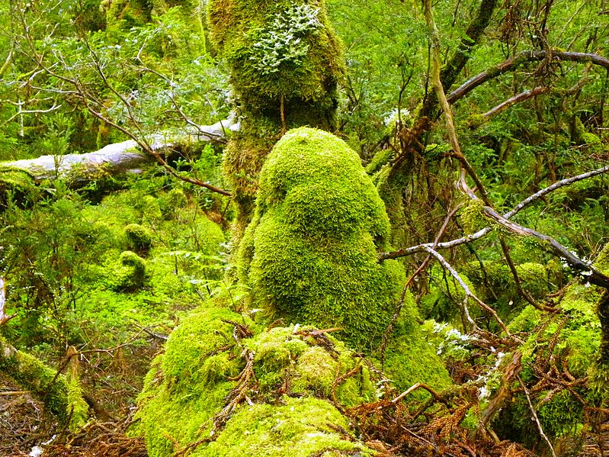

### Temperate woodland

