Breeding for balance • Trapping antechinus
Year 9
Name:

Modelling population density

Elliott traps
Elliott traps are small metal boxes used to catch small mammals like mice, rats, or marsupial mice like Antechinus agilis. When A. agilis moves into the fully enclosed trap to reach the bait, it steps on a pedal and the door snaps shut without hurting the animal. The traps are usually placed on the ground and camouflaged. Because the metal can get very hot or very cold, traps are only be left open at night during warm weather and always checked in the morning. A trap needs to be left out for at least three days as animals will not usually enter on the first night.
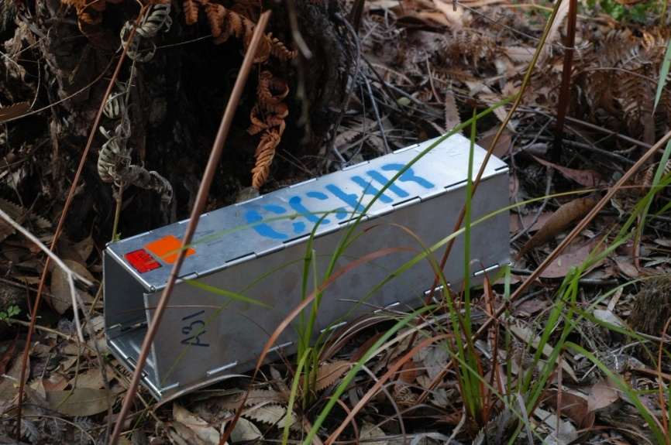

Procedure
Six traps were set up 20 m apart in a 7.4 ha area for 3 nights. Each A. agilis captured was identified according to its sex and number of feeding teats, then tagged so it could be recognised if recaptured. This process was repeated every few months.

The number of A. agilis in a population (N) in each 7.4 ha area can be estimated by the calculation:

$$N=\frac{M×n}{m}$$

M = number of individuals caught in the first sampling, which were marked and then released
n = number of individuals caught in the second sampling
m = number of marked individuals that were recaptured

Results
Two populations of A. agilis were identified.
Population 1 had female mice with 6 teats (6T).
Population 2 had female mice with 10 teats (10T).
The results of the population capture-recapture are shown in Table 1 and Table 2. Mice that have been tagged are marked with a gold star.

Discussion
- Use the population equation to calculate the number of A. agilis in:
  - population 1 (6T females).
  - population 2 (10T females).
- Identify the maximum number of offspring a 6T female A. agilis would be able to support. Provide reasoning to support your claim.
- Identify the maximum number of offspring a 10T female A. agilis would be able to support. Provide reasoning to support your claim.
- Compare the number of males caught in each population.
- Identify which population (6T or 10T) has the greater number of female A. agilis in the area. Use evidence from the results to support your claim.
- List three factors that could affect the number of A. agilis living in an area.
- Producing milk for their offspring takes a lot of energy. Contrast the amount of food each female (6T female or 10T female) would need to provide milk to their offspring (i.e. Which mother would need to eat the most food?). Provide reasoning to support your answer.
- Identify the reproductive strategy (r- or K-strategy) used by Antechinus agilis. Use evidence and reasoning to support your claim.

Table 1: Number of A. agilis caught in the ‘6-teat’ area
Location | Antechinus captured  (night 1) | Antechinus captured  (night 2) | Antechinus captured  (night 3)
1 |  | 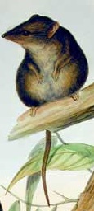  F6 | F6
2 |  | M | F6
3
4 |  |  | M
5 |  |  | F6
6 |  |  | M

Table 2: Number of A. agilis caught in the ‘10-teat’ area
Location | Antechinus captured  (night 1) | Antechinus captured  (night 2) | Antechinus captured  (night 3)
1 |  |  | F10
2 |  | F10
3
4 |  |  | M
5 |  | M | F10
6

