Breeding for balance • Who done it?

**Year 9**

|  |  |
| --- | --- |
| **Name:** |  |

# Bogong moth murder?

The number of bogong moths that visit the high country of Eastern Australia crashed in 2017. An essential part of the ecosystem, their decline has also threatened the survival of the Mountain Pygmy-possum (*Burramys parvus*) and the Marsupial mouse (*Antechinus stuartii*).

Your mission is to identify possible suspects responsible for the decline in the population of bogong moths.

|  |  |  |  |  |  |  |  |  |  |  |  |
| --- | --- | --- | --- | --- | --- | --- | --- | --- | --- | --- | --- |
| March | April | May | June | July | August | September | October | November | December | January | February |
| **Adults** | | |  |  |  | **Migration and Aestivation** | | | | | |
|  | **Eggs** | |  |  |  |  |  |  |  |  |  |
|  | **Larvae** | | | |  |  |  |  |  |  |  |
|  |  | **Pupae (chrysalis or cocoon)** | | | | |  |  |  |  |  |

**Suspect 2:**

*Sus scrofa* (feral pigs)

**Suspect 1:**

*Vulpes vulpes* (red fox)

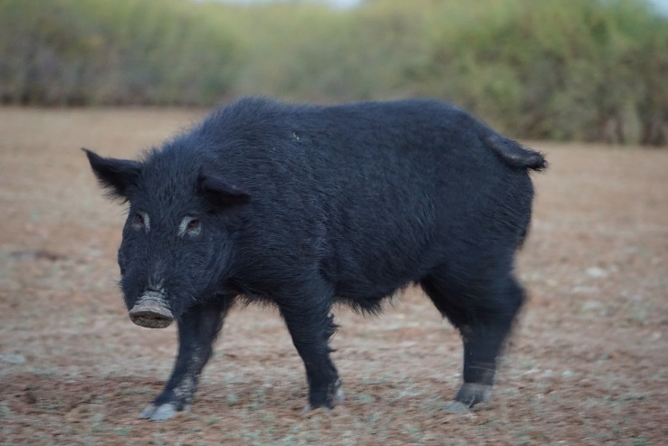

Foxes are carnivores that were introduced to Australia in mid-1850s. They are currently found in all mainland states and territories.

Diet: mammals, insects and plants.

Of the 1159 scats (animal poo) collected in the Kosciuszko National Park in 1978-79 along a transect line from 1500-1800 m above sea level, 151 contained only bogong moth remains. The number of moths present in the scats increased from October to January and decreased to zero by May. The number of moths remains present in scat decreased in 2017-2019.

Green, K., Caley, P., Baker, M., Dreyer, D., Wallace, J., & Warrant, E. (2021). Australian Bogong moths Agrotis infusa (Lepidoptera: Noctuidae), 1951–2020: decline and crash. *Austral Entomology*, *60*(1), 66-81.

Pigs are opportunistic omnivores that were introduced to Australia by European settlers.

Diet: mainly grasses, but also bulbs, tubers, seeds, carrion, mammals and insects.

In the 2015-2016 summer period, wild pig tracks were identified on the floor of the Mount Gingera caves. After the arrival of the bogong moths, cameras identified that pigs visited the cave an average of 13 visits/day for 24 days. Bogong moths were found high in the caves visited by the pigs (out of their reach.)

Caley, P., & Welvaert, M. (2018). Aestivation dynamics of bogong moths (Agrotis infusa) in the Australian Alps and predation by wild pigs (Sus scrofa). *Pacific Conservation Biology*, *24*(2), 178-182.

**Suspect 3:**

Insecticides

**Suspect 4:**

LED street lights

As cities grow and more lights are turned on at night, insects like bogong moths are being affected. Though there are no studies directly about the moths, researchers have noticed that artificial lights attract all insects including the moths, but this only stops them temporarily. Bogong moths usually continue their long migration after a while, maybe because it gets warmer and they need to travel to the cooler mountains for aestivation (a type of hibernation).

Caley, P. (2022). Identifying hypotheses for drivers of decline of the bogong moth (Agrotis infusa). *Pacific Conservation Biology*, *29*(5), 429-444.

Insecticides are chemicals used to kill insects that damage food crops. The bogong moth larvae are one of many insects that may be present during spraying. While they do not cause much damage to cereal crops, they can be killed by the neonicotinoid sprays that are used to kill other insect (such as aphids).

Some seeds are sprayed with insecticide in advance. The spray remains on the growing seedling for several weeks and could kill the bogong moth larvae that feed on them.

Caley, P. (2022). Identifying hypotheses for drivers of decline of the bogong moth (Agrotis infusa). *Pacific Conservation Biology*, *29*(5), 429-444.

**Suspect 6:**

Increased land use

**Suspect 5:**

Honey bees

Farming now uses more chemicals (herbicides) instead of machines to get rid of weeds in their crops. This removes the green plants that bogong moth larvae (called cutworms) need to eat when they hatch in late summer and autumn.

Farms have become bigger by joining paddocks together. This means there’s less space between crops for wild plants to grow—these are places where moths could have laid their eggs. Since fewer sheep are being raised, fences (which used to provide extra plant cover) are also disappearing.

Irrigation farming uses water and strong weed control, making the land unsuitable for bogong moths to breed.

Caley, P. (2022). Identifying hypotheses for drivers of decline of the bogong moth (Agrotis infusa). *Pacific Conservation Biology*, *29*(5), 429-444.

Caley, P. (2022). Identifying hypotheses for drivers of decline of the bogong moth (Agrotis infusa). *Pacific Conservation Biology*, *29*(5), 429-444.

During their migration from the breeding grounds to the mountains, bogong moths compete with commercial honey bees for nectar. Apiarists (beekeepers) describe how the amount of honey produced by their bees decreases during the migration periods. Most apiarists move their beehives away from the migratory path of the bogong moths during the months of October to February.

Birtchnell, M., & Gibson, M. (2008). *Flowering ecology of honey-producing flora in south-east Australia*. Deakin University.

Bogong moths hibernate (or *aestivate*) in cool mountain crevices during the summer, and smoke can disturb them. First Nations people used smoke to help collect moths from hard-to-reach places. The biggest recent drop in bogong moth numbers occurred in 2017-2019 (*before* the big bushfires in late 2019 and early 2020).

Caley, P. (2022). Identifying hypotheses for drivers of decline of the bogong moth (Agrotis infusa). *Pacific Conservation Biology*, *29*(5), 429-444.

Bogong moths spend the summer hibernating (*aestivation*) in cool mountain caves in Australia's High Country. But as the climate warms, these places are getting hotter. If they get too hot, the moths may no longer be able to escape the heat.

Some mountain spots, like Mount Gingera, are already reaching temperatures that may be too warm for the moths. Even though there’s still space at higher, cooler areas for the moths to go, scientists worry that the heat might still be harming them in ways we can’t easily see—like slowly reducing their health or energy—even if they don’t die right away.

Caley, P. (2022). Identifying hypotheses for drivers of decline of the bogong moth (Agrotis infusa). *Pacific Conservation Biology*, *29*(5), 429-444.

**Suspect 8:**

Increased temperature

**Suspect 7:**

Bushfires

**Suspect 10:**

Herbivores

**Suspect 9:**

Pest status

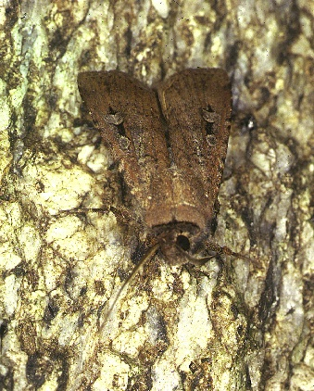

Bogong moth larvae usually feed on broad leaf plants, like weeds in crops, but they’ve been known to cause damage to a variety of crops.

In 2014, there was a huge problem with cutworms (bogong moth larvae) eating young crops, especially canola and cereals, across a long stretch of land from New South Wales to Victoria. This damage lasted from May to July, and in some cases, it almost destroyed entire crops. This was linked to increased numbers of moths in the mountains in October 2014.

However, the link between farming and moth numbers isn’t clear. For example, in 2015, even though there was almost no crop damage, large numbers of moths still appeared in the mountains.

Caley, P. (2022). Identifying hypotheses for drivers of decline of the bogong moth (Agrotis infusa). *Pacific Conservation Biology*, *29*(5), 429-444.

When early Europeans brought cows and sheep to Australia, these imported herbivores ate a lot of the broadleaf plants that bogong moth larvae rely on for food. At the same time, the removal of predators like dingoes and the end of widespread Indigenous hunting allowed native herbivores, such as kangaroos, to increase in number. This meant more competition for the plants eaten by the bogong moth larvae.

Continuous grazing by these animals also changed the types of plants that grew, making the environment less suitable with less available nutrients available for the larvae.

Caley, P. (2022). Identifying hypotheses for drivers of decline of the bogong moth (Agrotis infusa). *Pacific Conservation Biology*, *29*(5), 429-444.