
Y9

Breeding for balance • Lesson 1 • Cute enough to save
Lesson 1
LAUNCH
To read the most recent version of this lesson, download associated resources, and view embedded professional learning including classroom videos and work samples, visit: https://scienceconnections.edu.au/teaching-sequences/year-9/breeding-balance/lesson-1-cute-enough-save

Lesson overview
Students examine their understanding of breeding programs and investigate how the programs support the survival of endangered, vulnerable or at-risk species.

Key learning goals
Students will:
- discuss examples of breeding programs.
- compare the meanings of ‘endangered’, ‘vulnerable’ and ‘at-risk’.
- discuss factors that affect the funding or breeding programs.
Students will represent their understanding as they:
- brainstorm what might be needed for a breeding program.
- describe the factors that affect their choice of a sponsor animal.

Assessment advice
In the Launch phase, assessment is diagnostic.
Take note of:
- students’ understanding of:
  - the terms ‘extinct’, ‘endangered’, ‘vulnerable’, and ‘threatened’.
  - ‘breeding’ vs ‘reproduction’.
- students’ ability to research to identify and synthesise information.
- students' ability to identify possible limitations in their own positions by considering opposing viewpoints.

List of materials
Whole class
- Access to the internet and YouTube for videos
- Breeding for balance Resource PowerPoint
- The website of a local/nearby zoo that offers sponsorship for individual animals, for example:
  - ACT: National Zoo & Aquarium
  - NSW: Taronga Zoo
  - QLD: Australia Zoo or Currumbin Wildlife Sanctuary
  - VIC: Zoos Victoria
  - WA: Perth Zoo
  - SA: Zoos South Australia
  - TAS: Bonorong Wildlife Sanctuary
Each group
- Access to the internet for online research
Each student
- Individual science notebook (or electronic equivalent)
- Resources/materials to produce a digital or paper-based poster

Lesson routine | Estimated time | Task type
Experience & empathise | 10 minutes | Whole class
Elicit and Anchor | 10 minutes | Small group/Individual
Connect | 40 minutes | Whole class/Individual

Launch

Experience and empathise • Endangered or extinct
(Slide 3) Show an Australian animal that is endangered in your local area. Alternatively, discuss a well-known Australian animal that is endangered (e.g. koala, Gouldian finch, glossy black cockatoo, Eastern quoll, bilby).
(Slide 4) Discuss the difference between:
- ‘extinct’: having no living members of the species.
- ‘endangered’: at high risk of extinction in the near future.
- ‘vulnerable’: at risk of extinction in the medium term.
- ‘threatened’: at risk of extinction.
✎ STUDENT NOTES: Write definitions for ‘endangered’, ‘vulnerable’, and ‘threatened’.
Discuss the role that zoos play in supporting the breeding of endangered species. Watch the video Breeding Programs - Africa Team | Australia Zoo Life (7:31).
(Slide 5) Pose the question: What do we need to know to start a breeding program?
Potential discussion prompts
- What is meant by ‘breeding’? How is it similar or different to ‘reproduction’?
  - Reproduction is a term used to describe the production of offspring in general through sexual or asexual processes.
  - Breeding is a term mainly used for the sexual reproduction of selected desired traits.
- What is a breeding program?
  - A human-designed process that encourages animals to reproduce offspring.
- What is the purpose of a breeding program?
- Why are breeding programs important?
- What are the costs involved in a breeding program?

Elicit and Anchor • Breeding for success
Introduce the breeding program that was initiated to save the Tasmanian devil, and show the video One man's mission to save the Tasmanian devil from extinction (5:39).
✎ STUDENT NOTES: Brainstorm what might be needed for a breeding program, including a large enough population for genetic diversity, knowledge of the breeding process that is different for each animal, the environment they need, etc.
Discuss the challenges of coordinating such a program involving many different conservation groups, the capture, transport, and living requirements of the animals to new locations. Introduce the idea that funding is required to support such breeding programs.

Connect • Show me the money
Watch State of the Environment Report - Behind The News (4:19).
(Slide 6) Pose the question: How do you decide what animal or plant you will sponsor?
Provide students with the website of a local/nearby zoo that offers sponsorship for individual animals. In groups, students should research and identify which animal they would prefer to sponsor.
✎ STUDENT NOTES: Identify which animal you would most like to sponsor. Record what you know about the animal and how it breeds. Why do you think it needs a breeding program?
(Slide 7) Ask each group to share which animal they would like to sponsor. Discuss the class findings.
Potential discussion prompts
- How many animals were mammals/insects/reptiles/amphibians etc.?
- Why do you think some groups were represented more than others? Are they the animals that are most endangered?
- Does cuteness play a role in which animal is most likely to be sponsored or have a breeding program in a zoo?
  - While it can be true that ‘cute’ animals are more likely to be sponsored by the public, zoos are more likely to have a breeding program for animals according to need.
Compare ‘cute animals’ and ‘ugly animals’, for example by reviewing the webpages The 20 Cutest Animals in the World (With Photos) and The 25 Ugliest Animals on Earth (With Photos). Discuss how differences in how animals are perceived can sometimes affect how much money is donated for breeding programs.
✎ STUDENT NOTES: Select an ‘ugly animal’ and create a poster that would encourage people to sponsor a breeding program. If required, research how the animal breeds.

Reflect on the lesson
Students might:
- identify if their 'ugly' animal is currently endangered.
- identify if there is currently a breeding program for their selected 'ugly' animal.

Y9

Breeding for balance • Lesson 2 • Strategic survival
Lesson 2
INQUIRE
To read the most recent version of this lesson, download associated resources, and view embedded professional learning including classroom videos and work samples, visit: https://scienceconnections.edu.au/teaching-sequences/year-9/breeding-balance/lesson-2-strategic-survival

Lesson overview
Students model the advantages and disadvantages of r- and K-reproductive strategies on populations.

Key learning goals
Students will:
- explore how the reproductive strategies of multicellular animals are related to their environment and the complexity of the organism.
- examine how the number of offspring produced by animals is related to the amount of parental care.
Students will represent their understanding as they:
- record and graph data obtained from reproductive models.
- identify animals as r- and K-strategists.
- use argumentation processes in discussions regarding the impact of global warming on reproductive strategies.

Assessment advice
In this lesson, assessment is formative.
Feedback might focus on:
- selection and construction of appropriate representations to organise, process, and summarise data and information.
- analysis and connection of data and information to identify and explain patterns, trends, relationships and anomalies.
- analysis of the impact of assumptions and sources of error in methods, and evaluation of the validity of conclusions and claims.
- construction of logical arguments based on evidence to support conclusions and evaluate claims.
- selection and use of content, language, and text features effectively to achieve their purpose when communicating their ideas, findings, and arguments to specific audiences.

List of materials
Whole class
- Breeding for balance Resource PowerPoint
Each group
- Die
- Counters
- Permanent marker (to mark one side of the counter)
- Optional: Population growth example spreadsheet
Each student
- Individual science notebook
- Population growth Resource sheet
- Surviving siblings Resource sheet

Lesson routine | Estimated time | Task type
Re-orient | 5 minutes | Whole class
Question | 5 minutes | Whole class
Investigate | 30 minutes | Small groups
Integrate | 20 minutes | Whole class/Individual

Inquire

Re-orient
Discuss what is meant by the term ‘offspring’ and how it is preferred by scientists, as ‘babies’ can sometimes be born mature and ready to reproduce within 1-3 weeks (e.g. flies can reproduce within 2 weeks of hatching).

Question • Family
Pose the question: How many offspring do different animals have?
Potential discussion prompts
- How many offspring does a dog/cat/mouse/frog/cane toad have?
- What is the maximum number of offspring a parent could have at the same time?
  - Seahorse fathers and bogong moth mothers can have up to 2000 offspring in a single pregnancy.
- How many offspring does a human have in a single pregnancy? What is the maximum or the minimum?
- Do you think it is easy to have twins, triplets etc.? Why or why not?
(Slide 9) Pose the question: How does the way an animal reproduces affect the survival of...
- ...the parents?
- ...the offspring?
- ...the population?

Investigate • Reproduce for survival
Explain that students are going to do two simulations to explore how the number of offspring born affects animals’ chances of survival.
(Slide 10) Introduce the first activity Population growth Resource sheet. Discuss the assumptions made in this simulation (each parent is fertile, finds a mate outside the population, and only reproduces once), and how these assumptions simplify the model. This will be revisited during the integrate routine.
The population growth simulation compares population growth between animals with a small number of offspring (simulated by flipping a counter to generate 1-2 offspring) and animals with many offspring (simulated by tossing a die to generate 1-6 offspring). The total population only includes the number of offspring that were born during that generation.
Optional: The Population growth example spreadsheet can be used to generate random numbers and to automatically calculate the sum of offspring at each generation.
✎ STUDENT NOTES: Calculate the population growth over 4 generations and draw a line graph displaying the results for both populations. (Slide 11)
Potential discussion prompts
- Why do we have random numbers of offspring being born?
  - This reflects the variation in the real world.
- If the animals were only selecting mates within the population, what would happen if all the offspring were females?
  - The population would become extinct.
- What would happen if each parent produced the maximum/minimum number of offspring? Would the population grow faster or slower? Why or why not?
  - If each parent produced the maximum number of offspring, then the population would increase at a faster rate.
- What is happening to each population? How fast are they growing?
  - The population that has multiple offspring grows at a faster rate.
- What would happen to the population if each set of parents could breed more than once?
- What would happen if there were some infertile/non-breeding members of the community?
- Do you think this model accurately reflects what happens in a population? Why or why not?
- What are the strengths/weaknesses of this model?
Explain that animals that rapidly reproduce many offspring and use minimal parental care are using what is called the r-reproductive strategy. Animals that produce only a few offspring and spend time caring for them and teaching them how to survive are using the K-strategy of reproduction.
Pose the question: Which strategy is most effective in producing surviving offspring?
(Slides 12 and 13) Introduce the second activity Surviving siblings Resource sheet. Ask students to select one animal information card and identify if the animal is using the r- or K-reproductive strategy, and the number of offspring usually produced. Explain that students should work through the three scenarios and calculate the number of offspring that would survive each scenario. They should do this for three different animals of their choice.
✎ STUDENT NOTES: Calculate the number of offspring that would survive each of the three scenarios. Repeat for two more animals.

Integrate • r- and K-strategies
(Slide 14) Ask students to identify the advantages of the different r-strategy and K-strategy approaches. Encourage students to provide evidence from their modelling to support their claims of an advantage that helps offspring survive to the next generation.
✎ STUDENT NOTES: Use argumentation processes to make claims about the effectiveness of each strategy in ensuring survival of the population (claim, evidence, and reasoning that link everything together).
Potential discussion prompts
- Which strategy was most likely to produce surviving offspring? Why do you think that?
- How quickly would offspring need to ‘grow up/mature’ if their parents used the r-strategy?
  - r-strategy offspring usually mature and become independent very quickly.
- How would this be different to the offspring that used the K-strategy?
  - K-strategy animals are born very immature and need to grow while in their parents’ care.
- What would happen if a r-strategy population were able to grow unchecked (no predators, plenty of food etc.)?
  - The population would quickly become out of control.
Discuss how K-strategy animals tend to learn their survival processes from parents, while r-strategy animals rely on quick maturing and large numbers to survive.
(Slide 15) Revisit the assumptions made at the start of the lesson and discuss the impact of an assumption being incorrect, including:
- each parent is fertile (infertility affects the rate of population growth)
- each individual finds a mate outside the population (if a population has a higher number of males, then the population grows slower as females are needed to carry the young in most species)
- each individual only reproduces once each season (some animals can reproduce more quickly—rats can breed at 6 weeks of age)
Pose the question: Which reproductive strategy would be most affected by global climate change?
Discuss how the climate is changing in your local area, including more droughts, floods, and warmer weather. Discuss how K-strategy animals have longer life spans and tend to live in stable environments. This means the loss of a few animals in an unpredictable environment can affect the parental care of offspring.
✎ STUDENT NOTES: Explain how global warming would impact animals that use either r- or K-strategies.

Reflect on the lesson
Students might:
- research how temperature affects the sex of turtles (and the impact of global warming).
- categorise the remaining animal cards as r- or K-strategists.
- re-examine the intended learning goals for the lesson and consider how they were achieved.

Y9

Breeding for balance • Lesson 3 • Who killed the bogong moths?
Lesson 3
INQUIRE
To read the most recent version of this lesson, download associated resources, and view embedded professional learning including classroom videos and work samples, visit: https://scienceconnections.edu.au/teaching-sequences/year-9/breeding-balance/lesson-3-who-killed-bogong-moths

Lesson overview
Students examine the life cycle of the bogong moth and use argumentation to identify the possible causes of the population crash in 2017-2020. They connect the change in population to the vulnerabilities of r-strategy reproduction.

Key learning goals
Students will:
- examine the unique life cycle and migration of bogong moths.
- use information from scientific papers to identify possible causes of the decline in the bogong moth population.
- use argumentation to identify evidence that support their claims
Students will represent their understanding as they:
- identify possible causes of the decline in the population of the bogong moths.
- use argumentation to defend their scientific claims.

Assessment advice
In this lesson, assessment is formative.
Feedback might focus on:
- the identification of the advantages and disadvantages of r-strategy reproduction.
- the ability to link the number of offspring produced to the lack of parental care.
- the ability to provide evidence and reasoning to support their claims.
- the ability to identify gaps in conclusions.
- the ability to consider if areas of uncertainty could lead to a viable conclusion.

List of materials
Whole class
- Access to the internet and YouTube for videos
- Breeding for balance Resource PowerPoint
Each group
- Suspect cards from the Who done it? Resource sheet (laminate to allow for reuse)
- Sticky notes
Each student
- Individual science journal
- Bogong moth jury Resource sheet

Lesson routine | Estimated time | Task type
Re-orient | 5 minutes | Whole class
Question | 15 minutes | Whole class
Investigate | 20 minutes | Small group
Integrate | 20 minutes | Whole class/Small group

Inquire

Re-orient
Recall the previous lesson, focusing on the difference between r-strategy and K-strategy reproduction and the advantages of each.

Question • Population crash
Pose the question: How could we use our understanding of r- and K-strategies to help save animals?
Introduce and describe the life cycle of the bogong moth. Watch the video Mysteries of the Bogong Moth (3:42).
Discuss the lifespan of an adult bogong moth (8 months), which means the adults never meet their offspring. This means each year, offspring fly over 1,000 km without any previous experience or guides.
(Slide 18) Discuss the migratory pathway of the moths. Introduce the idea that the adults must survive the migration to breed each year, as larvae cannot wait out a drought, pause development or move to another area.
(Slide 19) Discuss the three graphs showing the decline in bogong moth populations 2011-2020. Identify that no real numbers are provided on the graphs, as over 70,000 moths can appear in the caves during ‘abundant years’. This is too many to count. Instead, the numbers are relative:
- 3=good abundance
- 2=normal-poor abundance
- 1=bad abundance
- 0=none sighted
Identify that all populations ‘crashed’ in 2017-2020.
Pose the question: Who or what caused the crash in the bogong moth population?

Investigate • Interviewing the suspects
(Slide 20) Provide each group of students with a copy of the suspect cards from the Who done it Resource sheet.
Introduce the idea that scientists want to identify the ‘culprit’ that caused the crash in the bogong moth population. Outline the ten possible suspects that have been identified.
(Slide 21) Challenge students to narrow down the list of suspects by identifying which could not have been involved during the years of the bogong moth population crash. Encourage students to use argumentation to support their decisions. Remind students that argumentation is a way to express the evidence and reasoning to back a claim (and not an excuse to ‘argue’ with their peers). Sticky notes can be used to support this process.
✎ STUDENT NOTES: Complete the Bogong moth jury Resource sheet and use the argumentation approach to decide if each suspect is not guilty or remains a suspect:
- Make a claim (suspect or not guilty).
- Provide evidence from the information that supports the claim.
- Provide reasoning that links the evidence to the claim.

Integrate • Who done it?
Divide the classroom into a ‘suspect’ side and a ‘not guilty’ side.
Name a suspect and ask students to move to the ‘suspect’ or ‘not guilty’ side of the room. Discuss with different students to provide their evidence and reasoning to support their claim. Encourage students to identify any qualifiers (specified conditions that may limit their claim), backing (underlying assumptions that support the data), or rebuttals (arguments that refute opposing claims or data).

Students could identify the following:
Name | Suspect or not guilty | Evidence | Reasoning
Fox | Not guilty | Few remains of moths are present during the decline. | It cannot be the cause if they didn’t eat much during the crash.
Pig | Not guilty | Moths can survive out of the reach of pigs. | Cannot eat all of the moths present.
Insecticide | Suspect | Moth larvae live on the ground in the spray area. | The spray killed the moth larvae.
LED street lights | Not guilty | Moths move on after a short rest. | LED lights do not kill the moths.
Honey bees | Not guilty | Apiarists move the honey bees out of the migratory path to avoid a decrease in honey production. | Honey bees do not compete during the migratory season.
Increased land use | Suspect | Less food is available for the moth larvae. | If the larvae do not survive, then they will not become moths.
Bushfires | Not guilty | The drop in the number of moths occurred before the big bushfires. | The fires could not have killed the moths.
Increased temperatures | Suspect | The mountain regions could affect the health of the moths. | Possible (although global temperatures are still increasing, but the moth numbers are increasing again)
Pest status | Not guilty…but… | Moth larvae live on the ground in the cropping area. | Farmers could be more likely to spray if they think the bogong moth larvae cause damage.
Herbivore | Not guilty…but… | Farming practices affect the bogong moth population, but are not the cause of the crash. | The change in farming practices did not occur during the years of the population crash.
✎ STUDENT NOTES: Add supporting evidence and reasoning or rebuttals that arise as a result of the discussion.
Introduce the idea that in science, more than one factor can affect the outcome and that a scientist’s role can involve separating the different factors.
(Slide 22) Use the diagram of the life cycle of the bogong moth to identify where in the life cycle each of the ‘suspects’ would affect large numbers of moths. Students should identify that the most dangerous period is the larval stage.
Discuss the disadvantage of the r-strategy of reproduction that caused the bogong moths’ population to decrease, including:
- a lack of parents to help offspring learn how to avoid dangers.
- all offspring being located in a limited area.
- offspring relying on ‘innate behaviours’ (behaviours they are born with and cannot unlearn).
This makes the bogong moths most vulnerable in the larval stage, and is why they lay so many eggs (over 2,000 per female).
(Slide 23) Introduce the graph showing the slow recovery of the bogong moth population. Outline the meaning of the x-axis (the months of moth aestivation) and y-axis (the number of sites that moths occupied along a transect on Mt Gingera). Discuss why the population takes time to slowly increase.

Reflect on the lesson
You might:
- compare the bogong moth larvae to other larvae to identify characteristics so they can be distinguished from other cutworms.
- re-examine the intended learning goals for the lesson and consider how they were achieved.
- discuss how students were thinking and working like scientists during the lesson.

Y9

Breeding for balance • Lesson 4 • Antechinus Mother’s Day
Lesson 4
Inquire
To read the most recent version of this lesson, download associated resources, and view embedded professional learning including classroom videos and work samples, visit: https://scienceconnections.edu.au/teaching-sequences/year-9/breeding-balance/lesson-4-antechinus-mother-s-day

Lesson overview
Students examine data that explores the advantages and disadvantages of the reproductive strategies of Antechinus agilis. This includes examining the advantages and disadvantages of females having 6 teats or 10 teats.

Key learning goals
Students will:
- explore the advantages and disadvantages of K-strategy reproduction.
- use a variety of data to identify the advantages and disadvantages of Antechinus agilis reproductive strategies.
Students will represent their understanding as they:
- use argumentation to discuss the advantages and disadvantages of Antechinus agilis reproductive strategies.

Assessment advice
In this lesson, assessment is formative.
Feedback might focus on:
- the identification of the advantages and disadvantages of K-strategy reproduction.
- the ability to link the number of offspring produced to the amount of parental care.
- the ability to provide evidence and reasoning to support their claims.
- the ability to identify gaps in conclusions.
- the ability to consider if areas of uncertainty could lead to a viable conclusion.

List of materials
Whole class
- Access to the internet and YouTube for videos
- Breeding for balance Resource PowerPoint
Each group
- Sticky notes
Alternative physical modelling activity
- Opaque paper bag
- 20-40 counters
- Permanent marker
Each student
- Individual science notebook
- Trapping antechinus Resource sheet

Lesson routine | Estimated time | Task type
Re-orient | 5 minutes | Whole class
Question | 10 minutes | Whole class
Investigate | 20 minutes | Small groups/Individual
Integrate | 15 minutes | Whole class/Small groups

Inquire

Re-orient
Recall the previous lessons on the different types of reproductive strategies (r- and K-strategies) that are used by animals. Discuss the r-strategy used by the bogong moth to ensure its survival and the disadvantage of the many young being vulnerable to environmental factors when immature.

Question • Reproductive survival
Compare the bogong moth reproductive r-strategy to the human K-strategy. Compare the number of offspring born, the level of care the young require, and how long until the young mature.
Pose the question: I wonder if other mammals are the same as humans?
Discuss the characteristics of mammals: skin with hair or fur, able to warm themselves/homeostasis, few young fed with milk.
(Slide 25 and 26) Introduce the Antechinus marsupial mouse (Antechinus agilis). Compare the differences between marsupials and other mammals: marsupials have a pouch to protect their immature offspring. Antechinus has a pouch-like flap of skin that covers the teats.
Watch Mating to death: the tough life of an antechinus (2:07).
Discuss how the survival of the species depends on the survival of the females and the babies in their pouch.
Pose the question: Is it an advantage or disadvantage to have a pouch-like structure?

Investigate • Calculating population density
✎ STUDENT NOTES: Brainstorm the advantages and disadvantages of having young in a pouch.
(Slide 27) Pose the question: Does the number of offspring make a difference to the survival of the Antechinus mouse?
Introduce the two types of Antechinus agilis. One has females with 6 teats (6T), and the other type has females with 10 teats (10T). These variations usually live in different areas and do not often interbreed.
✎ STUDENT NOTES: Hypothesise if the number of 6T females in an area would be the same or different from the number of 10T females in a different area that is the same size. Assume that the vegetation is consistent between the two areas.
(Slide 28) Provide students with a copy of the Trapping Antechinus Resource sheet. Discuss the trapping process: Elliott traps are spread 20 m apart over a set area for 3 nights. Mice are caught, tagged in a way that does not harm them, and re-released into the environment. An equation can be used to estimate the size of the population.
(Slide 29) The number of A. agilis in a population (N) in each area can be estimated using the equation:
$$N=\frac{M ×n}{m}$$
M = number of individuals caught in the first sampling, marked, and then released
n = total number of individuals caught in the second sampling
m = number of marked individuals that were recaptured
Potential discussion prompts
- Do you think trapping mice for only three nights each season gives an accurate picture of their population? Why or why not?
- The scientists assumed that capturing more mice in a trap means that more mice are living in that area. What does it mean when you assume something?
  - Is this assumption valid?
  - What other factors could affect the number of mice that are captured in a trap?
✎ STUDENT NOTES: Calculate the number of A. agilis in each population and answer the discussion questions.
(Slide 30) Introduce the table showing the mean densities of male and female A. agilis. Establish the meaning of ‘mean density (ha)’: the average number of animals trapped/hectare. Discuss how the mean density of males in each population were similar. This suggests that any differences in number of A.agilis caught were due to the number of females present.
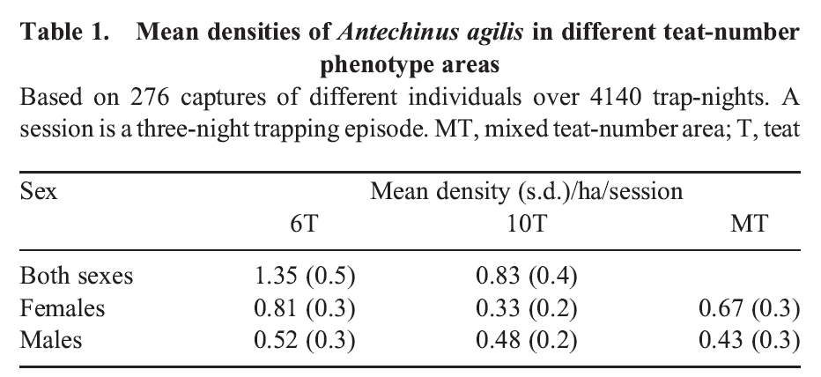
(Slide 31) Introduce the graph. Identify the data captured on each axis including the timing of each trapping session.
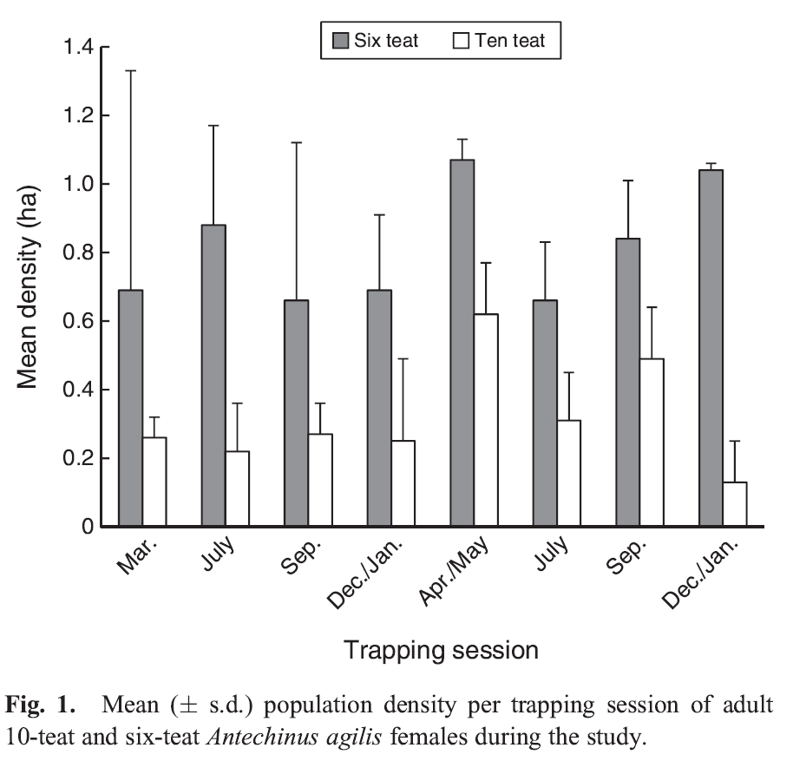
✎ STUDENT NOTES: Make a claim relating to the number of 6T or 10T females living in a hectare. Use data from the Trapping Antechinus Resource sheet or the graph from the scientists’ published data shown on slide 31. Identify the evidence that supports your claim and use reasoning to link the evidence to the claim.
(Slide 32 and 33) Discuss the claims made by students. Students should be able to identify that there is a greater density of 6T than 10T Antechinus agilis. Encourage students to identify the qualifiers (i.e. ‘...for Antechinus agilis living in these areas...’), the backing (underlying assumption that the number of mice caught is an indication of the number living in the area), and a rebuttal to any opposing arguments that people might make.
Potential discussion prompts
- How many offspring could a female with 6 teats feed? What if they had more or fewer offspring?
- How do you think this would affect the mother’s ability to survive?
- Would it be easier or more difficult for the mother to survive if they had more offspring? Why or why not?
- What other explanations could there be for more females being caught in a trap?
  - Could the 10T females be travelling further?
Pose the question: Could the 10T females be travelling further to find food?
(Slide 34) Introduce the data from Table 2 of the same article. Discuss how scientists placed radio transmitters on the individual A. agilis mice to measure how far they travelled in their search for food. Students should be able to identify that the 10T Antechinus agilis travel further to find food. Explore how the technology of radio transmitters has allowed scientists to understand more about how animals interact with their habitat.
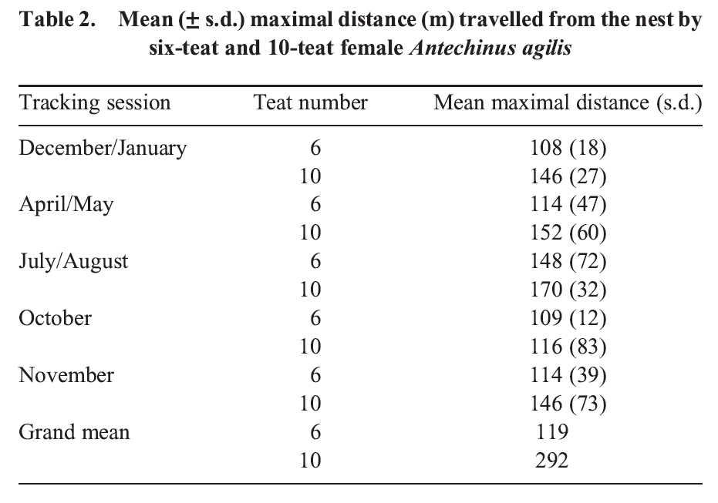
✎ STUDENT NOTES: Make a claim with evidence and reasoning from the data in Table 2 of the research paper.

Integrate • All families great and small
Discuss the claims made by students. Encourage students to identify the qualifiers (i.e., "...for Antechinus agilis travelling the distances..."), the backing (underlying assumption of the accuracy of the transmitters and that the amount of vegetation in both areas is similar), and a rebuttal to any opposing arguments that people might make.
(Slide 35-36) Link the claims made by students to K-strategy reproduction by posing the question: Which mother (6T or 10T) is more likely to have all her offspring survive?
Potential discussion prompts
- Which mother is most likely to survive multiple breeding seasons?
  - The 6T females are more likely to survive for 3 breeding seasons, while 10T females are less likely to survive. This is most likely due to the stress of finding enough food for all offspring.
- The offspring of which mother are most likely to survive?
- What are the disadvantages of K-strategy reproduction?
- What are the advantages of K-strategy reproduction?
- What would happen if the environment of the A. agilis were to change?
  - A slow change may mean the parent has long enough time with the offspring to teach them how to survive. Alternatively, if the habitat is suddenly disrupted, all parents and their smaller number of offspring die.
(Slide 37) Discuss why scientists publish their results (containing claims) in scientific papers for peer review. Compare the peer review to the process of discussion that students just completed about the claims they made, and how this serves to check claims that are made.
✎ STUDENT NOTES: Outline the advantages and disadvantages of K-strategy reproduction for A. agilis.
Discuss how many offspring parents would need to produce to be classified as r-strategy.
Potential discussion prompts
- How many offspring is a lot? 10? 20?
- How long is ‘too long’ to take care of offspring?
- Can animals only use r-strategy or K-strategy reproduction? Could animals use a combination of strategies (e.g. a slightly larger number of offspring being looked after for a shorter length of time)?
Discuss the importance of understanding the reproduction strategies of an animal when identifying if an animal is endangered or threatened.

Reflect on the lesson
You might:
- research current conservation strategies being used for small mammals such as A. agilis.
- research ‘Bogong Bikkies’ and how they are being used to support the conservation of the Mountain pygmy possum.
- re-examine the intended learning goals for the lesson and consider how they were achieved.
- discuss how students were thinking and working like scientists during the lesson.

Y9

Breeding for balance • Lesson 5 • Who will you save?
Lesson 5
ACT
To read the most recent version of this lesson, download associated resources, and view embedded professional learning including classroom videos and work samples, visit: https://scienceconnections.edu.au/teaching-sequences/year-9/breeding-balance/lesson-5-who-will-you-save

Lesson overview
Students consolidate their learning by applying their understanding of reproduction strategies to the criteria developed to identify endangered species, and develop arguments to include a plant or animal in the Threatened Species Action Plan 2022-2032.

Key learning goals
Students will:
- understand the criteria that were used to select plants and animals to be part of the Threatened Species Action Plan 2022-2032.
- select an endangered or threatened plant or animal to research.
- develop arguments to support the inclusion of an endangered or threatened animal on the Threatened Species Action Plan.
Students will represent their understanding as they:
- research the reproductive strategies and the vulnerabilities of threatened plants or animals.
- develop arguments or a report to support the inclusion of a plant or animal in the Threatened Species Action Plan 2022-2032.

Assessment advice
In this lesson, assessment is summative.
Students working at the achievement standard should:
- explore how governments determine which scientific research projects should be funded.
- analyse methods and conclusions to identify facts or premises that are taken for granted to be true, and evaluate the reasonableness of those assumptions.
- select and use appropriate representations to organise, process and summarise data and information.
- analyse and connect data and information to identify and explain patterns, trends, relationships and anomalies.
- analyse the impact of assumptions and sources of error in methods and evaluate the validity of conclusions and claims.
- construct logical arguments based on evidence to support conclusions and evaluate claims.
- research how assisted reproductive technologies have become widely used since their initial development.
- compare and contrast scientific texts addressing similar topics for different purposes or audiences, and analyse the author’s selection of content or use of language and text features.
Refer to the Australian Curriculum content links on the Our design decisions tab for further information.

List of materials
Whole class
- Breeding for balance Resource PowerPoint
Each student
- Individual science notebooks
- Access to resources for researching threatened plants or animals

Lesson routine | Estimated time | Task type
Connect | 20 minutes | Whole class/Individual
Anchor | 10 minutes | Whole class/Individual
Design | 20-60 minutes | Whole class/Individual
Communicate | 20-60 minutes | Whole class/Individual

Act

Connect • Who should we save?
Introduce the idea that governments have limited funds for research and conservation and that choices need to be made about which species to support.
(Slide 40) Discuss the Threatened species action plan 2022-2032, which outlines 110 priority species and 20 places across Australia that most need support. Outline the criteria that were used to select the plants and animals that are in the plan, including:
- the current size of the population.
- how much the population size has decreased in the last 10 years or 3 generations.
- the limited geographic range of the population.
- >50% probability of the population becoming extinct in the next 10-100 years.
Ask students to select a plant or animal that may be at risk but that is not currently considered a priority species (see all priority species at Appendix 1, Threatened Species Action Plan 2022-2023). Students should research their plant or animal to determine if it is endangered, vulnerable, or threatened, and identify possible factors that might be contributing to this.
✎ STUDENT NOTES: Name and describe the animal that you have selected for a conservation breeding program. Outline the reasons for selecting this plant or animal. Record notes on the research completed for the selected plant or animal.

Anchor • Survival risks
(Slide 41) Discuss what students know about how their chosen animal reproduces. Identify if the selected animal uses r-strategy, K-strategy, or a combination of both strategies to reproduce.
Potential discussion prompts
- What factors put the plant or animal at risk?
- Does it produce many or few offspring?
- How many offspring does each female produce during its lifetime?
- How much do parents care for or teach their offspring?
- What are the risks that parents or offspring encounter during their lifetime?
- When is the plant or animal most at risk?
- How does this affect the survival of the species?
✎ STUDENT NOTES: Outline the risks the plant or animal faces at different stages of its life cycle. Identify when the plant or animal is most at risk and why.

Design • Planning for survival
(Slide 42) Outline the six prioritising principles that were used to select the priority species and places included in the Threatened Species Action Plan (see Appendix 3):
- Risk of extinction: prioritising species and places under severe and imminent threat.
- Multiple benefits: prioritising species and places where recovery action will benefit other species.
- Feasibility and effectiveness: prioritising species and places where action can make a difference and is cost-effective.
- Importance to people: prioritising species and places of cultural significance.
- Uniqueness: prioritising species and places that are unlike any other.
- Representativeness: achieving balance in selected species and places.
Remind students how to identify valid sources of data and information by identifying who is producing the information and the purpose of publishing the data.
✎ STUDENT NOTES: (Slide 43) Develop an argument for why your selected animal or plant should be included in the priority species list. Address each of the prioritisation principles that are outlined in the action plan. Suggest a potential breeding program that could be used to support the survival of the species.

Communicate • Share to save
Students present their report to the rest of the class, or produce posters that invite younger students to ‘sponsor’ the animal.
The audience could provide feedback on the presentations or posters by nominating the plant or animal (not their own) that they have been convinced should be part of a conservation program.

Reflect on this lesson
You might:
- consider what factors people respond to when deciding to sponsor an animal.
- consider how you might improve the way you present the information to maximise the interest of sponsors.

