
Y7

Forces and sport • Lesson 1 • Forces in sport and physical activities
Lesson 1
Launch
To read the most recent version of this lesson, download associated resources, and view embedded professional learning including classroom videos and work samples, visit: https://scienceconnections.edu.au/teaching-sequences/year-7/forces-sport/lesson-1-forces-sport-physical-activities

Lesson overview
Students explore the role of forces in sports and physical activities. They also assess, and utilise, effective ways to communicate these forces using an infographic.

Key learning goals
Students will:
- define forces as an interaction that can change or maintain an object’s motion (speed or direction) or its shape.
- identify that there are many types of forces, but they are generally classified as acting as contact or non-contact forces.
- identify and describe the types and effects of forces in a chosen sport.
Students will represent their understanding as they:
- describe forces in a sport or physical activity.

Assessment advice
In the Launch phase, assessment is diagnostic.
Take note of:
- students’ ability to describe a range of forces.
- students’ understanding of force as an interaction that can change an object’s motion.
- students’ ability to relate movement in a sport or physical activity to the action of forces.

List of materials
Whole class
- Forces and sport Slides
- Access to an open area with a smooth surface e.g. a basketball court
- Tennis balls or Kanga cricket balls – one per player
- Cones or markers to mark out the playing area for Koolchee
- 10 x plastic skittles or 1.25 L water/soft drink bottles, partially filled with sand or water to add weight
- Video: Traditional indigenous games – Koolchee (2:07 min)
Each group
- Optional: A3 colour printout of Forces and sport Poster

Each student
- Individual science notebook
- Forces and sport Poster (A4)

Lesson routine | Estimated time | Task type
Experience and empathise | 30 minutes | Whole class/Small group
Connect and Elicit | 10 minutes | Whole class/Small group
Anchor | 20 minutes | Whole class/Small group

Launch

Experience and empathise • Playing a new game
(Slide 3) Discuss a variety of sports (including adventure sports) and physical activities students have played or are familiar with.
Pose the question: Think back to the first time you played a new sport or physical activity. What was that experience like?
Invite students to share their experiences.
(Slide 4) Explain that as a class you are going to play a new game, Koolchee (“kool-chee”).
Explain that Koolchee is a traditional Aboriginal bowling game of the Diyari people from the Kati Thanda (Lake Eyre) region in South Australia. Koolchee refers to the specially made balls, usually 8–10 cm in diameter, crafted from materials such as gypsum, sandstone, or mud.
Have students play Koolchee.

How to play Koolchee
- Go to an open area, such as a basketball court, that has a smooth surface. Mark out a playing area.
- Divide players into two teams. Each team lines up along opposite ends of the basketball court or playing area and faces each other. Provide each player with a ball (the koolchee).
- Place five skittles in a line 2-3 m in front of the teams at each end.
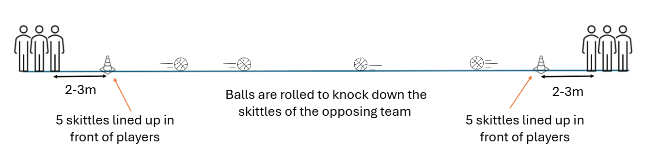
- Players roll their koolchee and attempt to knock down the other team’s skittles lined up on the far end of the play area. Teams must avoid hitting their own skittles directly in front of them, but may defend their skittles by using their ball to hit away any opposition koolchees.
- Koolchees may be recovered from the playing area after everyone has stopped rolling and the playing area is safe.
- The winning team is the one who knocks down all of the opponent’s skittles.
Show students the video Traditional Indigenous games – Koolchee (2:07) to see a game in action.
After the game, discuss:
- Was the game easy to play? What made it harder or easier?
- What was it like learning a new game?
- What would be the most important information to communicate to a new player?

Elicit and Connect • What’s important?
(Slide 5) Student groups choose a sport or physical activity they have played.
Invite students in their groups to share how people or equipment move in their chosen sport or physical activity.
Brainstorm the key information a new participant would need to understand about the chosen sport or physical activity to help them learn it quickly, and in particular, what causes movement to change in the activity.

Potential discussion prompts
- How do people move in this sport or physical activity?
- How does the equipment (for example, a ball, puck, bat, racquet, or surfboard) move during the activity?
- What actions make the movement change?
- When does something start moving, stop moving, speed up, slow down, or change direction?
- What do players do to control where they move or where equipment moves?
- What skills help players change movement successfully?
- What changes happen when a player kicks, throws, hits, catches, pushes, or paddles?
Introduce infographics as a visual way to communicate key information about movement in sport and physical activity. Explain that students will create an infographic about a chosen sport or physical activity at the end of the lesson sequence.
✎STUDENT NOTES: Write the ideas from the brainstorm about a chosen sport or physical activity. Include any forces (pushes or pulls) that are mentioned.

Anchor • Motion and forces
Explain that movement and motion in sport or physical activity is linked to forces.
Discuss the forces and movement students experienced while playing Koolchee.

Potential discussion prompts
- What forces did you apply to the koolchee?
- What other forces acted on the koolchee as it moved?
- What contact forces were important in the game?
(Slide 6) Introduce the definition and descriptions of forces: A force is a push or pull that acts on an object when it interacts with another object.
(Slide 7) Introduce or recall examples of forces.
Teacher note: The Newtonian definition of gravity is used in this sequence. Read more in the embedded professional learning Gravity below.
(Slide 8) Using the pictures on the slide, invite students to identify:
- the different types of forces involved.
- forces that are acting when objects or people are moving.
- forces that lead to motion that is wanted (like throwing a ball).
- forces that lead to motion that is unwanted (like suddenly stopping due to an incorrect tackle).
Encourage students to identify and describe the forces, or use terms such as “starting motion”, “stopping motion”, or “changing direction”. This provides an opportunity to identify alternative conceptions about force.

Potential discussion prompts
- What forces are acting on each player in the tackle? What are the pushes?
- The basketballer has made a shot. What forces allowed this to occur?
  - The basketballer applied a pushing force on the ball, gravity acting on the ball so it follows an arc path as it moves, friction between soles of shoes and court to grip so can jump up with shot.
- What forces are involved in the water polo player going for a shot at goal?
  - Buoyancy lifting the player up, kicking to push the player upwards, friction on the ball and the player’s hand so they can hold and then throw the ball.
✎STUDENT NOTES: Record the definitions and examples of force. List and describe three examples of forces in sport.
(Slide 9) Distribute the Forces and sport Poster around the class for students to stick into their book or keep in a science display folder. Explain that this resource will be used throughout the lesson sequence.
✎STUDENT NOTES: Identify and record the force/s shown in five sports or physical activities on the poster. Use three terms from the force word bank around the poster’s edge to write a sentence or two about sport and forces.

Reflect on the lesson
You might invite students to:
- start a glossary of key terms about forces.
- write down two questions about forces in sport and physical activity. These will be discussed at the start of the next lesson.
- watch a video of a favourite sport or physical activity (e.g. soccer highlights, gymnastics routine, skateboarding trick) and write down three moments where a force is seen to be clearly acting. For each moment:
  - name the force e.g. push, pull, friction, gravity, air resistance.
  - describe how the force affects the motion of the athlete or equipment.
- at home, choose one simple action related to sport e.g. kicking a ball, rolling a basketball, swinging a bat or racquet. Write a short explanation of the forces involved (and optionally include a sketch).
  - Consider: What force starts the movement? Which forces slow it down? How does the strength of the force change the motion?

Y7

Forces and sport • Lesson 2 • Balanced and unbalanced forces
Lesson 2
Inquire
To read the most recent version of this lesson, download associated resources, and view embedded professional learning including classroom videos and work samples, visit: https://scienceconnections.edu.au/teaching-sequences/year-7/forces-sport/lesson-2-balanced-unbalanced-forces

Lesson overview
Students explore how balanced and unbalanced forces affect the motion of objects.

Key learning goals
Students will:
- identify individual forces acting on an object.
- combine individual forces to find the net force acting on an object.
- represent forces using arrows on a force diagram.
- generate and record data with precision.
Students will represent their understanding as they:
- draw force diagrams using arrows to show the direction and relative magnitude of forces acting on an object.
- determine the net force acting on an object.
- use the symbol N when writing the magnitude of force.

Assessment advice
In this lesson, assessment is formative.
Feedback might focus on students’ ability to:
- plan and conduct an investigation.
- construct a hypothesis.
- record data, perform a calculation and analyse the results.
- draw a conclusion about the effect of the magnitude and direction of forces on the net force acting on an object.
- represent forces using force arrows.
Possible summative assessment
Students working at the achievement standard should:
- represent forces acting on objects.
- plan and conduct safe, reproducible investigations to test relationships.
- use equipment to generate and record data with precision.
Refer to the Australian Curriculum content links on the Our design decisions tab for further information.

List of materials
Whole class
- Forces and sport Slides
Each group
- Wooden block with a push pin or nail inserted into the middle (see the Preparing for this sequence tab on the sequence overview)
- 2 x identical elastic bands
- Butchers paper
- Marker pens
- Scientific calculator
- 30 cm ruler
Each student
- Individual science notebook
- Forces and sport Poster
- Forces in different directions Resource sheet
- Access to the PhET Forces and motion: basics ‬computer simulation model
- Net force simulation Resource sheet
- Optional: Forces in the same direction Resource sheet

Lesson routine | Estimated time | Task type
Re-orient | 5 minutes | Whole class
Question | 5-10 minutes | Whole class
Investigate | 10 minutes | Small group
Integrate | 30 minutes | Whole class/Small group

Inquire

Re-orient
Recall the previous lesson, focusing on forces in sport and the definitions of force. Discuss any questions the students may have about forces. Use the Forces and sport Poster as a visual prompt for students if needed.
(Slide 11) Invite students to find examples of these statements about forces in the picture of the bike rider shown on the slide.
- A force is a push or pull that acts on an object when it interacts with another object.
- Some forces cause movement such as changing direction or speeding up or slowing down.
- Other forces are balanced, and the object’s motion remains unchanged.

Potential discussion prompts
- Where do we see the effects of forces?
- The rider is doing a wheelie. What forces did the rider exert on the bike to cause this movement?
- Can you identify a pair of forces that might be the same size but acting in opposite directions on an object?

Question • Directions of forces
(Slide 12) Pose the questions: What happens when forces act in different directions? Why?
(Slide 13) Explain that forces have both size (which is called “magnitude”) and a direction.
Referring to the sports images shown on the slide, ask students to identify forces acting in different and similar directions and to identify what the force is acting on.
Explain that forces can act on the same object or different objects. If forces are acting on the same object, they can balance, resulting in no changes in motion. Alternatively, forces can be unbalanced and lead to starting motion, stopping motion, or result in a change of speed or direction. Invite students to identify if the forces acting on an object are causing or stopping movement.
✎STUDENT NOTES: Write a sentence describing forces having a size/magnitude and direction.

Potential discussion prompts
- What are the forces acting on the ball? Which directions are these forces acting?
- What forces is the swimmer exerting on the water? What effect do these forces have on the swimmer’s motion?
- Are there examples of forces pushing against each other?
  - The tennis ball is pushing against the racket, and the racket is pushing back on the ball.
  - The hockey sticks are pushing against each other in opposite directions.

Investigate • Modelling forces
Discuss how students could investigate the lesson question using a small model.
(Slide 14) Introduce the model shown on the slide and discuss how elastic bands provide forces acting on the block.
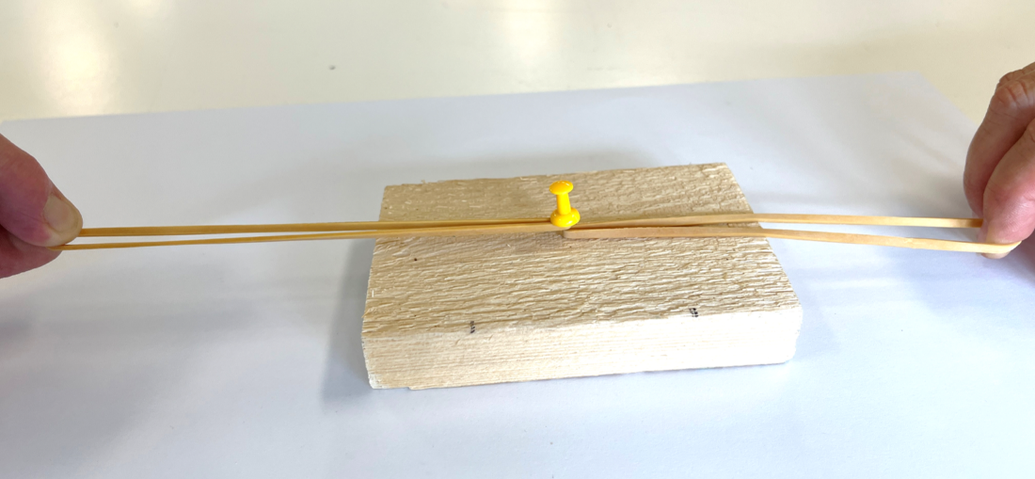
Provide students with a copy of Investigating forces - Forces in different directions Resource sheet.
Students read through the investigation, allocate roles, collect equipment and conduct the investigation.

Forces in different directions investigation—procedure
- Place the wooden block and pin on the butchers paper. Put two elastic bands around the pin/nail. Trace around the block to show your starting position.
- One team member holds the block stationary inside the traced shape. Two other team members gently pull the elastic bands equal distance (or force) from either end of the block.
- Another team member draws accurate arrows on the butchers paper alongside each stretched band, showing the distance they are stretched. Label these arrows “Pull force left” and “Pull force right”.
- Release the bands at the same time. Draw an accurate arrow to indicate the distance the edge of the block travelled in the direction of either band. Label the arrow as “Final force”, measure and record in the results table. Repeat the experiment another two times if time allows.
- Repeat steps 1 and 2, but this time the two team members pull back the bands different distances: one pulls their band same distance as previously, the other pulls their band twice the distance as previously.
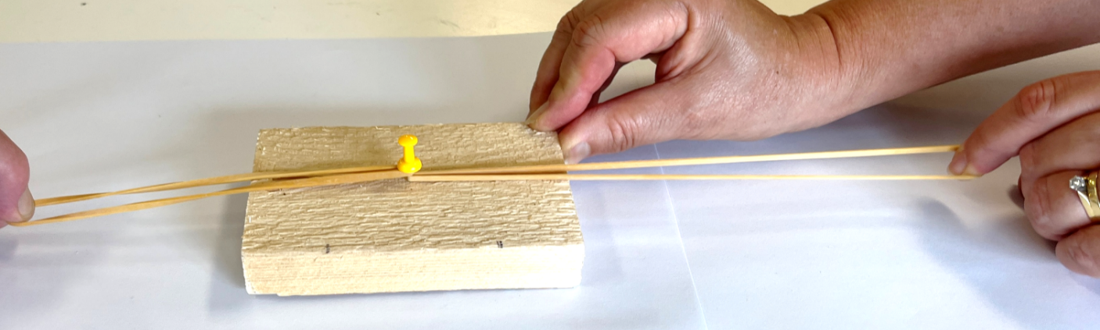
- Another team member draws accurate arrows on the butchers paper alongside each stretched band. Label these arrows “Pull force left” and “Pull force right”.
- Release the bands at the same time. Draw an accurate arrow to indicate the distance the edge of the block travelled in the direction of either band. Label the arrow as “Final force”, measure and record in the results table. Repeat the experiment another two times if time allows.
✎STUDENT NOTES: Complete the Results table of Investigating forces—Forces in different directions Resource sheet.
If required, guide students through the process of calculating an average of the three trials using this formula:
$$\text{Average}=\frac{{\text{distance}}_{\text{trial 1}}+{\text{distance}}_{\text{trial 2}}+{\text{distance}}_{\text{trial 3}}}{\text{number of trials}}$$
Optional: If time allows, extend students’ understanding of unbalanced forces by completing the Forces in the same direction investigation.
Optional investigation: Forces in the same direction
(Slide 15) Pose the questions: What happens when forces act in the same direction? Why?
Provide students with a copy of Investigating forces - Forces in the same direction Resource sheet.
Students read through the investigation, allocate roles, collect equipment and conduct the investigation.

Procedure
- Place the wooden block and pin on the butchers paper. Put an elastic band around the pin/nail. Trace around the block to show your starting position.
- One team member holds the block stationary inside the traced shape. One team member pulls one elastic band the same distance (or force) as the previous experiment on one side of the block.
- Another team member draws an accurate arrow on the butchers paper alongside the stretched band. Label this arrow as “Pull force 1”.
- Release the band. Draw an accurate arrow to indicate the distance the edge of the block travelled in the direction of the band. Label the arrow as “Final force”, measure and record in the results table. Repeat the experiment another two times if time allows.
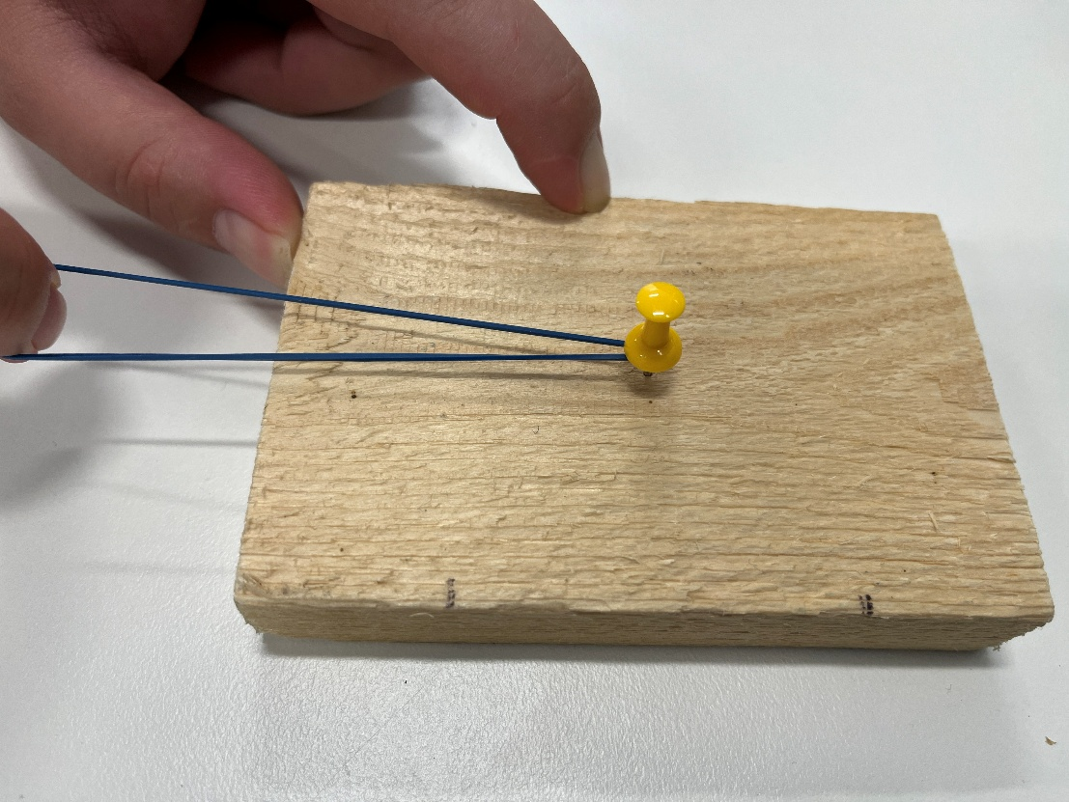
- Place the block with pin on a new piece of butchers’ paper. Put an elastic band around the pin/nail. Trace around the block to show your starting position.
- One team member holds the block stationary inside the traced shape. One team member pulls two elastic bands the same distance (or force) as the previous experiment on one side of the block.
- Another team member draws accurate arrows on the butcher’s paper alongside each of the stretched bands. Label these arrows as “Pull force 1” and “Pull force 2”.
- Release the bands at the same time. Draw an accurate arrow to indicate the distance the block travelled in the direction of the bands. Label this arrow as “Final force”, measure and record in the results table. Repeat the experiment another two times if time allows.
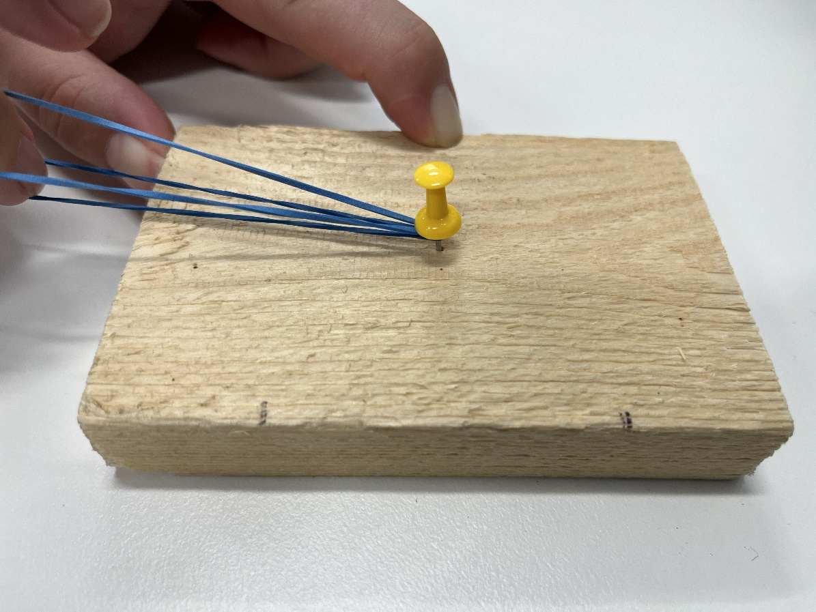
✎STUDENT NOTES: Record the distance travelled by the wooden block in the results table.

Integrate • Net force
Discuss and compare students’ results for the investigation/s. Invite students to explain why the block moved in one instance and not in the other.
(Slide 17) Explain that in the first part of the investigation, the forces were balanced (of equal magnitude or size and acting in opposite directions on the block). This resulted in a zero net force and the block remains stationary.
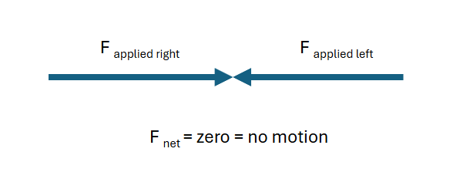
(Slide 18) Explain that in the second part of the investigation, the forces were acting in opposite directions on the block, but they were not of equal size or magnitude, so the net force was not zero. These unbalanced forces caused motion to occur. The net force can be calculated by subtracting the forces to determine the direction of motion.
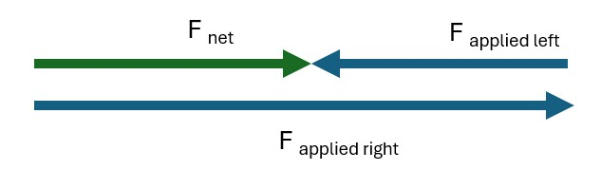
✎STUDENT NOTES: Complete the Discussion section of Investigating forces - Forces in different directions Resource sheet.

If you completed the Forces in the same direction investigation
Discuss and compare the results of the two force scenarios in the optional investigation. Ask students to explain the movement of each block using force arrows.
(Slide 19) Guide students through the force diagram to show the unbalanced force on the block and the net force in each scenario. Draw the force diagrams to aid your explanation.
One band:

Two bands in the same direction: 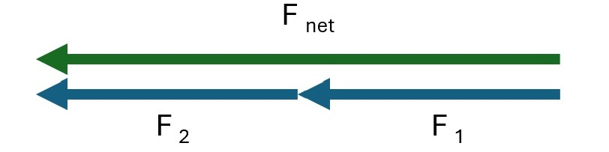
Explain that when forces act on the object in the same direction, the net force is determined by adding the forces.
✎STUDENT NOTES: Complete the Discussion section of the Investigating forces—Forces in the same direction Resource sheet.
(Slide 20) Introduce how scientists use different models to help them understand, explain, or test their hypotheses. Discuss how the investigation used a physical model to test how different forces interact to produce a net force.
Explain that all models are limited, and this physical model is limited to small forces in only a few directions because that is what can be produced in the classroom. Introduce the PhET Forces and motion: basics ‬computer simulation model. This model allows students to explore their ideas through real-world examples without needing to physically do the activity.
Distribute the Net force simulation Resource sheet. Explain that in this activity, students will be using their understanding of net force to complete two challenges: creating a situation where forces on an object are balanced and creating a situation where the forces are unbalanced.
Allow students time to work through the instructions for using the simulation and the two challenges, given on Net force simulation Resource sheet.

Two challenges
- Select the Net force simulation.
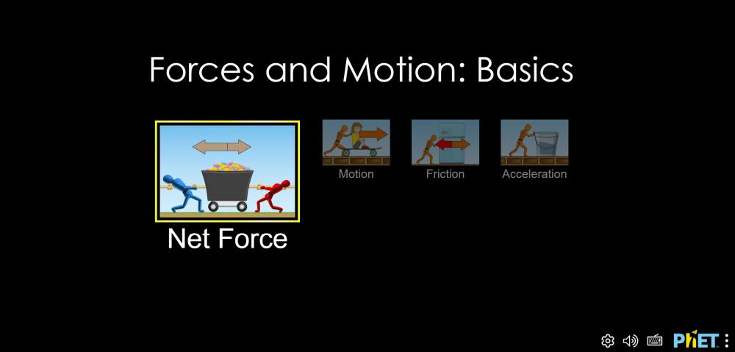
- Challenge 1: Challenge students to create a scenario using at least one person in which the forces are balanced and the cart is not moving. Point out to students that the net or final force in this simulation is called the “Sum of forces”.
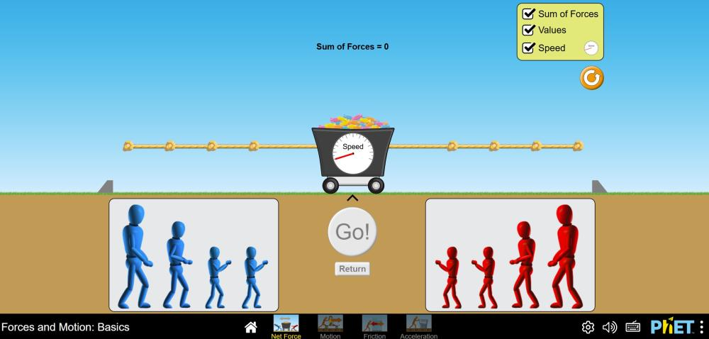
- Challenge 2: Challenge students to create a scenario using at least two people in which the forces are unbalanced.
✎STUDENT NOTES: Record the results of the challenges, draw a force diagram showing force arrows, and calculate the net force on the Net force simulation Resource sheet.
(Slide 21) Guide students in identifying the balanced and unbalanced forces on the barbell in the three pictures. Relate what students have learnt about balanced, unbalanced and net forces to the pictures.

Potential discussion prompts
- What are the forces acting on the barbell at each stage of the lift?
  - The forces acting on the barbell are the downward gravitational force (weight) and the upward force from the lifter’s arms.
- When is the net force zero?
  - The net force is zero when the barbell is not moving, such as when it is resting on the ground or being held still overhead.
- Which direction is the net force when the barbell is pulled upwards rapidly?
  - When the barbell is moving upward rapidly, the net force is upward because the lifter is applying a greater upward force than the weight force. If the lifter dropped the barbell, then the net force would be downwards, as gravitational force is the only force acting on the barbell as it falls.
(Slide 22) In small groups, students work together to:
- choose a sport or physical activity.
- identify situations where forces are balanced and where forces are unbalanced.
- explain how these forces affect motion.
If students find choosing an activity or sport difficult, provide the following examples: tennis, golf, table tennis, air hockey or tug-of-war.
✎STUDENT NOTES: Write an explanation of how motion is affected in two situations where forces acting on an object are balanced and unbalanced in a chosen sport or physical activity.

Reflect on the lesson
You might invite students to:
- review the learning goals for the lesson and check for understanding.
- write a list of the important forces of a sport or physical activity to show in an infographic.
- identify five examples in their sport or physical activity where forces are acting in opposite directions on an object (like a person or piece of equipment). For each example, they need to record:
  - what the object is.
  - the two opposing forces.
  - whether the forces are balanced or unbalanced.
  - the evidence (e.g. “the bin isn’t moving → forces are balanced”).
  - a force diagram for their favourite example.
- write a paragraph explaining why forces are important to playing or participating in their chosen sport or physical activity.
- add the words about forces covered in this lesson to their glossary.

Y7

Forces and sport • Lesson 3 • Does mass affect motion?
Lesson 3
Inquire
To read the most recent version of this lesson, download associated resources, and view embedded professional learning including classroom videos and work samples, visit: https://scienceconnections.edu.au/teaching-sequences/year-7/forces-sport/lesson-3-does-mass-affect-motion

Lesson overview
Students investigate the effect that changing an object’s mass has on its motion and then consider how these findings can be applied to a sport or physical activity infographic.

Key learning goals
Students will:
- use a simulation to test the effect of mass on an object’s speed.
- describe the effect on the motion of objects of different mass if the magnitude and direction of the applied force is kept constant.
- apply their understanding to analyse motion in a sport or physical activity.
Students will represent their understanding as they:
- conduct a simulation on the impact of mass on an object’s speed.
- construct a model to represent the relationship between mass and speed of an object in a certain time.
- analyse the results and draw valid conclusions.
- describe how varying masses affect movement in different sports and physical activities.
- identify how the impact of mass can be effectively communicated to new participants of a sport or physical activity.

Assessment advice
In this lesson, assessment is formative.
Feedback might focus on students’ ability to:
- describe the relationship between mass and motion (measured as speed).
- complete an investigation and record data.
- analyse data, create and use a model and draw a conclusion.
Potential summative assessment
Students working at the achievement standard should:
- generate and record data with precision.
- process data and information and analyse it to describe patterns, trends and relationships.
- identify evidence to support their conclusions.
Refer to the Australian Curriculum content links on the Our design decisions tab for further information.

List of materials
Whole class
- Forces and sport Slides
Each group
- Two different-sized soccer balls or two soft inflatable balls of different mass
- Sticky notes
Each student
- Individual science notebook
- Forces and sport Poster
- Access to the PhET Forces and motion: basics ‬computer simulation model
- PhET simulation: Mass & motion Resource sheet

Lesson routine | Estimated time | Task type
Re-orient | 5 minutes | Whole class/Individual
Question | 15 minutes | Whole class/Small group
Investigate | 15 minutes | Whole class/Individual

Inquire

Re-orient
Recall examples of different types of forces. Discuss how forces acting on an object can be balanced or unbalanced, with unbalanced forces leading to changes in motion.
Using the Forces and sport Poster invite students to find three examples of balanced and three examples of unbalanced forces acting on an object (characters or equipment). Examples of balanced forces include the rock climber, the person on the parallel bars, and anyone moving at a constant speed.
Remind students that forces were represented in the last lesson using arrows to show the direction and magnitude of the force. Invite students to draw an example of a pair of balanced forces and an example of a pair of unbalanced forces using arrows on a force diagram. They could use the poster for ideas or draw force arrows for a scenario on the poster.
✎STUDENT NOTES: Draw an example of a pair of balanced forces and an example of a pair of unbalanced forces using arrows on a force diagram.

Question • Mass and motion
(Slide 24) Pose the question: How does changing the mass of an object affect its motion?
TEACHER NOTE: The term “mass” is used in this question rather than “weight”. The mass of an object in Newtonian physics is related to how much matter it contains or by its ability to resist a given force. In contract, weight is a measure of the gravitational force acting on an object and can vary according to the strength of the gravitational field where the object is located.
Discuss an everyday example of lifting bags filled with, for example, groceries or books. Relate how extra effort or a larger force is required to lift the heavier bag.
Recall the forces on the barbell in each of the pictures as covered at the end of the previous lesson.
Discuss the adjustments the weightlifter would have to make if the mass on the barbell were increased.

Potential discussion prompts
- What would happen in the middle picture if double the amount of mass was added to the ends of the barbell?
  - Greater weight force downwards with the extra mass added. This means more lift force would be needed to unbalance the forces and cause motion upwards.
  - The barbell would not be lifted as fast, if at all, if the weightlifter could not increase the force exerted on the bar.
  - The net force would still be upwards if the person is still able to rapidly lift it.
- What would happen in the end picture if half the amount of mass were on the barbell?
  - The net force is still zero as the barbell is stationary at the top of the lift.
  - To balance the forces, the weightlifter would not need to apply as much force from the arms to the barbell as there would not be as much weight force acting downwards.
(Slide 25) Pose the question: Using your own experience, how does mass affect movement in sport? and discuss.

Potential discussion prompts
- Does mass affect throwing?
- Does mass affect hitting with a racket or bat?
- Does mass affect catching?
- Does mass affect kicking?
- Does mass affect pushing?
- What about when you shoot a basketball? Does a heavier basketball require more effort to shoot upwards towards the basket?
- If you were to try to keep the force of your kick the same, what distance would a size 3 vs. size 5 soccer ball travel on a grass field? Would the ball travel with the same speed off the boot?
  - The size 5 soccer ball is heavier (has more mass) and it would not travel as far if kicked with the same force.
- Has anyone used a sled-pull at the gym or in training? What happens when you add more weight?
  - The sled-pull is much harder to pull when more weight is added to the sled.
(Slide 26) If time allows, play Woggabaliri (“wog-gab-a-lir-i”) with two balls of different mass (for example, a size 4 and 5 soccer ball).
Explain that children from the Bogan and Lachlan rivers area of New South Wales played a kind of football with a ball made of possum fur. The fur was spun by the women and made into a ball about 5 centimetres in diameter. In Wiradyuri language, woggabaliri means “play”. Many Aboriginal groups in central and southern New South Wales understood or spoke this language.
This traditional game has been adapted here into a kicking volley game.

How to play Woggabaliri
- Form teams of 4-6 players. Players stand in a circle about 2 metres apart.
- One player kicks the ball into the air and other players in the circle try to keep the ball in the air by kicking it. No player should kick the ball twice in a row. All “kicks” are made with either the hands or feet. Players must have one foot on the ground when kicking the ball.
- Each group attempts to volley the ball (consecutive kicks) in the air as many times as they can within a set time. The group with the greatest number of volleys in the time wins. If the ball touches the ground, the count is restarted.
Watch this game being explained in the video Traditional Indigenous Games: Woggabaliri (0:51 min) or read about the game at Yulunga Traditional Indigenous Games | ASC.
Afterwards, discuss how the movements of the game changed when a heavier ball was used.
(Slide 27) Pose the question: What happens to the speed of an object if its mass is increased?

Investigate • What happens to the speed?
(Slide 28 and 29) Explain that students will investigate the effect of mass on motion using an online simulation model. Using the simulation, they will place different weights on a skateboard, push the skateboard with a constant force, and then record the speed of the skateboard after 10 seconds.
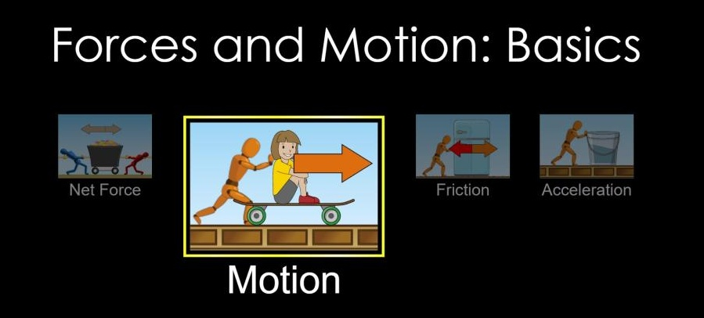
Demonstrate how to use the PhET Forces and motion: basics ‬computer simulation model.

Demonstration of PhET Forces and motion simulation
- Open the simulation and select Motion.
- Check all boxes at the top right-hand corner of the screen.
- Point out the features to take note of in the simulation, including:
  - the skateboard and 50 kg mass on the board that will be pushed by a force (kept constant).
  - the timer (that will be used to measure 10 seconds)
  - a dial that will show the speed of the skateboard after 10 seconds (essentially a measurement of the motion of the acceleration of different masses).
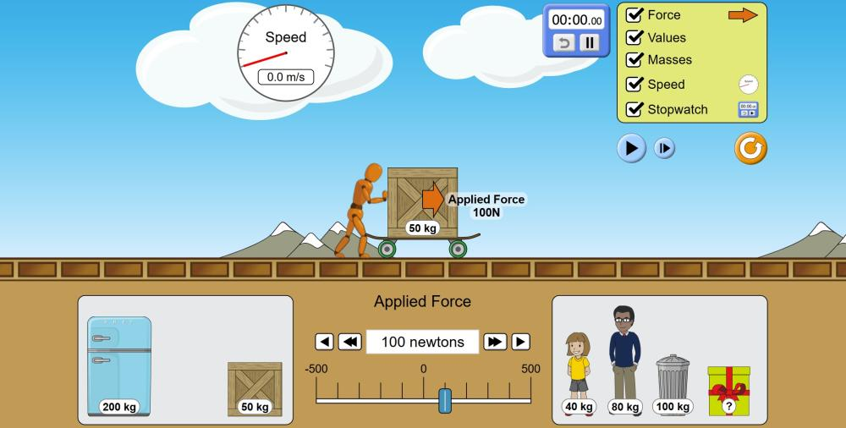
- Pause the simulation.
- Press the start button on the timer.
- Add 100 N of applied force by selecting the double arrow twice.
- Start the simulation and then pause it after 10 seconds have passed.
- Record the speed of the skateboard.
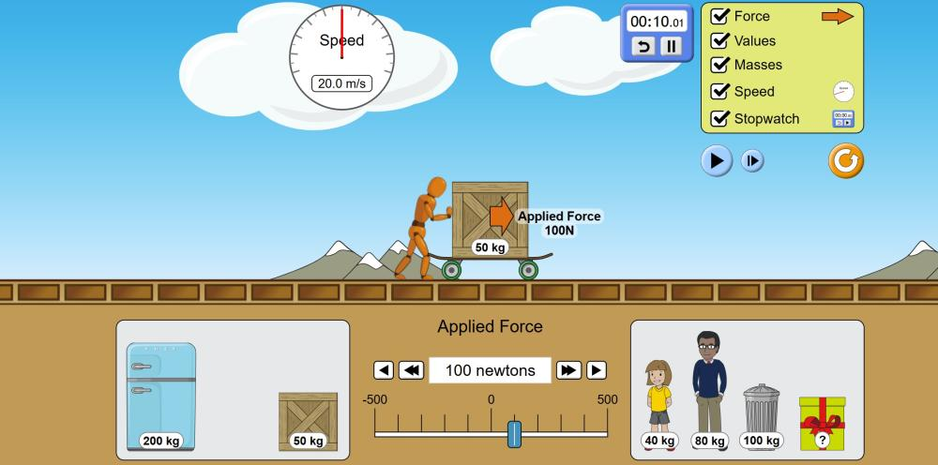
- Show how extra mass can be added to the skateboard by dragging objects from the bottom of the screen.
After showing students the features of the simulation, explain that even though there are a lot of different objects to choose from and test, students are going to test only one factor at a time. Inform students that this is to ensure the test is fair, and encourage discussion of fair testing.
Model designing a fair test by showing that students are:
- changing the mass by adding 50 kg each trial.
- measuring the speed of the skateboard after 10 seconds.
- keeping all the other factors that could impact the outcome the same in each trial.
Explain that if students changed the mass and the push force at the same time, the effect of mass could not be able to be determined.
Discuss why regular amounts of mass are going to be added to the skateboard each time. Guide the discussion so students understand that the regular increase in the independent variable allows for:
- patterns and trends to be detected more clearly.
- more reliable graphs.
- errors and anomalies to be detected.
- more accurate predictions to be made.

Potential discussion prompts
- If we added random amounts of mass each time, what might our results look like?
- How does using equal steps help you see what’s happening to the motion of the skateboard?
- Would it be harder or easier to see a pattern if the mass increases weren’t equal? Why?
- How would our graph look if the masses weren’t evenly spaced?
- How does even spacing of data points help with drawing a line of best fit?
- Would uneven points affect how confident we feel about the trend?
- Would irregular steps make mistakes or errors harder or easier to spot?
- How can regular increments help us decide if a result is unusual?
- How does regular spacing help with predictions?
Provide students with the PhET simulation: Mass & motion Resource sheet. Students complete Experiment 1.
✎STUDENT NOTES: Record results and write a conclusion.

Inquire and Integrate • Connecting mass and speed
(Slide 30) Invite students to look at their data and to consider the trend or patterns shown. Discuss how they could best display that data when making a scientific model.
Discuss ways that the relationship between mass and speed could be expressed with words. Students could express this relationship:
- pictorially, using arrows to show up or down.
  - For example, recording Mass ↑⇒ Speed ↓ to show an inverse relationship.
- by writing a description. For example:
  - “As one thing goes up, the other goes down.”
  - “One gets bigger while the other gets smaller.”
  - “Mass and speed balance each other out: if mass increases, speed decreases.”
Discuss the graph of the data collected from the simulation, shown on Slide 30 and on the Resource sheet.
To make student learning visible, probe student learning by asking:
- What are some things you notice?
- Where do you see that?
- What else?
Direct students’ attention to the axis labels. Model how to interpret the relationship between the variables on each axis by first going to the x-axis and then the y-axis and asking, for example, What happens to the speed for a lower mass? What happens to the speed of the skateboard for a higher mass?
(Slide 31) Read the example student’s claim: The speed of the skateboard has an inverse relationship to the mass on the skateboard. Invite students to provide feedback on the claim by asking: Is the student’s claim supported? Use evidence to support your decision.
(Slide 32) Examine the student’s diagram showing the relationship between mass and speed. Invite students to discuss whether it is an effective model of an inverse relationship, identifying its strengths and limitations. Extend the discussion by asking students how it could be improved.
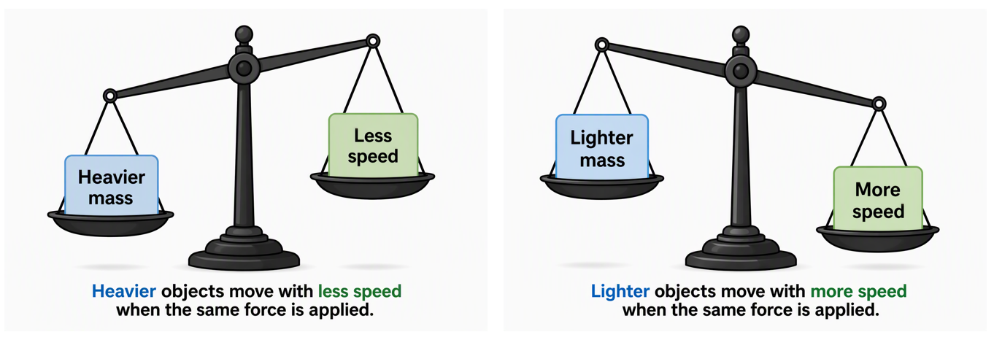
Develop a class consensus response by students writing responses to the claim and the diagram on sticky notes and posting them on a surface in the classroom. Discuss the commonalities of the responses and positively identify examples where evidence has been used in the response.
✎STUDENT NOTES: Complete the questions on page 2 of the PhET simulation: Mass & motion Resource sheet.
(Slide 33) Pose the question: Can the speed of an object be predicted if we know the mass?
Invite students to predict the speed of the 40 kg person and the 80 kg person when placed on the skateboard and 100 N of force is applied, using the data from Experiment 1, and then test predictions using the simulation.
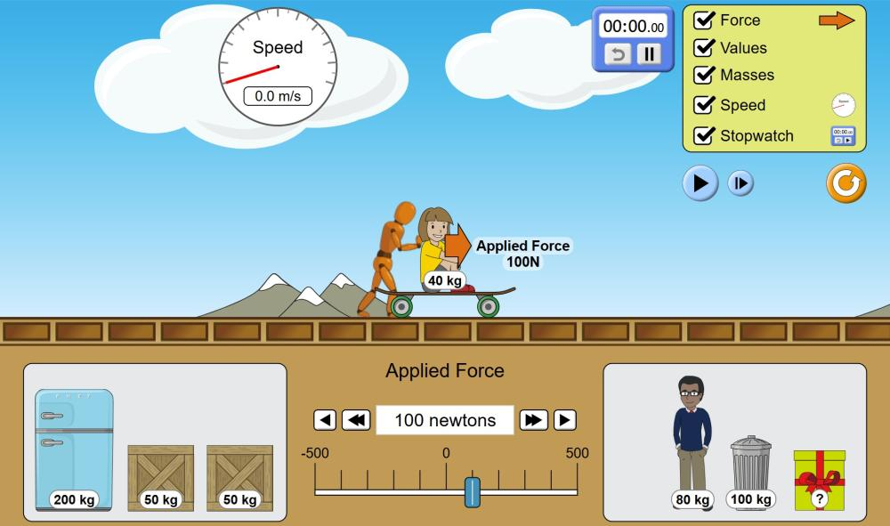
✎STUDENT NOTES: Record the results of Experiment 2 on the PhET simulation: Mass & motion Resource sheet.
(Slide 34) Pose the question: Can the mass of an object be predicted if we know the speed?
Invite students to measure the speed of the unknown object in the wrapped box when 100 N of force is applied (Experiment 3) and use this speed and the previous data to determine the mass of the object.
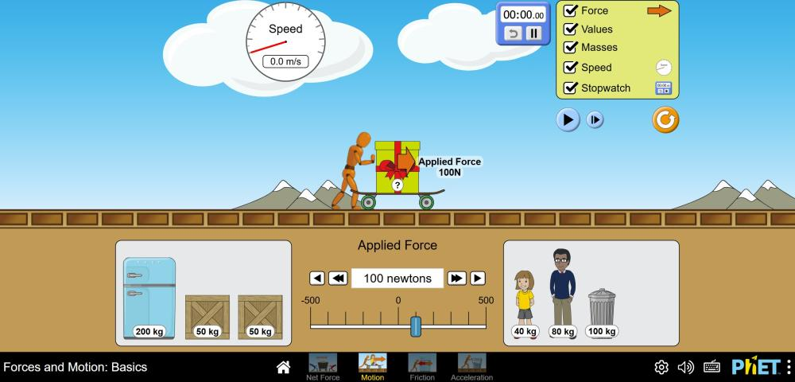
✎STUDENT NOTES: Record the results of Experiment 3 of the PhET simulation: Mass & motion Resource sheet.
(Slide 35) Pose the question: How will you show the impact of mass on motion in your sport or physical activity infographic?
Draw attention to the sports shown on the slide, highlighting how mass impacts motion in each. Discuss how:
- the weight of the backpack affects the motion up and down hills of bushwalkers and the distance covered each day.
- the mass loaded onto a sled pull in a gym makes it harder to pull or push.
- heavier boxing gloves lead to slower arm acceleration during a punch.
In small groups, brainstorm examples of mass (equipment or person) affecting motion in other sports and physical activities, including training. Students could discuss the sport or activity they have chosen for their infographic or discuss a range of other sports.
✎ STUDENT NOTES: Select a single sport and describe how different masses would change the outcome. Identify one way this could be communicated to new participants.

Reflect on the lesson
You might invite students to:
- review the learning goals for the lesson and check for understanding.
- choose a piece of equipment and the movements that occur when using this equipment in a sport or physical activity. Write a paragraph for the “What if mass is changed?” scenario such as:
  - What would happen if the equipment was twice as heavy?
  - What would happen if the equipment was half as heavy?

Y7

Forces and sport • Lesson 4 • Does the amount of force affect motion?
Lesson 4
Inquire
To read the most recent version of this lesson, download associated resources, and view embedded professional learning including classroom videos and work samples, visit: https://scienceconnections.edu.au/teaching-sequences/year-7/forces-sport/lesson-4-amount-force-affect-motion

Lesson overview
[Students investigate how changes in the size of the force acting on an object affects its motion, then apply their findings to consider how forces influence motion in their chosen sport or physical activity.

Key learning goals
Students will:
- analyse data and describe patterns to determine that more applied force on an object leads to an increased travel distance (if mass is kept the same).
- assess the reliability of data, identify errors and suggest improvements.
- describe uses or impacts of increased and/or decreased force in a sport or physical activity.
Students will represent their understanding as they:
- read a scale on the Newton meter and record measurements in a results table.
- construct a hypothesis
- plot averages on a set of axes, draw a line-of-best-fit and interpret the relationship between the variables.
- draw conclusions on the effect of increased force on the distance a block travelled.
- analyse the data and experimental design and suggest an improvement.

Assessment advice
In this lesson, assessment is formative.
Feedback might focus on students’ ability to:
- describe the relationship between force and motion (distance travelled).
- complete an investigation and record data.
- transform data by calculating averages.
- present data on an appropriate graph.
- interpret the relationship between force and distance and draw a conclusion.

Potential summative assessment
Students working at the Achievement Standard should:
- represent and explain the effects of forces acting on objects.
- conduct safe, reproducible investigations to test relationships.
- use equipment to generate and record data with precision.
- process data and information and analyse it to describe patterns, trends and relationships.
- identify evidence to support their conclusions.
- analyse methods and data for possible sources of error after considering the spread of repeated measurements.
- describe how the method could be improved to remove sources of error.
Refer to the Australian Curriculum content links on the Our design decisions tab for further information.

List of materials
Whole class
- Forces and sport Slides
- 10 x marker cones to designate playing area
- A large ball (a soccer ball up to an exercise ball size)
- 5 N Newton meter
- 20 N Newton meter
- Length of sewing elastic or three large elastic bands tied together
- Lab stool or table legs
Each group
- 5 N Newton meter
- Length of sewing elastic or three large elastic bands tied together
- Lab stool or table legs
- Chalk (or something to mark an erasable line between the chair legs)
- A4 paper
- 1 metre ruler or tape measure
- Wooden block
Each student
- 1-2 x tennis balls
- Force and motion investigation Resource sheet
- Individual science notebook
- Forces and sport Poster

Lesson routine | Estimated time | Task type
Re-orient | 5 minutes | Whole class
Question | 10 minutes | Whole class
Investigate | 20 minutes | Whole class/Small group
Integrate | 25 minutes | Whole class/Individual

Inquire

Re-orient
Recall the previous lesson, focusing on the effect of mass on the motion of an object.
Recall the model developed in the simulation: as the mass of an object increases, the speed (or motion) of the object decreases (with a constant force).
Examine the Forces and sport Poster and invite students to identify three examples of sports where mass can affect motion. Examples might include the sled pull (shown on the middle left), weightlifting (by the pool), or any ball sport.

Question • Force in sport and physical activities
Pose the question: How does increasing the applied force affect motion in sport and physical activity?
(Slide 37) Discuss how increased force applied on objects like the tennis ball, soccer ball and bow affect the motion of the balls or arrow.

Potential discussion questions
- What happens to the arrow and the balls if more force is applied?
  - The arrow and the balls will leave with more speed, and they will go farther.
- How would the archer increase force?
  - By pulling the bowstring back towards themselves more.
- What would happen if the archer pulled the bowstring back farther?
  - The extra force would transfer to the arrow, and it would leave the bow with extra speed or a high acceleration. It would reach the target more quickly.
- What is the effect of softly hitting the tennis ball versus slogging the ball?
- Sam Kerr has drawn back her leg to deliver a large force to the ball. What distance would we expect the ball to travel with this large force?
- What happens to the paddler’s motion on the water if they push the paddle through the water with more force?
  - More force pushing on the water means the paddle would be propelled faster forward, leading to a greater acceleration on the water.
Optional: (Slide 38) Play Gorri (“gor-ri”)—a moving target game.
Explain that many Aboriginal men and boys from all parts of Australia played games that used rolling balls or discs. For example, in the disc-rolling game common throughout Western Australia, a piece of rounded bark (disc) was rolled by one of the players for the other boys to aim at. The boy who set the disc rolling was about 15 metres away from the throwers and would call out gool-gool (going-going) as they started the disc rolling. The boy or young man who succeeded in piercing the disc took the place of the roller. Accuracy of eye and speed in casting the spear were easily learned from the disc game.

How to play Gorri
- Set up a playing area about 15-20 metres long and about 20 metres wide.
- Allocate two students to be “rollers”, while the rest of the class or teams are “throwers” who line up along two lines facing each other 10-20 metres apart. The target ball will be rolled across the playing area, parallel to the lines of throwers.
- Rollers stand near a marker at the middle of the side of the playing area. Throwers can only throw their tennis balls when the target ball is rolled between these markers.
- The throwers call out for the ball to be rolled when they are all ready. The roller calls out “gool-gool” and starts the ball rolling toward the second roller at the other end of the area.
- As the target ball rolls towards the marker, the players either throw or roll their tennis balls at the target in an attempt to hit it.
- The ball is then rolled from the other end to continue the game. Change around the throwers and rollers after a number of turns.
Safety: Remind players not to go out to retrieve the balls until all the balls have been thrown. Give a signal to allow them to retrieve their balls and re-form their lines.
See how this game is played:
- Video: Traditional Indigenous Games - Gorri (2:18 min) by the NSW Office of sport
- Game card: Yulunga Traditional Indigenous Games – Gorri by the Australian Sports Commission
- A two-team version: Gorri - Playing for Life Activity Cards by the Australian Sports Commission
Invite students to reflect on their experience playing Gorri and consider whether throwing with more force made a difference.
(Slide 39) Pose the question: How does increasing force affect motion?

Investigate • Force and motion
(Slide 40) Explain to students they will be conducting an investigation to determine the effect of force on the motion of an object. First, they need to understand the skill of using a Newton meter so they can measure forces.
Demonstrate the use of the Newton meter to the class.
V Newton meter explanation
- Show students the Newton meter (also called a spring balance or force meter). Explain that inside the device is a spring that will extend when something is pulled or lifted/suspended. Show different Newton meters (e.g. 5 N and 20 N) and explain that they all measure force but have different scales of measurement.
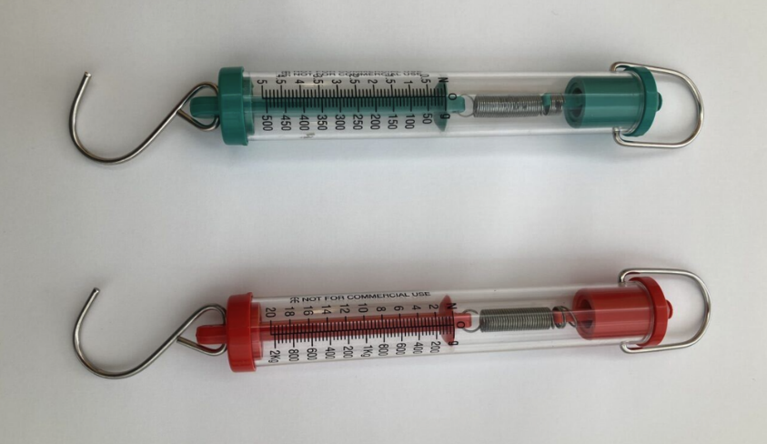
- Explain that in this experiment, students will use one of the Newton meters to measure force. The amount of extension of the spring inside represents the amount of force being exerted. Point out that for this reason, students need to be careful not to affect the accuracy of the device by extending the spring too much during their experiment.
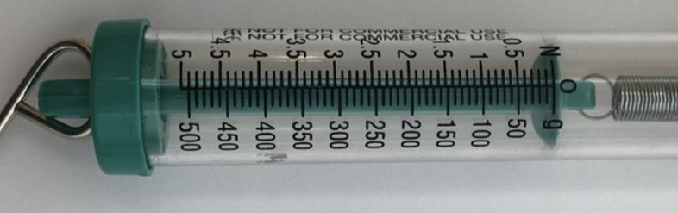:
- Draw attention to the scales on the side of the meter—one scale gives a measurement in grams and the other gives a measurement in Newtons. Explain that the measurements for this lesson will need to be read from the Newton scale.
- Check that both Newton meters are working (the spring will extend if the hook is gently pulled) and that it reads 0 N before starting.
- Discuss with students which Newton meter (5 N or 20 N) would be appropriate to use in this experiment, noting that the maximum force required is 5 N.
(Slide 41) Set up the force launcher for the investigation by making a Newton scale.

Force launcher instructions
- Tie the sewing elastic between the legs of a lab stool, chair or table and mark a straight starting line from leg to leg with chalk. Place the edge of a sheet of paper against this line.
- Attach the hook of the Newton meter to the elastic and hold the Newton meter level with the surface.
- Pull the Newton meter slowly and evenly until the pointer or marker reaches 1 N. If required, a student could sit on the stool or chair so that it does not move. Make sure to read the force value where the pointer or marker lines up on the scale.
- On the paper, mark where the elastic has been pulled to. Remove the meter from the elastic and check the marker inside the Newton meter returns to zero.
- Repeat the process to mark 2, 3, 4 and 5 N lines.
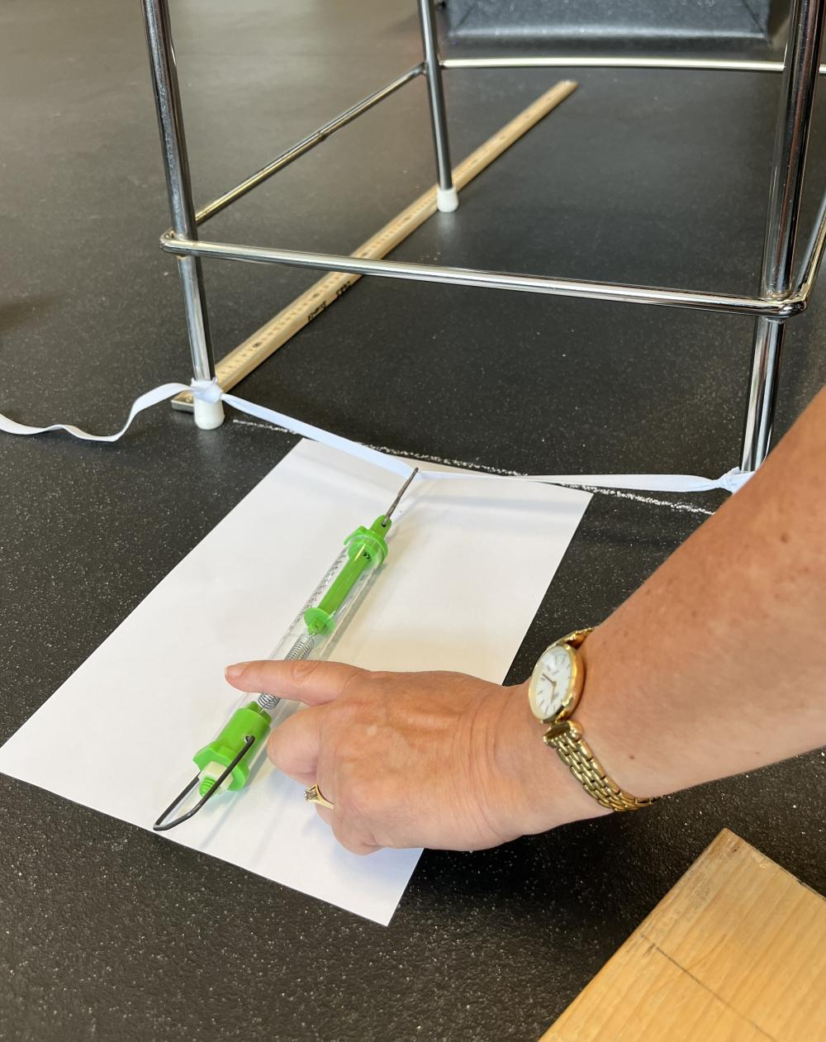:
(Slide 42) Remind students of the question posed at the start of the lesson: How does increased force affect motion? Refine the question so it addresses the investigation: What happens to the distance an object travels if more force is applied?
✎STUDENT NOTES: Write a hypothesis for the investigation.
(Slide 43) Provide students with the Force and motion investigation Resource sheet. Allow time for students to form groups, allocate roles, collect equipment and conduct the investigation.

Investigation steps
- Stretch the elastic between the legs of a stool, table or chair.
- Mark a chalk line from leg to leg of table/chair/stool and place the edge of the Newton scale A4 paper (from above) against this line.
- Place the block into the force launcher elastic and pull the block and elastic backwards so the edge of the block is lined up with the 1 N line.
- Release the block and measure the distance the edge of the block (that was in contact with the elastic) travels from the chalk line in centimetres. Record this value in the results table. Repeat this process another two times.
- Repeat steps 3 and 4 for 2 N, 3 N, 4 N and 5 N of force.
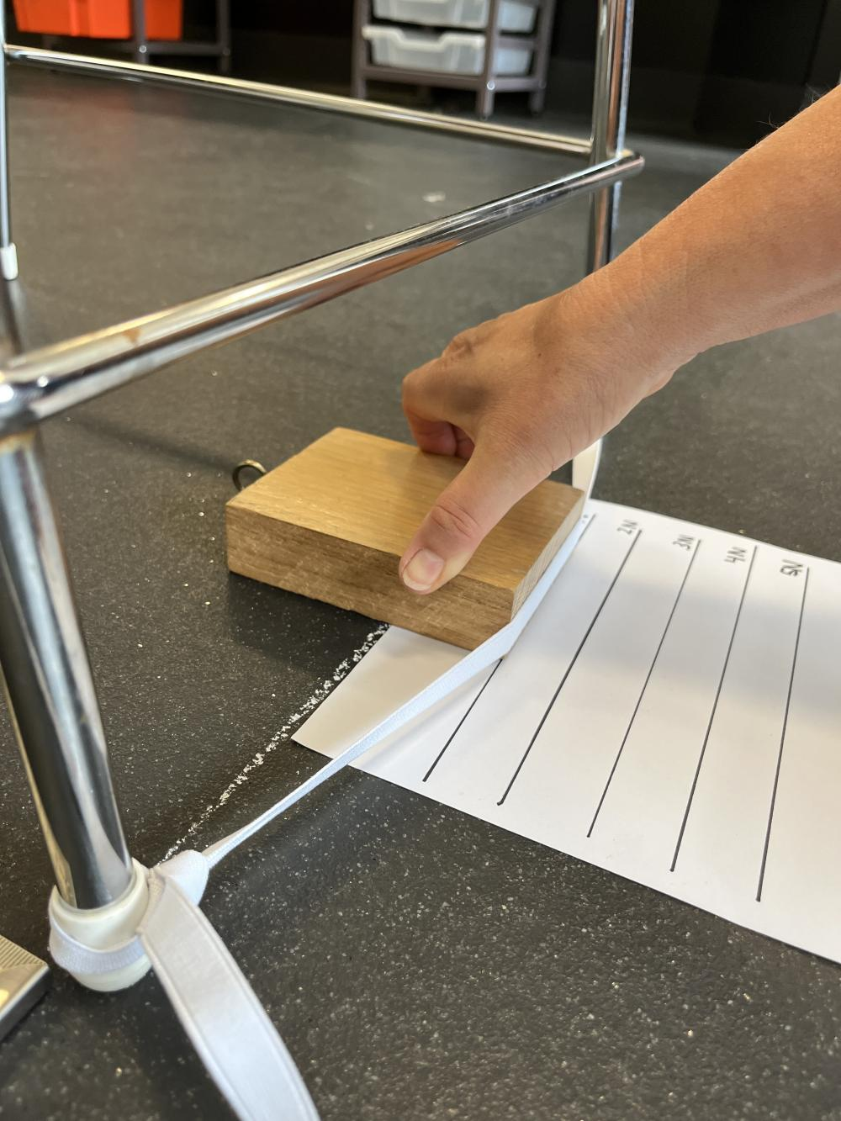
✎STUDENT NOTES: Record the distance the block travels in each trial. Calculate the average distance the block travelled (rounded to the nearest 0.5 cm to make it easier to graph).

Integrate • Connecting ideas
Discuss the main features of a graph and how to scale the vertical axis and plot points on the grid.
✎STUDENT NOTES: Graph the data collected in the investigation.
(Slide 44) Use the graph to discuss the patterns and trends shown in the investigation if student data is compromised due to the experimenter inexperience.
Discuss the pattern shown in the graph (or the graph’s appearance). Guide students to identify that the data increases at a steady rate, as it goes up by the same amount each time and the line is straight, not curved.
Invite students to describe the trend of the data (or what happens to the dependent variable as the independent variable is changed).
Use sentence starters such as: As the force used on the elastic ____, the distance travelled by the wooden block ____.
Discuss how applying extra force to the wooden block increased the distance it travelled. Relate this to the relationship between the variables. Invite students to describe this relationship using phrasing such as: As the amount of force was doubled on the block, the block moved twice the distance.
Example graph
Students should produce a graph showing a positive linear line-of-best-fit with a direct relationship between the force applied to the block and the distance it travels. A sample graph is shown below.
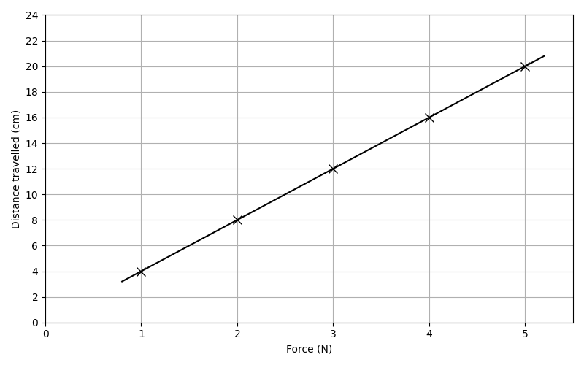
✎STUDENT NOTES: Complete the conclusion and discussion questions on the Force and motion investigation resource sheet.
If students need support, then the following prompts could be used as temporary scaffolds and could be reduced in future investigations as students become more comfortable with the scientific terminology.
Potential discussion prompts
Precision
- Look only at the repeated trials for the same force level. Are the distances close together or spread out?
- What does that tell you about how precise your measurements were?
  - You do not need to explain why yet, just describe the consistency.
Patterns in the data
- Read your results from lowest force to highest force. What generally happens to the distance as the force increases?
Model using comparative language such as increased, decreased, or remained similar.
Outliers
- Does one result look very different from the others for that force level?
- Circle the result that doesn’t fit in with the overall trend.
Encourage students not to think that outliers are wrong but that they are data points that need explaining.
Reliability (repeatability of the experiment)
- Imagine doing this investigation tomorrow. Would the results be the same? Similar? Very different? Why?
Error and improvement
- Where might the controlled variables not have been controlled?
- What part of the method could have introduced an error?
- What is one way the experiment could be changed to allow the variable to be better controlled?
- How will the improvement make the data more precise?
(Slide 45) Pose the questions: Which sports rely on increased force for extra distance or extra speed? Which sports rely on increased force to stop motion or to suddenly change direction?
Discuss how the forces applied to objects in the pictures relate to the motion of people. If required verbally model the thinking process for an image. You could, for example, highlight:
- what happens to the snowboarder’s direction when they apply more force through the board into the snow.
- when the wheelchair athlete pushes the ball harder, the ball’s speed as it leaves their hand is much faster as compared to a softer push.
- kicking the football with more force makes it leave the boot with more speed, and it goes farther than a soft kick.
- increased pulling force by the footballer would stop the kicker from being able to complete the kick.
- the bike image suggests that a large force has been applied, and as a result, the rider has suddenly stopped moving forward.
You could also model inferential thinking by asking questions like:
- If the person pushed or kicked with twice as much force, what do you predict would happen to the distance or speed of the ball or movement?
- Which sports in the images require the greatest force to change motion, and what evidence supports your decision?
- Looking at the wheelchair, what design features can you notice that might help the athlete move quickly or turn sharply so they can apply force in the right direction?
  - The wheelchair’s large, outward-angled wheels increase stability and help the athlete turn quickly without tipping. Their position closer to the body places the hand rims at a more efficient angle, allowing stronger, more effective pushes. The lightweight design also helps the athlete build up speed more quickly.
(Slide 46) Discuss examples of force changing motion in students’ chosen sport or physical activity, and how they might represent this on their infographic in the Act phase.
✎STUDENT NOTES: Write a list of what to include on your infographic about forces, and a list of important movements in your chosen sport or physical activity.

Reflect on the lesson
You might ask students to:
- review the learning goals for the lesson and check for understanding.
- go back to the PhET Forces and motion: basics ‬computer simulation model and change the amount of force applied to a mass.
  - What effect does this have on the speed of the skateboard?
  - Determine if the data from this simulation shows the same trend as the class investigation.
- review force diagrams and draw three force diagrams for different motion scenarios.

Y7

Forces and sport • Lesson 5 • Why are surfaces important in sport?
Lesson 5
Inquire
To read the most recent version of this lesson, download associated resources, and view embedded professional learning including classroom videos and work samples, visit: https://scienceconnections.edu.au/teaching-sequences/year-7/forces-sport/lesson-5-surfaces-important-sport

Lesson overview
Students investigate how frictional force affects the motion of objects and apply their findings to analyse the design of sporting equipment.

Key learning goals
Students will:
- conduct an investigation to determine how different surfaces change the amount of friction an object experiences while it is moving.
- describe friction as a force that opposes relative motion and explain why friction occurs.
- apply their understanding to describe and classify examples of friction in sport.
Students will represent their understanding as they:
- plan and conduct an investigation to determine the frictional force of different surfaces on an object.
- analyse the results and draw valid conclusions.
- use argumentation to provide an informed decision about the surface suitable for a sport scenario.

Assessment advice
In this lesson, assessment is formative.
Feedback might focus on students’ ability to:
- describe the relationship between frictional force and different surfaces.
- explain why friction occurs.
- label frictional force on a force diagram.
- complete an investigation and record data.
- transform data by calculating averages.
- analyse data to describe trends and patterns.
- assess the precision of data, identify possible errors and improvements to minimise errors.

Potential summative assessment
Students working at the Achievement Standard should:
- represent and explain the effects of forces acting on objects.
- conduct safe, reproducible investigations to test relationships.
- use equipment to generate and record data with precision.
- process data and information and analyse it to describe patterns, trends and relationships.
- identify possible sources of error.
- identify evidence to support their conclusions and construct evidence-based arguments.
Refer to the Australian Curriculum content links on the Our design decisions tab for further information.

List of materials
Whole class
- Forces and sport Slides
Each group
- 500g mass
- Wooden block with hook embedded in one end
- A range of Newton meters e.g. 5 N, 10 N and 20 N or a digital meter
- Different surfaces to pull the block and mass across, such as: carpet, plastic, rubber, laminate, concrete, bitumen, metal, gravel, mulch, sandpaper, dowel rods, wax paper, towel, wood
- Materials to reduce friction like vegetable oil or pieces of dowel
- Table or other flat surface e.g. lab bench
Each student
- Individual science notebook
- Forces and sport Poster
- Friction and motion investigation planner Resource sheet

Lesson routine | Estimated time | Task type
Re-orient | 5 minutes | Whole class
Question | 10 minutes | Whole class/Small group
Investigate | 25 minutes | Whole class/Small group
Integrate | 20 minutes | Whole class/Small group

Phase

Re-orient
Recall the previous lesson, focusing on the effect of increasing the force applied on the motion of an object.
Recall the links made to sport where increased force can be used to increase speed, increase distance, stop motion, or suddenly change its direction.
(Slide 48) Explain that the four images on the slide each show how increasing the amount of force applied can affect the motion of a person or object. Discuss how the images are similar or different.
Examine the Forces and sport Poster and invite students to:
- identify two examples of sports where increasing force can increase speed or distance.
- identify two examples of sports where increasing force can lead to stopping motion or suddenly changing direction.

Question • Surfaces in sport and physical activities
(Slide 49) Explain that in this lesson students will explore how different surfaces affect motion. Collect student ideas using the slide images to answer the question: Why are surfaces important in cycling?
(Slide 50) Point out to students that an explanation is needed to answer this question and the response requires certain features to be included. Model how to provide an explanation.
Potential discussion prompts
Questions, such as those below, can be used to model how students can think about and write a response.
- What is the verb in this question? What do you need to include in an answer to a “Why” question?
  - “Why” is the verb. It requires the cause and the effect linked with a word like “because”.
- What do you already know about surfaces and bikes?
  - Types of surfaces in cycling include:
    - tyres on smooth bitumen roads, on rough gravel and on dirt.
    - grip on handlebars.
    - feet on rough pedals.
    - bald tyres on road bikes, knobbly tyres on mountain bikes, brake blocks pushing on metal rims.
  - You could also extend the discussion to include smooth clothing and helmet shapes.
- What do you already know about the purpose of these surfaces? This will support the explanation.
  - For example: The rough pedals stop shoes from slipping, knobbly tyres grip gravel and dirt roads, slick road cycling tyres minimise gripping when riding on bitumen roads so the rider can go faster.
- To finish answering the question, generalise what you have discovered into one sentence.
  - For example: Rough surfaces slow or stop motion and stop slipping and sliding, slick or smooth surfaces allow motion.
(Slide 51) Students build on the teacher’s model answer by brainstorming examples in sport and physical activities where two surfaces are in contact and:
- equipment moving across a surface slows down (such as a hockey ball or sliding object slowing down on a surface).
- equipment in contact with another surface grips (such as spiked football shoes, track shoes or shoes for basketball, netball, or badminton on a court surface where quick changes of direction are needed).
- equipment in contact with another surface slides (such as the grip on the handle of a tennis racket or swimsuit to stop drag in water and to slide through the water)
(Slide 52) Pose the question: Why are surfaces important in sport or physical activities?
Invite feedback from the brainstorming, noting key ideas to include when answering the question at the end of the lesson.

Investigate • Investigating friction
Provide students with a copy of the Friction and motion investigation planner Resource sheet.
(Slide 53) Explain that the force that can affect motion when two surfaces are in contact is called “friction”. Define friction: Friction is a contact force that occurs when two surfaces touch and resist slipping or sliding when one surface moves, or tries to move, relative to the other.
✎STUDENT NOTES: Write the definition for friction (Question 1).
(Slide 54) Introduce the investigation that will try to answer the question: Why are surfaces important in sport or physical activities?
Demonstrate the equipment and different surfaces by:
- displaying the block of wood, 500g mass, and the Newton meter that will be used to measure the force needed to pull the block and mass.
- displaying or outlining the different types of surfaces the block will travel on, e.g. oil, dowel, carpet, plastic, rubber, laminate, concrete, bitumen, metal, gravel, mulch, sandpaper, wax paper, towel, wood.
- placing the mass on the block and attaching the Newton meter, then showing the action of pulling the block at a steady speed.
  - Explain that by pulling the block at a constant speed, the frictional force is balanced with the applied pulling force. Remind students that this balance can be represented using equal-length force arrows, as shown in the image and in the force diagram below. The balanced forces mean the reading on the Newton meter will be the frictional force.
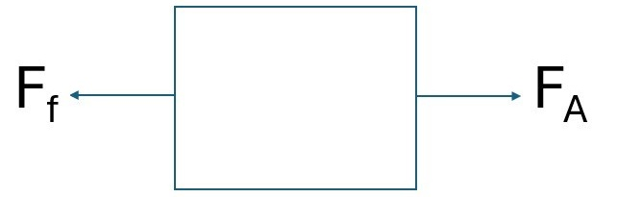
Read the aim of the investigation: To determine the effect of different surfaces on the force required to pull a block. Discuss how a research question is the big question that the investigation is trying to answer.
✎STUDENT NOTES: Write a research question for the investigation (Question 2).
Invite pairs of students to give feedback on each other’s questions using the criteria:
- Does it start with a word such as “Does…”, “How...”, “Why…” or “How…”?
- Does it include what will change, what will be measured, and why the investigation is being completed?
✎STUDENT NOTES: Draw a force diagram to represent the applied force and frictional force acting on a block being pulled at a constant speed (Question 3).
Discuss the meanings of “independent variable” and “dependent variable”. Ask students to identify the independent and dependent variables of this investigation, using the aim of the investigation as a reference.
✎STUDENT NOTES: Identify the independent and dependent variables for this investigation (Question 4).
As a class, brainstorm all the factors that could affect the reading on the Newton meter and why each factor could affect the reading. This may include:
- the speed the meter is being pulled (as it could be too fast for the other team members to take a reading).
- the steadiness of the pulling of the meter.
- the distance the meter will be pulled.
- the time at which the reading will be taken.
- the person taking the reading.
- whether the same wooden block is used.
Discuss why these variables need to be controlled.
✎STUDENT NOTES: Complete the planning for the investigation, including the controlled variables, hypothesis, procedure, and risk assessment (Questions 4 & 5).
Allow students time to conduct the experiment.
✎STUDENT NOTES: Record results in a results table (Question 6).

Integrate • Understanding and applying the investigation
(Slide 55) Compare the experimental results from each group and discuss the patterns found. Using the definition of friction, discuss why the same block experienced different frictional forces depending on the surface it was pulled across. Collate key ideas during the discussion and ask students to write an explanation. Co-construct the explanation or use sentence starters if students need support.
✎STUDENT NOTES: Complete the analysing results and conclusion questions (Questions 7 & 8).
Discuss the low and higher variation in the students’ data sets. Explain that when there is a high variation in the collected data between trials, then the experiment has low precision. Invite students to examine their data and reach a group consensus of the precision of their data.
Explain that random errors lead to variation in the collected data. Brainstorm possible errors that led to variation in the class data. Possible examples could be:
- surface irregularities.
- inconsistent contact between block and surface.
- the angle of pulling the Newton meter.
- changes in pull smoothness.
- the stretching and flexing of the spring in the Newton meter.
Select one error and discuss a possible improvement to how the experiment could be conducted to reduce the impact of their identified error.
✎STUDENT NOTES: Complete the remaining questions on the Friction and motion investigation planner Resource sheet.
(Slide 56) Re-pose the question asked at the start of the lesson: Why are surfaces important in sport or physical activities?
Referring to the results of the investigation, discuss how surfaces can reduce or increase the friction experienced and the different resulting changes in motion.
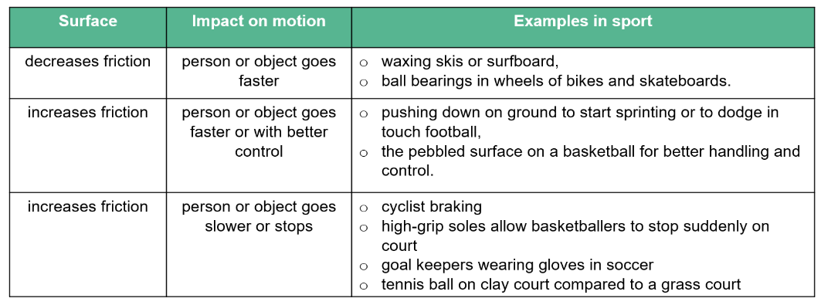
(Slide 57) Invite students to identify how the different surfaces in the pictures increase or reduce friction and the resulting impact on motion. Answers could include:
- Polished metal blades reduce friction and increase the speed of the bobsled.
- Aerodynamic helmets and “tucked-in” body position reduce air resistance or drag and allow the rider to go faster.
- Knobby tyres on motorbike wheels increase the surface area in contact with the ground and allow more grip in the muddy conditions. This increased friction allows the bike to accelerate faster around corners.
- The surfaces of gloves holding bar on wheelchair, rough surface of starting block, and specialised spike pads or soles on running blades increase friction and grip, allowing for increased acceleration.
(Slide 58) Pose the question: What surface would be best for a starting block, and why?
Discuss how the movement of a swimmer, diver or sprinter after pushing off the starting block determines the most appropriate block surface.
(Slide 59) Encourage students to use argumentation to make a claim regarding an appropriate surface for a starting block, supported by evidence from the investigation and reasoning.
Discuss the student claims, encouraging students to make changes to clarify their evidence and reasoning.
An example response could be: 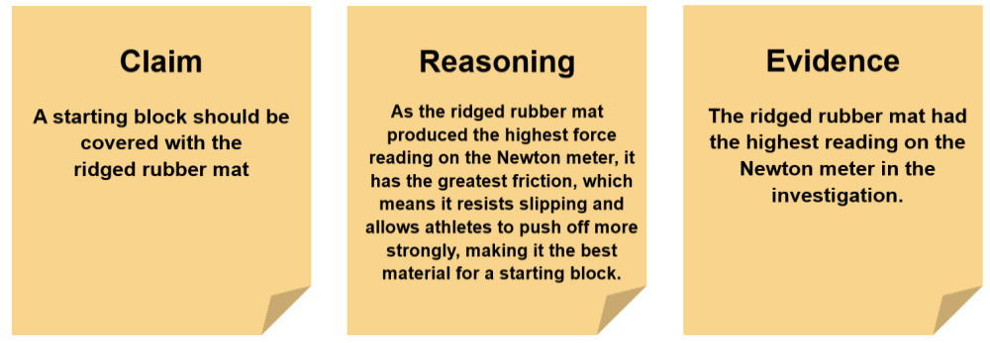

Reflect on the lesson
You might ask students to:
- review the learning goals for the lesson and check for understanding.
- reflect and write three things to add to their infographic in response to this lesson.
- add any new words to their glossary.
- represent three examples of horizontal motion in free-body diagrams using force arrows with labels. For a challenge add the magnitude of the force on the arrows. Ask another student to determine the direction (and magnitude if included) of net force.
- read about the wind tunnel testing of cyclists at the Canterbury University to find out what reduces drag. The article includes some data from the experiments as well.

Y7

Forces and sport • Lesson 6 • Lesson name
Lesson 6
Inquire
To read the most recent version of this lesson, download associated resources, and view embedded professional learning including classroom videos and work samples, visit: https://scienceconnections.edu.au/teaching-sequences/year-7/forces-sport/lesson-6-controlling-curve

Lesson overview
Students learn that gravitational force acts on balls in flight, changing their motion.

Key learning goals
Students will:
- demonstrate how gravitational force, acting as a net force, increases an object’s speed as it rolls down a ramp.
- develop the skills of collecting, transforming and analysing data from an investigation with a large sample size.
- explain the trajectory of different passes, shots and kicks in sports and physical activities.
Students will represent their understanding as they:
- plan and conduct an investigation to determine that gravitational force acting on an object as it rolls down a ramp causes its speed to increase over time.
- collect, present, transform and analyse data from a large sample size.
- use investigation findings to make inferences and draw conclusions about the action of gravitational force.
- assess and explain the paths of different passes, shots and kicks.

Assessment advice
In this lesson, assessment is formative.
Feedback might focus on students’ ability to:
- complete an investigation with a large sample size and collate and present data clearly.
- transform data by calculating averages.
- analyse data to describe patterns.
- assess the precision of data and methods to collect and present data from an investigation with a large sample size.
- explain how the trajectory of a pass, shot or kick is controlled by gravitational force acting on the ball.
Potential summative assessment
Students working at the Achievement Standard should:
- represent and explain the effects of forces acting on objects.
- conduct safe, reproducible investigations to test relationships.
- use equipment to generate and record data with precision.
- select and construct appropriate representations to organise and process data and information.
- process data and information and analyse it to describe patterns, trends and relationships.
- analyse methods and use evidence-based arguments to support claims.
Refer to the Australian Curriculum content links on the Our design decisions tab for further information.

List of materials
Whole class
- Forces and sport Slides
Each group
- Optional: Balls such as netballs, basketballs, footballs, tennis balls
- A wooden ramp or a long cardboard tube cut in half to use as a ramp
- A book to raise the ramp
- Metre ruler/tape measure
- Marble or ball bearing
- Marker/pencil
- Timer
Each student
- Individual science notebook
- Gravitational force investigation planner Resource sheet
- Forces and sport Poster (issued in Lesson 1

Lesson routine | Estimated time | Task type
Re-orient | 5 minutes | Whole class
Question | 10 minutes | Whole class
Investigate | 25 minutes | Whole class/Small group
Integrate | 20 minutes | Whole class/Small group

Inquire

Re-orient
Recall the previous lesson that focused on friction, where students investigated the effect of different surfaces on motion.
(Slide 61) Refer to the table on the slide to recall how surfaces can reduce or increase the friction experienced, and the resulting changes in motion. Invite students to provide examples to complete each row of the table.
Invite students to use the Forces and sport Poster to:
- identify two examples of different surfaces or equipment decreasing the frictional force between two objects (the ice skater at bottom right, the smooth surface used for bowling at the centre of the poster). Explain what happens to motion in each example.
- identify two examples of frictional force decreasing motion (the rhinoceros blocking the rabbit at bottom left, the boulder being climbed at top middle). Explain how and why motion is impacted.

Question • Gravitational force
(Slide 62) Using the images and student experiences, discuss how gravitational force affects motion. Invite students to describe how a ball moves after a kick, shot, or pass in a sport or physical activity, focusing on its motion through the air when it is acted on only by gravity (air resistance will not be considered in this lesson).
If time permits, take students to an outdoor area and ask them, in small groups, to observe how the path and speed of a ball change when it is passed, kicked or thrown.
Guide students to recognise that:
- because the ball’s motion changes while it is in the air, a force must be acting on it.
- the force acts continuously for the entire time the ball is in the air.
- when a ball is thrown upwards (e.g. in a tennis serve), it rises, reaches a highest point, and then falls back down.
- the ball follows a curved path if projected forward.
Potential discussion prompts
- When a ball is kicked or thrown, what is it doing while it is in the air?
  - Moving forward, upward, sideways, slowing down, changing direction.
- What is the direction at the start of motion?
- How does the speed change as the ball moves?
- How does the height of the ball change over time?
- In netball, how can a player use gravity to help the ball fall into the netball ring?
- In AFL, when a player kicks the ball long, what shape does the path usually look like?
- In a tennis serve, even before the ball starts coming down, how do players know it will come back down?
- How could a steady downward force explain those changes?
- Is the ball being pushed by the player while it is in the air?
- So, if nothing is touching the ball, what is still affecting its motion?
(Slide 63) Explain that in this lesson students are going to understand more about gravitational force and apply it to sports and physical activities to include on their infographic.
Pose the question: How does gravitational force affect motion?

Investigate • Gravitational force and motion
(Slide 64) Introduce students to a description of gravitational force, focusing on magnitude, direction and possible representations:
- Magnitude: At Earth’s surface, gravity exerts 9.8 N of force on every kilogram of mass.
- Direction: Gravitational force near Earth’s surface always acts downward, pulling objects toward the centre of the Earth.
- Representations:
  - Draw arrows pointing to the centre of the Earth, showing that the force acts vertically downwards at all locations.
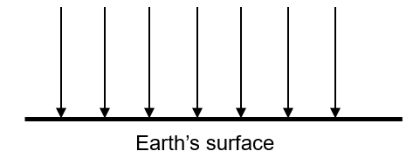
  - Draw a single arrow pointing downwards to show gravitational force acting on an object.
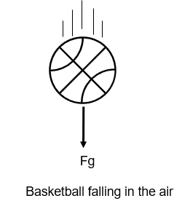
✎STUDENT NOTES: Write a description of gravitational force.
Introduce that the action of gravitational force on objects in sports and physical activities can be investigated using a simple model of a marble moving down a ramp. Explain that as the marble is acted upon only by gravitational force, we can find out more about this force if the motion or speed of the marble is measured.
(Slide 65) Show how the investigation is to be completed by demonstrating the following steps:
- Prop one end of the ramp/tube on a book to create a slope of approximately 10-20 degrees. This investigation will work better if the slope is not too steep.
- Mark a starting point on the higher end of the ramp, to be used in all trials.
- Place the marble on the starting point (but do not let it go yet).
- Simultaneously start the timer and let the marble roll down the ramp for one second.
- Mark the location of the marble on the ramp at one second.
- Measure the distance between the marked starting point and the location of the marble after one second (the distance the marble travelled in one second). Record this distance.
Demonstrate three runs of the test, drawing a line on the ramp each time to mark the distance travelled by the marble after one second.
(Slide 66) Draw students’ attention to the difficulty of determining the marble’s exact position after one second. With reference to the slide, define “variation” and “outliers”:
- Variation refers to how spread out the data points in an investigation are from each other.
- An outlier is a data point that is significantly different from the other points in the data set.
Discuss sources of measurement uncertainty that could have led to the variation observed, such as the differences in the release of the marble and the reaction time involved in starting the timer and judging the marble’s position on the ramp after one second.
✎STUDENT NOTES: Define data variation and outlier.
(Slide 67) Define “reliable data”: reliable data is achieved when the data points consistently show low variation. Invite students to suggest how the variation in the measurement data could be improved. Guide students to suggest:
- repeating the experiment multiple times (a large sample size).
- identifying and potentially excluding outliers or trials where an error is known to have occurred.
✎STUDENT NOTES: Explain the importance of a large sample size in identifying outliers and errors.
Provide students with a copy of the Gravitational force investigation planner Resource sheet.
Allow students time to develop a procedure to improve reliability by repeating the release of the marble and measuring the distance travelled multiple times to determine the best way to control variables and take consistent measurements.
✎STUDENT NOTES: Write a procedure to collect reliable data, account for any risks, and describe how to control variables.
Allow students time to use their new procedure to conduct the experiment and record the distance the marble rolls down the ramp after one second (the opportunity to complete up to ten trials is given in Table 1).
✎STUDENT NOTES: Record the measured distances in Table 1. Calculate the average distance travelled.
(Slide 68) Pose the question: Will the distance travelled by the marble double if the time doubles (to two seconds)?
(Slide 69) Discuss the possible outcomes of this experiment, including:
- the distance travelled will double (suggesting the marble’s speed does not change over time).
- the distance travelled will be less than double (suggesting the marble slows down).
- the distance travelled will be more than double (suggesting the marble speed is increasing/accelerating).
✎STUDENT NOTES: Write a hypothesis for the experiment.
Allow students time to complete the experiment. The number of repeat trials required may vary based on the precision of their collected data.
✎STUDENT NOTES: Record the measured distances in Table 2. Calculate the average distance travelled.
(Slide 70) Guide students to calculate the distance travelled in the interval between second 1 and second 2 by subtracting the average distance travelled in one second from the average distance travelled in two seconds.
✎STUDENT NOTES: Calculate the average distance travelled in the interval between second 1 and second 2 (Table 3).

Integrate • Connecting to sport & physical activities
Use the results to reach a class consensus that the distance the marble travelled was more than doubled when the time was doubled.
(Slide 71) Introduce the idea of “inference”: the logical process of reaching a conclusion, opinion, or educated guess based on available evidence, observations, and prior knowledge. Discuss the inferences that can be made from the results of the marble’s motion:
- Observation: Although the time intervals were the same, the marble travelled a larger distance in second 1 than second 2.
- Inference: This means that the marble must have been speeding up over time.
Discuss how a net force is needed to cause a change in speed. In this case, gravitational force was the net force.
- Inference: The marble’s motion was changing due to the gravitational force acting on it.
- Inference: Gravitational force causes the motion to change (speed up) as it is an accelerating force (causing falling objects to increase their speed by about 10 metres per second every second).
✎STUDENT NOTES: Complete the analysis of results and the discussion questions on the Gravitational force investigation planner Resource sheet.
Optional: Play Parndo (“parn-do”). Playing this game allows students to experience the effects of gravity on a ball’s motion.
Explain that this ball game was played by Aboriginal people near Adelaide (Kaurna language) in South Australia. Possum skin was stuffed with dry grasses and charcoal to make the tennis ball-sized parndo (ball). A parndo is a “ball to play with” in the Kaurna language spoken in the southern parts of South Australia.

How to play Parndo
(A) Larger team version: 12 players on a soccer or rugby field or 15 players on an Australian football field
- The players stand together in a circle or next to each other in a line. One of the players drops the parndo to their foot and kicks it as high and straight up into the air as possible.
- The players attempt to catch the parndo, minimising any physical contact between players.
- Once the parndo is caught, the player is free to kick it without interference.
(B) Alternative team version: Four to eight players in a 20 to 30-metre square area.
- One of the players drops the parndo to their foot and kicks it as high and straight up into the air as possible.
- The players attempt to catch the parndo, minimising any physical contact between players.
- Once the parndo is caught, it may be thrown/passed between players of the same team until the player holding the ball is touched or they can kick it into the air again.
- When a player catching a ball pass is touched by an opponent, they lose possession of the parndo.
- If the parndo falls to the ground, players attempt to retrieve the ball without diving on the ball or physical contact.
See this game being played at Parndo is a traditional game of the Kaurna People - Behind the News (3:35).
(Slide 72) Discuss the effect of gravitational force on balls in flight (from kicks, passes, and shots). Link the findings from the investigation to the information about the direction of the force (Slide 64) in the discussion. Guide students to recognise that:
- gravitational force constantly accelerates a ball in flight downward, causing its speed to change throughout the flight (slowest at the top of the curve).
- kicks, passes, and shots follow curved paths as they rise and fall due to the action of gravitational force.
- a kick, pass or shot's path, timing and likely landing point can be predicted using this understanding.

Potential discussion questions
Predicting the path
- Think about a sport you play or watch (e.g. soccer, AFL, netball, basketball). Where do you see players kicking or throwing a ball along a curved path?
- What clues do players use to judge how far and how fast the ball will travel?
- How does the height of a kick or throw help a player predict how long the ball will stay in the air?
- When a ball is kicked high in a game, when is it moving slowest? How do players use that moment to position themselves?
- How might knowing that the ball speeds up as it falls help a player prepare to catch or receive it?
Controlling the curve
- How can a player change the curve of the ball’s path when kicking or throwing?
- Why might a player choose a low, flatter pass instead of a high, curved one in a game?
- How does gravity affect every kick or throw in a game, no matter how skilled the player is?
- Even though players can’t control gravity, what can they control to make the ball go where they want?
- How does understanding how balls move help players make better decisions during a game?
✎STUDENT NOTES: Draw a diagram of a ball in flight. Add gravitational force arrows to the diagram at different points during the flight such as:
- when the ball first kicked, hit or passed.
- when the ball is at the top of its flight.
- when the ball is returning.
✎STUDENT NOTES: Explain how players use an understanding of gravitational force to predict the ball’s path, timing, and likely landing point during a game using examples.

Reflect on the lesson
You might invite students to:
- review the learning goals for the lesson and check for understanding.
- add to a glossary.
- complete a CER writing activity where they write a structured scientific explanation with the instructions: Write a short Claim–Evidence–Reasoning response:
  - Claim: What does gravity do to the ball?
  - Evidence: What was observed in the activity or diagram?
  - Reasoning: Why does gravity cause this change?
- create their own crossword, including clues, using force and motion terminology used in this unit.

Y7

Forces and sport • Lesson 6a • How does magnetic force affect motion?
Lesson 6A
Inquire (Optional)
To read the most recent version of this lesson, download associated resources, and view embedded professional learning including classroom videos and work samples, visit: https://scienceconnections.edu.au/teaching-sequences/year-7/forces-sport/lesson-6a-magnetic-force-affect-motion

Lesson overview
Students learn that magnetic forces can attract or repel objects without contact. They investigate how the strength of magnetic force changes with distance and explore how magnets are used to control motion in sporting contexts.

Key learning goals
Students will:
- describe magnetic force as a non-contact force that can cause attraction and repulsion between magnetic objects.
- investigate to determine how magnetic force varies with distance.
- describe how magnets are used in magnetic braking systems in sport and physical activity to slow motion.
Students will represent their understanding as they:
- use models and diagrams to represent forces between two magnets with like and unlike poles.
- use models and diagrams to represent the pattern of magnetic force around magnets.
- conduct an investigation and infer the relationship between magnetic force and distance.
- compare the braking systems in a road bike (contact braking) and an exercise bike which uses magnetic braking.

Assessment advice
In this lesson, assessment is formative.
Feedback might focus on students’ ability to:
- describe magnetic force as a force of attraction and repulsion on magnetic objects at a distance.
- represent the magnetic force around magnets in drawings of iron filings patterns.
- describe how magnets are used in magnetic braking systems in sport and physical activity to slow motion.
Potential summative assessment
Students working at the Achievement Standard should:
- represent and explain the effects of forces acting on objects.
- conduct safe, reproducible investigations to determine patterns.
- process data and information.
Refer to the Australian Curriculum content links on the Our design decisions tab for further information.

List of materials
Whole class
- Forces and sport Slides
- Paperclip
- Thread
- Retort stand
- Clamp
- Bar magnet
- Video: DIY eddy current braking demonstration for electromagnetic testing enthusiasts (0:12)
Each group
- 2 x bar magnets
- 3 x A4 paper
- Marker/pencil
- Saltshaker containing iron filings
- Plastic sleeve or clingwrap

Each student
- Individual science notebook
- Forces and sport Poster
- Magnetic force investigation Resource sheet

Lesson routine | Estimated time | Task type
Re-orient | 5 minutes | Whole class
Question | 5 minutes | Whole class
Investigate | 30 minutes
 |  | Small group/Individual

Inquire

Re-orient
(Slide 74) Recall the previous lesson on the influence of gravitational force on the path of balls after they are thrown, shot or kicked.
Recall the key features of gravitational force on objects:
- Gravitational force has magnitude and direction.
- Gravitational force can be represented using arrows.
- Gravitational force continuously accelerates a ball downward, causing its speed to change so that kicks, passes and shots follow curved paths as they rise and fall.
Discuss these key features in the context of golf, as shown on the slide.
Ask students to find two examples of gravity affecting motion on the Forces and sport Poster.

Question • Magnetic force in sporting equipment
Explain that in this lesson students will learn about magnetic force, which can affect motion without direct contact (similar to gravitational force).
(Slide 75) Introduce students to the use of magnets in three examples of sporting equipment—the Baitcaster fishing reel, stationary bike, and rowing machine. Explain that the magnets inside each piece of equipment, placed near a spinning metal disc, change the motion of the equipment. Invite students to discuss their experiences in using the equipment and how they think the motion changes as a result of magnets.
(Slide 76) Pose the question: How do magnets affect the motion of sporting equipment?

Investigate • Investigating magnetic force
Explain to students they will be conducting an investigation to examine magnetic force between two magnets and determine where magnetic force is strongest.
(Slide 77) Provide students with the Magnetic force investigation Resource sheet. Allow time for student groups to read through the investigation for the question What is magnetic force?.
Investigation: What is magnetic force?
- Place two bar magnets on a flat surface so that the north pole of one magnet is facing the south pole of the other.
- Slide the north pole of the magnet closer to the south pole of the other magnet. Record your observations.
- Move the magnets so that their north poles are facing.
- Slide the north pole of one magnet towards the north pole of the other magnet. Record your observations.
✎STUDENT NOTES: Write a prediction for this investigation.
(Slide 78) Allow students time to complete the investigation and record their results. Guide students to conclude that like magnetic poles attract and unlike magnetic poles repel. Students could also observe how the strength of the force they felt varies with the distance between the magnets.
✎STUDENT NOTES: Record the observations of the investigation in the results table.
(Slide 79) Explain that magnetic force cannot be seen directly, but its effects can be observed when iron filings align in patterns around a magnet. Allow time for student groups to read through the investigation for the question Where is magnetic force strongest?.
Investigation: Where is magnetic force strongest?
- Lay two magnets in a plastic sleeve on a flat surface, with the north pole on one magnet facing the north pole of the other magnet. Place a piece of A4 paper over the magnets. Trace the outline of each magnet and label the ‘N’ and ‘S’ poles on each outline.
- Gently shake the iron filings over the paper, focusing on where the magnets are and the surrounding area. Gently tap the paper to spread the iron filings evenly around the magnet if necessary.
- Draw the iron filings pattern in the results table.
- Lift the paper and carefully pour the iron filings back into the saltshaker.
- Move the magnets so that the north pole of one magnet is facing the south pole of the other magnet. Place a piece of A4 paper over the magnets. Trace the outline of each magnet and label the ‘N’ and ‘S’ poles on each outline.
- Gently shake the iron filings over the paper, focusing on where the magnets are and the surrounding area. Gently tap the paper to spread the iron filings evenly around the magnet if necessary.
- Draw the iron filings pattern in the results table.
- Lift the paper and carefully pour the iron filings back into the saltshaker.
✎STUDENT NOTES: Write a prediction for this investigation.
(Slide 80) Allow students time to complete the investigation and record their observations.
✎STUDENT NOTES: Record observations from the investigation, including annotations indicating where the iron filing patterns are most dense and where they are more spread out.

Integrate • Magnetic force & sports equipment
(Slide 81) Discuss the combined results of the investigation. Highlight:
- Magnets exert force without touching other magnets or objects.
- An attractive magnetic force existed between unlike poles.
- A repulsive magnetic force existed between like poles.
- Magnetic force changes with distance.
  - The force felt stronger when the magnets were closer.
  - The iron filings pattern showed that magnetic force is strongest near the magnet, particularly at the poles, where the filings were thickest, and weaker farther away.
Potential discussion prompts
- When you brought two magnets close together, what happened when the same poles faced each other?
- What happened when different poles were brought close together?
- How did the strength of the push or pull change as you moved the magnets closer together or further apart?
- When you sprinkled iron filings around the magnets, where did the filings gather the most?
- How did the pattern of iron filings differ near the ends of the magnets compared to the middle?
- How did the pattern of the iron filings differ closer to the magnets compared to farther out?
✎STUDENT NOTES: Complete the discussion questions on the Magnetic force investigation Resource sheet.
Explain that magnets are found in some sporting equipment like rowing machines and exercise bikes and in some fishing reels. Explain that in this equipment magnets provide resistance or a braking force that slows moving parts without direct contact.
Remind students of two key findings from the investigation:
- Magnets exert a force without touching (non-contact force).
- Magnetic force is stronger closer to the magnet.
Explain that these ideas help understand how magnets can be used to control motion.
Demonstrate how the motion of a magnetic object can be slowed or stopped by a magnet.
- Attach a paperclip to a length of thread suspended from a clamp on a retort stand.
- Position a bar magnet upright on the bench or laboratory surface approximately 1 cm below the paperclip.
- Gently swing the paperclip so that it passes over the magnet.
- Observe how the paperclip slows and eventually stops above the magnet.
Explain that in exercise equipment and fishing reels, magnets are used differently. Rather than attracting a magnetic object, they slow the motion of a nearby spinning non-magnetic disc (typically aluminium) without touching it. This process is called magnetic braking.
Note: Year 7 students are not expected to understand the underlying phenomenon of magnetic braking, but they can appreciate it as an effective demonstration of magnetic force in action.
Demonstrate magnetic braking or show an example of this phenomenon by showing DIY eddy current braking demonstration for electromagnetic testing enthusiasts (0:12).
(Slide 82) Using the images on the slide, explain that the magnets are not attracted to the aluminium disc or spool, but instead create a magnetic force that causes resistance, slowing the motion of the disc.
Highlight the relationship: Magnets move closer → resistance to motion increases → motion slows. Specifically:
- For fishing reels:
  - Magnets placed near a spinning aluminium spool inside the reel create a magnetic braking force.
  - This slows the motion of the spool, preventing it from spinning too fast and helping to control the cast.
- For cycling or rowing machines:
  - Magnets positioned near, but not touching, a spinning flywheel create a magnetic braking force.
  - Resistance makes pedalling or rowing more challenging.
  - The resistance can be adjusted by changing the distance between the magnets and the flywheel.
(Slide 83) In small groups, students compare the braking systems in a road bike (contact braking) and an exercise bike which uses magnetic braking. Explain that students will have to use their understanding about magnetic braking from this lesson and frictional force from Lesson 5.
Potential discussion prompts
- Which system has parts that touch?
- Which system might make more noise?
- Which system would wear out faster?
- Which system might require more maintenance?
- Which system allows more precise control of braking?
✎STUDENT NOTES: Record the similarities and differences of the two braking systems in a table.
 | Contact braking | Non-contact braking
Noise during braking | Brake pads rub against the wheel rim or disc, often producing noise during braking. | No physical contact between parts, so braking operates more quietly.
Wear and tear | Friction causes brake pads and braking surfaces to wear down over time and require replacement. | Very little wear occurs because the magnets do not touch the moving parts.
Heating | Heat is produced because of contact friction, causing brake components to become hot during use. | Less heat is generated because braking occurs without rubbing surfaces together.
Control of resistance | Braking force is controlled by increasing or decreasing the pressure of the brake pads on the wheel. | Braking force can be adjusted by changing the distance between the magnets and the spinning disc or flywheel, allowing for fine control of resistance or casting.
How the braking force is produced | Friction between two surfaces slows the motion. | Magnetic forces create resistance that slows the motion without contact.

Reflect on the lesson
You might invite students to:
- learn more about magnets using the PhET Magnets and electromagnets ‬computer simulation model.
- define and describe “magnetic force” in their glossary.
- watch Magnet braking on a skateboard (3:01), showing the effect of adding magnetic braking to a skateboard going down a ramp.
- design a vertical video ad that advertises either a magnetic braking reel used in fishing or exercise equipment using magnetic braking such as rowing machines, exercise bikes or treadmills. They should create a 3-frame storyboard for a vertical ad showing:
  - a hook (the problem the equipment solves).
  - an explanation of the push and pull forces and the science concepts involved, including arrows.
  - a selling point (why the technology is better).
Students share their design with another person in under 15 seconds and receive feedback on their communication of the science concepts covered in this lesson.

Y7

Forces and sport • Lesson 7 • Designing a forces infographic
Lesson 8
Act
To read the most recent version of this lesson, download associated resources, and view embedded professional learning including classroom videos and work samples, visit: https://scienceconnections.edu.au/teaching-sequences/year-7/forces-sport/lesson-7-designing-forces-infographic

Lesson overview
Students design an infographic to show how forces affect movement in a sport or physical activity for new or improving players.

Key learning goals
Students will:
- design an infographic to communicate the important aspects of a sport or physical activity and the forces involved.
Students will represent their understanding as they:
- recall the concepts covered in the lesson sequence.
- evaluate an infographic.
- design an infographic poster about the forces and movement in a sport or physical activity.
- participate in a gallery walk and provide feedback using criteria.

Assessment advice
In this lesson, assessment is summative.
Students working at the Achievement Standard should:
- relate the movement of people and objects in a sport or physical activity to unbalanced forces.
- explain examples of balanced forces in a sport or physical activity.
- represent forces using arrows showing direction and relative magnitude.
- describe the effect of mass and force on the motion of objects or people in a sport or physical activity.
- use correct scientific terminology when naming forces and the way they act on an object.
- create an infographic using appropriate language to communicate their ideas to a Year 7 audience.
Refer to the Australian Curriculum content links on the Our design decisions tab for further information.

List of materials
Whole class
- Forces and sport Slides
- A playing area about 50-75 metres long by 35-50 metres wide
- Size 2 or 3 soccer ball or touch football
- Cones or markers to mark the score lines at opposing ends of a field
- An object that can be used as the talking stick for the yarning circle
Each group
- Infographic evaluation Resource sheet
- Access to About the Indigenous seasonal calendars - CSIRO
Each student
- Individual science notebook
- Either:
  - A3 paper (if students are completing the infographic on paper), or
  - access to a computer (if students are creating a digital infographic)

Lesson routine | Estimated time | Task type
Connect | 15 minutes | Whole class
Anchor | 30 minutes | Whole class/Small group
Design | 30-60 minutes | Whole class/Small group
Communicate | 30-60 minutes | Small group/Individual

Act

Connect • Playing a new game
(Slide 85) Invite students to play Buroinjin (“bur-oin-jin”), a running-and-passing traditional Indigenous game, to experience what it is like to play a new or unfamiliar game.
Explain that Buroinjin originated with the Kabi Kabi people of south Queensland. The traditional game was played with a kangaroo skin ball stuffed with grass. The game, played between teams from different groups, often lasted until sunset. Spectators engaged with the action by cheering “Ei, ei”, making the game a significant community event.
How to play Buroinjin
- Set out a playing area of about 50-75 metres long by 35-50 metres wide with markers or a line to mark the end of the opposite ends of the field. Divide students into two teams.
- The buroinjin (a size 2 or 3 soccer ball) is thrown into the air in the middle of the playing area to begin the game.
- The player that catches the ball should try to run over a line at the other end of the field without being touched by the opposing team. The buroinjin may be thrown to another player, but it cannot be hit with the fist or kicked. There are no player positions or offside, and the buroinjin can be thrown in any direction.
- The game does not stop if a player drops the buroinjin. Players must bend over and pick it up (they should not dive on the ball).
- If a player with the buroinjin is touched by a member of the opposing team, the ball should be thrown up (at least 2-3 metres in the air) by that player so the game can continue. The player who was touched may not catch the buroinjin.
- Possession changes through infringements such as intercepts, a player deliberately playing the buroinjin into another player, a player running out, and holding or obstructing an opponent.
- If a player carries the buroinjin past the score line, one point is scored. The game is then restarted.
Safety: For safety reasons players should not be allowed to dive on the ball on the ground—they must bend over and pick up the ball. In competing for a loose buroinjin players must avoid contact.
Other resources:
- Watch Traditional indigenous games - Buroinjin (3:01) to see the game being played.
- Read the Australian Sport Commission’s instruction card at Yulunga Traditional Indigenous Games.
After the game, discuss what it was like to learn a new game including the forces involved.

Anchor • What has been learnt? Forces and motion
(Slide 86) After playing Buroinjin, find an appropriate place to conduct a whole class yarning circle. Provide a brief description of a yarning circle as a method of knowledge exchange that embodies the oral traditions of storytelling in First Nations cultures, with “yarning” being a word for an informal conversation. See the embedded professional learning Yarning below for more information on how to best conduct a yarning circle.
Explain the purpose of the yarning circle is to:
- learn from the group, as each student brings with them their own story and lived experience.
- to consider how to communicate through pictures and images just as First Nations’ history, educational stories, and the stories of country, creation and tradition have been passed down through the generations through storytelling, rock art, sand drawings, and craft traditions for over 40 000 years.
Recall the traditional Indigenous games played throughout the lesson sequence. Pass the yarning stick around the circle, inviting students to share:
- what was challenging when learning a new game.
- what they have learnt about forces and motion.
- what information a new participant to their sport or physical activity would need to know about force and motion.
- how they plan to communicate clearly and accurately on their infographic.
Invite students to suggest what features would make a good infographic. Guide students to identify the following features as important.
- Clear and descriptive title that immediately communicates the topic of the infographic.
- Subheadings for different sections of information.
- Simple and logical layout.
- Relevant images and icons to help explain ideas.
- Colour to highlight important information and draw attention to key messages.
- Familiar graphics and clear language that the intended audience can easily recognise and understand.
Potential discussion prompts
- How do images, symbols, and colour help messages reach more people quickly?
- Why might people choose an infographic instead of long paragraphs to communicate an important idea?
- Why are visual messages important when communicating movement in sport or physical activities?
- In sport, how could clear communication about forces help athletes perform better or avoid injury?
- How do posters, infographics and public messages help communities stay safe, informed, or connected?
Move out of the yarning circle and into small groups. Distribute the Infographic evaluation Resource sheet.
(Slide 87) Examine the infographics:
- A CSIRO Indigenous seasonal calendar (by going to the website and choosing one for your local area: Indigenous seasonal calendars) and
- Beach fishing infographic (on the Resource sheet).
Discuss the key features found in each using the criteria found on the Resource sheet.
Potential discussion prompts
- What is the main message of each infographic?
- Does the fishing infographic clearly explain what a force is?
- Are the examples given accurate and easy to understand?
- Would someone new to fishing or the seasons learn something from the infographic?
- Are the infographics easy to read from a distance?
- Do the images and diagrams help explain the ideas?
- Do the infographics use colour, headings, and labels effectively?
- Is the information organised in a logical order?
- Do the infographics include only the most important information, without overcrowding the poster?
✎STUDENT NOTES: Identify three (3) positive features in both infographics and suggest two (2) features in the beach fishing infographic that could have been presented differently. Describe, using words or annotated diagrams, the features that will be included in your new infographic design.

Design • Designing an infographic
(Slide 88) Students design an infographic to show how forces affect movement in a sport or physical activity for new or improving players.

Ideate
Brainstorm all the information about forces that could be included on the infographic. Encourage students to include all possible ideas at this stage.
Potential discussion prompts
- What different types of forces could you include?
- How does gravity affect the player or equipment?
- How does friction help or prevent movement?
- How do forces change the speed or direction of movement?
- What equipment is involved, and what forces act on it?
- What facts, key words, or definitions should you include?
- What diagrams, symbols, or pictures could help explain the forces?
- What interesting facts or “Did you know?” information could make your infographic more engaging?
- What questions might a beginner ask about forces in this sport?

Design
Group ideas into categories such as how to move the body, move equipment, speed up, slow down, or change direction. Encourage students to use the new terms related to forces learnt in this teaching sequence.
Infographics have limited space. Encourage students to identify the key information that will be needed or used by a beginner to the sport or physical activity. The infographic could take many forms depending on the time and resources available. It may be as simple as a detailed drawing with labels and explanations, or a digitally created poster.
Discuss with students the criteria that may be required in their infographic. This may include:

The context
- Three important movements or skills from a chosen sport or physical activity.

The science
- A clear description of the forces involved in each movement.
- Force diagrams with arrows showing direction and relative magnitude.
- Examples of balanced and unbalanced forces.
- At least one contact force (e.g. friction, push, pull, air resistance, tension).
- At least one non-contact force (e.g. gravity, magnetism if relevant).
- A description of how motion changes depending on mass and force magnitude.

Communication skills
- Correct scientific vocabulary (force, friction, gravity, balanced, unbalanced, motion, mass).
- Organised layout (rows, columns or sections) using icons and simple symbols, visual comparisons (e.g. balanced vs unbalanced, before, after), labelled diagrams and consistent visual coding (net force in same colour always).
- The language used would allow peers to understand the infographic information and message.
Allow students time to complete a draft of their infographic.

Communicate • Presenting the infographic and receiving feedback
Receiving feedback is an important part of the design process. This feedback could be from class visitors, a teacher or student peers.
Encourage students to display their draft design around the room and invite them to participate in a gallery walk to view and give feedback on the infographics.
Discuss with students the form that this feedback could take. For example, students could use:
- sticky notes identifying the best elements.
- sentence starters ‘I like …’, ‘Have you thought of…’, or ‘I didn’t know that…’.
- Two stars and a wish.
- TAG (Tell the author something you like, Ask a question, Give a suggestion).
- a structured feedback form, checklist, or a rubric.
Allow students time to use the feedback to prepare a finalised form of their infographic.

Reflect on the sequence
You might invite students to:
- reflect on the design process and what they would do differently next time.
- reflect on the importance of communication tools like infographics to change people’s perceptions or ideas.
- reflect how the learning from this lesson sequence has led to an increased understanding of First Nations Australians’ unique ways of being, knowing, thinking and doing.
- consider how the learning from this teaching sequence may have impacted the way students play their chosen sport or physical activity, the way they train, or their choice of equipment they use.
- research a career involved in the physics of sport such as:
  - biomechanics. They can start by watching A day in the life of a biomechanist (2:11) by the NSW Institute of Sport.
  - sports scientists. They can start by watching A day in the life of a sports scientist (2:43) by the Olympic Games.

