Forces & sport • Lesson 7 • Infographic evaluation
Year 7
Name:

Evaluating two infographics

Procedure
- Go to About the Indigenous seasonal calendars - CSIRO.
- Choose an Indigenous seasonal calendar from the list on the right.
- Evaluate the general features of the poster using the table below.

Results
Features of an infographic | Present or absent? (ü or X)
Clear and descriptive title
Subheadings for different sections of information
Simple and logical layout
Relevant images and icons used to explain ideas
Use of colour to highlight important information
Use of graphics and language the targeted audience will recognise and understand.

Specific features of a Forces and sport infographic
- Examine the Beach Fishing infographic.
- Evaluate the infographic using the table below.

Results
Features of a Forces and sport infographic | Present or absent? (ü or X)
Important movement or skill from a sport or physical activity displayed
Clear description of forces involved in the movement/s
Force diagrams using arrows showing directions and relative magnitude
Examples of balanced and unbalanced forces
Contact and non-contact forces included
Description of how motion changes due to mass and force
Correct scientific vocabulary and symbols
Forces and motion in the sport or physical activity communicated so a new participant understands the movements or skills involved in the activity.
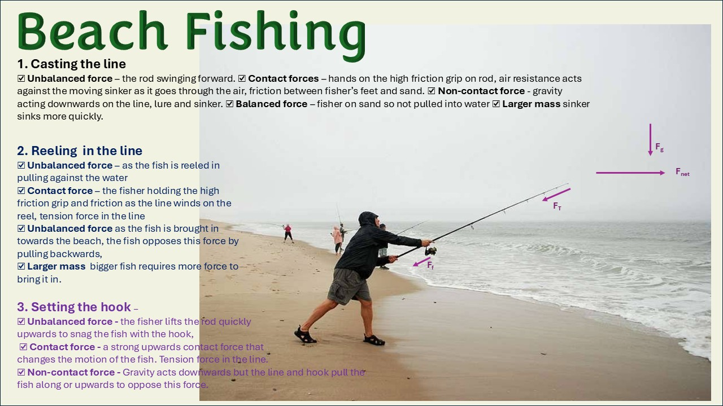

Discussion
- Identify three (3) positive features in each infographic.

- Identify two (2) features in the Beach Fishing infographic that you would have presented differently.

- Describe, using words or annotated diagrams, the features that will be included in your infographic design.

