Forces & sport • Lesson 6A • Magnetic force
Year 7
Name:

Magnetic force

Question 1
What is magnetic force?

Prediction
If the north poles of two bar magnets are brought near each other,
then the magnets will ……………………………………………………………………………………………………….
If a north pole and south pole of two bar magnets are brought near each other,
then the magnets will ……………………………………………………………………………………………………….

Equipment

- 2 x bar magnets with north (N) and south (S) poles labelled

Risk assessment
If a magnet is dropped it can lose its magnetism. Gentle handing is required.

Procedure
- Place two bar magnets on a flat surface so that the north pole of one magnet is facing the south pole of the other. | 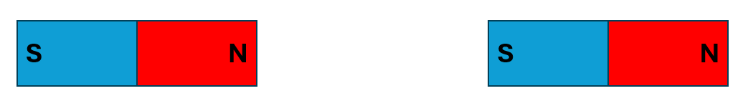
- Slide the north pole of the magnet closer to the south pole of the other magnet. Record your observations. | 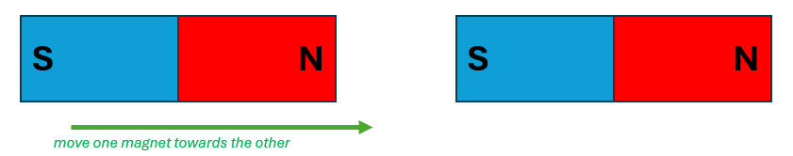
- Move the magnets so that their north poles are facing. | 
- Slide the north pole of one magnet towards the north pole of the other magnet. Record your observations. | 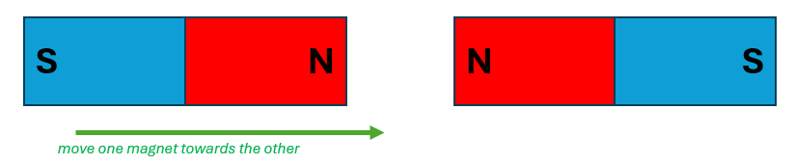

Results
Observations
North pole moving towards the south pole of second magnet
North pole moving towards the north pole of second magnet

Question 2
Where is magnetic force strongest?

Prediction
If iron filings, which are attracted to magnets, are shaken over and around two magnets placed near each other,
then the pattern of the iron filings will show magnetic force is stronger at
………………………………………………………………………………………………………………………………….
and weaker at ………………………………………………………………………………………………………………..

Equipment

- 2 x bar magnets with north and south poles labelled
- 3 x pieces of A4 paper
- plastic sleeve
- pencil or texta
- saltshaker with iron filings

Risk assessment
If a magnet is dropped it can lose its magnetism. Gentle handing is required.
If the iron filings attach to the magnet, they are very difficult to remove. Keep the iron filings on the paper and in the saltshaker.

Procedure
- Lay two magnets in a plastic sleeve on a flat surface, with the north pole on one magnet facing the north pole of the other magnet.  Place a piece of A4 paper on the magnets. Trace the outline of each magnet and label the ‘N’ and ‘S’ poles on each outline.  - Gently shake the iron filings over the paper, focusing on where the magnets are and the surrounding area. Gently tap the paper to spread the iron filings evenly around the magnet if necessary.  - Draw the iron filings pattern in the results table. | 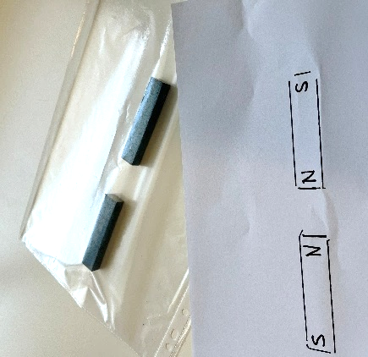
- Lift up and curl the paper to pour the iron filings back into the saltshaker.  - Move the magnets in the plastic sleeve so that the north pole of one magnet is facing the south pole of the other magnet.  Place a new piece of A4 paper on the magnets. Trace the outline of each magnet and label the ‘N’ and ‘S’ poles on each outline. | 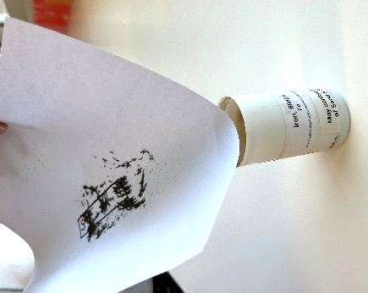
- Gently shake the iron filings over the paper, focusing on where the magnets are and the surrounding area. Gently tap the paper to spread the iron filings evenly around the magnet if necessary.  - Draw the iron filings pattern in the results table.  - Lift up and curl the paper to pour the iron filings back into the saltshaker. | 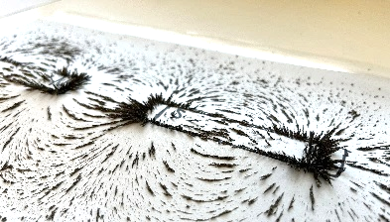

Results
Diagram of iron filings pattern
On and around two bar magnets with a north and south pole facing

On and around two bar magnets with a north and north pole facing

Discussion
            - What did this investigation show about magnetic force?
- Describe magnetic force. Use the terms “attraction”, “repulsion” and “non-contact”.

- Describe where magnetic force is strongest and weakest around magnets.

            - An iron nail experiences a force of attraction when placed near a magnet. Use argumentation to identify where around a magnet an iron nail would feel the greatest force of attraction.

Claim:

Evidence:

Reasoning:

