Forces and sport • Lesson 4 • Force and motion
Year 7
Name:

Force and motion investigation

Question
What happens to the distance the object travels if more force is applied?

Hypothesis
If the force applied to the object is increased,
then the distance the object travels will …..……………………………………………………………………………………………………………………………..
because……………………………………………………………………………………………………………………….

Equipment

- 5 N Newton meter
- Length of sewing elastic or three large elastic bands joined together
- Chair, lab stool or student desk
- Chalk

- A4 paper
- Metre ruler or tape measure
- Wooden block

Procedure
Setting up the force launcher
- Stretch the elastic between the legs of a stool, table or chair.  - Mark a chalk line from leg to leg of table/chair/stool and place the edge of a sheet of A4 paper against this line.  - Attach the 5 N Newton meter to the elastic and pull back the elastic until the marker reads a force of 1 Newtons. Mark this distance from the edge of the paper with a horizontal line and label as “1 N”.  - Repeat this process for 2 N, 3 N, 4 N and 5 N. | 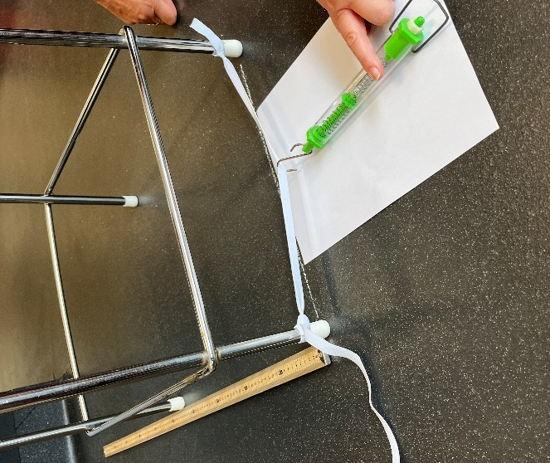
Conducting the experiment
- Place the block into the force launcher elastic and pull the block and elastic backwards so the edge of the block is lined up with the 1 N line.  - Release the block and measure the distance the block travels in centimetres, measuring from the edge of the block (that was in contact with the elastic) to the chalk line. Record this value in the results table. Repeat this process another two times.  - Repeat steps 5 and 6 for 2 N, 3 N, 4 N and 5 N of force. | 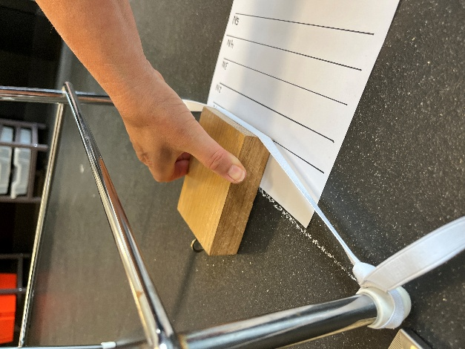

Results
Force  (N) | Distance the block travelled  (cm)
 | Trial |  |  | Average*
 | 1 | 2 | 3 | Average*
1
2
3
4
5

* Round your average to the nearest 0.5 cm so it is easier to graph.

Analysis of results
Draw a graph (label scale and title on both axes, add a graph title, plot averages, draw a line-of-best-fit).

Force (N)
0 1 2 3 4 5

Conclusion
Write a sentence to describe the relationship between the force applied and the distance an object travels.

Discussion
            - Describe the precision of your results.
Look at your repeated trials for each force level. Were the distances very similar or was there a lot of variation?

            - Analyse the pattern shown in the data.
Was there a consistent pattern as the force on the block increased? For example: Did the block always slide further when more force was applied? If the pattern changed at any point, what could have caused that?

            - Analyse the data. Were there any results that looked unusual or didn’t fit the overall pattern?
Identify any outliers in your data. Why do you think these outliers may have occurred?

            - Analyse reliability.
If you repeated the investigation on another day, would you expect to get the same results? Why or why not? Consider the changes in the surface, differences in how force was applied, and the accuracy of the measurements and equipment.

            - Describe one possible error that could have impacted your data. Identify one improvement and describe how this could reduce the impact of the error.

