Forces and sport • Lesson 3 • Simulation
Year 7-10
Year 7
Name:

Does mass affect motion?

Gathering data
Inquiry question: Is the speed of the skateboard affected by the mass on the board?  Go to the PhET Forces and motion: basics ‬computer simulation model. Click on Motion. | 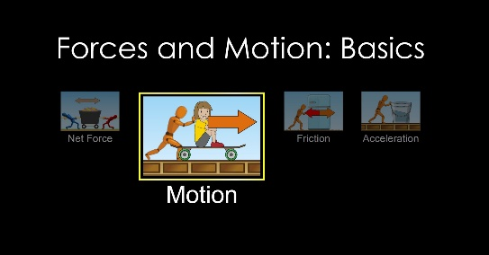
Select all the boxes at the top right of the screen. Click the pause button below this box (in the blue circle) and start the stopwatch. Add 100 N of applied force by clicking on the double arrow twice. | 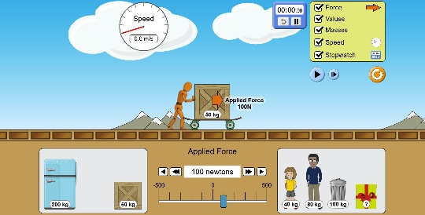
Experiment 1  Record the speed of each mass (listed in the table below) after 10 seconds.  After adding the mass being tested to the skateboard, press the play button (blue circle) to start and to pause after 10 seconds.  Record the speed in the table below. Add units to the column headings. | 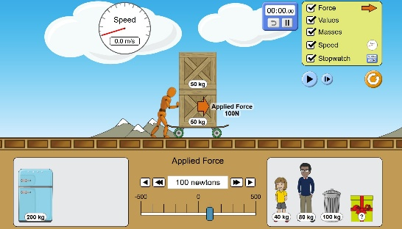

Results
Force = 100 N
Mass  (_______________) | Speed  (_______________)
50
100
150
200
250

Conclusion
Write a sentence/s describing the effect of increasing mass on motion.

Making a model
Scientists use models to explain ideas and to test predictions. There are many types of scientific models. One type of model uses patterns in data to show how different factors are related.
- In a direct relationship, as one value gets bigger (), the other value also gets bigger ().
- In an inverse relationship, as one value gets bigger (), the other value gets smaller (↓).

A scientific model
- A student’s results from the simulation at 100N of force have been graphed and shown below.

- Using the information about direct and inverse relationships above, the student looked at the graph and made a claim: The speed of the skateboard has an inverse relationship to the mass on the skateboard.
Is the student’s claim supported? Use evidence to support your decision.

- The student drew pictures to show the relationship between mass and speed. Are the diagrams a good model? Why? Why not?
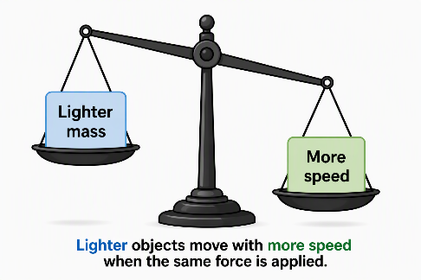
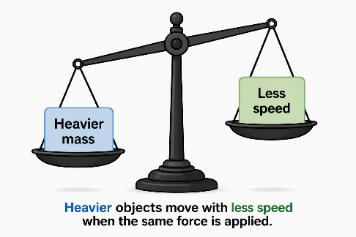

Making predictions
Use your understanding of the relationship between mass and speed to make a prediction and determine new values.
Inquiry question: Can you predict the speed of an object using the scientific model?  Experiment 2  Using the model and the data from Experiment 1, make a prediction of the speed of the 40 kg and 80 kg persons when placed on the skateboard and 100 N of force is applied. Record your prediction.  Carry out the experiment and record the results, again recording the speed after 10 seconds. | 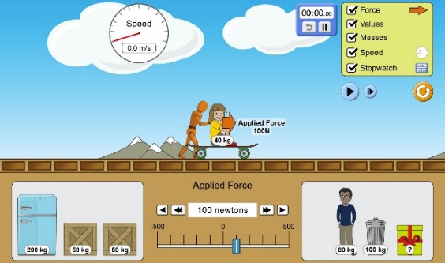

Results:
Force = 100 N
Mass  (_______________) | Predicted speed  (_______________) | Recorded speed  (_______________)
40
80

Experiment 3  What is the mass of the unknown object? Measure the speed of the object after 10 seconds using 100 N of force. Record the speed. Determine the mass of the unknown object using the data obtained from previous experiments. | 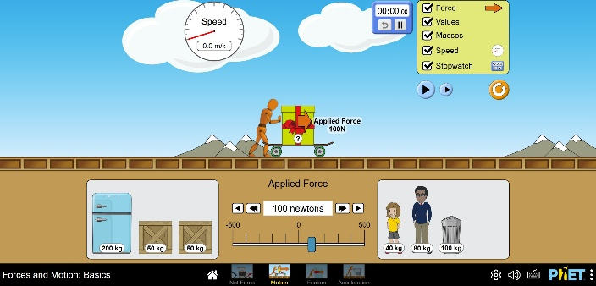
Results
Object | Recorded speed  (_______________) | What is the mass? | How did you determine this mass?
Unknown object

Answer the following questions.
- Experiment 2: Describe how a scientific model be used to make predictions.

- Experiment 3: Describe how a model can be used to determine an unknown value.

