Forces & motion • Lesson 2 • Net force simulation
Year 7-10
Year 7
Name:

Net force
Go to the PhET Forces and motion: basics ‬computer simulation model. Click on Net force. | 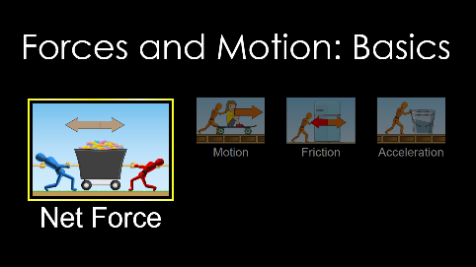
Select all the boxes at the top right of the screen. | 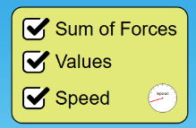
Challenge 1  Create a scenario in which the forces are balanced and the cart is not moving. Start by dragging one of the people up to the rope. You must use at least one person. Press Go! when you are ready to test your simulation.  Remember to include units in your data table below. | 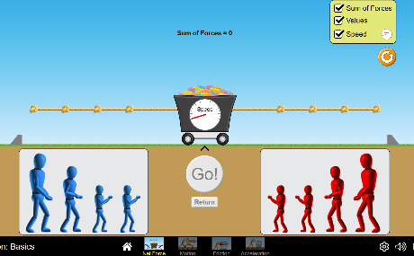

Left force = | Right force =
Net force (or sum of forces) = | Direction of net force =

Challenge 2
Press the reset button (orange circle at top right).
Create a scenario in which the forces are unbalanced. You must use at least two people. If the cart moves, observe the motion and then hit PAUSE. Remember to include units in your data table below.

Left force = | Right force =
Net force (or sum of forces) = | Direction of net force =
Draw a force diagram of the cart for Challenge 1 and 2, labelling the forces acting on the cart. You don’t need to include friction in this diagram.

In a different coloured pen/pencil, add a force arrow representing the net (or final) force to the above force diagram of the moving cart.

