Forces & sport • Lesson 2 • Investigating forces
Year 7
Name:

Forces in different directions

Question
What happens when forces act in different directions? Why?

Hypothesis
If two elastic bands are pulled in opposite directions with the same force,
then the block will …………………………………………………………………………………………………………
because……………………………………………………………………………………………………………………….

If two elastic bands are pulled in opposite directions with one elastic band being pulled with twice the amount of force as the other band,
then the block will …………………………………………………………………………………………………………...
because……………………………………………………………………………………………………………………….

Equipment

- Wooden block with a pushpin or nail inserted
- Two identical elastic bands
- Butchers paper
- Marker pens
- Scientific calculator
- 30 cm ruler

Procedure
- Place the wooden block and pin on the butchers paper. Put two elastic bands around the pin/nail. Trace around the block to show your starting position.
- One team member holds the block stationary inside the traced shape. Two other team members gently pull the elastic bands equal distance (or force) from either end of the block.
- Another team member draws accurate arrows on the butchers paper alongside each stretched band, showing the distance they are stretched. Label these arrows “Pull force left” and “Pull force right”.
- Release the bands at the same time. Draw an accurate arrow to indicate the distance the edge of the block travelled in the direction of either band. Label the arrow as “Final force”, measure and record in the results table. Repeat the experiment another two times if time allows.
- Repeat steps 1 and 2, but this time the two team members pull back the bands different distances: one pulls their band same distance as previously, the other pulls their band twice the distance as previously.
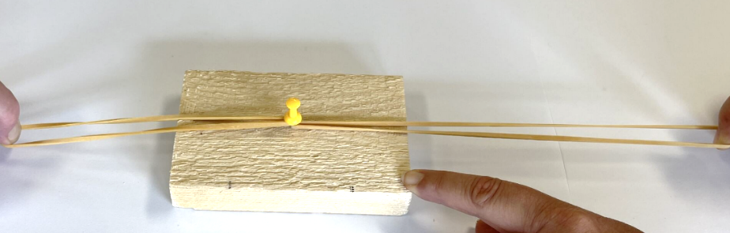

- Another team member draws accurate arrows on the butchers paper alongside each stretched band. Label these arrows “Pull force left” and “Pull force right”.
- Release the bands at the same time. Draw an accurate arrow to indicate the distance the edge of the block travelled in the direction of either band. Label the arrow as “Final force”, measure and record in the results table. Repeat the experiment another two times if time allows.

Results
Distance the block travelled
[The length of the “Final force” arrow] (cm)
Trial | Two elastic bands – equal forces in opposite directions | Two elastic bands – unequal forces in opposite directions
1
2
3
Average

Discussion
            - Draw a force diagram to show the forces acting on the block and the net or final force on the block for:
- equal but opposite forces.
- opposite forces: one force is twice the strength as the other force.

