Meiosis modelling
Year 10
Name:

Meiosis modelling
Introduction
Meiosis is a cellular replication process that produces cells with half the original number of chromosomes. Human cells have 46 chromosomes (23 pairs). Meiosis cellular replication results in four daughter gamete cells (egg or sperm) with 23 chromosomes in each (one copy of each chromosome).

Materials
8 x pipe cleaners per group (4 x colour 1, 4 x colour 2)
Masking tape
Scissors
A4 or A3 paper (to represent a cell)

Procedure
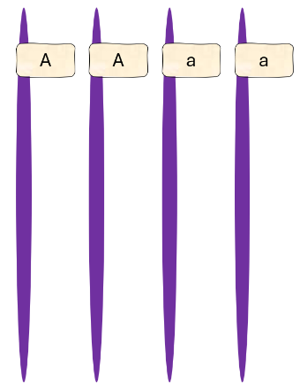
- Collect four pipe cleaners of the same colour. Each pipe cleaner represents a chromosome.
- Place a masking tape tag 2 cm from one end of each pipe cleaner. This represents the location of a gene “Apple”.
Gene “Apple” has two different types (alleles): “A” and “a”.
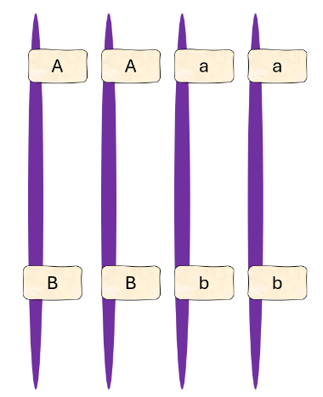
- Label two of the “Apple” gene alleles/tags “A” and the other two allele/tags “a”.
- Add new masking tape tags 5 cm from the opposite end of the same chromosomes. These tags represent the “Banana” gene.
Gene “Banana” has two different alleles: “B” and “b”.
- Label the “Banana” gene tags so that chromosomes with an “A” allele also have a “B” allele and chromosomes with an “a” allele also have a “b” allele.
You now have two pairs of homologous chromosomes. (2 x A/B, 2 x a/b)
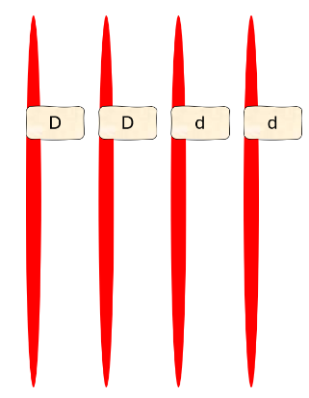
- Collect four pipe cleaners of a different colour. Each pipe cleaner represents a new chromosome.
- Place a masking tape tag 7 cm from the end of each pipe cleaner. This represents the location of a gene “Date”.
Gene “Date” has two different alleles: “D” and “d”.
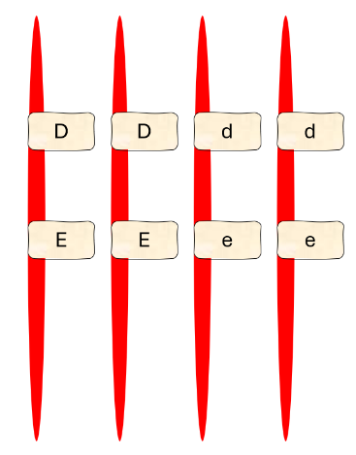
- Label two of the “Date” gene alleles/tags “D” and the other two allele/tags “d”.
- Add new masking tape tags 10 cm from the opposite end of the same chromosomes. These tags represent the “Elderberry” gene.
Gene “Elderberry” has two different alleles: “E” and “e”.
- Label the “Elderberry” gene tags so that chromosomes with an “D” allele also have a “E” allele and chromosomes with an “d” allele also have a “e” allele.
You now have two new pairs of homologous chromosomes. (2 x D/E, 2 x d/e)

To model the stages of meiosis, you will need one of each type of chromosome. Place them in the middle of the white paper “cell”.
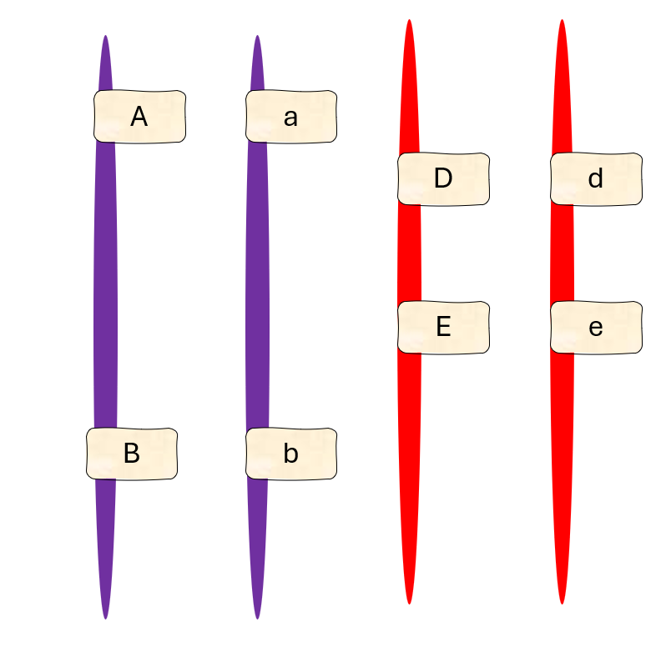

Meiosis

Follow the instructions below to demonstrate each of the stages of meiosis.

Meiosis I (First division – splitting pairs)
- Prophase I
The chromosome replicates and makes an identical copy of itself that stays attached at the centromere. Each half of the chromosome is called a sister chromatid.
- Add a matching pipe cleaner chromosome next to its partner and twist it so they are attached in the middle (the centromere). In the diagram below, label the chromosomes, alleles, sister chromatids and the centromere.
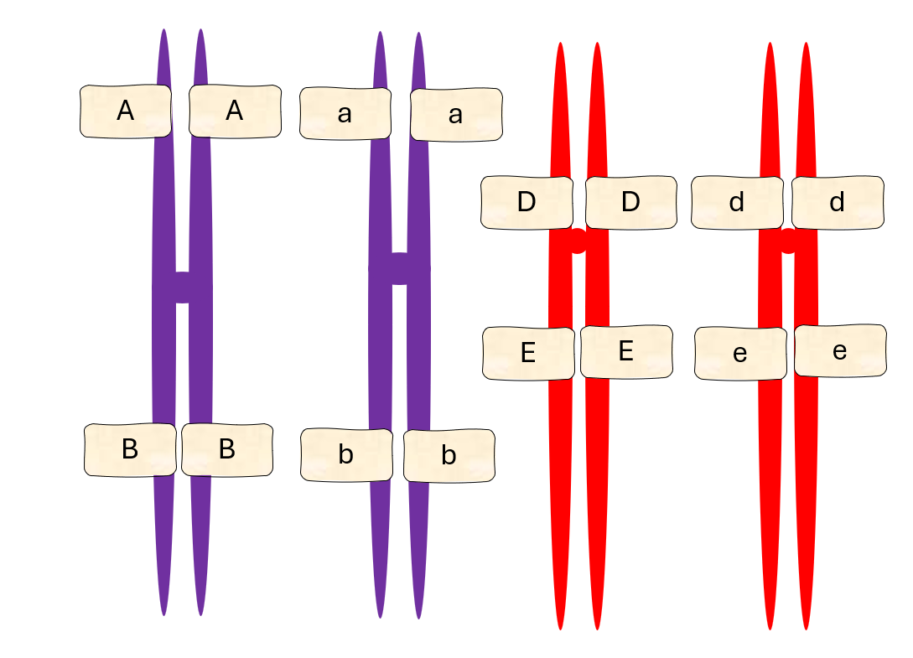
The chromosomes find their matching “colour” and align in pairs.
- Metaphase I
The pairs of chromosomes form a line down the middle of the cell. The order they line up is random (independent assortment).
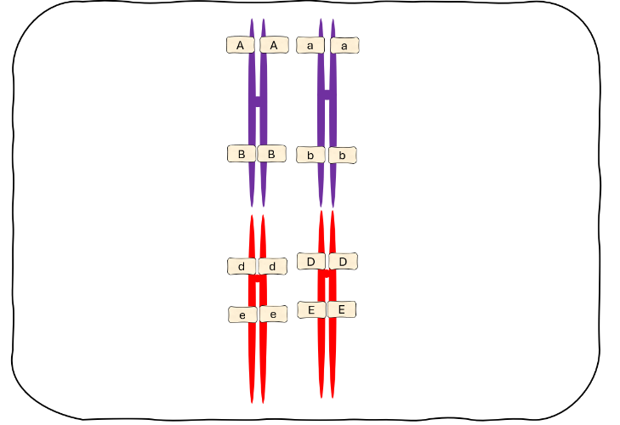
- Place the pairs of homologous chromosomes in a randomly ordered line down the middle of the white paper “cell”.

- Anaphase I
Small thread-like fibres attach to each chromosome. The homologous chromosomes move to opposite ends of the cell. The sister chromatids stay attached at the centromere.
- Move one of each homologous chromosome to each end of the cell.
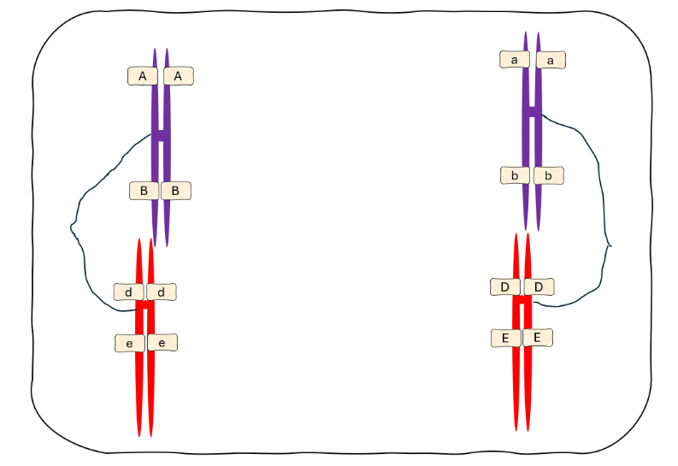
- Telophase I and Cytokinesis

The cell divides into two cells. Each cell has half the number of chromosomes.
- Rip or cut the white paper cell down the middle.

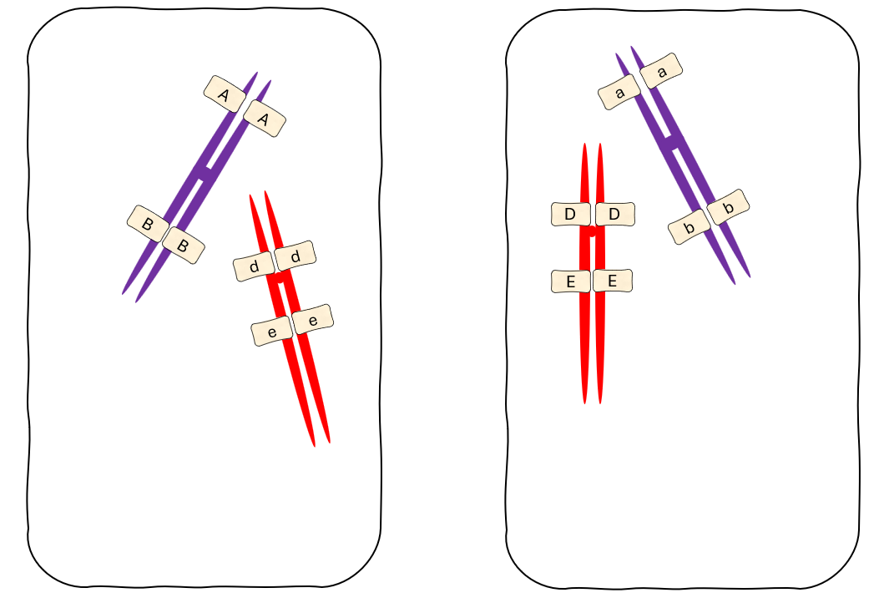

Meiosis II
- Prophase II
The chromosomes prepare to move again.
- Gather the chromosomes into the centre of each cell.

- Metaphase II
The chromosomes form a line in the middle of each cell.
- Place the chromosomes in a line down the middle of each white paper “cell”.
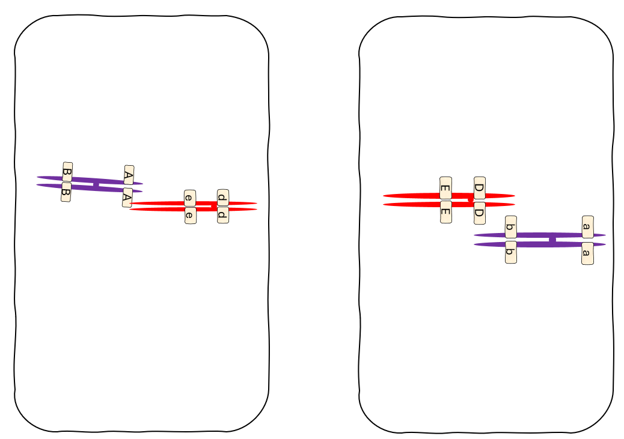
- Anaphase II
Small thread-like fibres attach to each sister chromatid. The sister chromatids separate and become individual chromosomes. Each new chromosome moves to opposite ends of the cell.
- Unwind the sister chromatids into individual chromosomes.
- Move each new chromosomes to opposite ends of the cells.
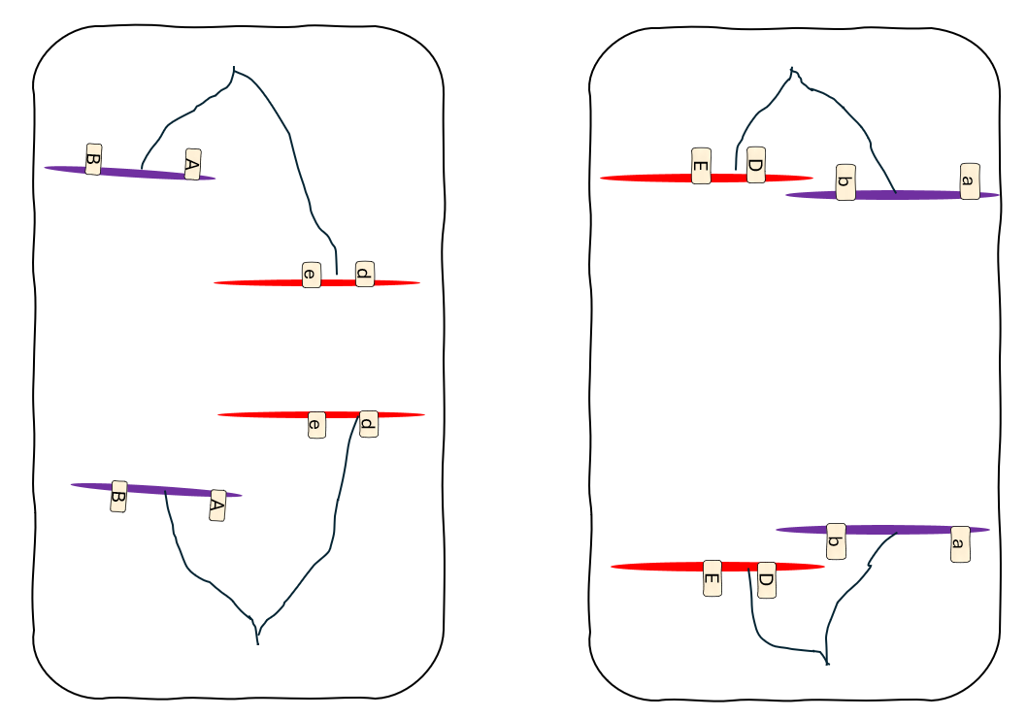
- Telophase II + Cytokinesis

A new nucleus forms around the chromosomes. Both cells divide, leaving four gamete cells that have half the number of chromosomes as the original cell.
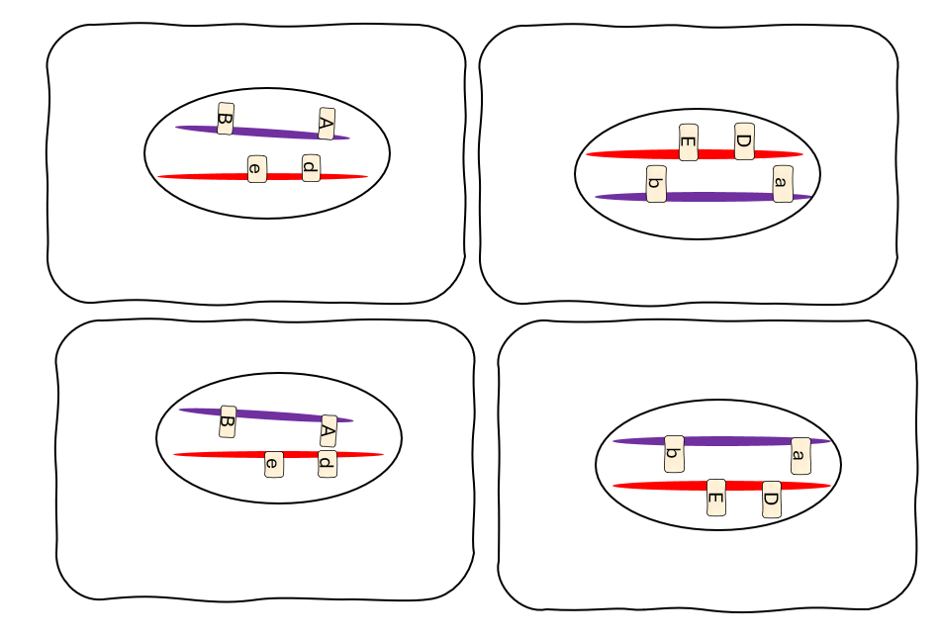

Discussion
- Explain how meiosis maintains the chromosome number across generations.
- Contrast (explain the difference between) homologous chromosomes and sister chromatids.
- Compare the similarities and differences of meiosis I and meiosis II.
- Describe what happens to the number of chromosomes during meiosis.
- Predict how errors in meiosis (such as chromosomes not separating properly) could affect offspring.
- Explain how the pipe cleaners and masking tape tags are similar to chromosomes and genes.
- Explain how the pipe cleaners and masking tape tags are different from chromosomes and genes.

