Meiosis mix-up
Year 10
Name:

Meiosis mix-up
Can you arrange each of the images below in the correct order to show the meiosis process?

A
B
A
B
a
b
a
b
e
d
e
d
E
D
E
D
A
B
A
B
a
b
a
b
e
d
e
d
E
D
E
D
A
B
A
B
a
b
a
b
e
d
e
d
E
D
E
D

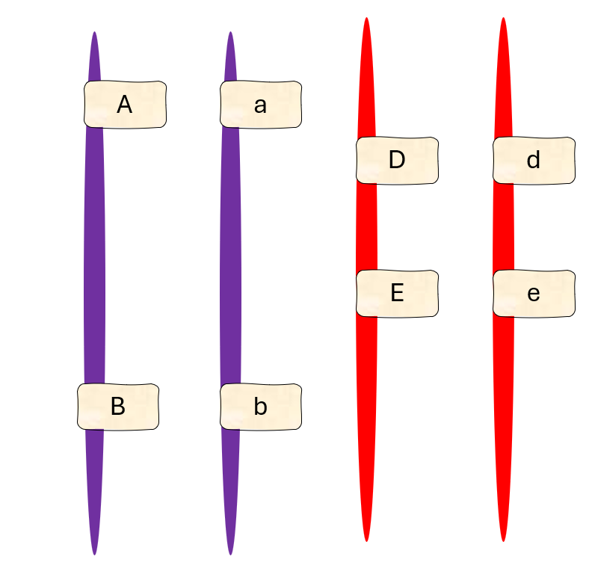
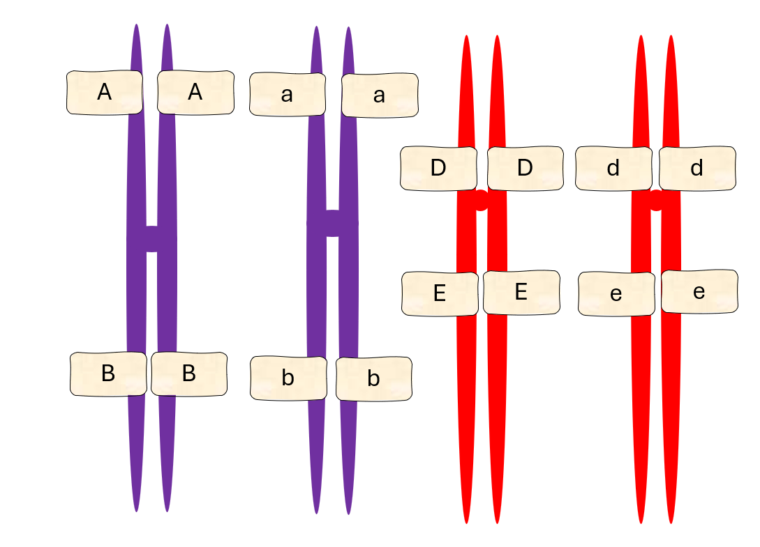
A
B
A
B
a
b
a
b
e
d
e
d
E
D
E
D
A
B
e
d
a
b
E
D
a
b
E
D
A
B
e
d
A
B
A
B
a
b
a
b
e
d
e
d
E
D
E
D
A
B
A
B
a
b
a
b
e
d
e
d
E
D
E
D
A
B
A
B
a
b
a
b
e
d
e
d
E
D
E
D
A
B
A
B
a
b
a
b
e
d
e
d
E
D
E
D

