Modelling DNA
Year 10
Name:

Constructing a DNA model
Introduction
Models or analogies can be used to help understand scientific concepts that are difficult to visualise. Models are used to explain, calculate and predict, while analogies help understand an idea or concept.
This activity uses pipe cleaners and straws to model the structure of a DNA molecule.
DNA is the molecule that carries the instructions for how living things grow, function, and reproduce. It is often called the “genetic code” of life.
The structure of DNA looks like a twisted ladder (an analogy), known as a double helix:
- The sides of the ladder are called the “DNA backbone” and are made from sugar and phosphate molecules.
- The rungs of the ladder are made from pairs of chemical DNA bases.
There are four bases in DNA:
- Adenine (A)
- Thymine (T)
- Cytosine (C)
- Guanine (G)
The DNA bases always pair in the same way:
- A pairs with T
- C pairs with G
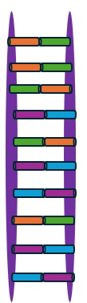
The order of these DNA bases forms a code, like letters in a message. Sections of this DNA code are called genes, and genes contain instructions to control traits such as eye colour, hair type, and many body functions.

Materials
4 x pipe cleaners
4 x paper straws (different colours)
Scissors

Procedure
- Cut the paper straws into 2 cm long sections. Each coloured straw section represents a particular DNA base.
Record the colours you will use for each base in your model DNA.

DNA base | Straw colour
Adenine (A)
Thymine (T)
Cytosine (C)
Guanine (G)

- Cut two of the pipe cleaners into 6 cm long segments. These will form the “rungs” on the DNA ladder.
- Thread matching pairs of DNA bases (adenine paired with thymine, cytosine paired with guanine) onto each pipe cleaner segment.
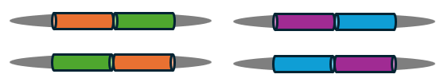
- Lay the remaining two pipe cleaners on the table in parallel, approximately 4 cm apart. This will form the sides of the DNA ladder (the sugar-phosphate backbone of the DNA).
- Place the matched pairs of DNA bases across the sides of the ladder (sugar-phosphate backbone) so that they form the rungs of the ladder. Check that they are equal distances apart from each other.
- Connect the pipe cleaner rungs (DNA bases) to the sides of the DNA ladder (sugar-phosphate backbone).
- Gently twist the sides of the DNA ladder so that it forms a double helix.

Results
Draw a labelled diagram of your DNA model.

Discussion
- Describe the strengths of this DNA model in helping people to understand DNA structure.
- Describe the limitations of using straws and pipe cleaners to represent DNA.
- Explain how models and analogies can help scientists understand complex structures like DNA.
- Explain how deleting one or more DNA bases could affect the genetic information contained in the DNA.

