Chromosomes, genes and analogies
Year 10
Name:

Making a wool analogy of a DNA chromosome
Introduction
Models or analogies can be used to help understand scientific concepts that are difficult to visualise. Models are used to explain, calculate and predict, while analogies help you understand an idea or concept by comparing it to a familiar example.
This activity uses linked wool strands as an analogy for one pair of chromosomes. Remember that each human cell actually has 23 pairs of chromosomes. You will make one pair of homologous chromosomes.
Materials
4 balls of wool in different colours, with 2 balls that are light and dark shades of the same colour
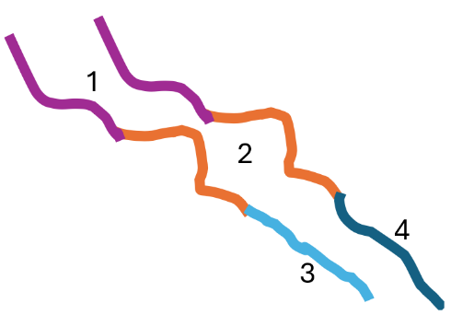
Scissors
Pencils that are the same colours as the wool
Procedure
- Cut 2 x 10-15 cm lengths of wool colour 1.
- Cut 2 x 10-15 cm lengths of wool colour 2.
- Cut 1 x 10-15 cm length of wool colour 3 (light shade).
- Cut 1 x 10-15 cm length of wool colour 4 (dark shade).
- Tie a length of colour 1 to a length of colour 2, then tie colour 3 to the other end of colour 2 to make one long strand.
- Create a second strand by tying the other length of colour 1 to the other length of colour 2, then tying colour 4 to the other end of colour 2.

The two long strands of coloured wool are an analogy for a pair of chromosomes.
Genetic structure | Wool analogy similarities | Wool analogy differences
DNA
Chromosome
Gene

