Discovering density
Year 7

Density
Density is one of the reasons an object floats on top of water or sinks to the bottom and becomes sediment. It is determined by how much “stuff” or matter is packed into a certain volume. In the picture below, both bags have the same volume. The bag on the left is denser because it contains more matter than the bag on the right.
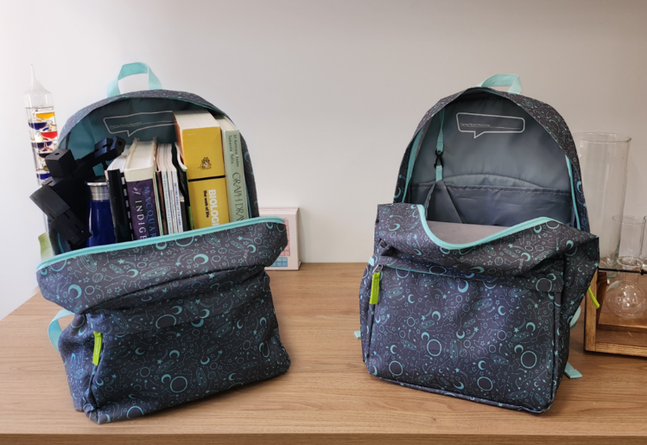
Density can be represented using diagrams where the number of dots represents the amount of matter in the same volume. The shape on the left contains more matter (the dots are closer together) in the same shape than the shape on the right.

In a tub of water, the left-hand shape (more matter in the same volume) will sink, while the right-hand shape (less matter in the same volume) will float.

Procedure
Cut out the shapes at the bottom of the page.
Use the density of each shape (how close the matter dots are) to determine if they would float or sink in the water tank drawn below. Paste each shape in the appropriate location (floating or sinking) in the water tank.
Draw your own shape (e.g. a rock) and use dots to represent the amount of matter in the shape.
Identify if your shape will sink or float in the water below.

Water tank

Discussion
- Identify what the dots in the diagrams represent.
- Explain why the two school bags have different densities even though they are the same size.
- If you squeezed the same amount of material into a smaller space, what would happen to its density?
- Use density to explain the following:
  - why oil floats on top of water.
  - why sand sinks.
- Explain how increasing the temperature of an object might affect its density.

 | 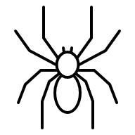 | 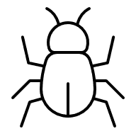 | 