
Y10

Tectonic collision course • Lesson 1 • Quake detectives
Lesson 1
Launch
To read the most recent version of this lesson, download associated resources, and view embedded professional learning including classroom videos and work samples, visit: https://scienceconnections.edu.au/teaching-sequences/year-8/tectonic-collision-course/lesson-1-quake-detectives

Lesson overview
Students use an empathy map to explore people’s experiences of earthquakes and map the frequency of earthquakes around the Ring of Fire. They then compare this to the limited number of earthquakes experienced in Australia.

Key learning goals
Students will:
- empathise with people experiencing earthquakes.
- use digital platforms to identify historical earthquake data.
- identify the relative frequencies of earthquakes in Australia.
Students will represent their understanding as they:
- empathise with people experiencing an earthquake.
- describe the impact of earthquakes.
- identify the frequency of earthquakes in the Ring of Fire.
- identify the decreased frequency of earthquakes in Australia.

Assessment advice
In the Launch phase, assessment is diagnostic.
Take note of:
- do students identify that earthquakes occur in Australia?
- can students make a claim backed by evidence and reasoning?
- how much do students know about tectonic plates and their boundaries?

List of materials
Whole class
- Tectonic collision course Resource PowerPoint
- Access to internet for ARGIS and Geoscience Australia
- Access to video clips of people experiencing earthquakes, for example:
  - Earthquake hits NSW’s Hunter Valley | 9 News Australia (3:34 min)
  - See the global impact of the sixth-largest earthquake ever (4:16 min)
  - If earthquakes have recently been experienced nearby, substitute with local videos.
Each group
- Sticky notes
- A3 or butcher paper
- Pens or pencils
Each student
- Individual science notebook

Lesson routine | Estimated time | Task type
Experience and empathise | 15 minutes | Whole class/Small group
Anchor and Elicit | 30 minutes | Whole class/Small group
Launch and Connect | 15 minutes | Whole class/Small group

Launch

Experience and empathise • Earthquake empathy
Pose the question: Has anyone ever experienced an earthquake?
Explore what happened to any affected students and what they felt as a result of their experience.
Pose the question: What would happen if we had an earthquake here today?
(Slide 3) Discuss how the Earth can move up and down or side to side in an Earthquake. Divide the students into smaller groups and ask them to write a series of predictions answering the questions: During an earthquake, what would happen to...
- ...the classroom (the shelves, chairs, tables, lights)?
- ...the school grounds/sports courts?
- ...the electricity and water supply?
- ...the roads?
- ...the shops and supermarkets.?
✎ STUDENT NOTES: Students write predictions for what would happen in each of the situations mentioned.
(Slide 4) Provide groups of students with a large piece of butcher’s paper, separated into quadrants.
✎ STUDENT NOTES: Students label each quadrant ‘Say’, ‘Do’, ‘Think’ and ‘Feel’ and add how people would react during an earthquake.
Watch the below videos (or substitute with local ones) showing the impact of earthquakes. Encourage students to watch what people say or do as an indication of what they are thinking and feeling.
- Earthquake hits NSW’s Hunter Valley | 9 News Australia (3:34 min)
- See the global impact of the sixth-largest earthquake ever (4:16 min)
Pose the question: Where do most earthquakes occur?

Anchor and Elicit • Mapping earthquakes
Show students the World Latitude and Longitude Grids in the ARCGIS map viewer.
(Slide 5) Bring Australia into the centre of the screen by clicking and dragging on the map. This allows the Pacific Ocean to be seen clearly.
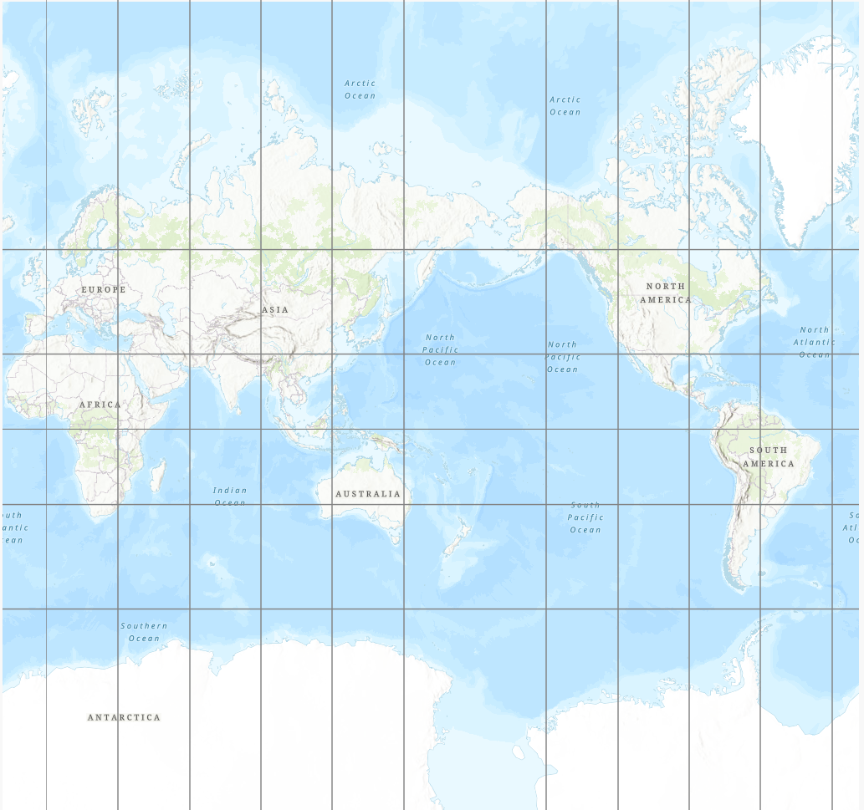
In the Layers menu in the sidepane, select ‘Add’ and then search ‘Earthquakes’. The feature layer ‘Recent Earthquakes’ should be visible in the results.
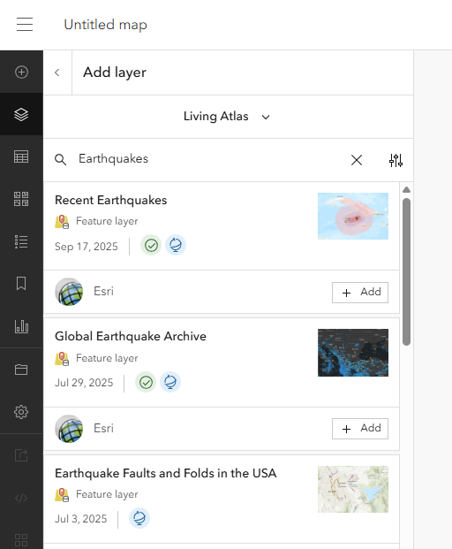
Select ‘+ Add’ to add ‘Recent Earthquakes’ as a layer to the world map. This shows all earthquakes that have been recorded in the past 30 days (or 90 days in the case of a highly significant earthquake).
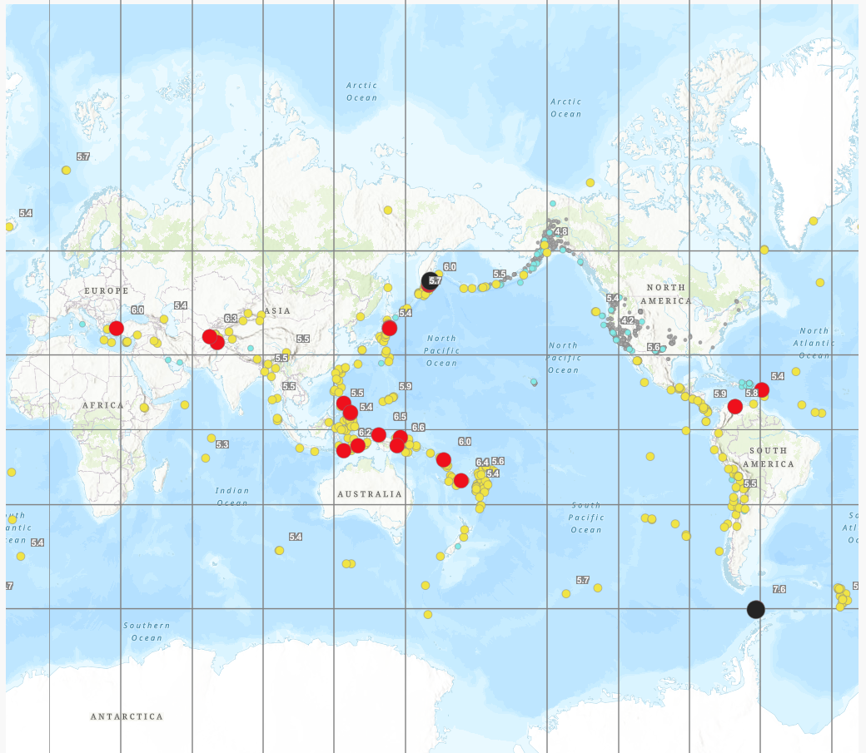
(Slide 6) Discuss how argumentation is a way to describe what students notice in order to make a claim. This claim needs to be supported using evidence from the map and reasoning that links the claim to the evidence.
✎ STUDENT NOTES: Use the plotted earthquake data on the map to write a claim about where earthquakes are most likely to occur.
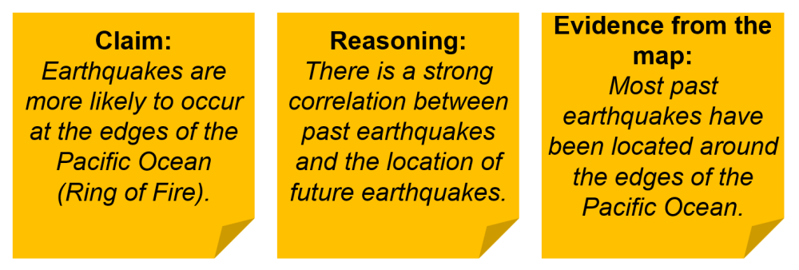:
(Slide 7) Once students have made a claim, draw students’ attention to the Ring of Fire around the Pacific Ocean as a frequent location of earthquakes.
Discuss how many of the earthquakes shown on the map are located in the Ring of Fire, a horseshoe-shaped zone around the Pacific Ocean that is known for frequent earthquakes and volcanic eruptions. It contains about 75% of the world’s active volcanoes and 90% of its earthquakes.
Discuss how this historical evidence of earthquakes indicates a correlation between earthquakes and the Ring of Fire, but does not show that the Ring of Fire causes earthquakes. They will learn the cause of earthquakes in the next few lessons.

Connect • Earthquakes in Australia
(Slide 8) Pose the questions: Is Australia in the Ring of Fire? Does that mean we don’t have to worry about earthquakes?
(Slide 9) Invite students to go to the Geoscience Australia monitoring website and select Recent Earthquakes > 30 days (in the top right menu) to view recent earthquakes in Australia. Many of these earthquakes would not have been visible in the ARCGIS map as their magnitude is too low.
(Slide 10) Discuss the locations of the most recent earthquakes in Australia over the last 30 days.
Potential discussion prompts
- Have earthquakes ever occurred near where we live? How might that influence our understanding of risk?
- If an earthquake happened here, what parts of our town (or school) do you think would be most affected?
- Why do people often think “Australia doesn’t get earthquakes”? What misconceptions exist?
- If you were in charge of planning for natural hazards in your state, how important would earthquakes be on your priority list?
Explain that over the next few lessons, students will explore the science behind earthquakes and how geophysicists use scientific modelling and technology to understand what is happening below the surface of the Earth.
Discuss how geologists around the world share data on earthquakes and volcanoes in the hope that one day they might be able to predict the locations and strength of an earthquake.

Reflect on the lesson
You might invite students to:
- identify the last earthquake that was in your state.
- write down three things they thought they knew about earthquakes, two things that they learned today, and one question that they still have about earthquakes.
- research what people in earthquake-prone areas are taught to do in the event of an earthquake.

Y10

Tectonic collision course • Lesson 2 • Quakes and plates
Lesson 2
Inquire
To read the most recent version of this lesson, download associated resources, and view embedded professional learning including classroom videos and work samples, visit: https://scienceconnections.edu.au/teaching-sequences/year-8/tectonic-collision-course/lesson-2-quakes-plates

Lesson overview
Students investigate the evidence that supports the linking of land masses to form Gondwana. They examine the development of the theory of plate tectonics and how scientists’ ideas may change as new evidence becomes available.

Key learning goals
Students will:
- identify the cause of earthquakes as tectonic plate movement.
- identify evidence that supports the movement of tectonic plates.
- examine the development of the theory of plate tectonics.
- understand that the Earth consists of different layers.
- explain how new evidence or different perspectives can lead to changes in scientific knowledge.
Students will represent their understanding as they:
- compare geological evidence and biological evidence of tectonic plate movement.
- develop a timeline of the development of scientific theories.
- describe how new evidence can lead to changes in science knowledge.

Assessment advice
In this lesson, assessment is formative.
Feedback might focus on students’ ability to:
- describe how tectonic plates have moved over time.
- identify evidence that supports the movement of tectonic plates.
- identify the different layers of the Earth.
- explain how new evidence or different perspectives can lead to changes in scientific knowledge.
Potential summative assessment
Students working at standard should:
- examine the evidence that led to the acceptance of the theory of plate tectonics over the idea of continental drift.
- develop investigable questions to explore scientific models, such as: How do the shapes of the continents support the theory of plate tectonics?

List of materials
Whole class
- Tectonic collision course Resource PowerPoint
Each student
- Individual student notebook
- Gondwana fossil Resource sheet or Gondwana geoscience Resource sheet
- Cracking the code of moving plates Resource sheet printed on A3 paper
- Scissors

Lesson routine | Estimated time | Task type
Re-orient | 5 minutes | Whole class
Question | 5 minutes | Whole class
Investigate | 10 minutes | Individual
Integrate | 15 minutes | Whole class/Individual
Investigate | 15 minutes | Small group/Individual
Integrate | 10 minutes | Whole class/Small group

Inquire

Re-orient
Pose the question: Did we have an earthquake in Australia yesterday?
Discuss the likelihood of earthquakes in Australia.
If required, refer to the Geoscience Australia earthquake monitoring website and select Recent Earthquakes > 30 days.

Question • The Earth moves
Pose the question: How far/much does the Earth move during an earthquake?
Discuss how it can be hard to tell exactly how far the Earth moves during a single earthquake. Most scientists study earth movements over a much long time period.
(Slide 12) Pose the question: How do scientists study how the Earth moves over time?

Investigate • Gondwana
(Slide 13) Divide the students into teams of biologists and geologists and provide each student with either the Gondwana fossil Resource sheet or the Gondwana geoscience Resource sheet. Encourage each student to cut out the different continents and fit them together so that the common elements match across the different continents.
Allow students time to rearrange their puzzles so that the continents are joined.

Integrate • Making continental connections
(Slide 14) Compare the similarities of the conclusions reached from the two forms of evidence. Discuss how different scientists collaborate and compare results as part of peer review processes.
Potential discussion prompts
- What do these two sets of data suggest about the land masses in the southern hemisphere?
- What does it mean for scientists to collaborate?
- How might scientists from different countries work together on the same research?
- Why is it helpful when scientists with different skills or backgrounds work together?
- Why do scientists compare their results with other scientists’ findings?
- Do you think peer review always makes science perfect? Why or why not?
- Can you think of a time when feedback from others improved your own work (school, sports, music, etc.)?
- How does collaboration and peer review help the public trust scientific information?
- Should scientists always agree with each other? Why is disagreement sometimes useful?
Explain how these continents were once joined together to form one large land mass called Gondwana.
Potential discussion prompts
- How long do you think it took for the land masses to move to their current positions?
- Do you think that the tectonic plates are still moving? Why or why not?
- How fast do you think Australia is moving?
- What direction is Australia moving?
✎ STUDENT NOTES: Paste the connected tectonic plates into their notebook and describe how the continents were once linked together as Gondwanaland.
(Slide 15) Introduce the idea that these jigsaw models are informational or educational models that help to explain the idea of a large land mass that shifts across the Earth’s surface. All models have limitations. Explain how one limitation of this model is that the visible land masses sit on larger tectonic plates that move over millions of years. It can be difficult to determine exactly when all these land masses were joined or separated.
Potential discussion prompts
- How can we locate the edges of the tectonic plates?
  - The edges of tectonic plates are marked by clusters of earthquakes, deep-sea ocean ridges, and mountain ranges.
- What do you think makes the tectonic plates move?
- Is the layer under the tectonic plates liquid or solid?
  - Solid, but can still move.
- Is it possible for something to look solid, but still move?
  - Yes. Tar can appear solid, but it can still slide down a hill. Glaciers look like solid snow and ice, but slowly flow and move over months.
- How quickly do these continents move?
  - Each plate moves at a different speed. The plate that contains Australia travels at 7 cm/year.
(Slide 16) ✎ STUDENT NOTES: Define tectonic plates: Large rigid plates on the outer crust layer of the Earth called the lithosphere. These tectonic plates move over a partially molten (but still solid) inner layer called the asthenosphere.
(Slide 17) Explain that scientists have identified that earthquake waves travel at different speeds through the centre of the Earth. This suggests that the Earth is made up of different layers, which affects how the waves move. Discuss how jelly moves (wobbles) differently when tapped than water or more solid objects.
✎ STUDENT NOTES: Draw the different layers of the Earth.
Discuss how earthquakes are generated when the tectonic plates that form the lithosphere move against each other. This sends earthquake waves (P waves and S waves) through the Earth. This will be discussed in more detail in Lesson 4.

Investigate • Developing theories
Text Pose the question: How did scientists develop tectonic plate theory?
Discuss how scientists collaborate and work together to build on each other’s ideas and research.
(Slide 18) Provide students with a copy of Cracking the code of moving plates Resource sheet. Discuss the key events embedded on the current timeline, including how the continents were once joined into large land masses.
Explain how there are key elements missing on the timeline:
- Orange events relate to the study of how tectonic plates move.
- Red events relate to the development of the structure of the Earth, including the mantle and core.
Allocate each group of students to cut out a set of timeline events (either orange or red events). Invite students to predict the order in which the historical events occurred that led to the development of the tectonic plate theory. These events should then be placed in the appropriate place in the timeline.
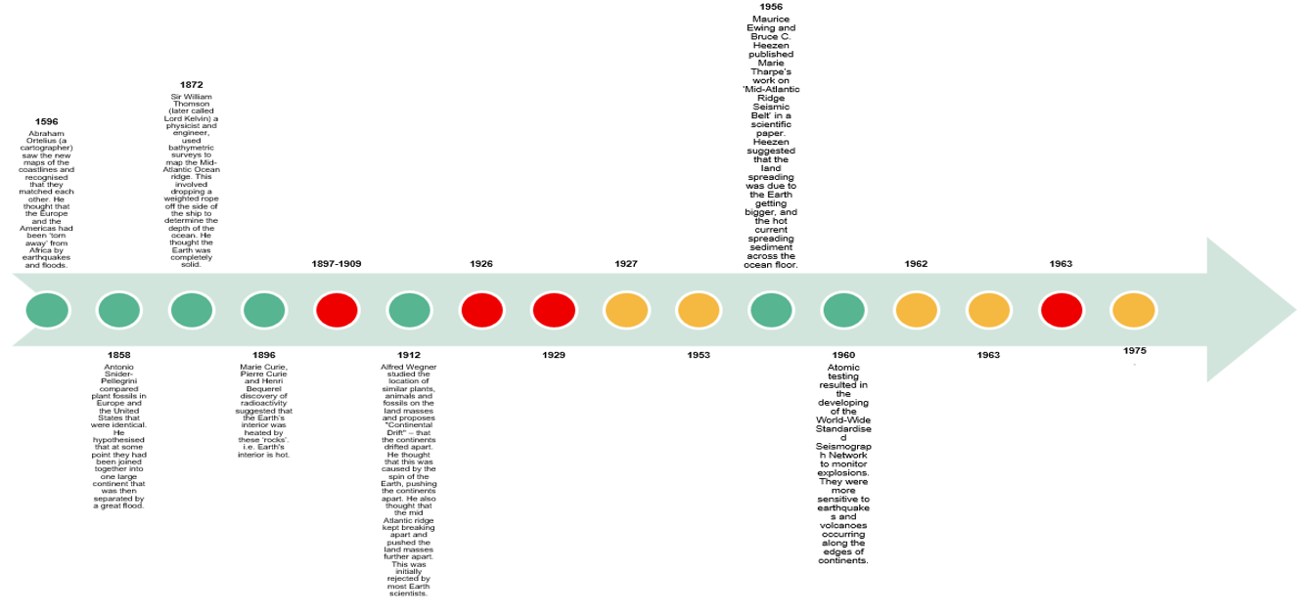

Integrate • Standing on the shoulders of giants
(Slide 18 animation) Encourage students to compare the order of their timelines and to discuss how they made their decision. This models how scientists discuss new findings and make decisions based on evidence.
✎ STUDENT NOTES: Paste the completed timeline in the notebook.
(Slide 19) Discuss how the timeline can make scientific discoveries seem linear. While many scientists often build on the ideas of others, some of these events occur simultaneously. Some scientists can also have different opinions and need different levels of evidence before they agree.
Potential discussion prompts
- Do you think scientists always know the “next step” in a discovery? Why or why not?
- What does it mean when scientists “build on the ideas of others”?
- Who should get credit for an idea or theory? (Should there be any consequences for Ezing and Heezen for publishing Marie Tharp’s theory?)
- How can one scientist’s work help another scientist fill in a missing gap?
- Why might two scientists look at the same evidence but reach different conclusions?
- How can scientists’ backgrounds, experiences, or fields affect their opinions?
- Is disagreement a bad thing in science? Why or why not?
- Why might one scientist need more evidence than another before agreeing with an idea?
- How does new evidence sometimes change what scientists think?
(Slide 20) Read the quote by Sir Mark Oliphant at the 1981 formal opening of the Australian Academy of Science’s Expanding Earth symposium.
I must admit that I am a rebel, attracted by the boldly unorthodox, and that I have a sneaking wish that the pundits of the present-day accepted cosmology be proven at least partially wrong. I remember in the 1920s, as a student in Adelaide, hearing a debate between Sir Douglas Mawson, Professor of Geology, and Wood-Jones, the Professor of Anatomy, concerning Wegener’s ideas of continental drift. Wood-Jones wanted it to be true, for it helped explain the distribution of animals, plants, and their fossil remains. Mawson, the celebrated geological expert, thought it an absurd idea that rigid rocks could flow in that strange manner.
Carey, S. Warren & Australian Academy of Science & Geological Society of Australia & University of Tasmania. Department of Geology. (1981). The Expanding earth, a symposium: Earth Resources Foundation, University of Sydney, February 10-14, 1981. Hobart: University of Tasmania
This symposium was examining why the tectonic plates moved. At the time, scientists thought that was due to the Earth expanding and becoming larger.
(Slide 21) Ask students to compare the two claims provided by scientists (one from 1981 and one from 2011).
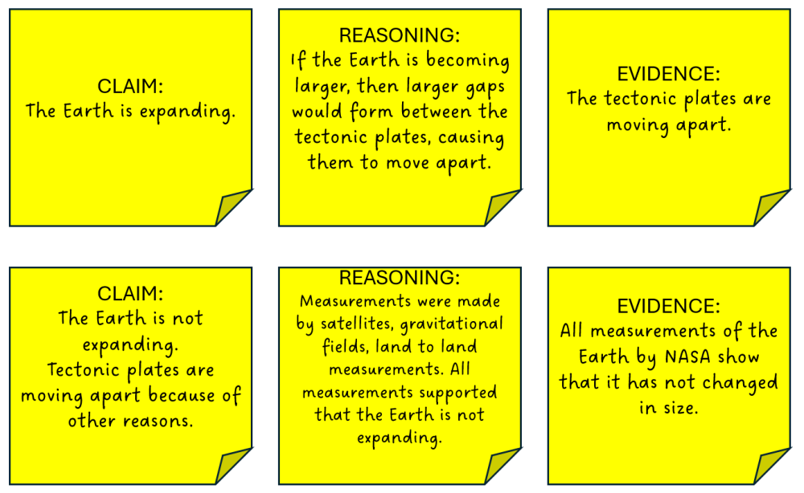
Discuss the importance of testing the link between claims, evidence, and reasoning.
The statement in the first claim may correctly describe an observation or pattern in the evidence. For example, the evidence might show that land masses seem to be moving apart. That observation itself may be accurate. However, simply observing that something is moving or spreading does not automatically support that the Earth is expanding.
The first claim is an attempt to explain the evidence. In science, this type of explanation is called a hypothesis: a possible explanation that can be tested. A hypothesis is not the same as proof. It is one way of making sense of the available evidence, but there may be other explanations that fit the same evidence equally well or better.
In this case, even if the evidence shows separation or movement, that alone does not support that the Earth is expanding. Additional evidence would be needed to specifically support expansion over other explanations. Helping students see this distinction strengthens their understanding of how scientific reasoning works—that explanations must be supported by strong, specific evidence, not just by observations that seem to fit.
✎ STUDENT NOTES: Write an example of how ideas in science have changed from the expanding Earth theory to the theory of plate tectonics over time.
Explain that the next lesson will examine how and why the tectonic plates move.

Reflect on the lesson
You might invite students to:
- cut out the tectonic plates on the Geoscience Australia tectonic plates jigsaw puzzle and put them together, modelling how the tectonic plates are moving.
- research how Gondwana (southern hemisphere land mass) and Laurasia (northern hemisphere land mass) were once combined to form one land mass called Pangea.
- identify one area of science where scientists are still working to identify key elements of a theory.
- research what a geoscientist does by watching the videos 2026 Dorothy Hill Medal award winner Dr Caroline Eakin, or A chat with a geoscientist - Everyday jobs.

Y10

Tectonic collision course • Lesson 3 • Forces beneath our feet
Lesson 3
Inquire
To read the most recent version of this lesson, download associated resources, and view embedded professional learning including classroom videos and work samples, visit: https://scienceconnections.edu.au/teaching-sequences/year-8/tectonic-collision-course/lesson-3-forces-beneath-our-feet

Lesson overview
Students model how convection, slab pull, and ridge push cause the movement of tectonic plates. They examine the types of boundaries and how different models (graphs or 3D) can be used for different purposes.

Key learning goals
Students will:
- examine the forces that act on tectonic plates including convection, slab pull and ocean ridge push.
- use data to graphically model a subduction boundary.
- identify different boundaries using the 3D map in the Geoscience Australia Portal.
- compare graphical and 3D models of tectonic plate boundaries.
Students will represent their understanding as they:
- draw their observations of a model of convection on a crust.
- use the TRAAP method to identify the appropriateness of geoscience data.
- graph the longitude vs depth of historic earthquakes at a subduction boundary.
- compare the advantages and disadvantages of different representations (graphs vs 3D).
- explain what the subduction boundary graph represents.

Assessment advice
In this lesson, assessment is formative.
Feedback might focus on students’ ability to:
- use data to generate a mathematical model of a tectonic boundary.
- describe a subduction boundary, a convergent boundary, a divergent boundary, and a transforming boundary.
- identify the forces involved in tectonic plate movement, including slab pull, ridge push, and convection.
Potential summative task
Students working at the achievement standard should:
- model interactions at plate boundaries.
- investigate the relative significance of different forces involved in tectonic plate movement, including slab pull, ridge push and convection.
- use visual displays of large data sets to identify temporal and spatial relationships.
- constructing graphs using correct conventions, such as naming the graph and labelling the axes.
- evaluate the quality of evidence of primary and secondary sources used when constructing an argument to support a conclusion or claim.
- examine the strengths and limitations of representations such as physical models, diagrams, and virtual simulations, and selecting the most appropriate

List of materials
Whole class
- Tectonic collision course Resource PowerPoint
- Hotplate
- Saucepan
- Milk
- Milo powder (Milo produces a thick layer on the surface of the milk, better than other powdered products)
- Spoon
- Video: The science behind earthquakes explained (5:20)
- Access to the Geoscience Australia Portal 3D map
Each student
- Individual science notebook
- Access to spreadsheet software (e.g. Microsoft Excel)
- Access to the Geoscience Australia Portal 3D map
- Indo-Australian earthquake Data resource

Lesson routine | Estimated time | Task type
Re-orient | 2 minutes | Whole class
Question | 2 minutes | Whole class
Investigate | 10 minutes | Whole class
Integrate | 10 minutes | Whole class
Question | 7 minutes | Whole class
Investigate | 10 minutes | Whole class/Individual
Integrate | 20 minutes | Whole class

Inquire

Re-orient
Recall the previous lesson focusing on how the tectonic plates have moved over time.
Discuss how Australia used to be joined to Antarctica, and was part of the larger land mass Gondwana (containing South America, Africa, Madagascar, India, Antarctica, and Australia).

Question • Moving mountains
Discuss how the tectonic plates sit on top of the solid, but flowing, mantle/asthenosphere.
Pose the question: Why do the tectonic plates move?

Investigate • Demonstrating convection
(Slide 23) As a class demonstration, model the convection of the Earth’s layers by following the below steps.
- Add milk to the saucepan so that it is half to three-quarters full. Discuss how this represents the flowing mantle. Note the limitation of this model: the mantle is actually a solid that can flow, not a liquid like milk.
- Place the saucepan on the hotplate.
- Carefully spoon Milo onto the surface of the milk to create a thick layer (at least 1 cm thick). Discuss how this represents the lithosphere layer, similar to the tectonic plates.
- Turn on the hotplate so that the milk will eventually simmer (not boil).
- Observe what happens to the Milo layer as the milk heats up.
The Milo layer will start to crack into ‘tectonic plates’. Careful observation will allow students to identify Milo plates moving apart (diverging), crashing into one another (converging), moving under one another (subducting), moving alongside each other (transforming), and even hot-spots (volcanic islands).
Draw students’ attention to isolated ‘volcano’ hot-spots where the hot milk is bubbling up through thin layers of the surface Milo. Compare this to the volcanoes that built the islands in Hawaii and the Galapagos Islands.

Integrate • Tectonic boundaries
(Slide 23 animation) Discuss how the milk is heated at the base of the saucepan by the hotplate, similar to the more liquid mantle in the centre of the Earth. Heated milk particles have more energy and are less dense. This makes them come to the top (convection) and cause cracks in the Milo.
(Slide 24) ✎ STUDENT NOTES: Draw a picture of the convection of heated milk with arrows showing the direction of energy flow. Define convection as the transfer of heat through the physical movement of a fluid caused by density differences. This means hotter, less dense material rises, while cooler, more dense material sinks.
(Slide 25) Discuss the four features of tectonic plate movement: convergence, divergence, subduction, and hot-spots. See the embedded professional learning Tectonic plate features below for more information.
Potential discussion prompts
- How does the heat in the centre of the Earth affect the surface of the Earth?
- What can happen when two tectonic plates move toward each other?
- How can convergent boundaries cause mountains or earthquakes?
- What happens when plates move away from each other?
- Where on Earth are divergent boundaries commonly found?
- What is subduction, and how is it different from general convergence?
- Why does one plate sink under another at a subduction zone?
- What natural events (volcanoes, earthquakes, trenches) are common near subduction zones?
- What is a hot-spot, and how is it different from a plate boundary?
- How are convergence and divergence opposites?
- Which of the four features do you think causes the most dramatic changes to Earth’s surface? Why?
- How does tectonic plate movement help explain earthquakes and volcanoes around the world?
- Why is it important for people living near plate boundaries or hot-spots to understand these processes?
✎ STUDENT NOTES: (Slides 26-27) Define the different types of boundaries found at the edges of tectonic plates. Draw a picture to illustrate each boundary.
Pose the question: Do tectonic plates move as fast as our Milo model?
Discuss how tectonic plates move only millimetres or centimetres each year in the real world. Australia moves 7 cm towards Indonesia each year. Calculate how far this movement has been so far in a student’s lifetime (14 x 7 cm = 98 cm). Compare this to First Nations Peoples, who have seen Australia move 4.5 km in the 65,000 years they have inhabited this land.

Question • Australian boundaries
Show the video The science behind earthquakes explained (5:20).
✎ STUDENT NOTES: Describe how earthquakes are measured using the moment magnitude scale.
Discuss how Australia is at the centre of the Indo-Australian plate.
Potential discussion prompts
- What does it mean for Australia to be near the centre of a tectonic plate?
- How does being in the middle of a plate affect how often Australia experiences earthquakes or volcanoes?
- Is the Indo-Australian Plate still moving even though Australia is not near a boundary?
- How might life be different in a country located on a plate boundary compared to Australia?
Pose the question: How can we tell what type of boundary is at the edges of the Indo-Australian plate?

Investigate • Using data
Explain that scientists can use data about the depth of earthquakes to provide a picture of a boundary.
Provide students with the Indo-Australian earthquake Data resource, which contains earthquake data from the boundary north of New Zealand. Explain this data came from the Geoscience Australia Portal, and, as a class, use the TRAAP method to evaluate its usefulness as a source.
Divide groups of students according to their abilities and select the appropriate data tabs from the Indo-Australian earthquake Data resource.
Adapt the data
There are four sets of data provided as part of this activity.
- Group A: Five years of earthquake data including location, latitude, longitude, magnitude, depth, date/time, and data source.
- Group B: Five years of earthquake data that includes only location, longitude and depth.
- Group C: 21 data points (location, longitude and depth) that provide a simplified image when graphed
- Group D: 21 data points (location, longitude and depth) with a pre-drawn graph showing the longitude and depth (m) of earthquakes north of New Zealand.
The tab Colourised graph contains five years of earthquake data graphed with colourised data points to reflect the depth of the earthquakes. This can be used to demonstrate the colours used in the Geoscience Australia 3D images.
Discuss how the depth of each earthquake is measured by elevation above sea level. A negative elevation suggests that the earthquakes are occurring below the Earth’s surface. The larger the negative number, the deeper under the Earth.
(Slide 29) Guide the students through the process of creating a chart:
- Select/highlight the ‘Longitude’ and ‘Elevation’ columns in the table.
- Select ‘Insert’ and then ‘Scatter graph’ in the ‘Charts’ section of the top ribbon of the Excel spreadsheet.
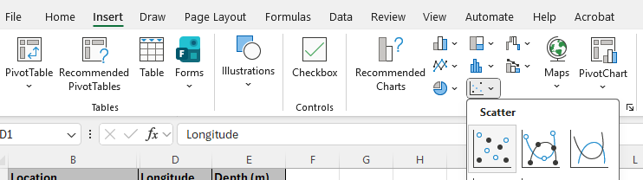
- Select ‘Chart design’ in the top ribbon and then ‘Add chart element’ to add a title for the graph and axis labels.
- If the numbers on the axis need to be moved (they may appear at the top of the chart rather than the bottom), double click on the numbers and then select ‘Axis options’ > the graph symbol > ‘Labels’ to change the label position.
✎ STUDENT NOTES: Paste the graph into your notebook.

Integrate • Mathematical models
(Slide 30) Discuss how the graph shows the places the two plates are moving against each other.
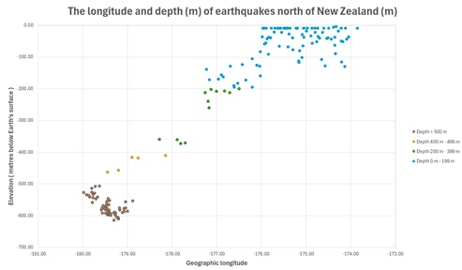
NOTE: The line of earthquakes is an indication of the two boundaries rubbing against each other. The right-hand plate is moving underneath the left-hand plate.
Potential discussion prompts
- What does the y-axis (vertical axis) show?
  - The depth below Earth’s surface.
- Where is the sea level on the graph?
  - 0 m elevation. If required, have students draw the Earth’s surface at 0 metres to emphasise that everything is happening below their feet.
- What do you notice about the shape of the graph?
  - The graph shows that one plate (Pacific plate) is moving/subducting under the Indo-Australian plate.
- Which plate is moving downwards?
  - The Pacific plate is moving downwards.
- What type of tectonic boundary is this?
  - Subduction.
Discuss how deep the subducting plate is located and how gravitational force can pull on the end of this plate in a process called slab pull. Emphasise that this is occurring at the same rate as fingernails grow.
Potential discussion prompts
- What do you think happens to the plate that is ‘hanging down’?
  - It keeps being pulled down and can break off and become part of the mantle.
- What effect do you think this pull at the end of the tectonic slab has an effect on the rest of the plate?
  - It can provide a pull force on the whole tectonic plate.
- How do you think this force compares to the force provided by convection?
  - Slab pull is a stronger force than the convection force.
(Slide 31) ✎ STUDENT NOTES: Define slab pull as the gravitational force that pulls down on a dense cold oceanic plate that is subducting beneath another plate. This is the main driver of tectonic plate movement.
Pose the question: What does this look like on a map?
Invite students to go to the Geoscience Australia Portal 3D map.
(Slide 32) Select ‘Layers’ > ‘3D layers’ > ‘Hazards, scenarios and risks’ > ‘Natural Hazards, Scenarios and Risks’ > ‘Earthquakes and Seismic Hazards, Scenarios and Risks’ > ‘Historic earthquakes (Global)’ > ‘Add to Map’.
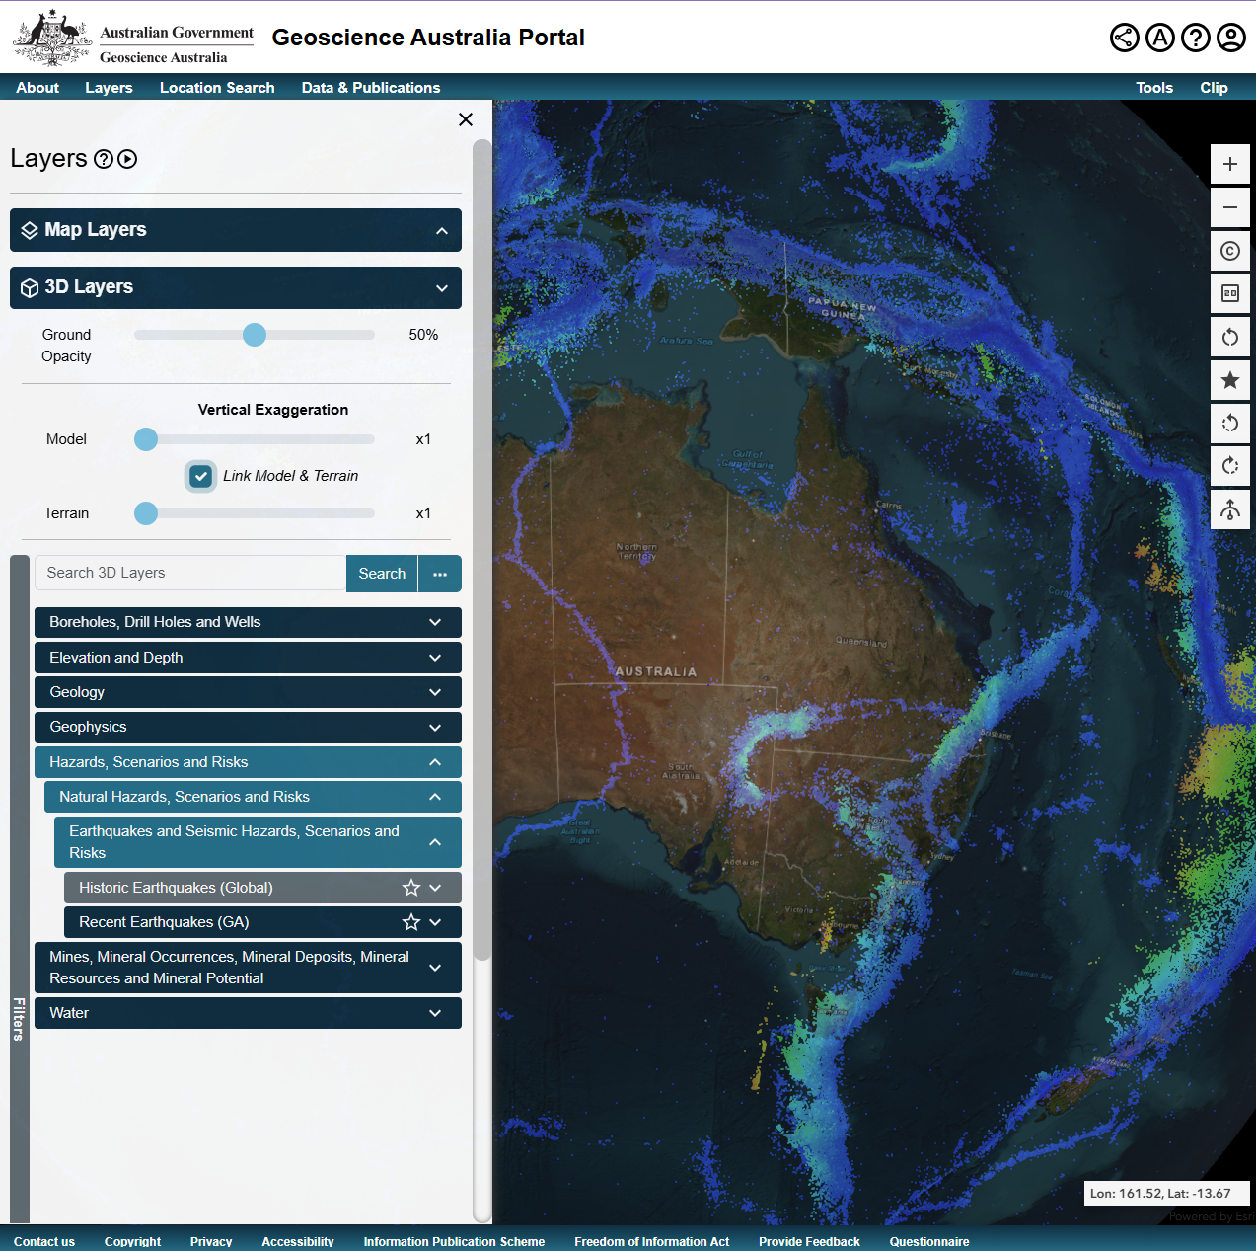:
Rotate the world map to locate New Zealand. If required, increase ‘Ground Opacity’ to 60-70% to make it easier to see earthquake locations.
Identify the subduction zone north of New Zealand and the different colours indicating the different depths of an earthquake. Relate the colours of the earthquake dots to the depth on Slide 30. Emphasise that each dot is a historical earthquake.
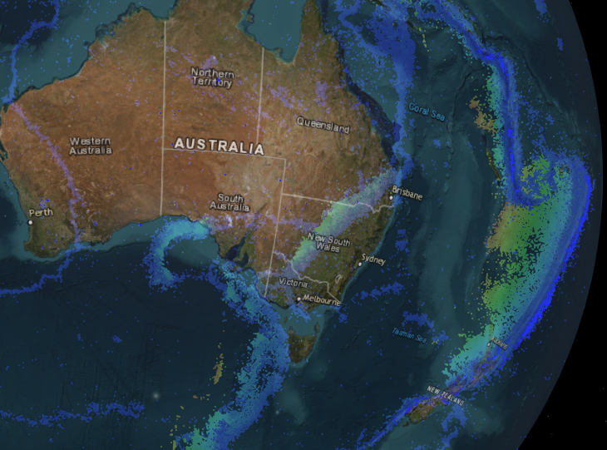:
Challenge students to rotate the Earth and locate other subduction zones. Discuss which representation (the graph or the 3D map) provides the most information for:
- educational purposes.
- scientific purposes (identifying types of boundaries).
(Slide 33) ✎ STUDENT NOTES: Draw a table identifying the advantages and disadvantages of the graphical model and the 3D model.
Model | Graph | 3D map
Advantages
Disadvantages
Look for places where lines of shallow earthquakes happen in the lithosphere below the ocean. These zones are where plates are pulling apart along a divergent plate margin. Students may need to adjust the opacity to ~25% to see the dots that represent earthquakes on the surface.
Discuss how the magma comes to the surface at a divergent boundary and forms ocean ridges.
Potential discussion prompts
- What happens when the plates move apart?
  - The magma comes to the surface and forms ocean ridges.
- Do you think that this has any effect on how the plates move?
  - Yes. This can add a push force to the plates moving apart.
(Slide 34) ✎ STUDENT NOTES: Define ‘ocean ridge push’ as the force that pushes tectonic plates apart at a divergent boundary.
(Slide 35) ✎ STUDENT NOTES: Draw a mind map of everything learned so far on earthquakes, their causes and tectonic plate boundaries.
Optional: Identify the following boundaries on the 3D map:
- Convergent boundaries:
  - subduction north of NZ
  - ocean/continental Andes
  - continental/continental Himalayas
  - oceanic/oceanic Caribbean Islands
- Divergent boundaries:
  - mid Atlantic ridge (magnetic stripes)
  - Northern Ethiopia Y shape rift
- Transformation boundaries (shallow earthquakes as the plates slide horizontally against each other):
  - San Andreas fault (west coast USA)
  - Anatolian Fault (along the northern and easter edges of Turkey)
  - Alpine Fault (New Zealand South Island)
  - Altyn Tagh Fault (Central Asia)

Reflect on the lesson
You might invite students to:
- examine the lack of earthquake zones in Australia.
- identify areas where major earthquakes could be expected.
- research the case of Italian geoscientists that were charged for not predicting a major earthquake.

Y10

Tectonic collision course • Lesson 4 • Tsunamis
Lesson 4
Inquire
To read the most recent version of this lesson, download associated resources, and view embedded professional learning including classroom videos and work samples, visit: https://scienceconnections.edu.au/teaching-sequences/year-8/tectonic-collision-course/lesson-4-tsunamis

Lesson overview
Students use a tsunami model to hypothesise and test the impact of tsunami waves during high tide and low tide. They compare the physical model to a mathematical model that generates a graph which allows the measurement of the change in tidal height at low tide and high tide.

Key learning goals
Students will:
- physically model the movement of a tsunami wave.
- develop and test a hypothesis on the effects of a tsunami wave arriving at high tide or low tide.
- use secondary data to graph the arrival of tsunami waves at low tide.
- compare physical and mathematical models.
Students will represent their understanding as they:
- use previous experience to develop a hypothesis of the impact of a tsunami at low and high tide.
- evaluate the accuracy of their hypothesis.
- use a large data set to generate a line graph of tidal heights and identify anomalies.

Assessment advice
In this lesson, assessment is formative.
Feedback might focus on students’ ability to:
- use previous experience to develop a hypothesis.
- use data spreadsheets to generate an appropriate line graph.
- analyse a line graph to identify anomalies in tidal height.
- evaluate claims made as a result of a hypothesis.
Potential summative task
Students working at the achievement standard should:
- evaluate the impact of tectonic events on human populations.
- understand the use of tsunami sensors to reduce the impact of tectonic events.
- develop reasoned predictions and hypotheses to explore scientific models, identify patterns, and test relationships.
- use visual displays of large data sets to identify temporal and spatial relationships.
- constructing graphs using correct conventions, such as naming the graph and labelling the axes.
- analyse data and information to describe patterns, trends and relationships and identify anomalies.

List of materials
Whole class
- Tectonic collision course Resource PowerPoint
- A tsunami wave tank prepared prior to the lesson according to the directions in the Preparing for this sequence tab
Tsunami wave tank
- Large clear container or fish tank
- Sand or soil to model beach zone
- Metal or wooden plank the same width as the tank
- String connected to one end of the plank
- Duct tape
- Water to fill the tank halfway
- Cloth to dry the sides of the tank
- 8 x filter paper
- Sticky tape
- Permanent markers
- Optional: food dye

- Access to the following videos showing tsunamis with different causes:
  - 1960 Chilean earthquake-generated tsunami (0:42)
  - Tsunami caused by landslide (2:03)
  - Tsunami caused by volcanic sources (2:42)
  - Tsunami caused by earthquakes (2:46)
Each student
- Individual science notebook
- One of the following options:
  - Vardon Harbour tide level Data resource and access to spreadsheet software
  - Pages 26-27 of the Tsunami - student activities booklet from Geoscience Australia
- Optional: Pages 24-25 of the Tsunami - student activities booklet from Geoscience Australia

Lesson routine | Estimated time | Task type
Re-orient | 5 minutes | Whole class
Question | 5 minutes | Whole class
Investigate | 25 minutes | Whole class/Individual
Integrate | 20 minutes | Whole class/Small group

Inquire

Re-orient
Recall the previous lesson focusing on the magnitude of earthquakes.
Discuss the location of the plate boundaries and how many of them are located under the oceans.

Question • Australian impact
Discuss how Australia does not have many large earthquakes.
(Slide 37) Pose the question: Do we need to know about earthquakes in other parts of the world?
Show 1960 Chilean earthquake-generated tsunami (0:42).

Investigate • Modelling tsunamis
(Slide 38) Add the water and (optional) dye to the prepared tsunami tank, to fill the tank halfway.
Carry out the tsunami tank demonstration described below.
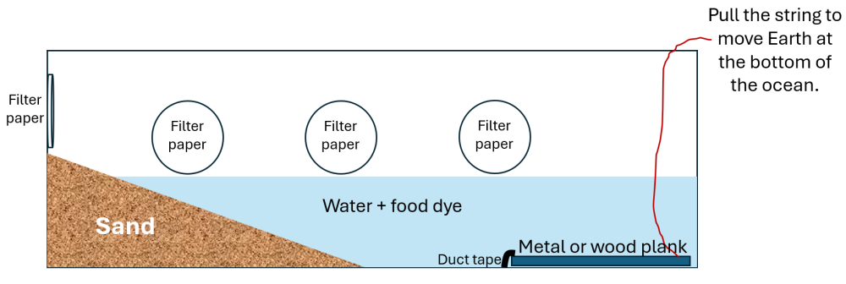
- Dry the sides of the tank.
- Use sticky tape to place the filter paper at different points along one side of the tank, just above the water level, and a final filter paper at the top of the sand ‘land’.
- Use the string to lift one end of the plank to model the tsunami wave.
- Have students use permanent markers to immediately mark the tsunami level on each filter paper.
Discuss how the tsunami waves (more than one) changed height at different locations along the tsunami tank, from small waves in deep water to taller waves as the water became shallower.
Watch the following videos demonstrating the three different causes of tsunamis:
- Tsunami caused by landslide (2:03)
- Tsunami caused by volcanic sources (2:42)
- Tsunami caused by earthquakes (2:46)
(Slide 39)✎ STUDENT NOTES: Define ‘tsunami’ as a series of powerful ocean waves caused by sudden displacements of water by earthquakes, landslides or volcanic activity.
(Slide 40) Pose the question: Does it make any difference if the tsunami waves arrive at high tide or low tide?
Remind students that tides are influenced by the Moon’s gravity.
Discuss how tides could be modelled using the water tsunami tank. Explain how this is a physical model designed to safely test the impacts of tsunamis. It also helps communicate the idea of tsunamis.
Allow students time to plan and suggest ways to model the impact of a tsunami at low or high tide.
Discuss how individuals in the class may need to mark the current depth of the water and the locations of the filter paper on the outside of the tank. Students should suggest that extra water be added to the tank to represent high tide, or water be removed from the tank to represent low tide. Use the cloth to dry the side of the tank before re-attaching fresh filter paper.
✎ STUDENT NOTES: Draw the tsunami tank and explain how the tsunami waves are modelled. Explain how high tide or low tide can be modelled.
Once agreement on the approach has been reached, allow time to complete the experimental model as a class.
Pose the question: What does this model not tell us?
Discuss how this physical model does not predict the effect of a tsunami on any particular beach.

Integrate • Higher ground
Discuss how the tsunami waves came higher on the land during high tide, or lower on the land at low tide.
✎ STUDENT NOTES: Describe how the tsunami waves changed at high tide or low tide.
(Slide 41) Discuss how the magnitude of the event generating a tsunami (earthquake, landslide or volcanic activity) would affect the amount of water that would be displaced. Consider the need for sensitive sensors around the edges of tectonic plates to detect the displacement of water (noting that the water levels do not change as much in deep water).
Potential discussion prompts
- How does the magnitude of an earthquake influence the volume of water displaced during a tsunami-generating event?
- In what ways does a large landslide displace more water than a smaller one, even if both occur in the same location?
- What challenges arise when trying to detect small water-level changes in deep water?
- Why must sensors around tectonic plate boundaries be extremely sensitive?
- Why are tectonic plate edges key locations for placing water-displacement sensors?
- What could be the consequences of relying on sensors that are not sensitive enough?
- How might false positives or missed detections impact public trust in warning systems?
(Slide 42) Introduce the next activity: graphing and analysing the tidal levels at a fictional Vardon Harbour every 15 minutes. Discuss what would happen if tsunami waves landed during low tide or during high tide.
Allow students time to make a hypothesis of what would occur using evidence from the tsunami tank demonstration.
✎ STUDENT NOTES: Write a hypothesis of what would occur if a tsunami arrived at Vardon Harbour during low tide or high tide.
The following chart can either be generated using Vardon Harbour tide level Data resource and spreadsheet software (to support students to focus on the data analysis) or manually using pages 26-7 of Geoscience Australia’s Tsunami - student activities booklet (to support students to focus on plotting a graph).
Introduce the spreadsheet data from the Vardon Harbour tide level Data resource as the tidal measurements taken every 15 minutes from Vardon Harbour. Guide students to use the data to insert a line chart of the change in tidal levels over time. Allow students time to complete the graph, including labels for the axis and a title for the graph.
Alternatively, use the Tide chart recordings for Vardon Harbour data from page 26 of Tsunami - student activities booklet to hand-draw the tidal graph on page 27.
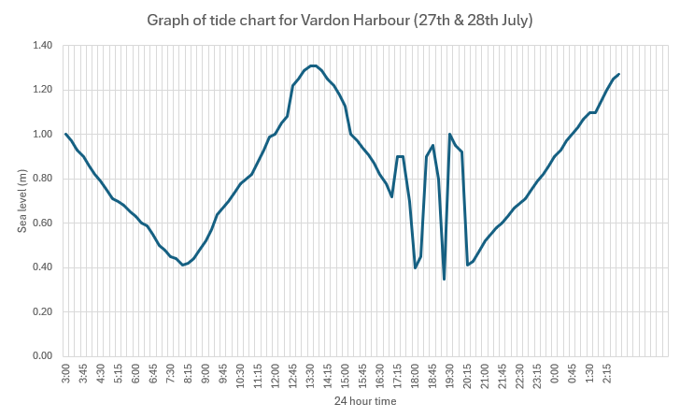:
(Slide 43) In groups, analyse the graph by identifying the three anomalies in the graph and the time that they occurred. Discuss how these anomalies represent three tsunami waves that arrived at Vardon Harbour during low tide, and the possible consequences if they arrived during high tide.
Potential discussion prompts
- What is the normal high tide at Vardon Harbour? What time was this?
  - 1.31 m, 13:30 (1:30 pm).
- What is the normal low tide at Vardon Harbour? What time was this?
  - 0.41 m, 8:00 am.
- What is unusual about the graph?
  - There are 3 ‘larger waves’ between 17:00-20:15.
- What do the three high sea level events represent?
  - Tsunami waves.
- What should the normal tide movement look like during this time?
- How much higher is the sea level than it should be?
  - Wave 1 is 0.2m higher. Wave 2 is 0.45 m higher. Wave 3 is 0.55 m higher.
- What would happen if these tsunami waves happened at high tide? How high would the water level be?
  - The water level would be 1.2m, 1.75m, and 1.8m for each wave, respectively.
✎ STUDENT NOTES: Add a copy of the graph to your notes. Describe the normal pattern of high tide and low tide. Use the graph to describe how the low tide levels changed during 17:00-20:15 hours.
Optional: Complete the questions on pages 24 and 25 of Tsunami - student activities booklet.
Discuss the accuracy of students’ hypotheses.
✎ STUDENT NOTES: Write a reflection on the accuracy of your hypothesis of the impact of tsunami waves during high or low tide.
Discuss the importance of communicating tsunami warnings to people who live on the coast of Australia, and how this mathematical model might be able to provide more useful information than the physical model.

Reflect on the lesson.
You might ask students to:
- play the Stop Disasters game created by the United Nations Office for Disaster Risk Reduction.
- research the location of tsunami warning sensors.
- research how tsunami warning sensors work.
- research the work done by scientists from Geoscience Australia and Bureau of Meteorology who work as part of the Joint Australian Tsunami Warning Centre.

Y10

Tectonic collision course • Lesson 5 • Shake, rattle, and roll
Lesson 5
Inquire
To read the most recent version of this lesson, download associated resources, and view embedded professional learning including classroom videos and work samples, visit: https://scienceconnections.edu.au/ teaching-sequences/year-8/tectonic-collision-course/lesson-5-shake-rattle-roll

Lesson overview
Students develop a model earthquake machine that can mimic P and S waves in earthquakes, then use these waves to determine the epicentre of an earthquake.

Key learning goals
Students will:
- understand and identify the different types of earthquake waves.
- compare the advantages and limitations of three different models of earthquakes.
Students will represent their understanding as they:
- identify the transfer of energy in the different types of earthquake waves.
- describe how liquefaction affects structures during an earthquake.
- identify the P and S wave on a seismogram.
- use the P-S time from three stations to identify the location of the epicentre.
- identify the advantages and limitations of different earthquake models.

Assessment advice
In this lesson, assessment is formative.
Feedback might focus on students’ ability to:
- model the different types of earthquake waves.
- identify the different types of earthquake waves from a seismograph.
- describe liquefaction.
- use seismographs to identify the epicentre of an earthquake.
- identify the advantages and limitations of different models.
Potential summative assessment
Students working at standard should:
- use visual displays of large data sets, such as maps.
- show the location of earthquakes to identify temporal and spatial relationships.
- examine the strengths and limitations of representations such as physical models, diagrams and virtual simulations and select the most appropriate representation to use.
- examine competing ideas, differences in methods and sources of error when constructing an argument.

List of materials
Whole class
- Tectonic collision course Resource PowerPoint
Liquefaction model
- Medium plastic tub
- Clean beach/playground sand (enough to ¾ fill the tub)
- Water (enough to make all the sand damp without pooling at the top surface)
- Large spoon
- Ping pong ball
- Heavier objects (toy metal car, solid house or a filled jar of water)
- Plastic toy animal
Seismic wave model
- Large plastic tub
- 4 occy straps (to fit snuggly across the width of the plastic tub)
- Flexible surface to place on top of occy straps e.g. artificial grass mat
- Objects to place on the flexible surface (toy car, house or person)
- Optional: a vibrometer app or micro:bit that shows movement in three dimensions
Locating the epicentre
- Three pages of the Epicentre Hunt - student activity from Geoscience Australia:
- Seismograms from Quakeville Station, Pearsons Crossing Station and Well Station (page 5)
- Time-distance graph (page 2)
- Quakeville area seismic stations (page 4)
- Ruler
- Pencil
- Compass drawing tool
Each group
- Large long spring (Slinky or similar)
Each student
- Individual science notebook
- Modelling earthquakes Resource sheet

Lesson routine | Estimated time | Task type
Re-orient | 3 minutes | Whole class
Question | 5 minutes | Whole class
Investigate | 10 minutes | Whole class/Small group
Integrate | 5 minutes | Whole class
Investigate | 20 minutes | Small group
Integrate | 10 minutes | Whole class/Small group

Inquire

Re-orient
Recall the previous lesson focusing on revising the different types of tectonic boundaries and how they move.

Question • Impact of earthquakes
Discuss the different ways the Earth can move at a boundary: up and down, side to side, or a combination of both.
Compare how the Earth would move on each side of a slipping subducting boundary—one side of the boundary might lift, sink, move sideways, or be compressed.
(Slide 45) Pose the question: How could we predict the effect that earthquakes will have?

Investigate • Modelling waves
Text Provide student teams with a large spring (or demonstrate as a class). Invite two students to stretch the large spring out to model the movement of the Earth.
Discuss how the spring could be used to model the Earth being quickly compressed or decompressed. If required, demonstrate each type of wave for the students.
(Slide 46) Explain how the first type of earthquake wave to arrive is the P or primary wave. This is when the earth compresses or is released from compression. These waves travel through all layers of the Earth, including the flexible molten mantle.
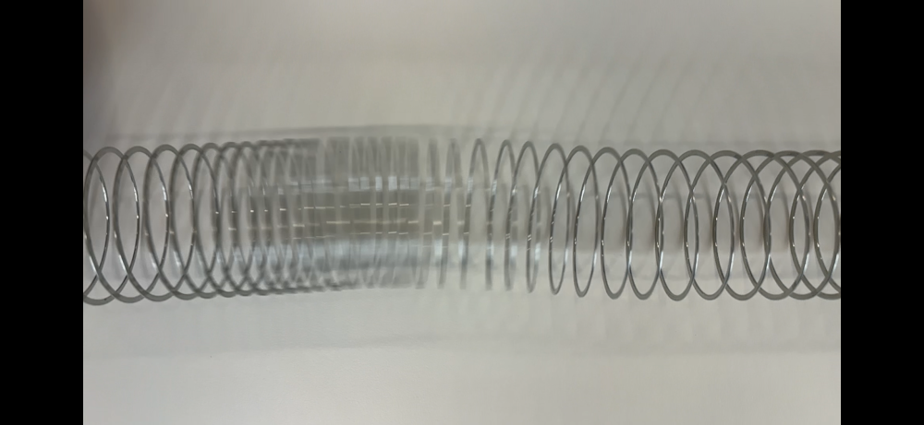
(Slide 47) Explain that the S or secondary shear wave is next to arrive. This occurs when the Earth moves side to side, perpendicular to the direction of the wave/energy. These waves travel through the solid layers of the Earth.
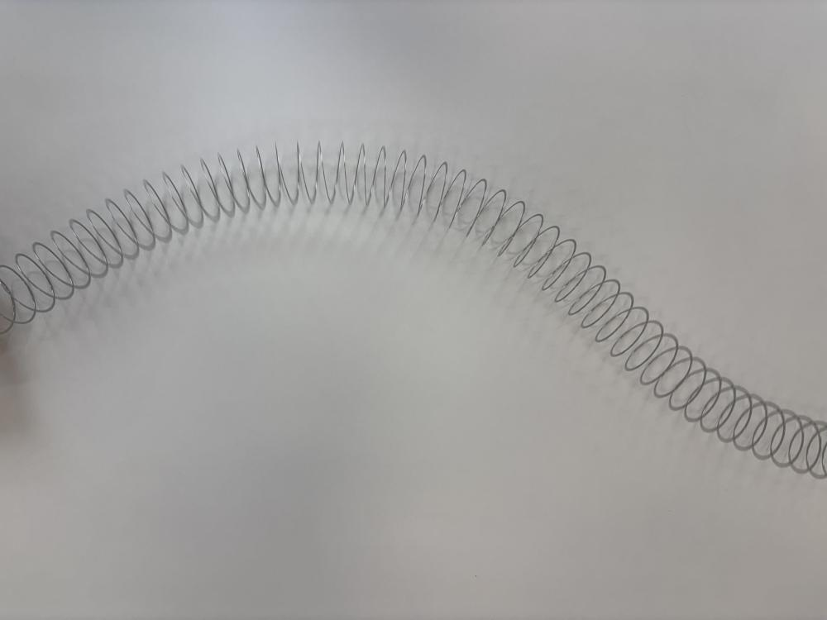
(Slide 48 and 49) Discuss how surface waves are the last to arrive. These waves only travel along the Earth’s surface and can have a rolling action.
Potential discussion questions
- How do P waves move the ground, and how might this motion feel to a person?
- How do S waves move differently from P waves?
- Why are surface waves usually responsible for the most damage?
- How might the motion caused by S waves or surface waves affect a person’s balance?
- Why do some people describe earthquakes as rolling, shaking, or jolting?
- How might people experience different motions depending on how close they are to the epicentre?
- Why is understanding seismic wave motion important for earthquake-resistant building design?
(Slide 50) Provide an example of the earthquake waves shown on a seismogram. Identify the different waves (P waves, S waves and surface waves) on the diagram.
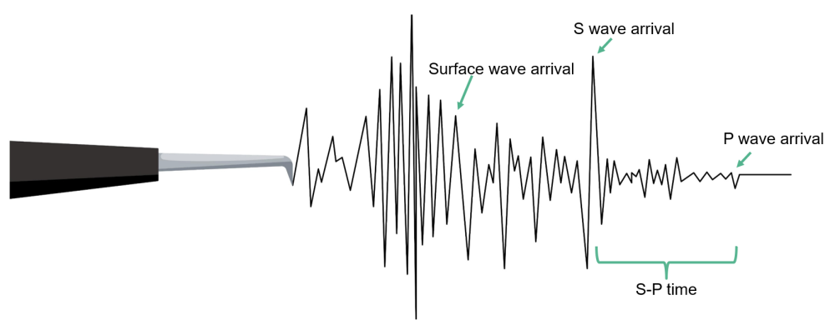
Discuss how the different types of waves provide different motions for people and buildings on the Earth’s crust.

Integrate • Comparing waves
(Slide 51) Make a direct comparison between the different types of waves that make up an earthquake.
✎ STUDENT NOTES: Compare the difference between P and S and surface waves.
P waves | S waves | Surface waves
The first wave measured by seismograph | The second wave measured by seismograph | The last waves measured by seismograph
Compression wave | Transverse/shear waves | Highest amplitude waves
Move through solids and liquids | Only move through solids (not liquids) | Travel across the surface of the Earth
Medium moves in the same direction as the wave/energy movement | Medium moves in a perpendicular direction to the wave/energy movement | Medium moves side to side or in a rolling motion
(Slide 52) Pose the question: How can we model the different types of earthquake waves and their impact?

Investigate • Modelling earthquakes
(Slides 53-55) Introduce the three models of earthquakes, either sequentially or simultaneously set up around the classroom.
Provide students with the Modelling earthquakes Resource sheet and the relevant pages of the Epicentre Hunt – student activity by Geoscience Australia. Allow students to explore each model, identifying its purpose and limitations.

Model 1: Seismic wave model
- Place the large tub (with no lid) on a flat surface.
- Hook the occy straps on the short edges of the large tub so that they are suspended across the open top.
- Place the flexible surface on top of the suspended occy straps to represent the Earth’s crust.
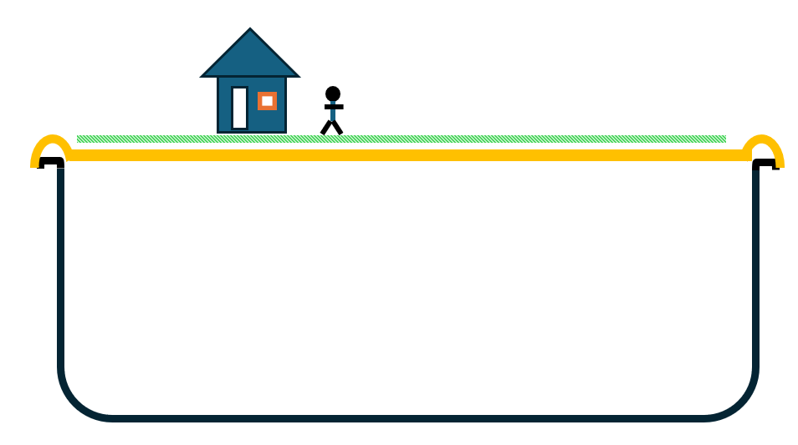
- Pull or push the occy straps to model:
  - P waves: pull then release the occy straps
  - S waves: move the occy straps from side to side
  - Surface waves: move the occy straps down and then quickly release them

Model 2: Liquefaction model
- Place the sand and water in the plastic tub.
- Mix it thoroughly until all the sand is consistently damp.
- Use the spoon to bury the ping pong ball in the sand. This represents an empty tank or pipe that is buried under the ground.
- Place the remaining objects on the surface of the sand.
- Simulate an earthquake by tapping the side of the tub or gently shaking the tub back and forth.

Model 3: Locating the epicentre
- Identify the P and S waves on the seismograms from Quakeville Station, Pearsons Crossing Station and Well Station.
- Measure the time between the start of the P and S waves on each graph (P-S time). This can be done by using the time measurements at the base of each graph (10 marks = 1 seconds). Record this time in Table 1 of the Resource sheet.
- Use the time-distance graph on page 2 of Epicentre hunt to convert the measured P-S time for each station into a distance. Record this distance in Table 1.
- Identify the town of Quakeville on the map on page 4 of Epicentre hunt.
- Expand the compass drawing tool to 5.3 cm between the pencil and the metal point. This represents 53 km (the distance between the town and the epicentre).
- Place the metal point of the compass drawing tool in the centre of Quakeville. Draw a circle around the town to represent the possible locations of the epicentre.
- Repeat this process of expanding the compass to the appropriate distance for Pearson Crossing Station and Well Station and drawing a circle around each station.
- Mark an ‘X’ on the location where all three lines overlap to show the epicentre of the earthquake.
✎ STUDENT NOTES: Complete the questions related to each activity.

Integrate • Comparing models
(Slide 56) Discuss the advantages and limitations of each model.
Model | Advantages | Limitation
Seismic wave model | Explains wave movement and energy  Improves our understanding of Earth’s internal structure (mantle/core) | Limited information on surface impact
Liquefaction model | Explains ground failure and building collapse  Useful for urban planning | Only applies in certain soil environments  Needs detailed local soil and groundwater data
Epicentre model | Identifies the location of the epicentre for emergency response  Identifies high-risk areas | Requires multiple seismograph locations  Does not identify the magnitude of the earthquake
✎ STUDENT NOTES: Record the advantages and limitations of each model.
(Slide 57) Use the Earthquakes@GA website to find seismograms of the latest earthquakes. Select an earthquake dot on the map, then select the ‘+’ next to “Seismograms’ on the pop-up menu to view the seismogram recordings from each nearby station.
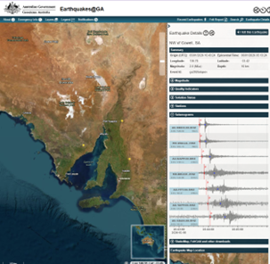:
Discuss how geoscientists at Geoscience Australia are constantly monitoring all earthquakes across Australia.
Potential discussion prompts
- How does Geoscience Australia detect earthquakes across such a large and sparsely populated country?
- How might satellite data and digital communication improve earthquake monitoring in remote areas?
- In what ways can this information be used to improve building codes and infrastructure safety?
- How does Geoscience Australia share earthquake information with emergency services and the public?
- Why is it important for earthquake information to be released quickly and accurately?
- How might climate, terrain, or human activity interfere with earthquake monitoring?
Optional: Watch the video Why are earthquakes so hard to predict? (4:52).

Reflect on the lesson
You might invite students to:
- add the following words to a glossary: epicentre, P wave, S wave, surface wave.
- watch the video Nuclear bomb test or earthquake? How we tell the difference (stop watching at 5:52 to avoid a sponsored advertisement).
- re-examine the intended learning goals for the lesson and consider how they were achieved.

Y10

Tectonic collision course • Lesson 6 • Earthquake materials
Lesson 6
Inquire
To read the most recent version of this lesson, download associated resources, and view embedded professional learning including classroom videos and work samples, visit: https://scienceconnections.edu.au/teaching-sequences/year-8/tectonic-collision-course/lesson-6-earthquake-materials

Lesson overview
Students design and test a variety of building materials for flexibility and strength to determine their suitability for building in an earthquake zone.

Key learning goals
Students will:
- examine the properties of building materials needed for building in an earthquake zone.
- design an experiment to test the flexibility and yield strength of bamboo, wooden dowel, and metal stakes.
- compare the results of the experiment to make a claim (with evidence and reasoning) of the best material to use for building in an earthquake zone.
Students will represent their understanding as they:
- complete an investigation planner to design an experiment to test the flexibility and yield strength of building material.
- record the results of their experiment in a table.
- compare the investigation of materials to real-world conditions.
- use argumentation to identify the best building material to use in an earthquake zone.

Assessment advice
In this lesson, assessment is formative.
Feedback might focus on students’ ability to:
- develop a hypothesis.
- plan and conduct an experiment.
- record data in an appropriate table.
- analyse data to identify trends.
- identify errors and evaluate the precision of the results.
- use scientific language to write a scientific report.
Potential summative assessment
Students working at standard should:
- investigate how scientific responses including new building materials, improved predictions and early warning systems have supported communities living in a country in the Asia-Pacific region located near plate boundaries, for example Japan, Indonesia or New Zealand.
- research how cultural building techniques such as houses built of bamboo led to the development of structures and materials better able to withstand the effects of earthquakes.
- develop investigable questions, reasoned predictions and hypotheses to explore scientific models, identify patterns and test relationships.
- plan and conduct reproducible investigations to answer questions and test hypotheses, including identifying variables and assumptions and, as appropriate, recognising and managing risks.
- select and construct appropriate representations, including tables, graphs, models and mathematical relationships, to organise and process data and information.
- analyse data and information to describe patterns, trends and relationships and identify anomalies.
- analyse methods, conclusions and claims for assumptions, possible sources of error, conflicting evidence and unanswered questions.
- construct evidence-based arguments to support conclusions or evaluate claims.
- write and create texts to communicate ideas, findings and arguments for specific purposes and audiences, including selection of appropriate language and text features, using digital tools as appropriate.

List of materials
Whole class
- Tectonic collision course Resource PowerPoint
- Video: Earthquake hits Christchurch, New Zealand (4:03)
Each group
- 1 x bamboo stake
- 1 x wooden dowel
- 1 x metal stake
- Bucket
- Water or weights to place in the bucket
- Scales or Newton meter to measure the mass of the water
- Metre ruler (to measure the bend on the testing materials)
Each student
- Testing building materials Investigation planner
- Individual student notebook

Lesson routine | Estimated time | Task type
Re-orient | 5 minutes | Whole class
Question | 5 minutes | Whole class
Investigate | 30 minutes | Small group
Integrate | 15 minutes | Whole class

Inquire

Re-orient
Recall the previous lesson, focusing on the different types of waves that occur during an earthquake.
Discuss how a person might experience the different types of waves during an earthquake.

Question • Earthquake buildings
Discuss the challenges of building in an earthquake zone where the Earth can move in different ways.
Show the video Earthquake hits Christchurch, New Zealand (4:03).
(Slide 59) Pose the question: What materials were used in the buildings that collapsed?

Investigate • Flexibility and strength
Discuss how concrete is not very flexible and is likely to crack during an earthquake. This makes it dangerous to be inside a concrete building that might collapse or just outside a building that has lumps of concrete falling off. It is also likely to sink in liquefaction zones.
Discuss what other materials could be used, including steel, wood, and bamboo.
(Slide 60) Explain that the properties of materials can be measured, including:
- rigidity—the ability of a material to resist movement.
- flexibility—the ability of a material to bend without breaking.
- strength. There are three ways to measure strength:
  - tensile strength—the ability to resist being stretched.
  - compressive strength—the ability to withstand being compressed.
  - yield strength—the level where a material is permanently deformed.
✎ STUDENT NOTES: Record the properties of materials, including rigidity, flexibility, and the three types of strength.
Discuss how flexibility and strength are two properties that would be useful materials in earthquake zones.
(Slide 61) Introduce this lesson’s investigation that will test the flexibility and yield strength of wood, bamboo, and metal stakes. Demonstrate how the material can be placed through a bucket handle and placed between two tables.
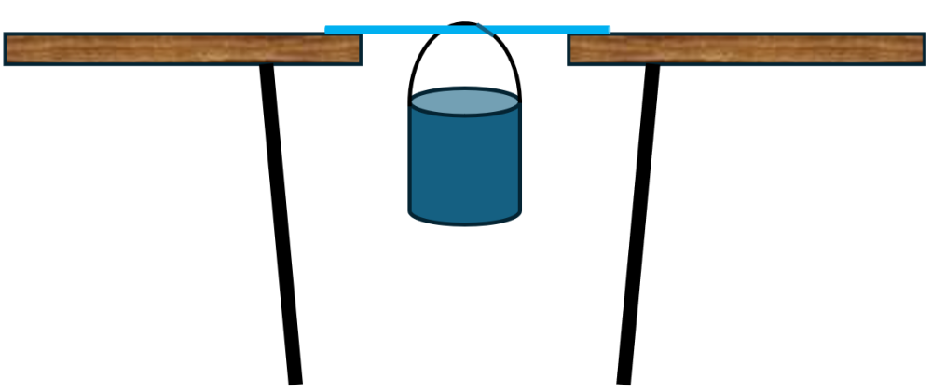:
Place the metre ruler vertically, directly behind the bucket, so the students can measure the amount the material flexes when water or weights are placed in the bucket.
✎ STUDENT NOTES: Complete the Testing building materials Investigation planner to plan a reproducible investigation testing the strength and flexibility of the materials.
Allow students time to conduct the investigation.

Integrate • Analysing materials
Compare the results from each student team, identifying similar trends in the material with the most flexible and the largest yield strength.
(Slide 62) Identify any discrepancies and errors that could cause differences in the results. Discuss how these errors could be minimised with more precise equipment or by repeating the experiment many times.
Potential discussion prompts
- Explain why it was important to test the wood, bamboo, and metal using the same setup.
- Describe how the results for flexibility would change if the material bending was measured from different angles.
- Describe how you knew the material had reached its yield point.
- Describe what might happen to the results if too much weight were added too quickly.
- Compare this testing model to what happens to materials during an earthquake.
- Describe how this experiment could be improved to better represent real-world conditions.
- Explain how engineers balance strength, flexibility, and safety when designing structures.
✎ STUDENT NOTES: Describe how the method could be improved if it were repeated.
(Slide 63) Use argumentation to identify the best material to use in earthquake zones.
(Slide 64) Discuss how it might be difficult to build with the circular structure of the bamboo rods, and how the properties of materials can be changed when combined with others.
Potential discussion prompts
- Why might it be harder to build structures using round bamboo rods instead of flat pieces?
- How could the shape of bamboo make walls or straight edges harder to build?
- What building techniques or tools could help make bamboo structures stronger?
- How can combining bamboo with another material (such as string, glue, or wire) make it stronger or more stable?
- Can combining materials change how flexible or stiff a structure is? Why?
- Why might one material be good for strength, while another is better for holding things together?
- Can you think of an example where combining materials makes something better than using just one?
Discuss the limitations of the materials, such as metal buildings sinking in liquefaction zones.
✎ STUDENT NOTES: Revisit previous claims and justify your decision following the discussion on the challenges of building with bamboo.

Reflect on the lesson
You might invite students to:
- add the following words to the glossary: rigidity, flexibility, tensile strength, compressive strength, and yield strength.
- watch the TED-Ed video Why do buildings fall in earthquakes? (4:51).
- research how large buildings in the earthquake zone of San Francisco resist the movement of earthquakes.
- research how cultural building techniques such as houses built of bamboo led to the development of structures and materials better able to withstand the effects of earthquakes.

Y10

Tectonic collision course • Lesson 7 • Designing for earthquakes
Lesson 7
Act
To read the most recent version of this lesson, download associated resources, and view embedded professional learning including classroom videos and work samples, visit: https://scienceconnections.edu.au/ teaching-sequences/year-8/tectonic-collision-course/lesson-7-designing-earthquakes

Lesson overview
Students provide evidence of their learning by identifying the geological features of an area affected by earthquakes and designing a building that would be able to resist the effects of an earthquake or tsunami.

Key learning goals
Students will:
- use the Geoscience Australia Portal to identify an area that would be affected by tectonic plate movement.
- describe the tectonic plate boundary and how it moves.
- describe how the forces of convection, slab pull and ridge push contribute to the movement of the tectonic plate.
- describe how tectonic plate movement could be monitored.
- design a building that would be able to withstand tectonic plate movement.
Students will represent their understanding as they:
- identify and describe the movement at a tectonic plate boundary.
- describe how the forces of convection, slab pull and ridge push contribute to the movement of the tectonic plate.
- describe how tectonic plate movement is detected by seismometers.
- identify P, S and surface waves.
- identify the features that enable a building to withstand tectonic plate movement.

Assessment advice
In this lesson, assessment is summative.
Students working at the achievement standard should:
- examine patterns of earthquake and volcanic activity over time and propose explanations.
- evaluate the impact of tectonic plate events on human populations and examine engineering solutions designed to reduce impact.
- describe the significance of different forces involved in tectonic plate movement including slab pull, ridge push and convection.
- investigate how scientific responses including new building materials, improved predictions and early warning systems have supported communities living in a country in the Asia-Pacific region located near plate boundaries, for example Japan, Indonesia or New Zealand.
- examine the strengths and limitations of representations such as physical models, diagrams and virtual simulations and select the most appropriate representation to use.
- analyse conclusions or claims for assumptions, possible sources of error, conflicting evidence and unanswered questions.
- communicate ideas for specific purposes and audiences and use digital tools as appropriate.

List of materials
Whole class
- Tectonic collision course Resource PowerPoint
- Video: The science behind the Australian tsunami detection system (0:46)
- Optional: Liquefaction model and seismic wave model from Lesson 5
- Optional: A selection of building material including bamboo, sticky tape, strong, wooden dowel, cardboard, miniature figures
Each student
- Individual science notebook
- Poster paper for design

Lesson routine | Estimated time | Task type
Connect and Anchor | 10 minutes | Whole class/Small group
Design | 30-60 minutes | Small group/Individual
Communicate | 30-60 minutes | Small group/Individual

Act

Connect and Anchor • Who needs support?
(Slide 66) Revise tectonic plates and locations of earthquakes by going to the Geoscience Australia Portal 3D map.
Select ‘Layers’ > ‘3D layers’ > ‘Hazards, scenarios and risks’ > ‘Natural Hazards, Scenarios and Risks’ > ‘Earthquakes and Seismic Hazards, Scenarios and Risks’ > ‘Historic earthquakes’ > ‘Add to Map’.
Rotate the world map to locate New Zealand. If required, increase ‘Ground Opacity’ to 60-70%.
Identify the different types of boundaries and the locations of people living near the area.
(Slide 67) Discuss the challenges of people living in a particular area, the frequency of earthquakes and the most recent ‘large’ earthquake experienced. You may choose to reference GeoNet's list of the most recent 100 earthquakes in New Zealand.
Potential discussion prompts
- Why do you think people still choose to live in areas where earthquakes happen often?
- What challenges might people face living in an area with frequent earthquakes?
- How could earthquakes affect homes, schools, and hospitals?
- Looking at the list of earthquakes from the past year, what do you notice about how often they occur?
- Are most earthquakes small or large? Why is this important?
- What was the most recent ‘large’ earthquake recorded, and where did it happen?
- Why do you think some earthquakes cause more damage than others?
- How is living in an earthquake-prone area different from living in a place with few or no earthquakes?
- If you lived in an area with frequent earthquakes, what would worry you the most and why?
Show The science behind the Australian tsunami detection system (0:46).
Optional: Show the video of geoscience being used to predict global sea level rises 2026 Anton Hales Medal winner - Dr Mark Hoggard.
Discuss how the tsunami warning system works.
Potential discussion prompts
- Why do countries in the Asia-Pacific region share seismic data with each other?
- What could happen if countries did not share earthquake data?
- Why do tsunami warnings need to be sent out very quickly?
- In what ways does seismic data help emergency services after an earthquake or tsunami?
- Why is seismic data useful for planning where buildings and cities are built?
- Do you think people always take tsunami warnings seriously? Why or why not?
If you lived near the coast, how would tsunami alerts change the way you think about earthquakes?

Design • Designing earthquake-proof houses
(Slides 68-70) Students should prepare a model or a poster of a design for an earthquake-proof design.

Define
Outline the location for the house to be built and the communities that live in the area. Consider the materials that might be available, the risks of earthquakes or tsunamis, and the lifestyle of the community (do multiple generations live in the same building, do people live alone, how do they shop or obtain food).

Ideate
Brainstorm the key features that could be used to minimise damage during an earthquake or tsunami, including:
- the way the earth will move.
- the type of materials that could be used.
- the use of counterbalance weights.
- natural land features that may minimise the risk of tsunamis.

Prototype
Design the prototype
Select the different features that are required for the house. Consider the size of the building, doorways and windows. Is the type of soil important (liquefaction)? Consider whether the building would need to survive both earthquakes and tsunamis.
Building the prototype
Prototypes can take many forms depending on the time and resources available. It may be as simple as a detailed drawing with labels and explanations, or as complex as a scaled model of the design.
Optional: Select one of the earthquake models used during this teaching sequence to test the model house.

Communicate • Sharing ideas
Receiving feedback is an important part of the design process.
Before students present their designs, discuss how to give effective feedback to each other by planning the approach to be used in the classroom. Each group could use a structured feedback form, checklists, or rubrics to guide their review. This can include specific areas to review, for example:

The science
- Have tectonic plates been defined?
- Does the design consider real scientific principles of tectonic plate theory by:
  - describing the nearest type of boundary between the tectonic plates?
  - describing how and why the tectonic plates move (including convection, slab pull and ridge push)?
  - calculating the rate at which the tectonic plates move over time?
  - describing the frequency of earthquakes in the area?
- Does the model/design:
  - describe the impact of tectonic events on the human population in the identified area?
  - describe the materials that will be used in the construction of the building?
  - identify a material that would not be used in the construction and justify this decision?
  - identify and describe the engineering principles that are applied to the building?

The model or design
- Does the design offer creative solutions to the problem?
- How practical is the design for actual implementation, considering available resources and technology?
- What could be improved in the design?
- Are there any flaws or missing elements in the design?
- What are the strengths of the design?
- Is the design unique and well thought out?

The communication
- How well is the design communicated, both visually and verbally?
- What are the assumptions that have been made about the design?
Allow the students time to present their designs.

Reflect on the sequence
You might invite students to:
- research First Nations Australians’ cultural accounts that provide evidence of earthquakes and volcanoes.
- explore how geologist and oceanographic cartographer Marie Tharp’s topographic maps of the Atlantic Ocean floor provided support for the acceptance of the theory of plate tectonics.
- film a documentary on the dynamic nature of the geosphere and select appropriate language, models or analogies to engage a specific audience.

