Tectonic plates • Testing building materials
Year 8

Investigation planner
Name: | Date:
Other members of your team:

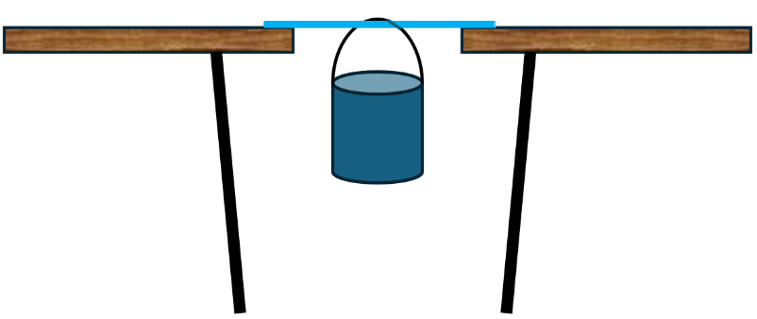
Materials required
- 1 x bamboo stake
- 1 x wooden dowel
- 1 x metal stake
- Bucket
- Water or weights to place in the bucket
- Scales or Newton meter to measure the mass of the water
- Metre ruler (to measure the bend on the testing materials)

Independent variable: | Dependent variable:
Controlled variables (keep the same): | How they will be controlled:
Hypothesis:
If…
Then…
Because…
Describe how you will set up your investigation  Write, draw, or upload a photo of your drawing. | What equipment will you use?  Use dot points and include the amounts needed.
Risk assessment:

What I will do to avoid accidents or injuries with equipment or chemicals.

Results—Use a data table. How many rows and columns will you need? What are their headings?

Comparing results: How do your results compare to others in your class? Are there any patterns or trends?

Why do you think that happened?

Discussion
- Explain why it was important to test the wood, bamboo and metal using the same setup.
- Describe how the results for flexibility would change if the material bending was measured from different angles.
- Describe how you knew the material had reached its yield point.
- Describe what might happen to the results if too much weight were added too quickly.
- Compare this testing model to what happens to materials during an earthquake.
- Describe how this experiment could be improved to better represent real-world conditions better.
- Explain how engineers balance strength, flexibility, and safety when designing structures.

