Modelling earthquakes
Year 8

Seismic wave model

Question
How do the different types of earthquake waves affect people and buildings?

Equipment
- Large plastic tub
- 4 occy straps (to fit snuggly across the width of the plastic tub)
- Flexible surface to place on top of occy straps e.g. artificial grass mat
- Objects to place on the flexible surface (toy car, house or person)
- Optional: a vibrometer app or micro:bit that shows movement in three dimensions

Procedure
- Place the large tub (with no lid) on a flat surface.
- Hook the occy straps on the short edges of the large tub so that they are suspended across the open top.
- Place the flexible surface on top of the suspended occy straps to represent the Earth’s crust.
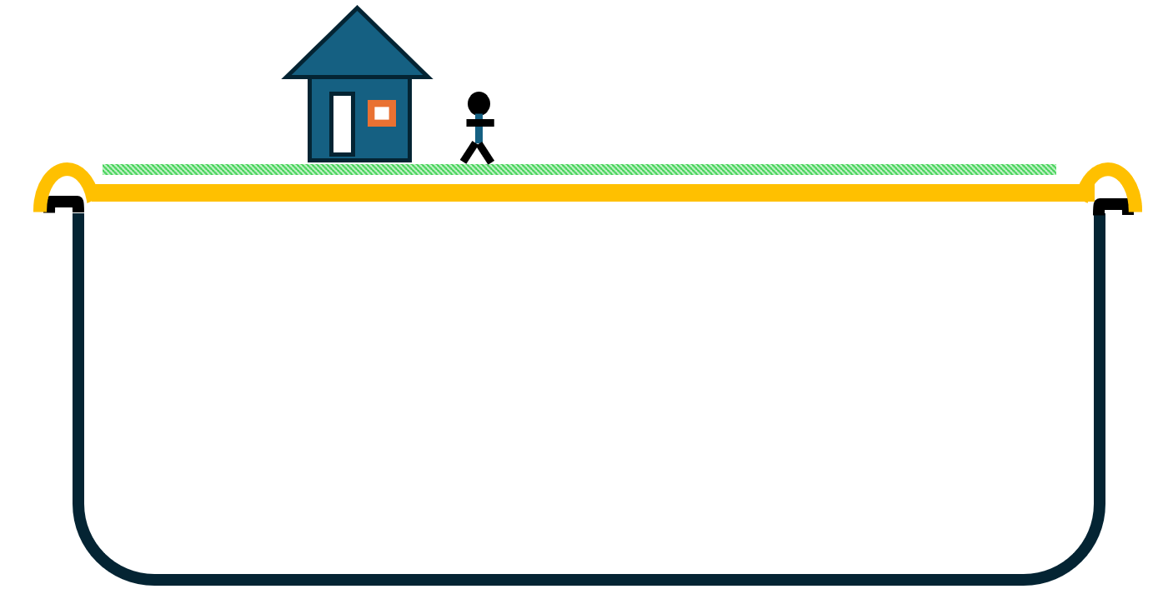
Figure 1: Explaining earthquakes model
- Pull or push the occy straps to model each type of wave.
Optional: Use the vibrometer app or micro:bit to record the different types of waves that were modelled.

Results
Wave type | How you produced each wave | The direction the wave moved (the direction of the energy flow) | How the flexible surface and objects moved with each type of wave
P wave | Pull then release the occy straps
S wave | Move the occy straps from side to side
Surface wave | Move the occy straps down, then quickly release them

Discussion
- Describe how this model helps explain P waves, S waves, and surface waves.
- Describe why it is useful to visualise wave motion.
- Describe how this model helps explain earthquake damage patterns.
- Describe how the wave movement in the model is different from waves inside Earth’s layers.
- What information about earthquakes is missing?

Liquefaction model
Liquefaction is what happens during an earthquake when loose wet soil shakes so much that it starts to behave like a liquid instead of a solid. When this happens, the ground can sink, crack, or tilt, and buildings or roads on top of it may collapse or sink because the soil can no longer support them.

Question
How are objects affected when loose wet soil experiences an earthquake?

Equipment
- Medium plastic tub
- Clean beach/playgound sand (enough to ¾ fill the tub)
- Water (enough to make all the sand damp without pooling at the top surface)
- Large spoon
- Ping pong ball
- Heavier objects (toy metal car, solid house or a filled jar of water)
- Plastic toy animal
Procedure
- Place the sand and water in the plastic tub.
- Mix it thoroughly until all the sand is consistently damp.
- Use the spoon to bury the ping pong ball in the sand. This represents an empty tank or pipe that is buried under the ground.
- Place the remaining objects on the surface of the sand.
- Simulate an earthquake by tapping the side of the tub or gently shaking the tub back and forth.

Results
Describe your observations of what happened to each object during the simulated earthquake.

Discussion
- Describe how the shaking in this model is different from a real earthquake.
- Explain why this model is useful for showing why some areas/objects are more at risk than others during an earthquake.
- Describe how the soil in this model is different from real ground conditions.
- Describe how the small scale of this model limits what we can learn.

Locating the epicentre
Late at night, while everyone in Quakeville and the surrounding towns slept, the ground gave a tiny shudder. No one woke up—the shaking was far too gentle to feel. Still, the earthquake didn’t go completely unnoticed. Seismometers at nearby seismic stations quietly recorded the tremor. By morning, some locals were worried. They remembered that in the past, small, barely noticeable earthquakes like this one had often come before much stronger quakes.

Question
Where was the epicentre of the earthquake located?

Equipment
- Three pages of the Epicentre Hunt - student activity from Geoscience Australia:
  - Seismograms from Quakeville Station, Pearsons Crossing Station and Well Station (page 5)
  - Time-distance graph (page 2)
  - Quakeville area seismic stations (page 4)
- Ruler
- Pencil
- Compass drawing tool

Procedure
- Identify the P and S waves on the seismograms from Quakeville Station, Pearsons Crossing Station and Well Station.
- Measure the time between the start of the P and S waves on each graph (P-S time). This can be done by using the time measurements at the base of each graph (10 marks = 1 seconds). Record this time in Table 1.
- Use the time-distance graph on page 2 of Epicentre hunt to convert the measured P-S time for each station into a distance. Record this distance in Table 1.
- Identify the town of Quakeville on the map on page 4 of Epicentre hunt.
- Expand your compass drawing tool to 5.3 cm between the pencil and the metal point. This represents 53 km (the distance between the town and the epicentre).
- Place the metal point of the compass drawing tool in the centre of Quakeville. Draw a circle around the town to represent the possible locations of the epicentre.
- Repeat this process of expanding the compass to the appropriate distance for Pearson Crossing Station and Well Station and drawing a circle around each station.
- Mark an ‘X’ on the location where all three lines overlap to represent the epicentre of the earthquake.

Results
Table 1: The recorded differences in time and distance of each earthquake station from the epicentre
Station | Time difference between the P and S waves (seconds) | Distance between the station and the epicentre (km)
Quakeville Station | 6.0 | 53
Pearson Crossing Station
Well Station

Discussion
- Describe how this model is used by scientists.
- Explain why using more than one seismogram is important.
- Explain why this method only works after an earthquake has occurred.
- Describe how inaccurate data could affect the result.
- Explain why this model cannot be used to predict future earthquakes.

