
Y10

Newton meets AI • Lesson 1 • Accidental physics
Lesson 1
launch
To read the most recent version of this lesson, download associated resources, and view embedded professional learning including classroom videos and work samples, visit: https://scienceconnections.edu.au/teaching-sequences/year-10/newton-meets-ai/lesson-1-accidental-physics

Lesson overview
Students use car safety data to determine if it is becoming more dangerous to walk to school. They determine the average speed of cars travelling past their school.

Key learning goals
Students will:
- use the TRAAP method to identify the trustworthiness of data.
- compare average speed and instantaneous speed.
- measure and calculate the average speed of a car.
- assess the validity and reliability of a method for measuring the average speed of a car.
Students will represent their understanding as they:
- describe the trends in road traffic deaths in their state/territory.
- measure the time taken for a car to travel a set distance.
- calculate the average speed of a car.

Assessment advice
In the Launch phase, assessment is diagnostic.
Take note of:
- students’ understanding of speed as a relationship between distance and time.
- students’ ability to distinguish between average speed and instantaneous speed.
- students’ ability to calculate the average speed of a car.
- students’ ability to assess the validity of secondary data.
- students’ ability to assess the validity and reproducibility of methods.

List of materials
Whole class
- Newton meets AI Resource PowerPoint
- A 50 or 100 m length of road near the school (with footpath alongside) where students can measure the time taken for a car to travel
- Chalk or cones to mark start and finish points

Each group
- Stopwatch (or smartphone with a stopwatch app)
- Trundle or surveyor’s wheel for measuring distance on the footpath
- Optional: Calculator (for speed calculations)
Each student
- Individual science notebook
- School zone speed Resource sheet

Lesson routine | Estimated time | Task type
Connect | 15 minutes | Whole class
Elicit and Anchor | 15 minutes | Whole class/Small groups
Experience and empathise | 30 minutes | Whole class/Small groups

Launch

Connect • Walking safely
(Slide 3) Pose the question: How did you travel to school today?
Identify how few students walk to school. Suggest that this is a big change compared to 40 years ago when most students walked to school and discuss the quote on the slide.
Pose the question: Is the traffic more dangerous now than in the past?
(Slide 4) Identify the trend in your state over the previous 10 years. Identify that data is from the Australian Road Deaths Database.

Potential discussion prompts
- Why do you think the number of road deaths decreased in most states in 2020-2021?
- Why might the number of fatalities have increased in Queensland during this time?
- Why is the overall trend of fatalities increasing?
- Is this because more people are driving?
- How has the population changed in this time?
- What more information might we need?
Pose the question: Where does the database obtain their information?
(Slide 5) Discuss why it is important to check the source of data. Identify why this data could be considered reliable. If required introduce the TRAAP method for checking the reliability of information:
- Timeliness: When was the information published or updated?
- Relevance: Is it relevant to the discussions on road safety?
- Authority: Is the publisher of the information an expert on the information?
- Accuracy: Can the information be verified by another source?
- Purpose: Why was the database published?
Go to the Australian Road Deaths Database to identify the source of information: the Bureau of Infrastructure and Transport Research Economics (BITRE), which gathers its information from each state and territory government. They also release a monthly data report on road deaths.
Optional: The BITRE was established in 1970 to “analyse the economics of transport in Australia”. Discuss why the BITRE might collect data on road deaths across Australia.
(Slide 6) Use the graph to describe the trend of road deaths in 2015-2024 in your state/territory.
✎ STUDENT NOTES: Describe the trend of road deaths 2015-2024 in your state/territory.
Pose the question: Does this data support the claim that walking to school is more dangerous now than in the past?
(Slide 7) Discuss the need to use evidence and reasoning (argumentation) to support claims.

Elicit and Anchor • School zones
Pose the question: Do cars travel safely around our school?
Discuss what is meant by ‘travel safely’ and brainstorm the traffic conditions students think are needed for the roads to be safe for drivers and pedestrians.
✎ STUDENT NOTES: Write the question posed and the conditions that are needed for roads that are safe for drivers and pedestrians.
Pose the question: How could we judge if the roads around our school are safe?
Discuss the challenges of determining how fast cars are travelling around the school (i.e. needing to see the speedometer of a travelling car or accessing a police radar, which would provide the speed at a particular point in time).
(Slides 8-10) Introduce the difference between average speed (the total distance travelled divided by the total time travelled) and instantaneous speed (an object’s speed taken at a particular time). Average speed can be demonstrated by measuring the total time taken to move around the classroom with a short pause in the middle.

Potential discussion prompts
- What does it mean for something to be ‘fast’ or ‘slow’? How can we measure that scientifically?
- If two runners start and finish a race at the same time, does that mean they had the same speed the whole way?
- If your average speed during a run was 5 m/s, does that mean you ran at 5 m/s the entire time?
- If you run a race and slow down at the end, how would your average speed compare to your fastest speed during the race?
✎ STUDENT NOTES: Write the definition for ‘average speed’ and ‘instantaneous speed’.

Experience and empathise • Our school
(Slide 11) Explain to students that they will measure the average speed that cars travel past the school. Provide students with a copy of the School zone speed Resource sheet.
Explain that students will be measuring a 50 or 100 m distance on the footpath alongside a road near the school. In groups of at least three:
- Student 1 will be the safety officer checking that their group is safe from passing cars and will not be blocking the footpath for pedestrians or bike riders.
- Student 2 will be at the starting point and will raise their arm when the front of a car passes.
- Student 3 will be at the finish line. They will start the stopwatch when they see Student 2’s arm is raised and will stop the timer when the front of the car passes them.
Safely move to the location for testing and provide time for students to measure the speed of cars.
✎ STUDENT NOTES: Complete the School zone speed Resource sheet.
(Slide 12) Following the investigation, review students’ findings.

Potential discussion prompts
- What were the challenges of measuring the average speed of the cars?
- How did the time you measured for a particular car compare with the time measured by another group?
- What factors could have affected any differences in the time measured?
- What did/could you change to make the average speed measurements more reliable?
- How could we track if a car slows down when passing the school, but speeds up after?
- If a car is going faster than the speed limit outside a school, how might that affect the safety of the roads?
- How could technology (like speed cameras or radars) help monitor average speeds outside schools?
Discuss how a car’s speed might make it unsafe to walk to school and why low speed school zones may be needed (e.g. to avoid accidents when students appear suddenly on the road, or car doors suddenly open).
Pose the question: Are all drivers equal in their ability to react in a school zone? Will autonomous cars make it safer on the roads?
Discuss that over the next few lessons the class will explore the physics of car accidents and how the manufacturers of automated cars need to understand motion so that the cars will be safe.

Reflect on the lesson
You might invite students to:
- describe a journey where the average speed is faster or slower than the instantaneous speed at any point.
- identify the different speed zones around the school or their houses. Discuss why the speeds may vary.
- explore how automated cars are currently being used in America and potentially here in Australia.

Y10

Newton meets AI • Lesson 2 • Fast, faster, fastest
Lesson 2
INQUIRE
To read the most recent version of this lesson, download associated resources, and view embedded professional learning including classroom videos and work samples, visit: https://scienceconnections.edu.au/teaching-sequences/year-10/newton-meets-ai/lesson-2-fast-faster-fastest

Lesson overview
Students explore the relationship between speed, distance, and time by walking at different speeds. They identify that travelling at a faster speed corresponds to walking a longer distance in a unit of time.

Key learning goals
Students will:
- identify that speed is the distance travelled in a unit of time.
- draw graphs to represent the speed of a person walking.
- determine that a faster speed means that a person will travel further in a unit of time.
Students will represent their understanding as they:
- generate data on the distance travelled over a unit of time at different speeds.
- draw distance/time graphs for different speeds.

Assessment advice
In this lesson, assessment is formative.
Feedback might focus on:
- students’ ability to quantitatively analyse the relationship between speed, distance, and time.
- students’ ability to plan and conduct an experiment.
- students’ ability to process and analyse data.
- students’ ability to evaluate the validity of a claim or argument.
Potential summative assessment
Students working at standard should:
- propose and articulate the relationship between distance, time and speed.

List of materials
Whole class
- Newton meets AI Resource PowerPoint
Each group
- Long tape measure (at least 10 m)
- Metre rulers
- 10 cones or objects to use as markers
- Stopwatch
- Metronome
Each student
- Individual science notebook
- Measuring speed Resource sheet

Lesson routine | Estimated time | Task type
Re-orient | 5 minutes | Whole class
Question | 5 minutes | Whole class
Investigate | 30 minutes | Small group/Individual
Integrate | 15 minutes | Whole class

Inquire

Re-orient
Remind students of their observations of cars moving past the school from the previous lesson.
(Slide 14) Pose the question: What do we mean when we say a car is speeding?
Discuss the different times the cars from the previous lesson took to travel the distance between the two points on the road. Compare the different times that were recorded, identifying the cars that took the shortest and longest times.

Fast speed • Question
Pose the question: Which car was the fastest—the car that took the most time or the car that took the least time?
Discuss how a quick/short time to travel a distance means that the car is fast (moving at a higher speed).
Pose the question: Did the speed of the cars passing the school stay the same, or did they change?
Discuss how it can be difficult to see any small changes in a car’s speed over such a short distance.
Challenge students: Can you walk at a constant speed?

Investigate • Constant speed
(Slide 15) Explain to students that they will try to model constant (unchanging) speed by walking at a constant speed for 10 metres.
Provide students with a copy of the Measuring speed Resource sheet and allow students time to practice walking 10 metres in 10 seconds along the tape measure. Each group should select:
- a Walker (to walk the 10 m).
- a Timer (to use the metronome or time to count the seconds aloud).
- several Markers (to place cones at the location of the Walker each second).
Discuss how the Markers will identify the location of the Walker at each second. The Walker may need to carry a metre ruler hanging down their side to identify their centre of mass each second. The Markers should practice placing cones along the tape measure every second (as counted by the Timer).
When students are ready, the Timer should start the metronome and count down for the Walker to start (ready, set, go). On go:
- the Walker should walk at their own pace alongside the tape measure, not in time to the metronome.
- the Timer should count the seconds aloud.
- at each second, the Markers should place a cone on the tape measure at the Walker’s centre of mass.
✎ STUDENT NOTES: Record the location of each cone on the 10 m tape. Calculate the distance travelled during each time period (1 second). Draw a graph of the distance travelled during each time period (every second).

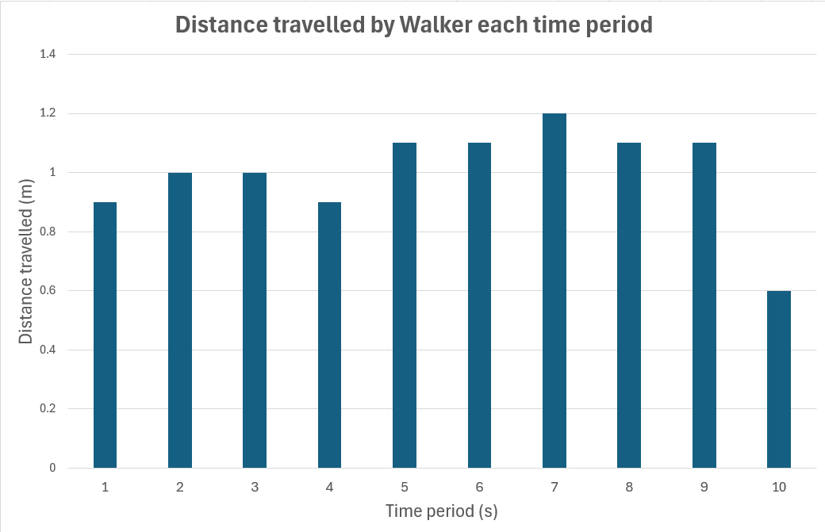

Potential discussion prompts
- What does each column represent on the graph?
  - The distance travelled each second.
- During which time period did the Walker travel the fastest? How do you know?
  - The tallest column means Walker travelled the greatest distance in the time period (fastest).
- Why might the Walker have travelled more slowly during some time periods?
  - The Walker might have been talking to a friend or slowed down other times to keep step with the Timer. The Marker might not have been ready to place the cone in the correct position.
- How could we work out the average speed that Walker travelled?
  - By dividing the total distance travelled by the total time taken.
Discuss if the Markers were able to accurately record the position of the Walker. Consider any errors and how that would affect the shape of the column graph.
Discuss how a constant speed on the graph could be shown with a horizontal line (line of best fit).
(Slide 16-17) Discuss how the graph might change if the Walker were moving faster (travelling at a greater speed).
Allow students to repeat the investigation and measurements with the Walker travelling faster.
✎ STUDENT NOTES: Record the location of each cone on the 10 m tape. Calculate the distance travelled during each time period (1 second). Draw a second graph of the distance travelled during each time period (every second).

Integrate • Graphing speed
(Slide 18) Compare the two graphs, noting that there are fewer columns on the second (fast walking) graph and that the columns are taller. Discuss how a person travelling faster moves a longer distance during each time period.

Potential discussion prompts
- Is this what you expected the graph to look like?
- How is this graph different to the first graph?
  - The columns are taller, and there are fewer of them.
- Why are the columns longer?
  - The Walker travelled further during each time period.
- During which time period did the Walker travel the fastest?
- During which time period did the Walker travel the slowest?
- How could we calculate the average speed of the Walker during this investigation?
✎ STUDENT NOTES: Answer the discussion questions on the Measuring speed Resource sheet.
Discuss how speed was defined in the last lesson as the distance travelled per unit of time, but it can also mean that someone takes less time to travel the same distance.

Potential discussion prompts
- How did we define speed in the last lesson? Can you explain it in your own words?
- In a 100 m running race, one person finishes in 15 seconds, while another person finishes in 11 seconds. Who wins the race? Why do you say that?
  - When running the same distance, the person who runs the shortest time wins.
- What does it mean to “take less time to travel the same distance”? How is that related to speed?
- If your speed doubles, does it take you more or less time to travel the same distance?
(Slide 19) Draw a table with two columns: ‘High speed/Fast’ and ‘Low speed/Slow’. Discuss with students where each of the following should be placed:
- Takes longer to travel 10 m
- Takes less time to travel 10 m
- Travels further in 10 s
- Travels a shorter distance in 10 s
✎ STUDENT NOTES: Students add the completed table in their notes.
High speed/Fast | Low speed/Slow
Takes less time to travel 10 m | Takes longer to travel 10 m
Travels further distance in 10 s | Travels a shorter distance in 10 s
Discuss how autonomous cars control the speed they travel. Some cars use GPS to measure how far they have travelled in a set time period. This is used to calculate their speed.
Pose the question: What happens if the internet connection is not reliable? Could this affect the speed of the car?
Discuss how autonomous cars may need to maintain their ‘current’ speed when driving in remote areas. This may be done by measuring the speed the wheels turn and sending the data to the control module. When this changes, the autonomous car sends information to the throttle so that the speed is maintained.

Reflect on the lesson
You might invite students to:
- research the way non-autonomous cars measure their speed (for the speedometer).
- explain the relationship between speed, distance and time in their own words.
- research how autonomous cars use GPS to measure speed.

Y10

Newton meets AI • Lesson 3 • Think fast
Lesson 3
INQUIRE
To read the most recent version of this lesson, download associated resources, and view embedded professional learning including classroom videos and work samples, visit: https://scienceconnections.edu.au/teaching-sequences/year-10/newton-meets-ai/lesson-3-think-fast

Lesson overview
Students measure their reaction time, then calculate the distance that a car will travel during that reaction time.

Key learning goals
Students will:
- identify people who may need autonomous cars.
- develop questions about how driving decisions are made in autonomous cars.
- determine the impact of distractions on reaction time.
Students will represent their understanding as they:
- use speed-time graphs to calculate the stopping distances of distracted drivers.
- plan and conduct an experiment that examines the impact of distractions on reaction time.
- draw speed-time graphs to represent the impact of different reaction times.

Assessment advice
In this lesson, assessment is formative.
Feedback might focus on:
- students’ ability to quantitatively analyse the relationship between speed, distance, and time.
- students’ ability to plan and conduct an experiment.
- students’ ability to process and analyse data.
- students’ ability to evaluate the validity of a claim or argument.
Potential summative task
Students working at the achievement standard should:
- investigate a moving object to analyse and propose relationships between distance, time, and speed.
- plan and conduct safe, valid, and reproducible investigations to test relationships.
- select equipment and use it efficiently to generate and record appropriate sample sizes and replicable data with precision.
- select and construct effective representations to organise, process, and summarise data and information.
- analyse data to identify and explain patterns.
- evaluate the validity and reproducibility of methods and the validity of claims.
- construct logical arguments based on analysis of evidence to support conclusions and evaluate claims.
Refer to the Australian Curriculum content links on the Our design decisions tab for further information.

List of materials
Whole class
- Newton meets AI Resource PowerPoint
- Videos:
  - How do self-driving cars work? (3:16)
  - The hidden autopilot data that reveals why Teslas crash (11:05)
  - Meet Graham, TAC’s interactive sculpture by artist Patricia Piccinini (2:35)
Each group
- Sticky notes
- 1 m ruler
- Stopwatch
- Timer or smartphone with timer app
- Distraction object (e.g. loud sound, flashing lights, or a talking partner)
- HIGH TECH ALTERNATIVE: Any reaction timer website which measures how long the user takes to press a button
Each student
- Individual science notebook
- Reaction time Resource sheet

Lesson routine | Estimated time | Task type
Re-orient | 5 minutes | Whole class
Question | 10 minutes | Whole class
Investigate | 30 minutes | Small group
Integrate | 20 minutes | Small group/Whole class

Inquire

Re-orient
Discuss the challenges being faced by drivers when travelling on the roads. Ask students to identify the risks of drivers driving past the school, such as students chasing a ball onto the road or drivers opening car doors suddenly.

Question • Autonomous car safety
Pose the question: How would autonomous cars identify these hazards?
Discuss how autonomous cars are a recent technological development and many people do not know much about them. Explore how self-driving cars would support people who may have difficulty driving themselves, and how the needs of some people in society can drive the development of science and technology. Suggest that it might be useful to share what we do know.
Pose the question: What do we need to know about autonomous cars to decide if they are safe?
(Slide 21) Encourage students to collate information on autonomous cars on a series of sticky notes. Provide students time to write down all they know about autonomous cars on sticky notes (one idea/note). Collect the notes in one area and, if appropriate, sort the notes into general topics (e.g. mechanical-related, safety-related, software-related).
(Slide 22) Encourage students to brainstorm any questions they have about autonomous cars. Outline the rules for brainstorming:
- Ask as many questions as you can.
- Do not stop to discuss, judge, or answer questions.
- Write down every question exactly as it is stated.
- Change any statement into a question.
Collect the questions and collate them into groups of common questions related to the topic (e.g. sensor-related, accidents, programming decisions, driver/passenger-related).
(Slide 23) Show the video How do self-driving cars work? Artificial intelligence for STEM kids (3:16).
Draw on student questions related to safety and the previous discussion about the hazards of driving past the school. Flag the need for drivers to react quickly, particularly near a school.
Pose the question: How fast could you react (hit the brakes) to a child running onto a road?

Investigate • Distracting reactions
Explain to students that they can measure how long it takes for a person to react when stopping a car.
Wonder aloud what it would be like to drive with many people in the car. Do drivers become distracted?
Provide students with a copy of the Reaction time Resource sheet.
(Slide 24) Explain that students will be measuring how quickly they would react if they were driving a car. First, they will test without distractions.
✎ STUDENT NOTES: Complete the first section of the Reaction time Resource sheet, including writing a hypothesis on the first page.
Outline the reaction time test:
- Student 1 holds the ruler vertically above Student 2’s thumb and forefinger. The ‘0’ of the ruler should be equal with the thumb and forefinger.
- Student 1 drops the ruler randomly (without warning) and Student 2 tries to catch it as quickly as possible between their thumb and forefinger.
- Record the position of Student 2’s fingers on the ruler in cm.
Discuss how the experiments must be repeated several times to ensure the reliability of the test.
Allow students time to complete this test without distractions.

Potential discussion prompts
- Was the method used valid? Does the test allow reaction times to be tested effectively?
- Was the sample size large enough?
- Were all the variables identified and controlled?
- Is the test reproducible?
- Are the results clearly and accurately shown?
- Is the analysis of results reliable (and not overstated)?
- Are the limitations of the test, results and analysis described?
(Slide 25) Discuss how the experiment could be repeated with a variety of distractions, including having a conversation, a noisy classroom, flashing lights, etc.
✎ STUDENT NOTES: Students plan how to modify the test to determine if distractions affect a driver’s reaction time.

Potential discussion prompts
- What type of distractions could affect a person’s reaction time?
- How could you control the environment to test reaction times with and without distractions?
- Who will have their reaction times tested? Why did you choose that person?
- How could you make sure your test is reliable?
- Why do you think you may need to repeat the test many times?
- How will you collect or record your data?
- What variable might be difficult to control?
- How will you make sure your experiment is safe and respectful to everyone?
✎ STUDENT NOTES: Students conduct their experiment and gather and record data.

Integrate • Distracting consequences
Text Discuss the results of students’ experiments, including the types of distractions used and the effect of distraction on reaction time. Identify the similarities in the way each group conducted their experiment and explore the purpose of the similarities. For example, some groups may have used noise as well as visual distractions. Most groups would have used a single person as their test subject (controlling a variable).
Identify the commonalities of the results: distraction increased the reaction time of an individual.
Draw a speed-time graph of a car travelling at a steady 60 km/h (16.67 m/s). This will be a horizontal line.
(Slide 26) If required, describe how 60 km/h is equivalent to 16.67 m/s: 1 kilometre = 1000 metres and 1 hour = 3 600 seconds, so 1 km/h can also be written as 1000/3 600 = 0.28 metres/second.
(Slide 27) Use the graph to tell a story of a car travelling at a constant speed of 16.67 m/s (60 km/h) when a child runs onto the road. Describe how the driver hits the brake at 0.35 seconds and then the car starts to slow down.
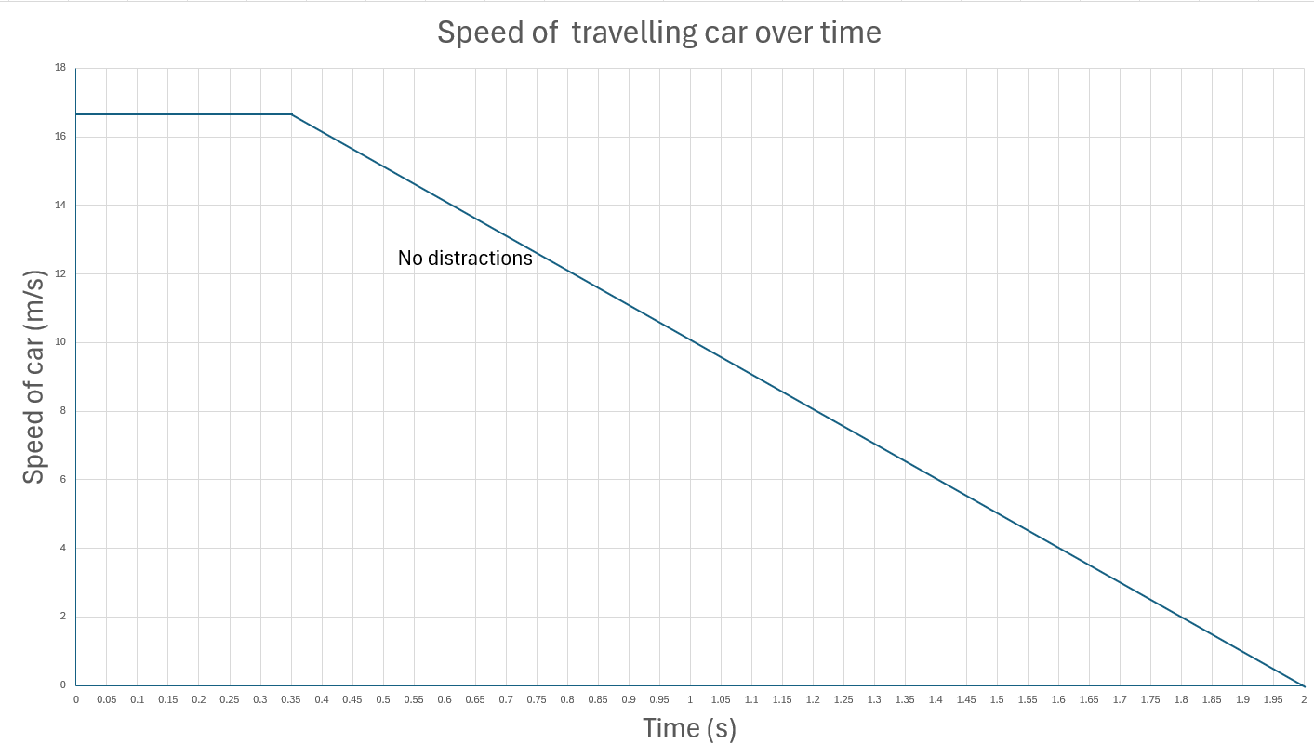

Potential discussion prompts
- When did the driver react?
  - From the graph, 0.35 seconds.
- How does this compare to your reaction time measurements with and without distractions?
- How does the speed change once the driver starts braking?
- How does the graph show this?
- From this graph, how much time does it take for the car to stop?
✎ STUDENT NOTES: Draw the graph in notebooks with the speed and the reaction times and final stopping times.
(Slide 28) Discuss how distractions mean that the human driver takes longer to react (distraction reaction time = 0.95 s versus no distraction time = 0.35 s).

Potential discussion prompts
- Are both cars driving at the same speed? How is this represented on the graph?
- When did the non-distracted driver start braking? How do you know this?
- How does the quicker reaction time change the total amount of time it takes for the car to stop?
- Would a shorter time to stop affect the distance the car travels?
- How would a shorter stopping time affect the distance the car travels?
Pose the question: Which car would take a longer distance to stop?
(Slide 28 animation) Explain that this can be worked out using the graph. Identify the length of time it took for the distracted driver to start applying the brakes (0.95 s) and the speed (16.67 m/s). Draw the rectangle under the graph and calculate the area (15.84 m). Remind students that this is the distance the car travels before braking starts.
(Slide 28 animation) Compare the distance travelled by the distracted driver to the distance the non-distracted driver travels before braking: time (0.30 s) x speed (16.67 m) = 5.00 m.
✎ STUDENT NOTES: Describe how the distance travelled by the car can be determined from the area under a speed/time graph. Write the calculations for the distance both cars travel in a notebook.

Potential discussion prompts
- How much further does the distracted driver travel compared to the non-distracted driver?
- How does this affect the overall stopping distance of the cars? Which car will travel further?
- Do both cars brake in the same way?
  - Yes. The lines that show the cars braking on the graph are parallel. This shows that both cars brake in the same way.
- How long does it take for both cars to stop after the brake was applied?
  - 3.05 seconds.
- How could we work out how far the cars travel during the braking?
  - By calculating the area under the graph.
- Would both cars have the same braking distance?
  - Yes. The slopes of the cars slowing are the same angle and size. This means the area under the graph (distance travelled) is the same.
(Slide 28 animation) Support students to calculate the area under the graph (a triangle) for both cars to compare and confirm that both cars travelled the same distance while braking.
$$Braking distance=\frac{1}{2}base×height \left(graph\right) \\ =\frac{1}{2}time \left(s\right) ×speed \left(m/s\right) \\ =\frac{1}{2}×3.05×16.67 \\ =25.42m$$
Discuss how the distance travelled by the two cars (reaction distance + stopping distance) is different:
- Non-distracted driver = 30.42 m
- Distracted driver = 41.29 m.
✎ STUDENT NOTES: Record the calculations in your notebook.
(Slide 29) Explain that there are other ways to calculate the distance travelled. Compare the calculations of reaction times (not braking times) from the graphs to the speed equation from the previous lesson. Support the students to rearrange the ‘Speed’ equation and model the calculation of the distance travelled during the reaction time.
From:
$$Speed=\frac{distance travelled}{time taken}$$
To:
$$Distance=speed×time$$
✎ STUDENT NOTES: Use the above formula to calculate the distance the car would travel before its driver would start braking (with and without distractions).
Compare the two approaches (graph and equation) to determine the same answer. Discuss how the equation could not be used to determine the distance travelled by the slowing down car.
(Slide 30) Pose the question: Would an autonomous car react faster than human drivers?
Discuss how autonomous cars have a reaction time of 0.1 s once the risk has been identified.
(Slide 31) Compare the reaction distance and stopping distance of a (non-distracted) human driver and an autonomous car.

Potential discussion prompts
- How much quicker is the autonomous car in applying the brake?
- How would this affect the distance travelled by the car before it stops?
- How could we calculate this?
(Slide 32-33) Allow students time to calculate the area under the autonomous car graph: $$reaction time+stopping time=1.67m+25.42m=27.09m$$
Compare all three stopping distances:
- Autonomous car = 27.09 m
- Non-distracted driver = 30.42 m
- Distracted driver = 41.29 m
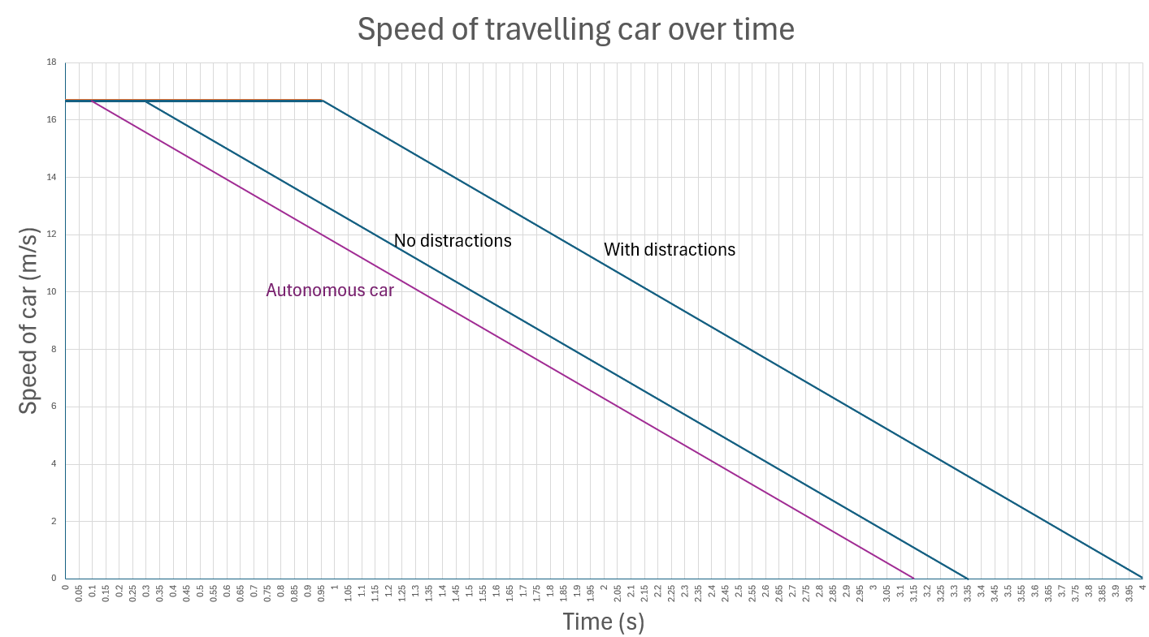 (Slide 34) Encourage students to use argumentation to make a claim supported by evidence and reasoning to answer the question: Would autonomous cars make it safer to walk to school?.
✎ STUDENT NOTES: Students make claims supported by evidence and reasoning. For example:
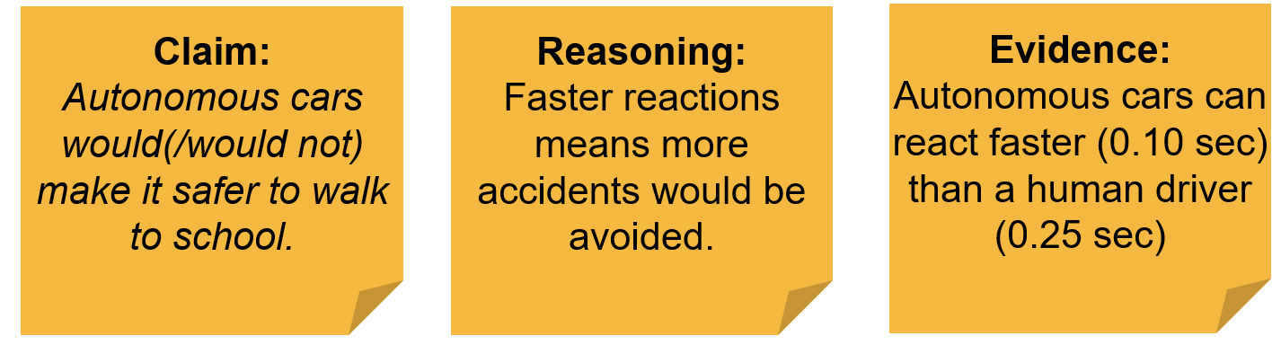 Pose the question: Do autonomous cars become distracted?
Show the first 3:18 minutes of The hidden autopilot data that reveals why Teslas crash (11:05). This video includes footage of car accidents (the crashes become more disturbing beyond 3:18 minutes). Before playing the video, consider whether any students might have been impacted by vehicle accidents. Provide these students with a warning about the content and an opportunity to leave the room if required.
Remind students of the earlier video about how most autonomous vehicles use a variety of sensors to detect the environment around the car, and that the sensitivity of the sensors will improve over time.
Discuss if any students want to modify their claims in light of the new evidence. Explain how this is how scientists constantly revisit hypothesis and concepts when new data becomes available.
✎ STUDENT NOTES: Rewrite argumentation claims in light of new data.
Discuss how students will examine the way cars brake and how the programmers of autonomous cars could use this to minimise accidents in future lessons.

Reflect on the lesson
You might invite students to:
- investigate the safety features used in modern cars.
- explore Project Graham, an art project developed to design “the only person who could survive a car accident”.

Y10

Newton meets AI • Lesson 4 • Stopping in time
Lesson 4
INQUIRE
To read the most recent version of this lesson, download associated resources, and view embedded professional learning including classroom videos and work samples, visit: https://scienceconnections.edu.au/teaching-sequences/year-10/newton-meets-ai/lesson-4-stopping-time

Lesson overview
Students examine data that compares the speed a car travels and the stopping distance of the car. They identify that the faster a car travels, the longer it takes to stop and the further it travels. Students are introduced to the concept of acceleration.

Key learning goals
Students will:
- understand that total stopping distance = reaction distance + stopping distance.
- use a computer model to test how starting speed affects the total stopping distance of a car.
- use a computer model to test other factors (tyres, road surface, or weather) that affect the stopping distance of a car.
Students will represent their understanding as they:
- plan and conduct an experiment that examines factors that affect the stopping distance of a car.
- analyse the results and draw conclusions of an experiment that examines factors that affect the stopping distance of a car.
- use argumentation to provide advice to an autonomous car manufacturer related to how the car should drive on different road surfaces, weather, or worn tyres.

Assessment advice
In this lesson, assessment is formative.
Feedback might focus on:
- students’ ability to quantitatively analyse the relationship between speed, distance and acceleration.
- students’ ability to plan and conduct an experiment.
- students’ ability to process and analyse data.
- students’ ability to evaluate the validity of a claim or argument.
Potential summative assessment
Students working at the achievement standard should:
- investigate a moving object to analyse and propose relationships between distance, speed and acceleration.
- plan and conduct safe, valid and reproducible investigations to test relationships.
- select equipment and use it efficiently to generate and record appropriate sample sizes and replicable data with precision.
- select and construct effective representations to organise, process and summarise data and information.
- analyse data to identify and explain patterns.
- evaluate the validity and reproducibility of methods and the validity of claims.
- construct logical arguments based on analysis of evidence to support conclusions and evaluate claims.
Refer to the Australian Curriculum content links on the Our design decisions tab for further information.

List of materials
Whole class
- Newton meets AI Resource PowerPoint
- Video: Eddie Woo discusses stopping distances and speed (2:05)
Each student
- Individual science notebook
- Access to It’s a drag website interactive
- Braking distance Resource sheet

Lesson routine | Estimated time | Task type
Re-orient | 5 minutes | Whole class
Question | 10 minutes | Whole class
Investigate | 25 minutes | Individual
Integrate | 15 minutes | Whole class/Small groups

Inquire

Re-orient
Discuss the time it takes to start braking (the reaction time) when driving a car. Recall the type of distractions that a car driver might experience and how this could impact their driving time.
Discuss the distraction that had the biggest impact on the reaction time and the impact it had on the stopping distance (calculated from the area under the graph).

Question • What happens when we brake?
Pose the question: What factors could affect how quickly the brakes slow you down?
(Slide 36) Brainstorm all the factors that could affect the effectiveness of the brakes, including the speed of the car, tire wear, type of road surface, and weather conditions.
Pose the question: How would these factors affect the ability of a car to brake?

Investigate • Braking distance
Explain to students that they will be using an online simulator to model how long it takes for a car to stop.
Students will need access to the It’s a drag website interactive. Provide students with a copy of the Braking distance Resource sheet.
(Slide 37) Discuss how scientists use models to represent, explain, and predict real-world phenomena that may be too complex, dangerous, or impractical to observe directly. All models have their limitations but they can help simplify things so that scientists can gain a greater understanding. In this instance, the digital model is simplified and uses mathematical equations as part of the programming.
(Slide 38) Explain that students will be measuring the distance a car will travel before it is able to stop. This distance is divided into two parts: the distance travelled during the reaction time and the distance travelled during the braking time.
Demonstrate the It’s a drag simulation and identify the reaction time and the braking distance.
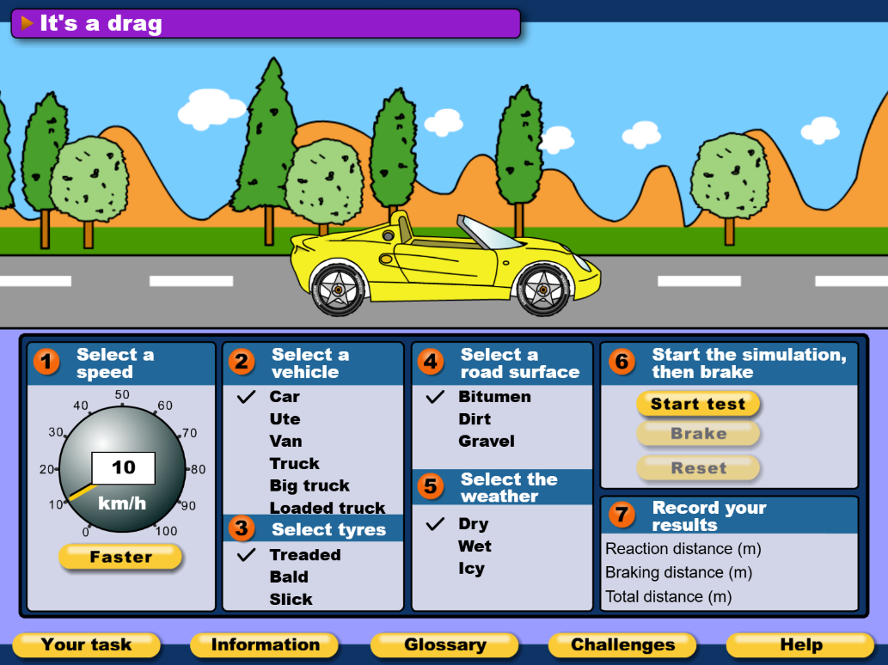
Relate these to the graphs from the previous lesson.
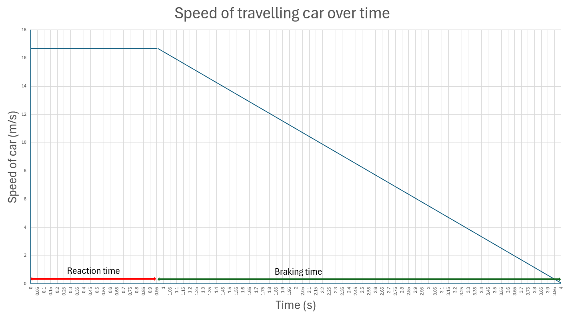
In this part of the experiment, students will determine how the initial speed of the car affects the total stopping distance. Students will be increasing the speed of the car in 20 km/h increments. Discuss the need for experiments to be repeated several times to ensure the reliability of the test.
(Slide 39) ✎ STUDENT NOTES: Complete the tests and draw a graph of the relationship between starting speed and braking distance.
Discuss students’ findings.

Potential discussion prompts
- What type of model are you using?
- What are the limitations of this model? What doesn’t it do or show?
- Why is it important to practice using the braking simulation before starting your tests?
- What could happen if you didn’t understand how the program works before collecting data?
- What is the difference between reaction distance and stopping distance?
- Why can’t we just look at the braking distance when thinking about a car’s total stopping distance?
(Slide 40-41) In the second part of this experiment, students select different tyres, road surface, or weather as the independent variable. This can be done by allocating independent variables to each group of students and providing time for students to report back to the class. The effect of mass on a vehicle’s stopping distance will be covered in the next lesson, so the vehicle type should not be used as an independent variable at this stage.

Potential discussion prompts
- Why do you change only one variable in your tests?
- What is your independent/dependent variable?
- Will the braking time of an autonomous car be different to the braking time of a human driver?
  - While the reaction time will be different between autonomous cars and humans, the braking time should not change.
- How do you think tyres/road surface/weather will affect the braking distance?
- Why do you think tyres/road surface/weather will increase the braking distance?
- How do the brakes work to stop the car?
- How will the tyres/road surface/weather affect the friction between the road and the tyres?
- How does this affect the stopping distance of the car?
✎ STUDENT NOTES: Complete the tests that examine the relationship between tyres or road surface or weather and stopping distance.

Integrate • Introducing acceleration
(Slides 42-43) Discuss the results of the experiment. The results should show that a faster starting speed of the car will result in a longer stopping distance.
✎ STUDENT NOTES: Draw a graph of the results.
Compare the student graph to slide 42.
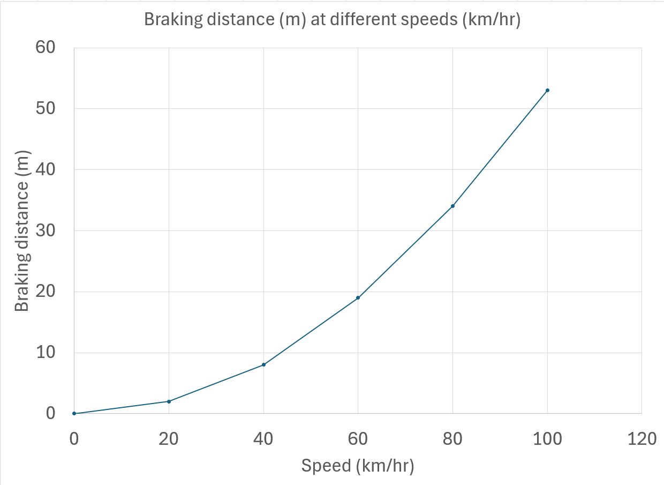
Discuss students’ findings and reflect on the implications for school zones and autonomous cars.

Potential discussion prompts
- What trend did you notice between the car’s starting speed and the total stopping distance?
- Did stopping distance increase steadily, or was the increase more dramatic at higher speeds?

- What pattern did you observe between the car’s speed and braking distance when the car speed was doubled from 20 km/h to 40 km/h?
  - The braking distance should increase by approximately a factor of 4 (2²).
    - This can be calculated using the equation
$Velocity^{2}=initial velocity^{2}+2×acceleration×displacement$ and solving for displacement.
    - Students are not expected to understand the mathematical reasoning for this at this stage—noticing that the braking distance is closely related to the car’s speed is sufficient.
- How much did the braking distance increase when the speed increased by a factor of 3 (20 km/hr to 60 km/hr)?
  - The braking distance should increase by a factor of 9 (3²).
- How much did the braking distance increase when the speed increased by a factor of 4 (20 km/hr to 80 km/hr)?
  - The braking distance should increase by a factor of 16 (4²).
- Why do you think speed limits are lower near schools?
- How could your experiment results help explain the danger of speeding in school zones?
- If a child suddenly ran into the street near a school, how would a driver’s speed affect their ability to stop in time?
- Should speed limits in school zones be enforced more strictly based on this data? Why or why not?
- How could the data from this experiment be used to help self-driving cars make safer decisions?
- What kinds of sensors or programming might an autonomous car need to calculate stopping distance in real time?
(Slide 44) Students provide a summary of the results of their investigation into the effects of bald tyres/road surface/weather on the braking distance.

Potential discussion prompts
- What factors did you need to control in your test?
- How did the factor you investigated affect the braking distance of the car?
- Why do you think the bald tyres/road surface/weather had this effect?
- What do you think would happen if these factors were combined (bald tyres in wet weather)?
- Do you think the effects would be additive?
✎ STUDENT NOTES: Complete the discussion questions on the Braking distance Resource sheet.
(Slide 45) On the graph, draw students’ attention to how quickly the speed of the car changes (a starting speed of 60 km/h and a final speed of 0 km/h). Identify the downward slope or gradient of the graph as an indication of the car slowing down.

Potential discussion prompts
- On the graph, how much does the speed change each second?
- Is it the same change each second?
- Does this mean it is speeding up or slowing down?
- What would a graph of a car with better brakes (stops faster) look like?
Pose the question: What would the graph/slope look like if the car were speeding up?
Discuss how the slope of the graph describes the acceleration of a car. Sloping up is positive acceleration (speeding up), and sloping down is negative acceleration (slowing down).
(Slide 46) Define acceleration as “the rate at which speed and direction changes”. Explain that acceleration can be positive (as an object increases its speed from 0 km/h to 60 km/h) or negative (as an object decreases its speed from 60 km/h to 0 km/h).
NOTE: The Australian Curriculum does not include the vectors of displacement or velocity. If your state curriculum includes vectors at this level, it is worth including extra Inquire phases to introduce this content.
✎ STUDENT NOTES: Write the definition of acceleration as “the rate that speed and direction changes”. Draw a graph showing positive acceleration and negative acceleration.
Show Eddie Woo discusses stopping distances and speed (2:05).
✎ STUDENT NOTES: Include examples of positive and negative acceleration from the video.
(Slide 47) Discuss how autonomous cars might need to modify the way they accelerate and drive on different road surfaces, weather, or as tyres wear out.
✎ STUDENT NOTES: Use argumentation (claim, reasoning, and evidence) to write at least one recommendation to an autonomous car manufacturer related to the way a car should drive on different road surfaces, weather, or as tyres wear out.

Reflect on the lesson
You might invite students to:
- explain how stopping distance calculations can be used to determine the speed limits on roads—for example, high-use roads that have pedestrians will usually have lower speed limits than roads with fewer pedestrians.
- re-examine the intended learning goals for the lesson and consider how they were achieved.

Y10

Newton meets AI • Lesson 5 • Does mass matter?
Lesson 5
INQUIRE
To read the most recent version of this lesson, download associated resources, and view embedded professional learning including classroom videos and work samples, visit: https://scienceconnections.edu.au/teaching-sequences/year-10/newton-meets-ai/lesson-5-does-mass-matter

Lesson overview
Students examine Newton’s second law and how it relates to vehicles of different masses. They explore how a car full of people takes longer to stop.

Key learning goals
Students will:
- use three activities to explore the relationship between acceleration, mass and force.
- use evidence from the activities to make a claim about how autonomous car manufacturers should modify their programming when there are many passengers.
Students will represent their understanding as they:
- explain the relationship between force, mass and acceleration.
- use argumentation to make a claim about how autonomous car manufacturers should modify their programming when there are many passengers.

Assessment advice
In this lesson, assessment is formative.
Feedback might focus on:
- the relationship between force, mass and acceleration.
- the examples students use to illustrate Newton’s second law of motion.
- students’ ability to identify the need for lower speed limits near schools or for trucks in urban environments.
- construct arguments based on analysis of a variety of evidence to support conclusions or evaluate claims.

List of materials
Whole class
- Newton meets AI Resource PowerPoint
- Video: STEMonstrations: Newton’s second law of motion (2:40)
Each group
- Elastic strip or elastic bands looped together
- Long smooth board with two nails placed 10 cm from one end, close to the sides of the board (see diagram under Activity 1: Move the car)
- Physics cart or toy car with minimal friction
- 4 x 50 gm mass
- Sticky/masking tape
- Ruler
- Stopwatch
- Retractable tape measure
Each student
- Individual student notebook
- Newton’s second law Resource sheet

Lesson routine | Estimated time | Task type
Re-orient | 5 minutes | Whole class
Question | 5 minutes | Whole class
Investigate | 30 minutes | Small groups
Integrate | 20 minutes | Whole class/Small groups

Inquire

Re-orient
(Slide 49) Discuss how an autonomous car has a faster reaction time and how this reduces the overall stopping distance of the car.
Pose the question: How closely should you follow an autonomous car?
Discuss how an autonomous car will react faster than a human driver to the same stimuli, and so a human driver would need to leave more distance between their car and an autonomous car in front. This would give the human more time to react if the autonomous car were to suddenly stop.
Pose the question: What other factors would be useful to notice about the driving conditions that would hint at a car’s stopping time (negative acceleration)?
(Slide 50) Discuss how bald tires, loose road surfaces and wet weather affect a car’s negative acceleration and cause the stopping time/distance to increase. Discuss which line on the graph would represent a car’s negative acceleration on a wet or dry road.
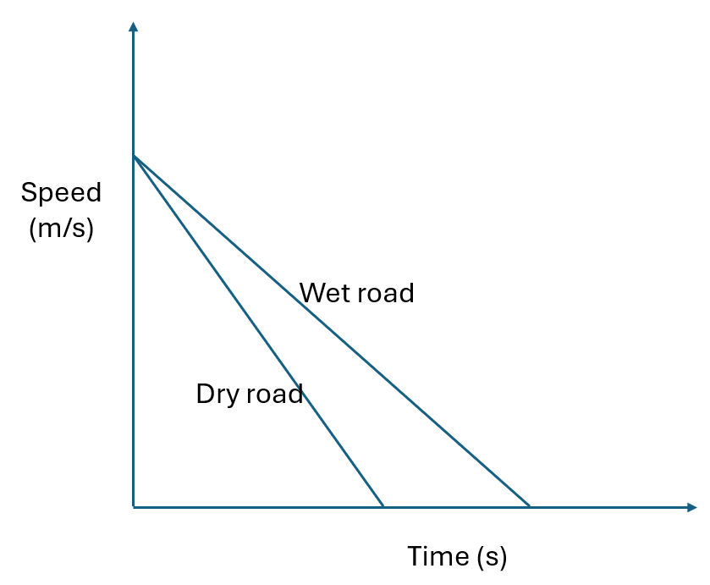
(Slide 51) Pose the question: What does this graph tell you about how the car is moving?

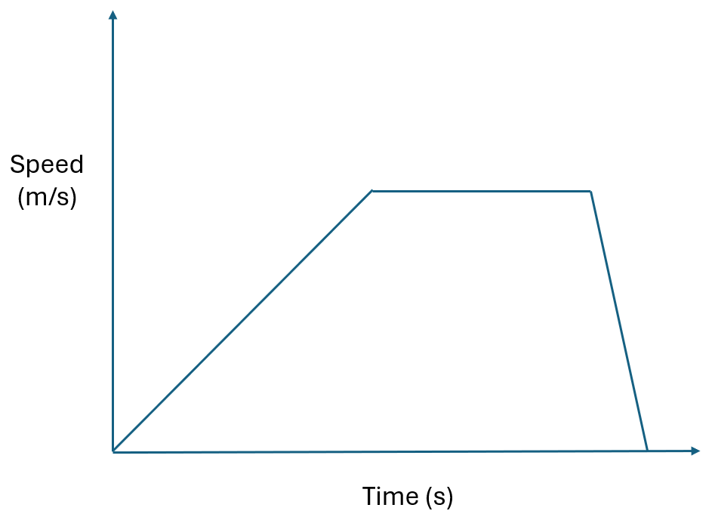

Potential discussion prompts
- How is the speed of the car changing at the start of the graph?
  - The car’s speed starts at 0 m/s and increases over time. This means the car is accelerating.
- Does the speed of the car change in the middle of the graph? What is the car’s acceleration at this point?
  - The car does not change its speed in the middle of the graph. There is no acceleration (a=0 m/s).
- What happens to the car’s speed at the end of the graph?
  - The car slows down.
- How quickly does the car stop? How can you tell this from the graph?
  - The car slows down quickly (high negative acceleration). We know this because of the steep slope of the graph.

Question • Loaded car
(Slide 52) Pose the question: Will a car’s acceleration (negative or positive) change if there are a lot of people in the car?
Discuss mass in terms of the number of people in a car—more people means that the car has more mass.
Pose the question again: Does the number of people in a car affect its acceleration?

Investigate • Newton’s second law
✎ STUDENT NOTES: Record the question: Does the number of people in the car affect its acceleration?
(Slide 53) Discuss how students will do two activities to help them answer this question. Provide students with a copy of Newton’s second law Resource sheet, which outlines the following two activities.

Activity 1: Move the car
Students use a slingshot to generate a constant force to move a toy car. Mass is added to the car and the measurements are repeated.

- Tie the length of elastic to the two nails on the board.
- Place the toy car in the centre of the board against the elastic.
- Pull the toy car and elastic towards the end of the board. Use the ruler to measure how far the elastic has stretched. Record this measurement.
- Release the car so that it rolls along the board. Use the stopwatch to measure how long it takes for the car to reach the end of the board. Record the time.
- Repeat steps 2-4 another two times with the car and elastic pulled back to the same starting mark.
- Use the tape to add a 50g mass on top of the car. Make sure the wheels of the car are not affected by the tape.
- Repeat steps 2-4 three times with the mass on the top of the car, using the same starting mark.
- Repeat steps 6-7 (the car now has 2 x 50g masses).

Activity 2: Tape measure race
Students will time how long it takes for a retracting tape measure to fully retract, with and without a weight added to the end.
- Extend the tape measure to 2 metres and lock it into place.
- Tape a 50 g mass to the end of the tape measure.
- Release the lock and measure the time taken for the tape measure to fully retract. Record your measurements.
- Repeat steps 1-3 two further times. Determine the average time for the tape measure to retract.
- Repeat steps 1-4 for 100 g.
✎ STUDENT NOTES: Students complete Newton’s second law Resource sheet.

Potential discussion prompts
- What is the force we are using in this activity?
- How do you think the mass will make a difference?
- If a car takes more time to travel along the board, what does this mean about the way it is accelerating?
  - More time to travel the same distance (from 0) means the acceleration is less/slower.
- How did doubling the mass on the car affect the acceleration of the car?
  - Doubling the mass should almost halve the acceleration. This is an indication rather than a mathematical model as other factors are involved (i.e. the friction of the wheels).
- How did adding mass to the tape measure affect the way it retracted?
- The size of the force in the tape measure did not change. So how did the acceleration change when the mass was added?

Integrate • Force, mass, and acceleration
Discuss how the two activities explored the relationship between force, mass and acceleration.
(Slide 54) Discuss how the activities used a constant force. Encourage students to consider how the acceleration of both the car and the tape measure decreased when mass was increased. This means that as the mass increased, the movement was slow to start and acceleration (change in speed and direction) was less, with the same force.

Potential discussion prompts
- What was the force that moved the car?
- How did you make sure the force was the same in both cases?
- How did the car accelerate (change its speed) when the force was applied?
- How did adding the mass change the acceleration of the car?
- How did doubling the mass change the acceleration of the car?
  - Doubling the mass reduced the speed from the slingshot and the time taken for the car to reach the end of the board.
- How did the end of the tape measure accelerate (change its speed) as it retracted?
- What provides the force for the tape measure to retract?
  - The spring inside the tape measure.
- Was this force different for the two different masses?
- If the force did not change, what did change when you increased the mass?
  - The acceleration decreased when more mass was added.
Explain how Sir Isaac Newton called this his second law of motion. Discuss how the equation F=ma means that as the mass increases (doubles), the acceleration will decrease (halve) if the force is constant.
(Slide 55) ✎ STUDENT NOTES: Write Newton’s second law of motion, “Force = mass × acceleration”, and provide an explanation and example in your own words.
Pose the question from the beginning of the lesson: Does the number of people in a car affect its acceleration?
Discuss how more people in a car increases its mass and that this affects positive and negative acceleration. A car engine will need to provide a greater force to accelerate in the same way.
(Slide 56) Discuss how more people in the car will make it harder for the car to come to a stop (negative acceleration). A car will have a greater stopping distance.

Potential discussion prompts
- How fast does a car full of people accelerate compared to a car with no passengers?
- Does this mean the car engine needs more or less force to accelerate at the same rate?
- What about slowing down? Does a car full of people need more or less force to slow down compared to a car with no passengers?
- Can you brake with more force if you have a car full of passengers?
  - In an emergency, most drivers will ‘slam on the brakes’ as hard as they can, regardless of the number of passengers. Although the greater mass of many passengers does increase the friction, this does not affect the available friction between the brake pads and the wheels.
- How will the stopping distance change if you have a car full of passengers?
(Slide 57) ✎ STUDENT NOTES: Use argumentation and the evidence from the activities to make a claim of how autonomous cars may need to change their driving programs when there are many passengers.

Reflect on the lesson
You might invite students to:
- consider how a driver might change the amount of space between the car in front and their car when they have many passengers.
- research how sensors could be used to determine the number of passengers in a car.
- re-examine the intended learning goals for the lesson and consider how they were achieved.

Y10

Newton meets AI • Lesson 6 • Seatbelt Safety
Lesson 6
INQUIRE
To read the most recent version of this lesson, download associated resources, and view embedded professional learning including classroom videos and work samples, visit: https://scienceconnections.edu.au/teaching-sequences/year-10/newton-meets-ai/lesson-6-seatbelt-safety

Lesson overview
Students examine a variety of examples of Newton’s first law in practice. They then apply this law to the need for seatbelts in all cars that brake rapidly.

Key learning goals
Students will:
- make a series of observations of examples of Newton’s first law.
- use previous observations to make a hypothesis for new examples of Newton’s first law.
Students will represent their understanding as they:
- write a series of hypotheses related to examples of Newton’s first law.
- draw conclusions as a result of comparing examples of Newton’s first law.

Assessment advice
In this lesson, assessment is formative.
Feedback might focus on:
- students' use of examples to explain Newton’s first law of motion.
- students’ ability to identify the key factors that contribute to their science knowledge and practices being adopted as they learn to drive.
- students’ ability to develop hypotheses to test relationships and develop explanatory models.

List of materials
Whole class
- Newton meets AI Resource PowerPoint
- Videos:
  - Forces and motion: the physics of car crashes (2:40)
  - Newton’s law of inertia (0:10)
  - Newton’s first law demo (0:05)
  - Will I fall? Newton’s first law (0:34)
  - Optional: STEMonstrations: Newton’s first law of motion (4:19)
Each group
- 50g weight
- A4 paper cut in half longways

Each student
- Individual student notebook
- Newton’s first law Resource sheet

Lesson routine | Estimated time | Task type
Re-orient | 5 minutes | Whole class
Question | 5 minutes | Whole class
Investigate | 30 minutes | Small group/Whole class
Integrate | 20 minutes | Small group/Whole class

Inquire

Re-orient
Review Newton’s second law of motion which states that the amount of force needed to accelerate is dependent on the mass ($F=ma$). Relate this to the force needed to accelerate a car full of passengers compared to a car containing only a driver.
Discuss how the amount of stopping force from the brakes does not change if the car is loaded with passengers or not. If the force and the mass cannot change, this means the negative acceleration will be less (it will take longer for the car to come to a stop).

Question • Sudden stop
Discuss how the brakes increase the friction between tyres and the road, causing the car to stop.
(Slide 59) Pose the question: What happens to the driver and passengers when the car stops suddenly?

Routine name • Step name
Provide students with a copy of Newton’s first law Resource sheet. Explain that you will be watching some short videos that explore what happens when objects start or stop moving.
Introduce the first video of a car crash involving test dummies without seatbelts. Some students may find watching the test crash stressful—discuss different options for these students so they are included in the learning, e.g. turning away from the screen or leaving the room and having friends describe what happened.
✎ STUDENT NOTES: Write a hypothesis about what will happen to the dummies during the crash.
Show 0:15 to 0:41 of Forces and motion: the physics of car crashes (2:40) without sound.
(Slide 60) Draw students’ attention to the way the dummies in the car keep moving when the car crashes.
Potential discussion prompts
- What did you notice about the motion of the crash test dummies during and after the crash?
- What stopped the car?
- What stopped the crash test dummies?
- Why do the dummies continue moving forward even after the car has stopped suddenly?
- How does the seatbelt change the outcome for the dummies, based on what you saw?
Play the clip again so that students can see how the dummies keep moving forward until stopped by the windscreen or the steering wheel.
✎ STUDENT NOTES: Write observations about what happened to the dummies during the crash.
Introduce students to the idea that objects in motion keep moving until something stops them.
Ask: What would happen if a person jumped up and down on a moving trampoline?
✎ STUDENT NOTES: Write a hypothesis about what will happen when a person jumps on a moving trampoline.
Show Newton’s law of inertia (0:10).
(Slide 61) Examine the up/down motion first: the trampoline pushes the jumper up then gravitational forces slow their upwards movement and pull them back down. Then examine the forward movement. Discuss the observation that the person is moving forward before they jump. This forward movement is constant and does not change when they jump.

Potential discussion prompts
- How fast were the person, the car, and the trampoline moving before they jumped?
- Watching just the forward motion of the person on the trampoline, did their speed forward change? How do you know?
  - The take-off position and landing position on the trampoline were the same.
- If you were watching from the car, would the person’s forward motion change?
  - No.
- What would happen to the person if the car started accelerating while they were in the air?
  - The person in the air would not change their speed. The car and the trampoline would move faster, and the person might miss the trampoline when they landed.
- What if the car pulling the trampoline slowed down while the person was in the air?
  - The friction between the ground and the trampoline would cause it to slow down. The person in the air would not slow down and might land in front of the trampoline.
- How is this video similar to the previous video?
  - Both showed that an object in motion stays in motion unless something stops it.
✎ STUDENT NOTES: Write down your observations.
Ask: What would happen if a person on a moving ute threw a ball in the air?
✎ STUDENT NOTES: Write a hypothesis about what will happen when a person on a moving ute throws a ball in the air.
Show Newton’s first law demo (0:05).
(Slide 62) Discuss the observation that the ball continued moving forward when it was thrown straight up in the air.

Potential discussion prompts
- How could you describe the forward motion of the ball, person, and ute at the start of the video?
  - They were all moving at a constant speed.
- What happened to the ball when it was thrown in the air?
  - It kept moving forward at the same speed.
- Were there any forces keeping the ball moving forward?
  - No.
- Why did the ball keep moving forward when it was thrown in the air?
  - An object in motion stays moving at the same speed until something stops it.
- What would happen if it were a windy day?
  - The wind would be an extra force acting on the ball and possibly changing its motion.
✎ STUDENT NOTES: Write down your observations.
Discuss how all three videos showed that an object in motion stayed in motion until something stopped it.
Pose the question: What about things that are not moving? What happens when something is at rest? How could their motion change?
Introduce Will I fall? Newton’s first law (0:34), a video of a person wearing roller blades on a trolley platform.
✎ STUDENT NOTES: Write a hypothesis about what will happen to a person on roller blades when the trolley starts moving.
Show Will I fall? Newton’s first law (0:34).
(Slide 63) Discuss the observation that the person stays in the same (at rest) position when the trolley starts moving. Compare this to standing on a bus or train when it starts moving. When a train pulls out of a station, passengers feel like they are falling back. Emphasise that passengers are actually staying ‘at rest’ until a force (the friction between their shoes and the train floor) accelerates them with the train.

Potential discussion prompts
- What did you notice about the person’s position when the trolley started moving?
  - The person stayed in the same position.
- Why did the person seem to stay still while the trolley moved forward underneath them?
  - Because the wheels of the roller blades were free to move, there was no force to make the person move.
- Have you ever stood on a bus or train when it suddenly started moving? What happened to your body?
  - When the bus/train starts moving, the people on the bus/train stay still and it feels like the bus/train is moving out from under them.
- Why do you think you feel like the vehicle is moving forward without you when a vehicle starts moving?
  - Your body stays at rest until the friction of the seat or shoes starts you moving.
- What helps you stay in place on a moving bus or train (e.g. shoes, friction, handrails)? How is that different from wearing roller blades?
- What would happen if the person on roller skates grabbed onto a handle or railing? How would their motion change? How would you explain that?
  - The friction between the handle and the person hanging on to pull them forward.
- How does this video similar to the other videos?
  - The body at rest/moving, stays at rest/moving until an unbalanced force changes it.
✎ STUDENT NOTES: Write an observation about what happened to a person on roller blades when the trolley started moving.
Challenge students to do their own version of this experiment by placing a strip of A4 paper so that half the length is hanging off the table. Place the 50 g weight on the paper.
✎ STUDENT NOTES: Write a hypothesis about what will happen when the paper is quickly pulled out from under the weight.
Allow students time to complete the activity.
✎ STUDENT NOTES: Write observations about what happened when the paper was quickly pulled out from under the weight.

Integrate • Consensus discussion
(Slide 64) Discuss how the first set of videos showed that an object in constant motion stayed in constant motion until something stopped it.

Potential discussion prompts
- In the crash test dummy video, the dummies were moving at the same speed as the car. What caused them to stop moving when the car crashed?
- Now think about the person jumping on the moving trampoline. What was the same about their motion and the motion of the crash test dummies?
- What was different about the situation with the trampoline jumper compared to the crash test dummies?

- Why does the jumper continue to move forward even when they are in the air and not touching the trampoline?
- How is the motion of the trampoline jumper like a ball being thrown into the air?
- What makes the two situations different (think about direction, control, or how they start moving)?
- How does gravity affect both the jumper and the ball?
(Slide 65) Discuss how the video of the person on roller blades and the activity with the paper and the weight both showed that an object at rest will stay at rest until something moves it.

Potential discussion prompts
- What happened to the person on roller blades when the trolley started moving?
- What happened to the weight when the paper was quickly pulled out from under it?
- What do both demonstrations show about how objects behave when they are at rest?
- Why did the roller-blading person and the weight both stay in place at first, even though the surface beneath them moved?
- Can you think of other examples in daily life where something stays still until a force moves it?
- How might this understanding help you in real situations, like riding on a bus or carrying objects in a moving car?
(Slide 66) Discuss how all the videos and demonstrations illustrated Newton’s first law. Introduce Newton’s first law as ‘a body in motion remains in motion until an unbalanced force acts on it’ and the law of inertia as ‘a body at rest remains at rest until an unbalanced force acts on it’.
✎ STUDENT NOTES: Write the definition and an example of Newton’s first law.
Remind students of the first video of the test dummy in the simulated accident. Discuss why people should wear a seatbelt when a car is moving.
Pose the question: Why is wearing a seatbelt written into law?

Reflect on the lesson
You might invite students to:
- watch STEMonstrations: Newton’s first law of motion (4:19).
- plan an advertising campaign on the importance of wearing seatbelts.
- re-examine the intended learning goals for the lesson and consider how they were achieved.

Y10

Newton meets AI • Lesson 6A • What can this data tell us?
Lesson 6A
inquire
To read the most recent version of this lesson, download associated resources, and view embedded professional learning including classroom videos and work samples, visit: https://scienceconnections.edu.au/teaching-sequences/year-10/newton-meets-ai/lesson-6a-what-can-data-tell-us

Lesson overview
Students use publicly available data to identify the prevalence of pedestrian fatalities at different speeds in their state/territory. They develop an investigable question and use the secondary data to answer that question.

Key learning goals
Students will:
- use the TRAAP method to identify the validity of secondary data.
- develop an investigable question that can be asked regarding road traffic fatalities.
- develop a hypothesis for the question.
- understand the importance of cleaning available data.
- use secondary data to answer the question being asked.
Students will represent their understanding as they:
- develop an investigable question using road traffic fatalities.
- clean/remove unwanted data from the Australian Road Deaths Database: Fatalities.
- use the available data to draw a conclusion related to their question.
- communicate the question and conclusion to an appropriate audience.

Assessment advice
In this lesson, assessment is formative.
Feedback might focus on:
- constructing an argument, supported by data, to answer a question regarding the causes or distribution of road fatalities. This may include supporting arguments for lower speed limits in school zones.

List of materials
Whole class
- Newton meets AI Resource PowerPoint
Each group
- Access to the Australian Road Deaths Database

Each student
- Individual student notebook
- Access to a digital spreadsheet program (e.g. Microsoft Excel)

Lesson routine | Estimated time | Task type
Re-orient | 5 minutes | Whole class
Question | 20 minutes | Whole class/Small groups
Investigate | 30-60 minutes | Small groups
Integrate | 20-40 minutes | Small groups/Whole class

Inquire

Re-orient
Review how quickly autonomous cars react and the factors that need to be considered when planning for autonomous driving.
These may include:
- the speed the car is travelling.
- the conditions of the tyres, road, and weather.
- the number of people in the car (mass).
- the use of seatbelts.
Discuss how these factors also affect human drivers.

Question • Trusting data
Text (Slide 68) Revise the TRAAP method for identifying valid data.
- T: Timeliness: When was the information published or updated?
- R: Relevance: Is it relevant to the discussions on road safety?
- A: Authority: Is the publisher of the information an expert on the information?
- A: Accuracy: Can the information be verified by another source?
- P: Purpose: Why was the database published?
Examine the data provided by the website Australian Road Deaths Database. Identify that the data is sourced from reports to the state and territory road safety authorities by the police each month. Refer to the Australian Road Deaths Database Data Dictionary for the full details of the source information.
Students can download the spreadsheet on fatalities by selecting ‘Explore’ and ‘Go to resource’.
Identify the different levels of information that are provided in this database, including crash ID, state/territory, month, year, day of the week, time, crash type, speed limit, road user, gender, age, and others.
Discuss the complexity of all the information and how it can make it difficult to see any trends in the data.
(Slide 69) Demonstrate how to remove unwanted data by selecting column A (Crash ID) and deleting the column.

The top 4 rows can also be removed using this approach.
(Slide 70) Freeze the top row so that the titles of each column will not be lost (Select ‘View’ tab and ‘Freeze Top Row’).
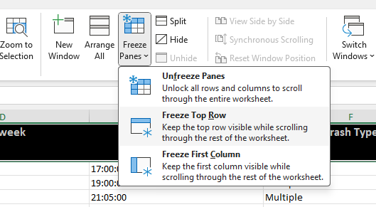
(Slide 71) Demonstrate how data can be sorted to identify key data by selecting the entire table (selecting the arrow in the top left-hand corner of the rows and columns).
Select the ‘Data’ tab, and ‘Sort’.
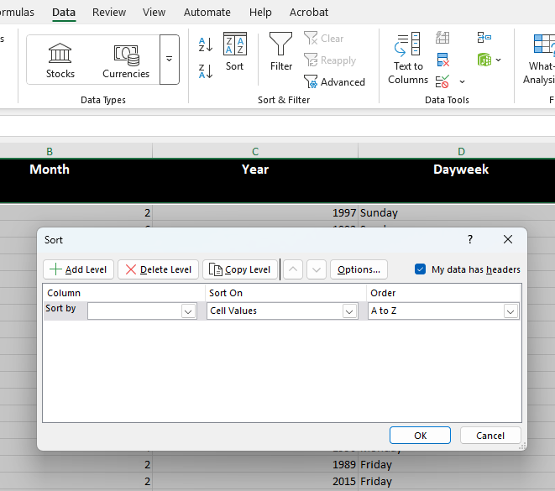
The data can now be sorted according to state. The year of the accidents can also be added to the ‘Sort’ function, by ‘Add Level’.
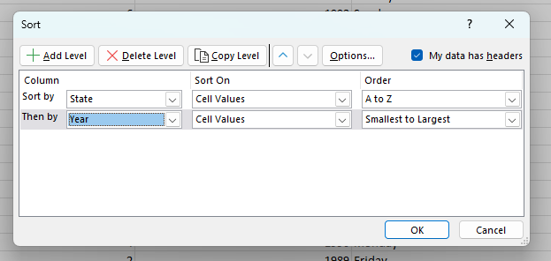
Students should be able to concentrate their data to their state and within a set time period.
(Slide 72) Pose the question: What factors could affect the number of road fatalities in our state?

Cleaning and using data • Investigate
Encourage students to ask open-ended questions about the data.

Potential discussion prompts
- What do you notice?
- What patterns can you find?
- How do these variables seem to be related?
- What is the relationship between...
- How does ___ affect ___?
- Is there a link between...?
✎ STUDENT NOTES: Brainstorm a list of questions that can be asked about the data.
(Slide 73) Support students in turning broad questions into specific, investigable questions by guiding them to identify two key variables (independent variable and dependent variable).

Potential discussion prompts
- I wonder if there are more fatalities at 60 km/h or 40 km/h.
- I wonder if there are more fatalities on weekends or weekdays.
- I wonder if there are more male or female fatalities.
- I wonder if more young or old pedestrians are killed in car accidents.
- What would be the independent variable in your question?
Let students share their questions with peers or in small groups to clarify their question. Encourage peer feedback and revise questions for clarity and focus.

Potential discussion prompts
- Is the data available?
- Can the question be answered by analysing the data?
- Is the question measurable and focused?
- Is the question specific and easy to understand?
- Does it avoid vague terms like "better" or "interesting"?
  - Example: Why are car crashes bad? is too vague. How has the number of road fatalities in NSW changed from 2010 to 2020? is an answerable question.
- Does the question involve interpreting data, finding patterns, or making comparisons?
- Does the question require more than a yes/no answer or a single fact?
- Does it relate to a real-world issue or scientific concept?
✎ STUDENT NOTES: Write your finalised question. Identify the secondary data that will be needed to answer the question.
Encourage students to copy the data to a new tab on the spreadsheet. This allows the original data to be available should students accidentally remove data that is later needed. Use the new data set to remove all unwanted/irrelevant data.
NOTE: In the spreadsheet, ‘-9’ is used for missing/unknown values.
Allow students time to identify the data that is useful to answer their question.
✎ STUDENT NOTES: Collate the final data and represent the data using a graph or other forms.

Integrate • Causation vs correlation
Text (Slide 74) Discuss how cleaning the data made it easier to identify trends or patterns in the key variables. Identify the risks involved, such as removing other data that might also have affected the dependent variable.

Potential discussion prompts
- What does it mean to ‘clean’ data? What kinds of data might be removed or changed?
- Why is it important to clean data before analysing it? What problems might happen if we don’t?
- How did cleaning the data help you see patterns or relationships between variables more clearly?
- What kind of errors or outliers were removed during the cleaning process? How did that affect your results?
- Can removing ‘bad data’ make your conclusions more accurate? Why or why not?
- What could happen if you accidentally remove data that was actually important?
- Should we always remove outliers or strange data points? Why or why not?
- How can we make sure our data cleaning choices are fair, honest, and based on good reasoning?
- If two people cleaned the same dataset differently, could they come to different conclusions? What does that tell you?
(Slide 75) Discuss students’ findings and the difference between causation (when one variable causes a change in another variable) and correlation (when two variables move at the same time, but one does not cause the other to move).

Potential discussion prompts
- What does it mean if two things are correlated? Can you give an example?
- What is causation? How is it different from correlation?
- Why is it important not to assume that correlation means causation?
- Ice cream sales and the frequency of sunburns both increase in December. Does this mean ice cream causes sunburn? Why or why not?
- How can scientists test whether a relationship is actually causal?
- Why are controlled experiments better for finding causation than just looking at data trends?
- Why do people often jump to conclusions when they see two things happen together?
- What are the risks of making decisions based on a false assumption of causation?
✎ STUDENT NOTES: Describe the conclusions that you have drawn as a result of the data. Describe the limitations of these conclusions.
Discuss if students had all the data that they needed to answer their question. If not, brainstorm where/how they could obtain the data.
Discuss how students could communicate their questions and conclusions to different audiences. Consider which audiences would be most interested in the conclusions and how they could be communicated most effectively.
✎ STUDENT NOTES: Draw an infographic that communicates the question and conclusion to an appropriate audience.

Reflect on the lesson
You might invite students to:
- identify other questions that could be answered by the data.
- examine other infographics to identify the factors that help in effective communication.
- re-examine the intended learning goals for the lesson and consider how they were achieved.
- discuss how they were thinking and working like scientists during the lesson.

Y10

Newton meets AI • Lesson 6B • Ethical dilemmas
Lesson 6B
INQUIRE
To read the most recent version of this lesson, download associated resources, and view embedded professional learning including classroom videos and work samples, visit: https://scienceconnections.edu.au/teaching-sequences/year-10/newton-meets-ai/lesson-6b-ethical-dilemmas

Lesson overview
Students use variations on the classic trolley problem to examine the importance of considering ethics when programming autonomous cars.

Key learning goals
Students will:
- examine a number of variations of the Trolley problem and how it could relate to autonomous cars.
- compare consequentialist and deontological approaches to ethics.
Students will represent their understanding as they:
- identify the possible actions an autonomous car could take.
- compare the actions of an autonomous car selected as a result of a consequentialist approach and a deontological approach.

Assessment advice
In this lesson, assessment is formative.
Feedback might focus on:
- students’ ability to describe the values and needs of society and how they influence the focus of scientific research.
- students’ ability to construct logical arguments based on analysis of a variety of evidence to support conclusions and evaluate claims.

List of materials
Whole class
- Newton meets AI Resource PowerPoint
- Video: The ethical dilemma of self-driving cars - Patrick Lin (4:15)
Each group
- Ethical dilemmas Resource cards (laminated for future use)
Each student
- Individual science notebook
- Ethical dilemma Resource sheet

Lesson routine | Estimated time | Task type
Re-orient | 5 minutes | Whole class
Question | 5 minutes | Whole class
Investigate | 30 minutes | Small group
Integrate | 20 minutes | Whole class/Small group

Inquire

Re-orient
Review how quickly autonomous cars react and the factors that need to be considered when planning for autonomous driving.
These may include:
- the speed the car is travelling.
- the conditions of the tyres, road, and weather.
- the number of people in the car (mass).
- the use of seatbelts.

Question • Self-driving cars
(Slide 77) Pose the question: What should autonomous cars be programmed to do in an accident?
Show The ethical dilemma of self-driving cars - Patrick Lin (4:15).

Investigate • Consequentialism and deontology
Introduce the idea that decisions are not a matter of right or wrong. Instead, it is important to understand the reasons why an ethical decision was made.
(Slide 78) Explain that students will use two approaches (consequentialism and deontology) to examine the ethics of a decision that will be made by an autonomous car.
Explain that:
- Consequentialism looks at the final outcome of a decision and decides if it was good or bad (the end justifies the means).
- Deontology looks at the individual actions and decides if they are good or bad (what was the intention of the action?). The consequences do not matter.
✎ STUDENT NOTES: Write the definition of consequentialism and deontology.
(Slide 79) Other ways to consider ethics are to use ethical concepts to make decisions. Two of these are:
- Minimise harm (the least number of people harmed)
- Maximise the benefits (who will people/society most need or benefit from)
✎ STUDENT NOTES: Write the ethical concepts of minimise harm and maximise benefits.
(Slide 80) Provide students with a copy of the Ethical dilemma Resource sheet and the Ethical dilemmas Resource cards.
Explain that students should:
- examine each dilemma and identify what actions the car could take.
- decide if they will use the ethical concepts of either ‘minimise harm’ or ‘maximise benefits’ for their decision-making process.
- use consequentialist and deontological approaches to identify the action the car should take.
✎ STUDENT NOTES: Complete the Ethical dilemma Resource sheet.

Integrate • Sharing the loss
(Slide 81) Select one of the ethical dilemmas and discuss it as a class. Model a Socratic approach to the discussion, including:
- the teacher acts as a facilitator not a lecturer.
- ask open-ended questions to stimulate deep thought.
- challenge assumptions about how/why actions will minimise harm or maximise benefits.
- foster active listening so that follow-up questions are asked.
- draw as many students into the conversation as possible.
- allow students time to think before answering questions.
- encourage students to provide evidence or examples.
- summarise and reflect when appropriate.

Potential discussion prompts
- What is your initial decision to this situation?
- What action could the car have taken?
- Did you use a minimise-harm approach or a maximise-benefit approach? Was there any difference to these approaches when you were making decisions?
- Is anyone’s life more important than another person? Why or why not?
- Who might you (as the driver) sacrifice your life for? Why?
- Would your decision change if your family was in one of the groups? Why?
- Is the number of lives saved more important than whose life is saved? Why?
- What are the challenges of having to make these decisions years before the actual event?

Reflect on the lesson
You might invite students to:
- consider how their initial reaction to a dilemma might be different from a considered option. How would this reflect an instinctive decision vs programming an autonomous car?
- prepare an argument about who should be at fault when an autonomous car crashes.

Y10

Newton meets AI • Lesson 7 • Autonomous car design
Lesson 7
act
To read the most recent version of this lesson, download associated resources, and view embedded professional learning including classroom videos and work samples, visit: https://scienceconnections.edu.au/teaching-sequences/year-10/newton-meets-ai/lesson-7-autonomous-car-design

Lesson overview
Students consolidate their learning by using their understanding of distance, speed, acceleration, and Newton’s laws to design and communicate the features of a future autonomous car.

Key learning goals
Students will:
- revise the factors that affect the safety of occupants of an autonomous car.
- use their learning to design the safety features of an autonomous car.
- communicate their learning to their peers.
Students will represent their understanding as they:
- prepare a model, a poster, or an advertisement showing the programming and safety features for an autonomous car.

Assessment advice
In this lesson, assessment is summative.
Students working at the achievement standard should:
- investigate a moving object to analyse and propose relationships between distance, speed, and acceleration.
- explain how Newton’s laws describe motions and apply them to predict the motion of objects in a system.
- model how a change in net force acting on an object affects its motion and relate this to the purpose of safety features such as seatbelts.
- constructing an argument, supported by data, to support lower speed limited near schools or for trucks in urban environments.
- investigating how driverless vehicles apply Newton’s laws of motion to brake in time.
- analyse the relationship between science, technology, and engineering.
- construct logical arguments based on analysis of evidence to support conclusions and evaluate claims.
Refer to the Australian Curriculum content links on the Our design decisions tab for further information.

List of materials
Whole class
- Newton meets AI Resource PowerPoint
- Video: Self-Driving Cars & Pedestrian Safety (4:20)
Each student
- Individual science notebook
- Optional: Poster paper or electronic equivalent

Lesson routine | Estimated time | Task type
Anchor | 10 minutes | Whole class
Connect | 10 minutes | Whole class/Small groups
Design | 30-60 minutes | Individual/Small groups
Communicate | 30-60 minutes | Individual/Whole class

Act

Anchor • Revising motion
Review the factors that affect how quickly an autonomous car could stop, including:
- the speed the car is travelling.
- the conditions of the tyres, road, and weather.
- the number of people in the car (mass)—Newton’s second law.
- the use of seatbelts—Newton’s first law.

Connect • Walking safely
Show the video Self-Driving Cars & Pedestrian Safety (4:20).
(Slide 83) Discuss how manufacturers of autonomous cars are making decisions for the students (as future drivers and passengers) right now.

Potential discussion prompts
- Do you trust the car manufacturers to make the right decisions for you (as a driver or a pedestrian) now?
- When do you intend to get your driver’s license? Will this change if autonomous cars become more affordable?
- How many autonomous cars are currently available? How could we find out?
- What types of decisions do these cars make? How do we know? How could we find out?
- What types of decisions would encourage you to buy an autonomous car? Why?

Design • Designing for the future
(Slides 84-85) Students should prepare a model, a poster or an advertisement for an autonomous car of the future.

Define
Outline the group of people who will want to buy the autonomous car. Consider the price range, the age and life stage (retirees, families, young sports car enthusiasts).

Ideate
Brainstorm the key features that will attract potential buyers including:
- the type and number of sensors used.
- the way the car responds in different situations.
- how the car modifies its driving in different conditions.
- the safety features of the car.

Design the prototype
Select the different features that will be used in the autonomous car. Consider where the sensors will be located and the style of the dashboard. For example, consider whether the car will be fully autonomous or if the driver will need to take control in an emergency.

Building the prototype
Prototypes can take many forms depending on the time and resources available. It may be as simple as a detailed drawing with labels and explanations, or as complex as a scaled model of the design.

Allow students time to complete their prototype designs and accompanying explanations of the design.

Communicate • Sell the design
Receiving feedback is an important part of the design process.
Before students present their designs, discuss how to give effective feedback to each other by planning the approach to be used in the classroom. Each group could use a structured feedback form, checklists, or rubrics to guide their review. This can include specific areas to review, for example:

The science
- Have the science ideas been explained in the design?
- Does the design consider real scientific principles of motion by predicting how the car will sense and react in different situations? Does the presentation describe:
  - the relationship between braking distance, speed, and acceleration?
  - how Newton's first law relates to the number of occupants in the car?
  - how Newton's second law relates to the availability of seatbelts?
  - the recognition of speed zones (including school zones)?

The model or design
- How realistic is the design given the constraints?
- Does the design offer creative solutions to the problem?
- How practical is the design for actual implementation, considering available resources and technology?
- What could be improved in the design?
- Are there any flaws or missing elements in the design?
- What are the strengths of the design?
- Is the design unique and well thought out?

The communication
- How well is the design communicated, both visually and verbally?
- What are the assumptions that have been made about the design?
Allow the students time to present their designs.

Reflect on the sequence
You might invite students to:
- consider how the learning from this teaching sequence may affect their driving in the future.
- identify the key features that will be required in their first/next car.

